# Langtnag, landcover 1

# Langtnag, landcover 2

# Langtang, landcover 3

# Langtnag, landcover 4

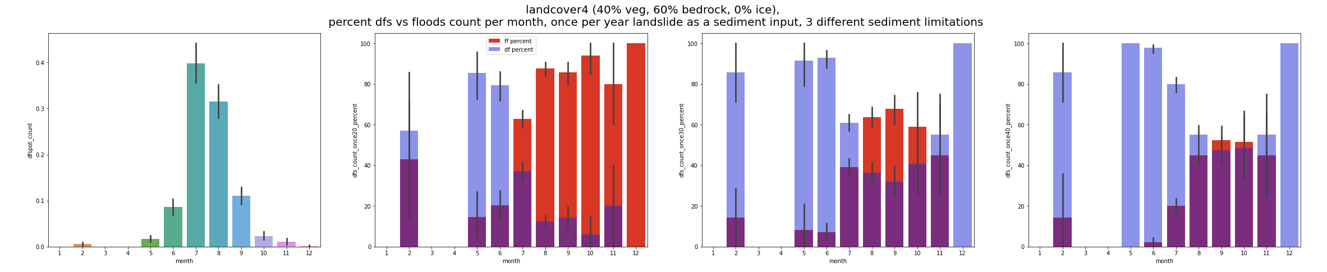

# Mustang, langcover 1

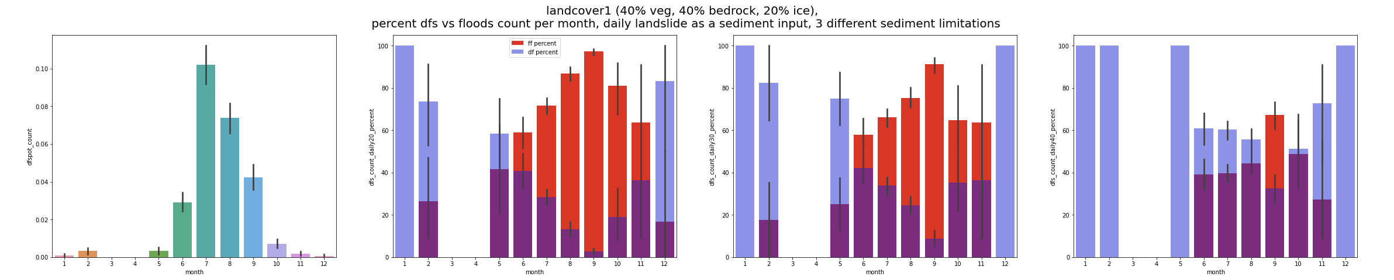

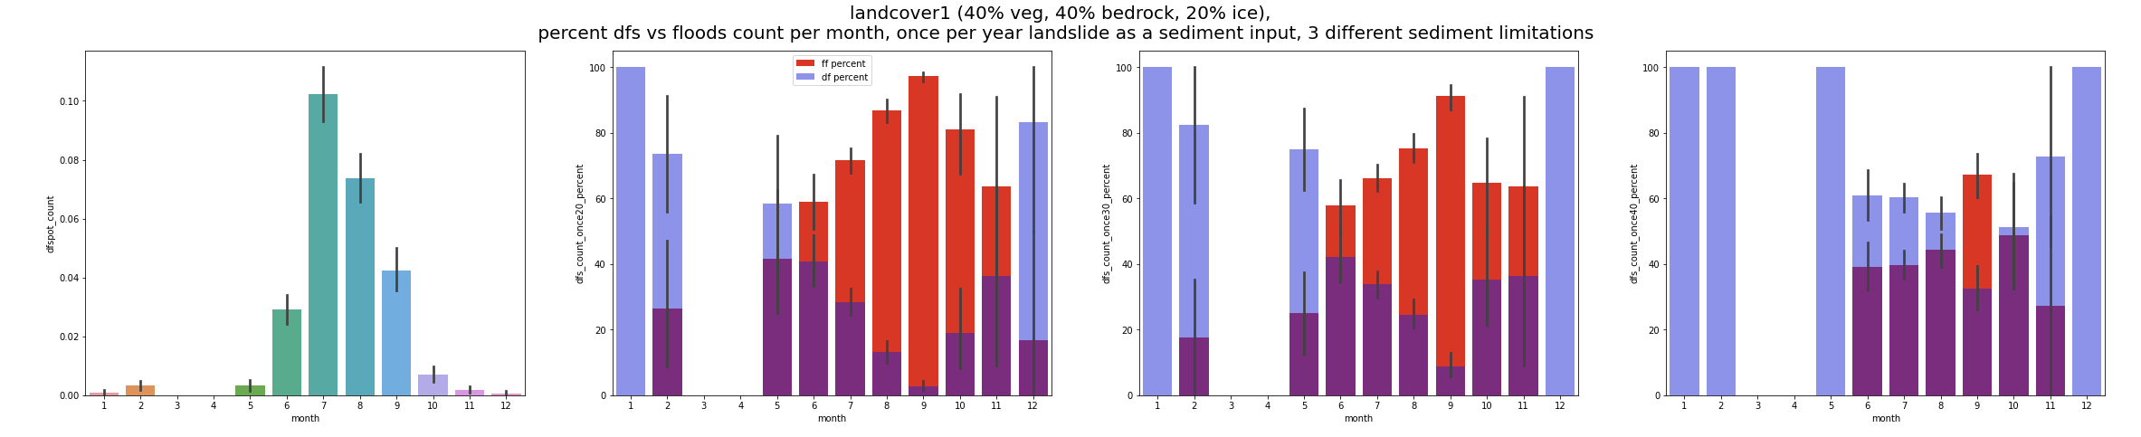

# Mustang, landcover2

# Mustang, landcover 3

# Mustang, landcover 4

