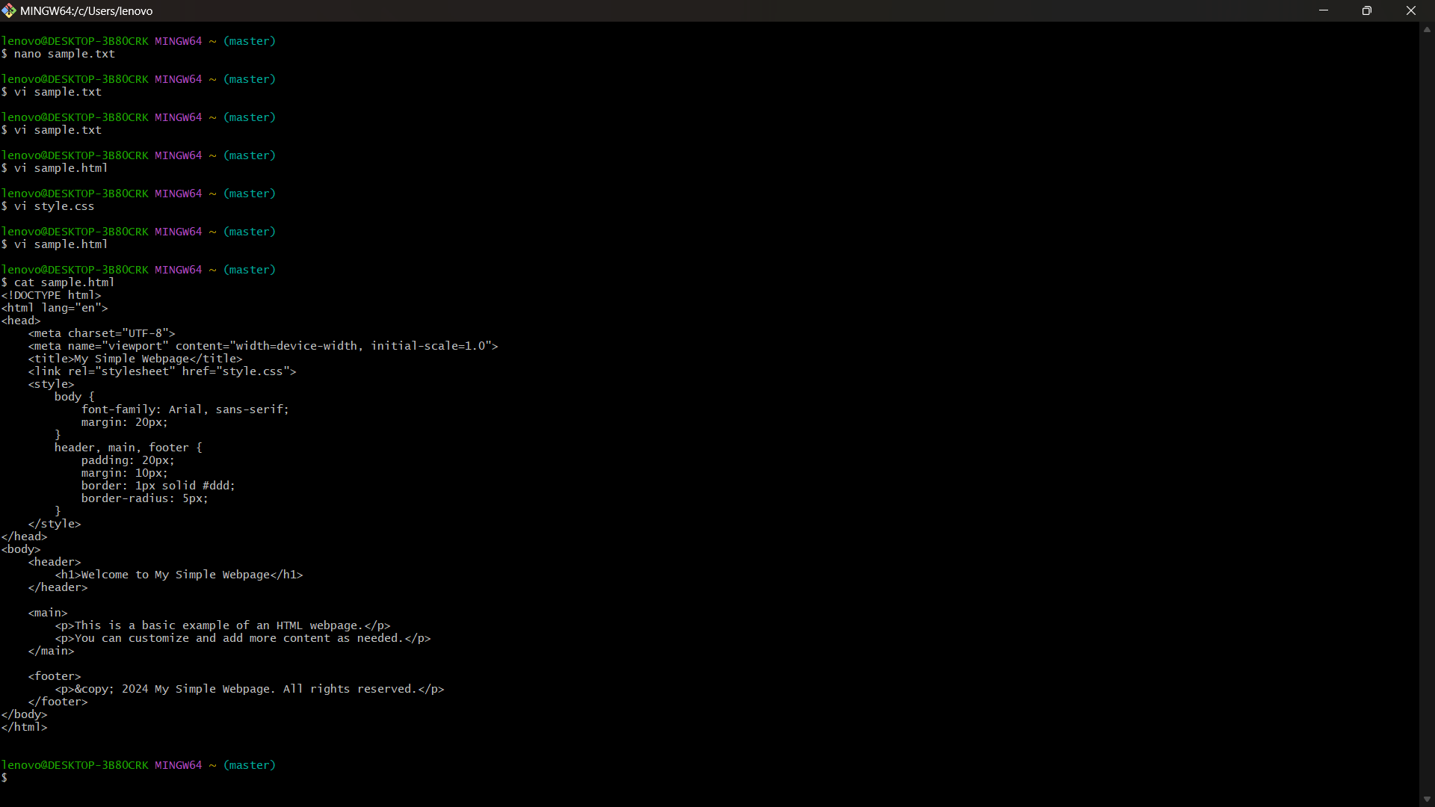

Cat command shows the content of a file

## How to save a file and exit In vi?

Esc then : then w then q

## How to open vi editor?

Vi filename.extention

# Git add

Takes file to the staging area

git add filename.ext

