RideMesh: A Cloud-Native, Event-Driven Microservices Platform for Geospatial Ride-Hailing, Automated Settlement and Observability
Ritish Kumar (A042) | 70612500068
Yog Vasaikar (A064) | 70612500073
Sumukh Kanekar (A067) | 70612500076
Department of Computer Applications

Abstract
RideMesh is a ride-hailing platform built as seven decoupled Spring Boot components that coordinate through Apache Kafka events and a Spring Cloud API Gateway. This report describes its third phase, which extends the Phase 2 service decomposition into a production-oriented system: every component is containerised with a multi-stage Dockerfile, the full stack runs from one Docker Compose file and from a set of Kubernetes manifests, and Prometheus and Grafana provide continuous visibility into JVM and HTTP behaviour. The platform keeps database-per-service isolation, edge JWT validation, OSRM road distance with a Haversine fallback, PostGIS proximity matching, a four-digit OTP trip handshake and a double-entry wallet ledger with a 70/30 driver-platform split. Phase 3 adds full-precision reverse-geocoded addresses, a Google Gemini location classifier for district resolution, a driver duty switch that removes off-duty drivers from the match queue, driver incident reporting, and a categorised feedback channel with administrator moderation consoles and Kafka-delivered replies. Secrets are kept in a git-ignored environment file and Kubernetes Secrets. We present the architecture, patterns, algorithms, data model, interfaces and a qualitative evaluation with a failure-mode analysis, and we state plainly that no quantitative load measurements have been taken.
Index Terms—microservices, event-driven architecture, Apache Kafka, saga pattern, ride-hailing, PostGIS, OSRM, API gateway, JWT, Docker, Kubernetes, Prometheus, Grafana, Spring Boot.

I. Introduction
Urban ride-hailing couples several concerns that scale and fail differently: identity, trip orchestration, geospatial search, payments and notifications. In a monolith these share one codebase and one database, so a slow email provider or a payment retry can degrade booking latency, and a single fault can take the whole service down [1], [2]. Teams that split such a system gain independent deployment and failure isolation, but they inherit new problems: data that no longer lives in one transaction, configuration and secrets that must be managed per component, and behaviour that can no longer be understood by reading one stack trace [2], [3].
RideMesh addresses these problems incrementally. Each service owns its data, services discover one another through Netflix Eureka, and all external traffic enters through one gateway. State changes that span services, such as ending a trip and paying the driver, are propagated as Kafka events instead of distributed transactions. Phase 3 closes the gap between a working decomposition and an operable platform by adding packaging, orchestration, observability, secret handling and a set of user-facing quality features.

A. Architectural Evolution
The project has moved through three phases, summarised in Table I. Phase 1 was a single Spring Boot application with one relational schema. Phase 2 split it into independent services with a gateway, a service registry and an event bus. Phase 3, the subject of this report, concentrates on how the system is built, shipped, observed and used.
TABLE I. EVOLUTION OF RIDEMESH ACROSS PROJECT PHASES
Aspect | Phase 1 and 2 | Phase 3
Structure | Spring Boot monolith, then seven decoupled components | Same seven components, now packaged and orchestrated as containers
Deployment | Maven wrapper start-up in a fixed order | Multi-stage Dockerfiles, one docker-compose.yml, Kubernetes manifests in k8s/
Monitoring | Logs only | Micrometer metrics, Prometheus scraping, provisioned Grafana dashboards
Secrets | Values in configuration files | Git-ignored .env, classpath fallback loader, Kubernetes Secrets
Addresses | Truncated display strings | Full reverse-geocoded pickup and drop-off addresses stored untruncated; Gemini fallback for district resolution
Driver control | Availability changed only by trip events | Driver duty toggle that shields off-duty drivers from matching
Community | None | Driver incident reports and a categorised feedback channel with administrator replies by email
Messaging | Eight Kafka topics | Nine topics, adding the general notification.email topic

B. Objectives
- Decompose a cab-booking system into services with isolated databases and independent failure domains.
- Preserve full address precision from map selection through storage to display, and let users copy a complete address without leaving the table.
- Compute fares from real road distance rather than straight-line distance, and degrade gracefully when the routing service is unreachable.
- Match riders only to nearby drivers who are available and on duty, using native spatial queries.
- Settle payments through an immutable double-entry ledger with a fixed platform commission and one settlement per ride.
- Make the system observable and reproducible: the same stack must start from one command and expose its health through standard metrics.
- Give riders and drivers a channel for feedback, suggestions, complaints and bug reports, and give administrators tools to moderate and answer them.

C. Contributions
- A seven-component reference architecture combining Eureka discovery, a JWT-validating gateway, Kafka choreography and PostgreSQL/PostGIS persistence, now delivered as containers and Kubernetes manifests.
- A strategy-based policy layer for fare calculation, driver matching and payment settlement that lets business rules change without touching service orchestration.
- An OSRM-first distance service with a Haversine fallback, a Gemini-assisted location classifier, and a PostGIS proximity query that respects a driver availability shield.
- Idempotent event consumers for wallet settlement and email delivery, plus a double-entry ledger keyed by ride identifier.
- An observability stack that scrapes standard Micrometer metrics from every service into Prometheus and visualises them in pre-provisioned Grafana dashboards.
- A configuration and secret-management scheme that works identically for local development, Docker Compose and Kubernetes.
- A Thymeleaf and Leaflet portal for riders, drivers and administrators, including KYC review, incident moderation and an Improvement Console whose replies travel over Kafka.

D. Paper Organization
Section II reviews background. Section III presents the architecture, containerisation and secret management, and Section IV the design patterns. Section V describes the core algorithms and mathematical models, Section VI the messaging layer, and Section VII the data model and API surface. Section VIII covers the interface, moderation consoles and observability. Section IX evaluates the system and analyses failure modes, and Section X concludes with future work.

II. Background and Related Work

A. Microservices and Database-per-Service
The microservices style structures an application as small services organised around business capabilities, each running in its own process and communicating over lightweight protocols [1]. Giving every service its own datastore keeps schemas private and avoids the coupling that shared tables create, at the cost of giving up cross-service ACID transactions [3]. A monolith offers simpler transactions, a single deployable and straightforward debugging, and it remains the better choice for small teams with modest scale [2]. RideMesh adopts services because its concerns have genuinely different load profiles: settlement is write-heavy and must be exact, notification is bursty and tolerant of delay, and matching is read-heavy and latency-sensitive.

B. Event-Driven Choreography versus Orchestration
A saga replaces one long distributed transaction with a sequence of local transactions, each publishing the trigger for the next [5]. In an orchestrated saga a central coordinator tells each participant what to do; in the choreographed variant used here there is no coordinator, and each service reacts to events and emits its own [3]. Choreography removes a single point of coordination and keeps services ignorant of one another, but the overall flow becomes implicit and harder to trace. Because brokers can redeliver messages, consumers in either style must be idempotent [3], [16].

C. Event Streaming with Kafka
Kafka is a distributed, partitioned, replicated log that decouples producers from consumers and lets many consumers read the same topic independently [4]. Recent releases can run without ZooKeeper by using a built-in Raft-based metadata quorum, known as KRaft mode [17], which reduces the number of containers needed to run a broker in development and in Compose-based environments.

D. Edge Authentication
JSON Web Tokens carry signed claims that a verifier can check without a session store [6]. Validating the token once at an API gateway and forwarding trusted identity headers is a common way to avoid repeating signature checks in every service [3]. The trade-off is that downstream services must not be reachable except through the gateway, a point revisited in Section IX.

E. Road Routing and Geospatial Indexing
OSRM computes shortest paths on OpenStreetMap road graphs, using preprocessing techniques such as contraction hierarchies to answer queries quickly [7], [18]. The Haversine formula gives great-circle distance between two coordinates [8] and serves as a conservative estimate when road routing is unavailable. PostGIS adds geometry and geography types and spatial functions such as ST_DWithin and ST_Distance to PostgreSQL [9]. Its spatial indexes are built on the Generalized Search Tree (GiST) framework [19], which implements an R-tree-like structure over bounding boxes [20], so a radius filter can discard most rows without computing exact distances.

F. Observability
Observability is the ability to infer the internal state of a system from its outputs. Prometheus uses a pull model: it periodically scrapes an HTTP endpoint that exposes metrics in a text exposition format closely related to the OpenMetrics specification, and stores them as time series [12], [13]. Micrometer provides a vendor-neutral instrumentation facade for JVM applications and publishes such metrics through Spring Boot Actuator [14]. Grafana queries the Prometheus store and renders dashboards. Together they supply the signals recommended for service monitoring: latency, traffic, errors and saturation [11].

G. Containers and Orchestration
Containers package an application with its runtime dependencies so that it behaves the same on every host [10]. Kubernetes schedules and supervises containers across a cluster and descends from Google's internal Borg system [21]. Liveness and readiness probes let the orchestrator restart a stuck process and withhold traffic from one that is not yet ready [22]. The twelve-factor methodology recommends keeping configuration in the environment rather than in code [23], which motivates the secret-handling design in Section III.

H. Positioning
Commercial ride-hailing platforms are proprietary, so their internals are not directly comparable. RideMesh is a compact, open implementation of the same building blocks, intended to show how discovery, gateway security, event choreography, geospatial matching, wallet accounting, containerised deployment and monitoring fit together in one Spring-based codebase.

III. System Architecture and Topology
RideMesh applies the database-per-service and gateway-offloading patterns. The browser portal sends every request to the API Gateway, which validates the JWT and forwards the request to the service that owns the route. Services register with Eureka and coordinate through Kafka events and a small number of synchronous REST lookups between services. Prometheus scrapes every service independently of this request path.
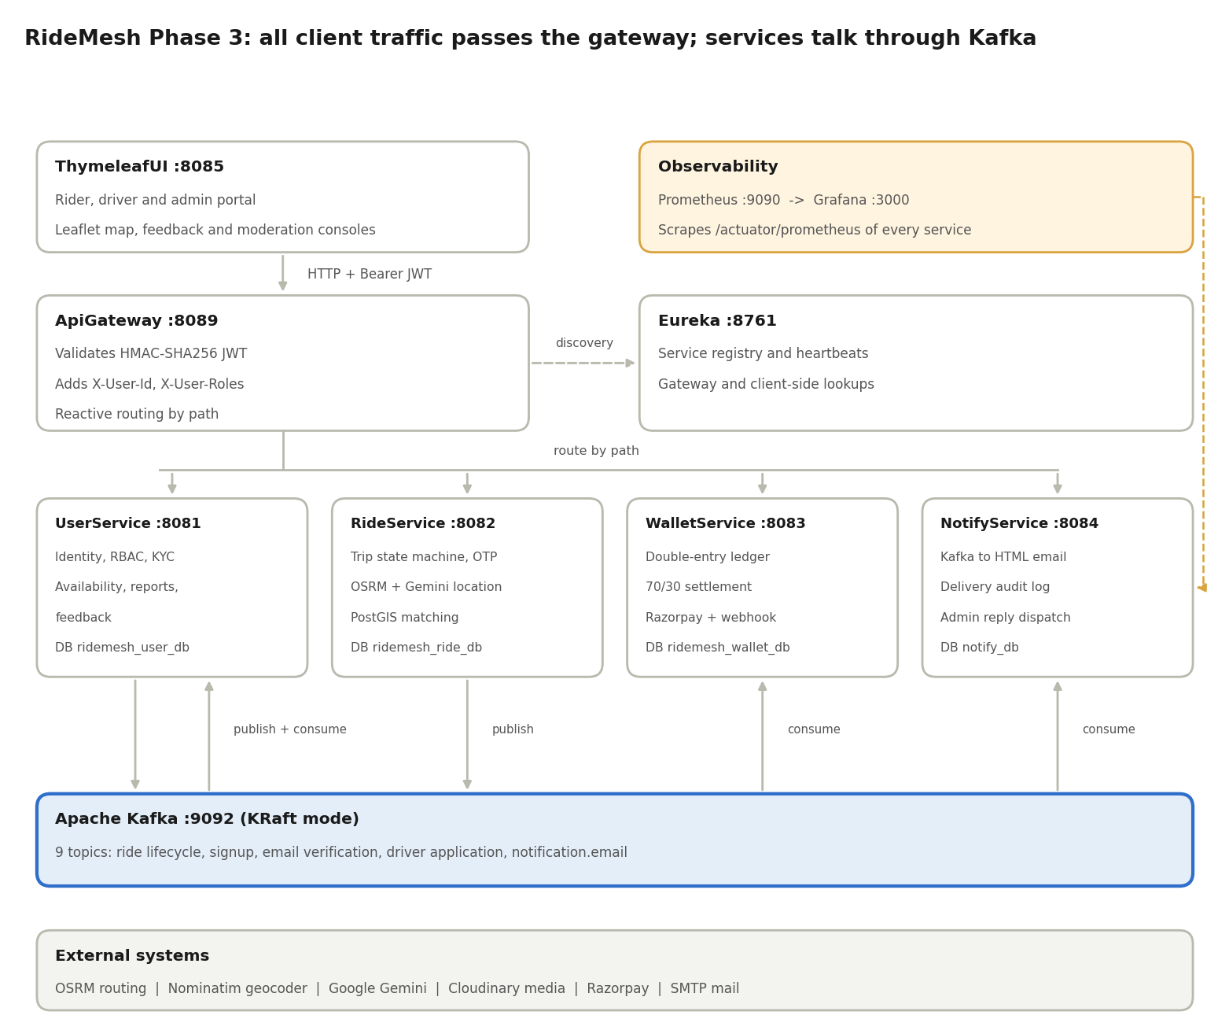
Fig. 1. RideMesh Phase 3 topology. Solid arrows show request routing and event flow; dashed arrows show service discovery and metrics scraping. Each service box names its own database.

A. Service Inventory
TABLE II. SERVICE AND INFRASTRUCTURE INVENTORY
Component | Port | Datastore | Primary responsibility
eureka-server | 8761 | In-memory registry | Dynamic service registration, heartbeat-based discovery and cluster topology catalogue
ApiGateway | 8089 | None (stateless) | Edge reverse proxy, reactive routing, HMAC-SHA256 JWT validation, injection of X-User-Id and X-User-Roles
UserService | 8081 | ridemesh_user_db (PostgreSQL with PostGIS) | Identity and BCrypt hashing, roles (RIDER, DRIVER, ADMIN), email verification, driver KYC onboarding, driver availability, incident reports, user feedback, admin moderation
RideService | 8082 | ridemesh_ride_db (PostgreSQL with PostGIS) | Trip state machine, OSRM distance with Haversine fallback, Gemini location classifier, PostGIS driver matching, OTP verification, full address capture
WalletService | 8083 | ridemesh_wallet_db (PostgreSQL) | Double-entry ledger, 70/30 settlement, wallet, Razorpay and cash payment strategies, webhook verification
NotifyService | 8084 | notify_db (PostgreSQL) | Asynchronous Kafka consumer, HTML email through SMTP, persistent delivery audit log
ThymeleafUI | 8085 | None (client portal) | Rider, driver and admin web interface with Leaflet, OpenStreetMap and Tailwind CSS
Apache Kafka | 9092 | Log segments (KRaft) | Nine topics carrying all asynchronous events
PostgreSQL | 5432 | Four databases | Relational storage with the PostGIS extension enabled
Prometheus | 9090 | Time-series store | Periodic scraping of /actuator/prometheus on every service
Grafana | 3000 | Provisioned dashboards | JVM, CPU, HTTP throughput and error-rate visualisation

B. Technology Stack
The services use Java 20, Spring Boot 3.4.0 and Spring Cloud 2024.0.0 (Eureka and Spring Cloud Gateway). Messaging runs on Apache Kafka in KRaft mode on port 9092. Persistence uses PostgreSQL on port 5432 with PostGIS and Hibernate Spatial. Routing and mapping use OSRM, Leaflet.js with OpenStreetMap tiles, and the Nominatim geocoder. Google Gemini supports location classification, Razorpay handles online payments with webhooks, Spring Mail delivers email over SMTP, and KYC and feedback media are stored on Cloudinary. The interface is rendered with Thymeleaf and Tailwind CSS. Metrics use Micrometer, Prometheus and Grafana.

C. Containerisation and Docker Compose
Every microservice has its own multi-stage Dockerfile. The first stage compiles the project with Maven in a full JDK image; the second copies only the resulting jar into a slim JRE image. This keeps build tools and source code out of the runtime image, reduces its size and attack surface, and makes the build reproducible on any machine with Docker.
The root docker-compose.yml orchestrates the entire platform: PostgreSQL with PostGIS, Kafka in KRaft mode, Prometheus, Grafana and every microservice. On first start PostgreSQL runs sql/create_database.sql, which creates the four databases (ridemesh_user_db, ridemesh_ride_db, ridemesh_wallet_db and notify_db) and enables the spatial extension where it is needed, so no manual database preparation is required. Services reach one another by Compose service name on a shared network, and start-up dependencies order the infrastructure containers ahead of the services that need them.
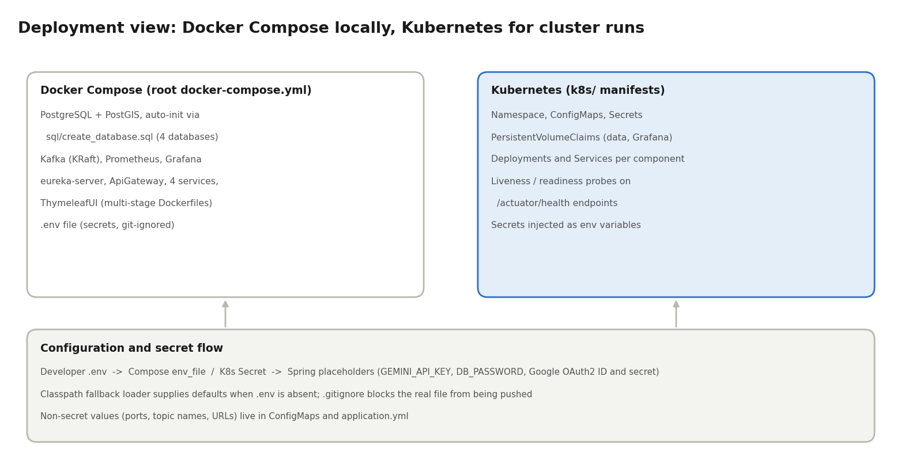
Fig. 2. Deployment view. Docker Compose runs the whole stack locally; the Kubernetes manifests express the same topology for a cluster. Both draw secrets from the environment rather than from source files.

D. Kubernetes Manifests
The k8s/ directory contains manifests for each kind of resource the platform needs:
- Namespace that groups all RideMesh resources.
- ConfigMaps for non-secret settings such as ports, Kafka bootstrap address, topic names and service URLs.
- Secrets for database passwords, the Gemini API key and the Google OAuth2 client credentials.
- PersistentVolumeClaims so PostgreSQL and Grafana state survives pod restarts.
- Deployments and Services for each component, giving stable cluster DNS names.
- Liveness and readiness probes against the Spring Boot Actuator health endpoints. A failing liveness probe causes a restart; a failing readiness probe removes the pod from service endpoints until it recovers [22].

E. Secret Management
Third-party credentials, namely the Google OAuth2 client identifier and secret, the Gemini API key and the database passwords, never appear in source-controlled files. A local .env file holds them for development and for Compose. Spring configuration refers to them through placeholders, and an automated classpath fallback loader supplies safe defaults when the file is absent so that a fresh clone still starts. A .gitignore rule prevents the real .env from being committed or pushed. In Kubernetes the same placeholders are satisfied from Secret objects exposed as environment variables. This follows the twelve-factor principle of strictly separating configuration from code [23], and it keeps the same artefact deployable in every environment.

IV. Design Patterns and Architectural Mechanisms

A. Gateway Offloading and Stateless Identity Propagation
A JwtValidationFilter in the gateway checks the Bearer token signature (HMAC-SHA256) once per request. It extracts the user identifier and roles and adds them to the downstream request as X-User-Id and X-User-Roles headers. Each service, for example UserService through its HeaderAuthFilter, reads these headers to build the Spring SecurityContext. No service repeats signature verification or queries the user table to learn who is calling, and no session is stored anywhere. Role checks then use ordinary method-level authorisation on RIDER, DRIVER and ADMIN, which also protects the moderation consoles.
This design depends on services not being reachable except through the gateway; Section IX examines the consequences.

B. Strategy Pattern
Business policies that change independently of the trip workflow are isolated behind interfaces, each with a manager that selects the implementation [15].
TABLE III. STRATEGY INTERFACES AND IMPLEMENTATIONS
Concern | Manager | Implementations
Fare calculation | RideFareCalculationStrategyManager | RideFareDefaultCalculation (distance × vehicle rate); RideFareSurgePricing (applies SURGE_FACTOR = 2.0)
Driver matching | DriverMatchingStrategyManager | DriverMatchingNearestDrivers (PostGIS proximity over available drivers); DriverMatchingHighestRatedDriver (rating priority)
Payment settlement | PaymentStrategyManager | WalletPaymentStrategy; RazorpayPaymentStrategy; CashPaymentStrategy

Adding a pricing rule, a matching rule or a payment method therefore means adding a class and registering it with the manager, not editing the booking flow.

C. Choreographed Saga for Settlement and Ratings
When a driver ends a ride, RideService publishes ride-ended-event and returns. WalletService and UserService consume the event independently: the first debits the rider, credits the driver and records the transactions; the second marks the driver available and creates a pending rating record. No coordinator or two-phase commit is involved, so a slow or restarted consumer delays only its own step [3], [5]. A parallel branch handles cancellation: ride-cancelled-event lets UserService restore the driver's availability. The platform does not yet publish compensating events for failed payments, which is listed as future work.

D. Idempotency in Asynchronous Consumers
Kafka delivers at least once, so consumers must tolerate duplicates [16]. Table IV lists the guard used by each consumer.
TABLE IV. IDEMPOTENCY GUARDS IN EVENT CONSUMERS
Consumer | Event | Guard
WalletServiceConsumer | ride-ended-event | Looks up paymentRepository.findByRideId(rideId) before settling; the payment table enforces a unique ride_id, so a replay cannot bill a trip twice
NotificationConsumer | all email topics | Reads an eventId from each message and checks NotificationLogRepository before sending, so a replay does not send a second email
UserService consumers | ride-accepted-event, ride-cancelled-event | Set availability to an absolute value (false or true) rather than toggling, so repeated delivery converges to the same state
WalletService signup consumer | user-signup-event | Creates a wallet only if none exists for the user

E. Graceful Degradation
Two external dependencies are wrapped so that their failure does not stop a booking. If OSRM times out or errors, the distance service falls back to the Haversine formula, so a fare can still be quoted. If the geocoder cannot supply a usable district for a location, the Gemini classifier is asked to resolve it. Both are fallbacks rather than full circuit breakers: they handle a failed call but do not stop repeated calls to an unhealthy dependency, a distinction discussed in Section IX.

F. Availability Shield
Driver availability is a single boolean owned by UserService and mutated from two directions: ride events set it automatically, and the driver can switch duty on or off from the profile page. The matching query filters on this flag, so an off-duty driver is invisible to the matching strategies. Because the flag is the only input, the shield needs no additional matching logic and no cross-service call at query time.

V. Core Algorithms and Mathematical Models

A. Road Distance with Haversine Fallback
Straight-line distance understates urban driving distance. DistanceCalculationOSRMImpl requests a driving route from the public OSRM endpoint (router.project-osrm.org, driving profile) and uses the returned road distance [7]. If the call fails or times out, the service falls back to the Haversine great-circle distance with Earth radius R = 6371 km [8], so a fare can still be quoted. For two points with latitudes φ₁, φ₂ and longitudes λ₁, λ₂, the fallback distance is
$d = 2R \arcsin{\sqrt{\sin^{2}\left(\frac{Δφ}{2}\right) + cos φ_{1} cos φ_{2} \sin^{2}\left(\frac{Δλ}{2}\right)}}$ (1)
The result is a lower bound on the road distance, so a fare computed from it is conservative. The service does not currently mark such a fare as an estimate, which is noted in Section IX.

B. Address Precision and Location Classification
Phase 3 treats the address as first-class data. When a rider selects a point on the Leaflet map or picks a Nominatim suggestion, the portal reverse-geocodes the coordinates and submits the complete address string together with the latitude and longitude. RideService stores that string untruncated for both pickup and drop-off, so every later view (ride history, active ride, driver request list, admin screens) shows the same full text that the rider saw at booking time. Truncation happens only in the presentation layer, never in storage.
Structured geocoder responses do not always contain a usable district or city component, especially for informal or newly mapped places [30]. In that case RideService passes the address to a Google Gemini location classifier [28], which returns a district label that is stored with the location. The classifier is a fallback: the geocoder result is used first, and a failed or unparseable classifier response leaves the district unset rather than blocking the booking.

C. Spatial Driver Matching
Drivers store their position as a JTS Point with SRID 4326 in a PostGIS geometry column. The nearest-drivers strategy runs a native query that filters available drivers within a radius using ST_DWithin, orders them by ST_Distance and returns at most 50 candidates [9]. The available = true predicate is what implements the duty shield: a driver who has switched to Unavailable, or who is currently on a trip, is excluded before any distance is computed.
SELECT d.*, ST_Distance(d.current_location, :pickUpLocation) AS distance
FROM driver d
WHERE d.available = true
AND ST_DWithin(d.current_location, :pickUpLocation, 100000)
ORDER BY distance
LIMIT 50;

The ST_DWithin predicate can use a GiST index on current_location, which organises bounding boxes in an R-tree-like hierarchy [19], [20], so most drivers are rejected without an exact distance calculation. The units of the radius argument deserve care. For a geometry column in SRID 4326, PostGIS interprets the distance in degrees, and one degree of latitude is roughly 111.32 km. A radius of r metres therefore corresponds to about
$r_{deg} ≈ \frac{r_{m}}{111 320}$ (2)
so a literal value of 100000 passed against a geometry column would cover far more than 100 km. The query should cast both operands to geography, for which distances are in metres, or project the coordinates, so that the constant means what it says. Section IX records this as a risk.

D. Dynamic Fare Model
The default strategy multiplies road distance by a vehicle-specific rate. The surge strategy applies a fixed multiplier of 2.0 during peak hours. With road distance D in kilometres, the fare is
$F = D × r_{vehicle} × m_{surge}, m_{surge} ∈ \{1.0, 2.0\}$ (3)
TABLE V. VEHICLE RATE COEFFICIENTS
Vehicle category | Rate r (INR per km)
Scooter | 10
Bike | 15
Auto-rickshaw | 20
Standard car | 25
6-seater van | 40
8-seater van | 50

The multiplier is selected by the strategy manager, not computed from live demand. Replacing it with a demand-driven value is one of the planned extensions.

E. Cryptographic OTP and Trip Handshake
When a driver accepts a request, RideService creates a confirmed ride and generates a four-digit code with java.security.SecureRandom (GenerateOtp), a cryptographically strong generator suitable for security tokens [26]. The code is sent to the rider by email through Kafka (ride-otp-notification). The driver must submit it to POST /driver/startRide/{rideId} before the ride moves from CONFIRMED to ONGOING, which prevents a driver from starting a trip for a rider who is not present. Fig. 3 shows the full state machine.
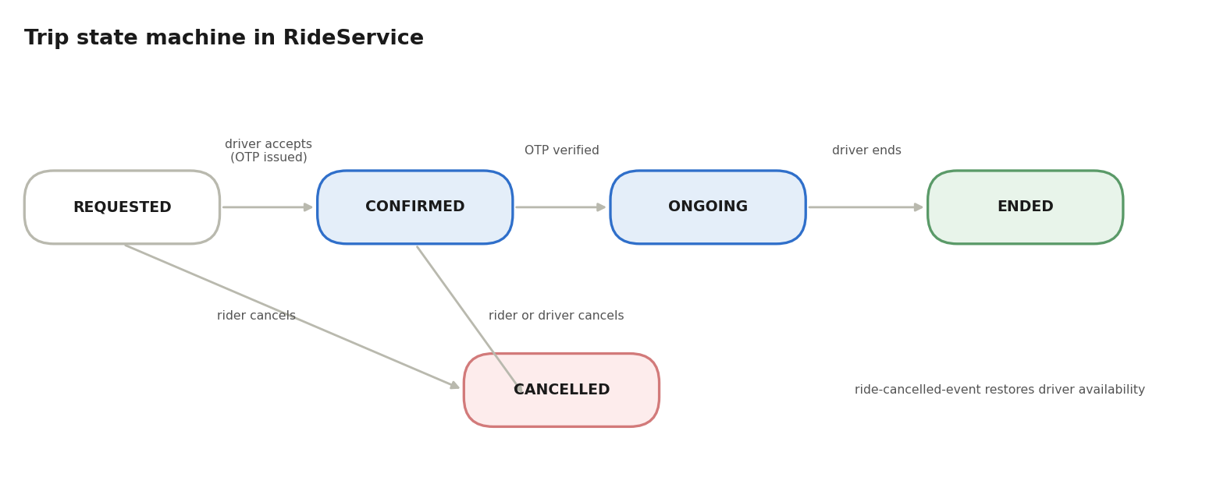
Fig. 3. Trip state machine in RideService. Only a verified OTP moves a ride from CONFIRMED to ONGOING; cancellation is possible before the trip starts and restores driver availability.
A four-digit code has 10⁴ possible values, so the probability that a guesser succeeds within n independent attempts is
$P_{guess}(n) = \frac{n}{{10}^{4}}$ (4)
Ten attempts would succeed one time in a thousand, and a thousand attempts one time in ten. The code is therefore adequate only when the number of attempts per ride is bounded; Section IX lists attempt limiting as a hardening step.

F. Double-Entry Ledger Settlement
WalletPaymentStrategy debits the rider by the full fare F and credits the driver with 70% of it, so the platform retains 30%:
$P_{driver} = 0.70 × F, P_{platform} = 0.30 × F$ (5)
Every movement is appended to WalletTransaction as an immutable CREDIT or DEBIT record linked to the ride identifier. Records are never updated or deleted, so the balance of a wallet is the sum of its entries and any discrepancy can be traced to a specific ride. For one completed ride the two wallets change by
${ΔB}_{rider} = -F, {ΔB}_{driver} = +P_{driver}, P_{driver} + P_{platform} = F$ (6)
The platform's share is not stored as a third wallet movement but is the residual of the fare, which keeps the ledger consistent with the equation above. Settlement is keyed by the unique ride_id, so processing the same event twice leaves balances unchanged. RazorpayPaymentStrategy handles online payment and wallet top-ups through POST /wallet/create-order, with asynchronous capture confirmed by a signature-verified webhook at POST /webhooks/razorpay [29]. CashPaymentStrategy records in-person payment and adjusts the platform commission.

VI. Event-Driven Messaging and Kafka Topology
Nine Kafka topics carry all asynchronous traffic. Producers publish and move on; each consumer service reacts on its own schedule and in its own consumer group, so adding a new consumer to an existing topic does not affect the others.
TABLE VI. KAFKA TOPICS, PRODUCERS, CONSUMERS AND PAYLOADS
Topic | Producer | Consumer | Trigger and effect | Principal payload fields
ride-request-notification | RideService | NotifyService | Rider books a cab; candidate drivers receive an email with the request details | request id, pickup and drop-off addresses, fare, driver emails, event id
ride-accepted-event | RideService | UserService | Driver accepts; driver.available is set to false | ride id, driver id, rider id
ride-otp-notification | RideService | NotifyService | Ride confirmed; four-digit OTP is emailed to the rider | ride id, rider email, OTP, event id
ride-ended-event | RideService | WalletService, UserService | Trip ends; fare is settled, driver is made available, rating record is created | ride id, rider id, driver id, fare, payment method
ride-cancelled-event | RideService | UserService | Rider or driver cancels; driver.available is reset to true | ride id, driver id, cancelling party
user-signup-event | UserService | WalletService | New user; a zero-balance wallet is created | user id, email, roles
send-email-verification | UserService | NotifyService | New user; activation link with a UUID token is emailed | user id, email, token, event id
driver-application-notification | UserService | NotifyService | KYC application approved or rejected; applicant is notified | user id, email, decision
notification.email | UserService | NotifyService | General-purpose email: administrator replies from the Improvement Console and driver report acknowledgments | recipient, subject, HTML body or template key, event id

The payload column lists the fields each consumer needs rather than a formal schema. Messages are serialised as JSON, and the email topics carry an eventId that the notification consumer uses for idempotency.

A. Ride Lifecycle Across Services
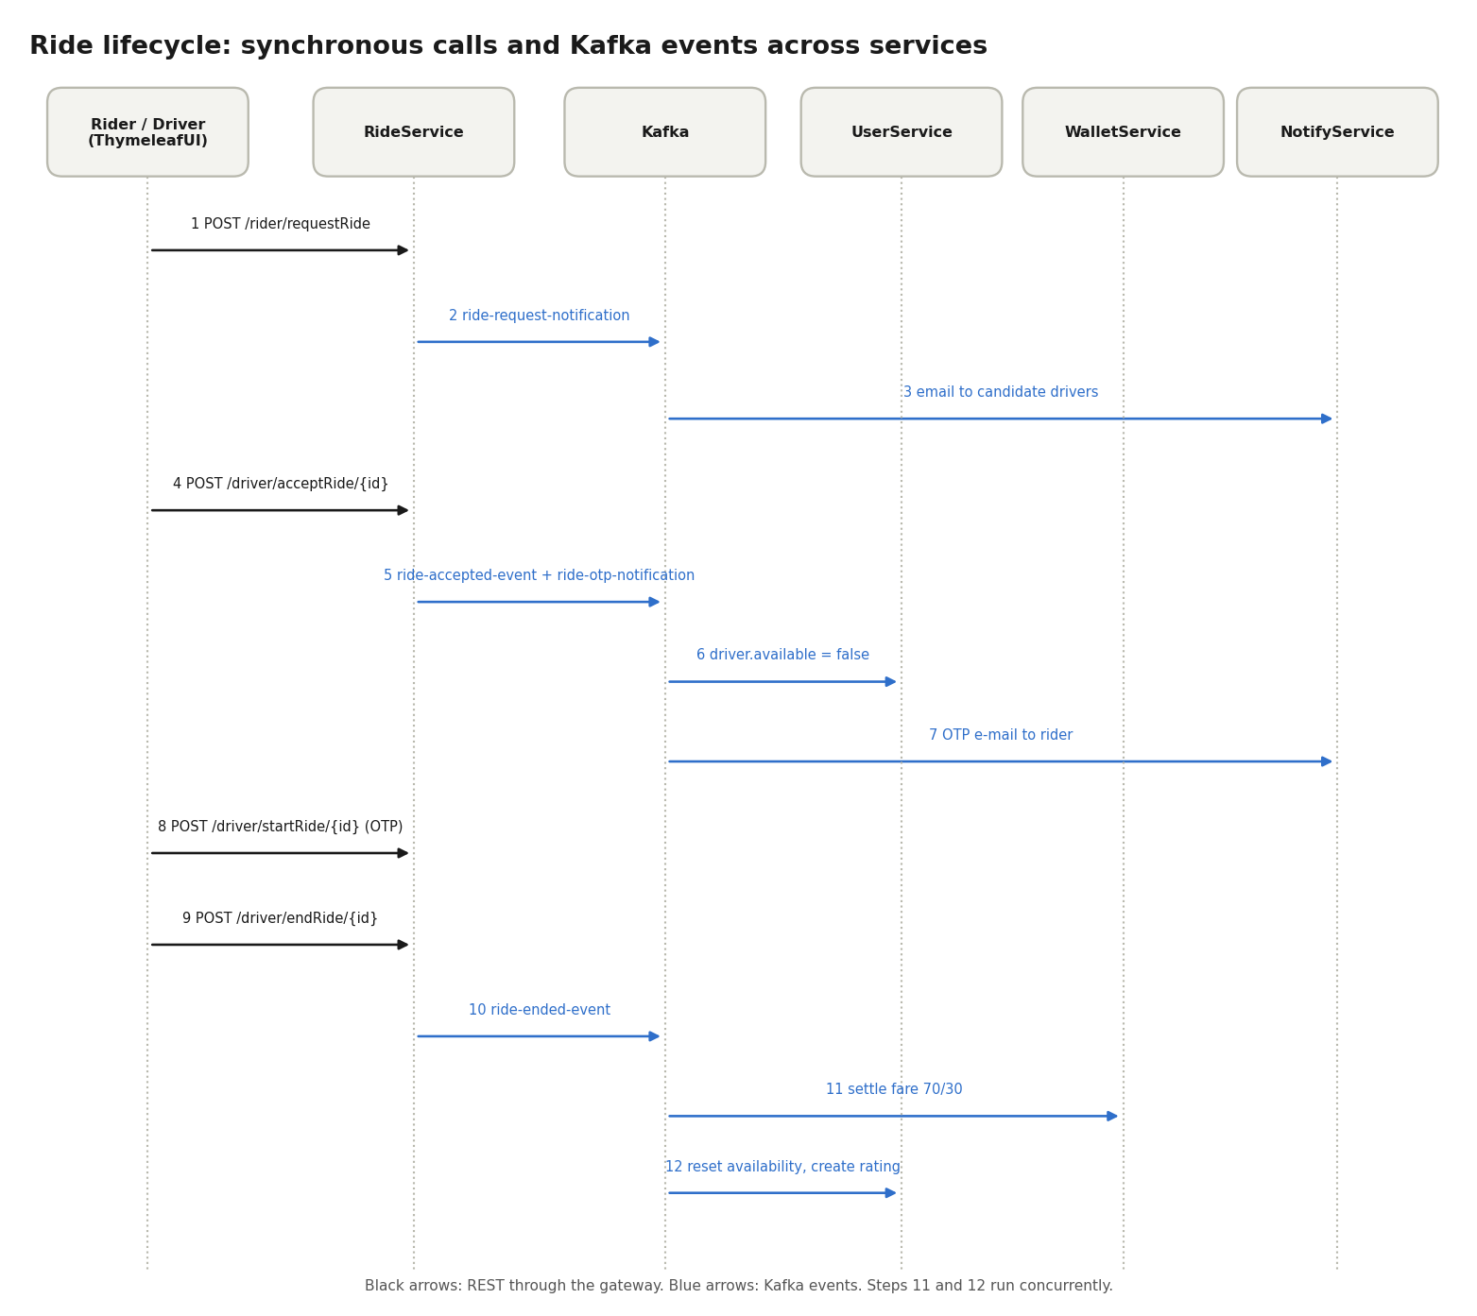
Fig. 4. Ride lifecycle from booking to settlement. Black arrows are REST calls through the gateway; blue arrows are Kafka events. Settlement and availability reset run concurrently.
- The rider calls POST /rider/requestRide. RideService computes road distance and fare and publishes ride-request-notification.
- NotifyService emails the candidate drivers, who are the available, on-duty drivers returned by the matching query.
- A driver calls POST /driver/acceptRide/{rideRequestId}. RideService creates the ride and publishes ride-accepted-event and ride-otp-notification.
- UserService marks the driver unavailable; NotifyService emails the OTP to the rider.
- The driver enters the OTP at POST /driver/startRide/{rideId}; the ride becomes ONGOING.
- The driver calls POST /driver/endRide/{rideId}. RideService publishes ride-ended-event.
- WalletService settles payment at the 70/30 split, and UserService restores driver availability and creates the rating record, in parallel and independently.
Because settlement runs outside the request thread, ending a ride does not wait on wallet writes or on email delivery. A cancellation follows a shorter path: ride-cancelled-event is consumed by UserService alone.

B. Moderation and Notification Flow
Administrator actions use the same mechanism. When an administrator approves or rejects a driver application, UserService publishes driver-application-notification. When a driver submits an incident report, UserService stores it and publishes an acknowledgment on notification.email. When an administrator answers an entry in the Improvement Console, the reply is published on the same topic and NotifyService sends it as HTML email, writing a NotificationLog row whether the send succeeds or fails. The web tier therefore never talks to an SMTP server, and a mail outage cannot block a moderation action.

VII. Data Modeling and REST API Surface

A. Per-Service Schemas
Each service owns one PostgreSQL database. References across services, for example a user identifier stored in the wallet database, are plain identifiers rather than foreign keys, so databases can change independently.
TABLE VII. DATABASE ENTITIES ACROSS THE FOUR ISOLATED DATABASES
Database | Entity | Key attributes
ridemesh_user_db | User | id, name, email, password (BCrypt hash), roles, email_verified, verification token
ridemesh_user_db | Driver | id, user_id, rating, available (duty and trip state), vehicle_id, vehicle_type, current_location (Point, 4326), district
ridemesh_user_db | Rider | id, user_id, rating
ridemesh_user_db | DriverApplication | id, user_id, vehicle_number, vehicle_type, license_number, aadhaar_url, license_url, status (PENDING, APPROVED, REJECTED)
ridemesh_user_db | Rating | id, ride_id, rider_id, driver_id, rider_rating, driver_rating
ridemesh_user_db | DriverReport (driver_report) | id, driver_id, reason, media_url, status, created_at
ridemesh_user_db | UserFeedback (user_feedback) | id, user_id, category (FEEDBACK, SUGGESTION, COMPLAINT, BUG_REPORT), sub-category (positive or negative; against driver or platform), message, media_url (required for bug reports), status, admin_reply, created_at
ridemesh_ride_db | RideRequest | id, rider_id, pickup_location and dropoff_location (Points), pickup_address and dropoff_address (full text), fare, vehicle_type, status (PENDING, CONFIRMED, CANCELLED)
ridemesh_ride_db | Ride | id, ride_request_id, rider_id, driver_id, otp, fare, status (CONFIRMED, ONGOING, ENDED, CANCELLED), started_at, ended_at
ridemesh_wallet_db | Wallet | id, user_id, balance
ridemesh_wallet_db | WalletTransaction | id, wallet_id, amount, transaction_type (CREDIT, DEBIT), transaction_method (RIDE, BANKING), transaction_id, ride_id, created_at
ridemesh_wallet_db | Payment | id, ride_id (unique), rider_id, driver_id, amount, payment_method (WALLET, RAZORPAY, CASH), payment_status (PENDING, CONFIRMED, FAILED)
notify_db | NotificationTemplate | id, template_name (for example RIDE_REQUEST, RIDE_OTP, EMAIL_VERIFICATION), subject, body
notify_db | NotificationLog | id, event_id, recipient_email, subject, body, status (SENT, FAILED), sent_at

Two of the Phase 3 additions deserve comment. The address columns are unbounded text so that no reverse-geocoded address is cut to a fixed length. The user_feedback and driver_report tables hold only a media URL, while the file itself lives on Cloudinary, which keeps binary data out of the relational store.

B. REST Endpoints
All endpoints are reached through the gateway on port 8089. The Phase 2 endpoints are retained; the final group lists the endpoints that serve the Phase 3 features.
TABLE VIII. REST API SURFACE
Service | Endpoint | Purpose
UserService | POST /auth/signup | Register, hash password with BCrypt, publish signup events
UserService | POST /auth/login | Authenticate and issue access and refresh JWTs
UserService | POST /auth/refresh | Re-issue tokens without a new login
UserService | POST /auth/send-verification, GET /auth/verify-email?token= | Issue and confirm an email verification link
UserService | POST /auth/onboardDriver/{userId} | Activate an approved applicant as a driver
UserService | GET /rider/getMyProfile, GET /driver/getMyProfile | Profile, vehicle status, availability and rating
UserService | POST /driver/rateRider/{rideId}, POST /rider/rateDriver/{rideId} | One to five star ratings
RideService | POST /rider/requestRide | Submit pickup and drop-off with full addresses, compute fare, broadcast request
RideService | POST /rider/cancelRide/{rideId}, POST /driver/cancelRide/{rideId} | Cancel a trip
RideService | GET /rider/getMyRides, GET /driver/getMyRides | Paginated trip history
RideService | GET /rider/activeRide, GET /driver/activeRide | Current trip
RideService | GET /driver/pendingRides | Nearby requests open for acceptance
RideService | POST /driver/acceptRide/{rideRequestId} | Create confirmed ride and OTP
RideService | POST /driver/startRide/{rideId} | Verify OTP, move to ONGOING
RideService | POST /driver/endRide/{rideId} | Complete trip, trigger settlement
WalletService | GET /wallet/balance | Balance and recent transactions
WalletService | POST /wallet/create-order | Create a Razorpay top-up order
WalletService | POST /webhooks/razorpay | Verified asynchronous payment capture
UserService (Phase 3) | POST /driver/availability | Switch duty status between Available and Unavailable
UserService (Phase 3) | POST /driver/reports | Submit an incident report with reason and media
UserService (Phase 3) | POST /user/feedback | Submit feedback, a suggestion, a complaint or a bug report
UserService (Phase 3) | GET /admin/driverApplications, POST /admin/driverApplications/{id}/decision | Review KYC, approve or reject
UserService (Phase 3) | GET /admin/reports, GET /admin/feedback, POST /admin/feedback/{id}/reply | Moderate incidents and answer Improvement Console entries
All services | GET /actuator/health, GET /actuator/prometheus | Probe target and Prometheus scrape target

UserService, RideService and WalletService each expose Swagger UI for interactive documentation.

VIII. User Interface, Moderation Consoles and Observability

A. Web Portal and Map Integration
ThymeleafUI is a Spring Boot application on port 8085, styled with Tailwind CSS. A GatewayClient class sends all of its backend calls through the API Gateway, and AuthUiController handles login and role-specific pages. Riders pick pickup and drop-off points by clicking a Leaflet map over OpenStreetMap tiles [30], [31] or by searching with a debounced Nominatim autocomplete. Clicking the map fills the latitude and longitude fields and reverse-geocodes a readable address. The debounce waits for a short pause in typing before querying, which keeps the portal within the geocoder's usage limits.

B. Interactive Address Exploration
Ride tables must stay compact, yet pickup and drop-off addresses can be long. The portal therefore truncates them visually while keeping the full string in the page. On a double-click (ondblclick) the table cell is replaced by an active text box that holds the complete address, already focused, so the user can press Ctrl+A and Ctrl+C to copy it, or select a part of it, without opening another screen. Leaving the box restores the compact cell. Because the full address was stored untruncated at booking time, the copied text is exactly what the rider saw on the map.
Rider History and Driver Completed Rides also include a client-side search bar. It filters the rows already in the page by ride identifier, counterparty name, pickup address or drop-off address as the user types, with no extra request to the gateway.

C. Driver Availability Shield
The driver profile page carries a duty toggle with the states Available and Unavailable. Switching to Unavailable sets the driver's availability flag to false, and the matching query filters on that flag, so the driver stops receiving request emails and cannot appear in any candidate list until duty is resumed. The same flag is lowered automatically when a trip is accepted and raised again by ride-ended-event or ride-cancelled-event.

D. Driver Incident Reporting
A driver can file an incident report from the portal by giving a reason and attaching a media file. UserService stores it in driver_report, uploads the attachment to Cloudinary, and publishes an acknowledgment email on notification.email. Administrators review these reports in an Incident Reports console that lists them with their reason and attachment and lets them change their status.

E. Feedback Channel and Improvement Console
A profile modal lets any user submit one of four kinds of message: Feedback (positive or negative), a Suggestion, a Complaint (against a driver or against the platform) or a Bug Report. Validation is dynamic: choosing Bug Report makes a screenshot compulsory and blocks submission until one is attached, while the other categories accept optional media. Entries land in user_feedback.
Administrators work from an Improvement Console with one tab per category, a search box, and a reply modal. Sending a reply publishes it to notification.email, and NotifyService delivers it to the submitter as HTML email. The reply is therefore asynchronous, auditable through NotificationLog, and independent of whether the mail server is momentarily slow.
A Driver Applications console completes the set. Administrators view the uploaded Aadhaar and licence images stored on Cloudinary, and approve, reject or suspend drivers; the decision is published on driver-application-notification.

F. Prometheus Metrics Scraping
Every service enables Spring Boot Actuator with the Micrometer Prometheus registry, which exposes standardised metrics at /actuator/prometheus [14]. Prometheus scrapes each endpoint on a fixed interval [12]. A scrape configuration has the following shape, with one job per service:
global:
scrape_interval: 15s
scrape_configs:
- job_name: userservice
metrics_path: /actuator/prometheus
static_configs:
- targets: ["userservice:8081"]
# ...one job each for rideservice, walletservice,
# notifyservice, apigateway, eureka-server, thymeleafui

Because the pull model needs only an HTTP endpoint, a failing scrape is itself a signal: Prometheus records the up series as 0 for a target it cannot reach.

G. Grafana Dashboards
Grafana is pre-provisioned with a Prometheus data source and dashboards, so they exist as soon as the container starts and do not have to be built by hand. The dashboards follow the four golden signals of latency, traffic, errors and saturation [11]. Table IX lists representative panels and the queries behind them.
TABLE IX. REPRESENTATIVE GRAFANA PANELS AND THEIR PROMQL QUERIES
Panel | Query | What it shows
JVM heap usage | sum by (job) (jvm_memory_used_bytes{area="heap"}) | Heap allocation per service; a steady climb suggests a leak
GC pause time | rate(jvm_gc_pause_seconds_sum[1m]) | Time spent paused by garbage collection per second
Process CPU | process_cpu_usage | Fraction of CPU used by each service process
HTTP throughput | sum by (job) (rate(http_server_requests_seconds_count[1m])) | Requests per second per service
HTTP error rate | sum(rate(http_server_requests_seconds_count{status=~"5.."}[1m])) / sum(rate(http_server_requests_seconds_count[1m])) | Share of responses that are server errors

IX. Evaluation, Security and Limitations
The project materials describe the design and implementation but report no load tests, latency measurements or automated test results. This section therefore assesses the system qualitatively against its objectives and analyses how it can fail. Quantitative evaluation is left to future work.

A. Assessment Against Objectives
TABLE X. QUALITATIVE ASSESSMENT AGAINST REQUIREMENTS
Objective | How it is met | Remaining gap
Isolated failure domains | Seven components, four private databases, Kafka between producers and consumers | Synchronous REST lookups between services still couple some calls
Address precision | Full reverse-geocoded addresses stored untruncated; double-click cell to copy the whole string | Quality depends on Nominatim and OSM data coverage
Realistic fares | OSRM road distance with Haversine fallback | Fallback underestimates road distance; fares are not marked as estimated
Spatial matching and duty shield | PostGIS ST_DWithin and ST_Distance, 50-driver cap, available filter | Radius unit must be verified (see below)
Auditable payments | Immutable CREDIT and DEBIT records; unique payment per ride | Failure and refund paths are not described
Safe trip start and access | SecureRandom OTP; gateway JWT validation | Services trust forwarded headers; no OTP attempt limit
Observability and reproducibility | Prometheus, Grafana, Compose, Kubernetes manifests with probes | No alert rules, tracing or measured baselines
Community feedback | Categorised submissions, mandatory bug-report screenshot, Kafka-delivered replies | No spam control or rate limiting on submissions

B. Failure-Mode Analysis
Distributed systems fail in partial and unexpected ways. Table XI examines the principal failure modes of RideMesh, the mitigation already present, and the hardening that would close the gap. Where the mitigation column says a mechanism is a fallback, it handles a failed call but not a persistently unhealthy dependency.
TABLE XI. FAILURE MODES, CURRENT MITIGATION AND RECOMMENDED HARDENING
Failure | Effect | Current mitigation | Recommended hardening
OSRM slow or unreachable | Fare quoted from straight-line distance | Haversine fallback keeps booking available | Self-host OSRM; add timeout and circuit breaker so repeated failures stop calling the dependency [24]; flag fare as an estimate
Gemini unavailable or returns malformed text | District left unresolved | Geocoder result is used first; classifier is only a fallback | Strict timeout, response validation against a fixed schema, cache by address
Kafka consumer lag | Delayed settlement, availability reset and emails | Independent consumer groups; idempotent consumers | Alert on consumer-group lag; add partitions and consumer instances
Network partition between a service and the broker or database | Publish fails or consumer stalls; a ride may be saved without its event (dual-write gap) | Kafka client retries; broker retains events | Transactional outbox, backoff retries, dead-letter topic
Duplicate or poison message | Double billing or email; stalled partition | Unique ride_id and eventId guards | Error handler with dead-letter topic and bounded retries
Radius interpreted in degrees | Candidate set far larger than intended | 50-driver cap limits the result size | Cast to geography or project coordinates; add a test with known distances
Forged identity headers | Impersonation if a service is reachable directly | Services are not published outside the Compose network or cluster | NetworkPolicy, signed internal token or mutual TLS
SMTP outage | OTP, acknowledgment or reply not delivered | NotificationLog records FAILED sends | Retry with backoff; secondary channel such as push or SMS
Forged or replayed payment webhook | Wallet credited without payment | Webhook signature verification [29] | Idempotency on payment identifier; timestamp tolerance
Database or PostGIS outage | Owning service unavailable | Readiness probe removes pod from service; volumes persist data | Replication, backups and tested restore
Secret leakage | Credentials exposed | .env is git-ignored; Kubernetes Secrets | External secret manager and rotation policy

Consumer lag deserves a quantitative statement because it governs how stale the downstream state can become. For a partition p, with log end offset LEO and committed offset C, the lag is
$L_{p} = {LEO}_{p} - C_{p}, T_{drain} = \frac{L}{μ - λ}, μ > λ$ (7)
where λ is the arrival rate and μ the processing rate of the consumer. If μ does not exceed λ the lag grows without bound, which is why lag, rather than only CPU or heap, should be an alerting signal.

C. Security Considerations
- Passwords and tokens. Passwords are stored as BCrypt hashes [25]. Access tokens are HMAC-SHA256 JWTs validated at the edge, and the signing secret is supplied through the environment.
- Trusted internal network. Downstream services accept X-User-Id and X-User-Roles without re-verifying the token. This is safe only while the gateway is the sole entry point; in Compose and Kubernetes that means not publishing service ports to the host or cluster edge.
- Personal data. KYC uploads include Aadhaar and licence images. They should live in access-controlled storage with a retention policy, and administrators should be the only roles able to retrieve them.
- Uploads and input. Feedback and report attachments need server-side checks on type and size in addition to the client-side requirement that a bug report carry a screenshot. Thymeleaf escapes output by default, and the double-click text box must set its value as text, not markup, so that stored addresses cannot inject script [27].
- OTP. The code is generated with a strong source of randomness [26], but with only 10⁴ values it needs an attempt limit per ride.
- Secrets. Real credentials are excluded from version control; the fallback loader supplies placeholders only.

D. Limitations
- No measurements. There are no load tests, latency figures or automated test results, so no performance claim is made.
- Search radius. The matching constant is only correct if the query operates on geography or projected coordinates, as explained in Section V.
- Public OSRM server. The demo endpoint is shared infrastructure with usage limits; a production deployment should self-host OSRM.
- Default credentials. The documentation lists a default administrator account for local use, which must be replaced in any shared environment.
- Single-broker Kafka. The setup uses one broker. Replication, retry policy and dead-letter handling are not described.
- Fixed policy constants. The 30% commission, the surge factor of 2.0 and the per-kilometre rates are code constants, and surge is applied by a strategy rather than computed from live demand.
- Notification channel. Notifications are email only; ride requests reach drivers by email rather than by push or socket updates, which limits dispatch latency.
- No circuit breaker. The OSRM and Gemini integrations use fallbacks but not circuit breakers.

E. Discussion
The architecture shows that a moderate-sized team can obtain most of the structural benefits of microservices with a small toolset: Eureka for discovery, a gateway for authentication, Kafka for decoupling, PostgreSQL for each domain, and Prometheus with Grafana for visibility. The strategy layer remains the most reusable piece, because new pricing or matching rules become new classes instead of changes to the booking flow. Phase 3 shows that much of the effort in running microservices lies outside the business code: packaging, configuration, secrets and monitoring took as much design attention as the features, and the failure-mode analysis suggests that the next gains come from resilience rather than from new functionality.

X. Conclusion and Future Work
RideMesh demonstrates a complete ride-hailing workflow built from seven cooperating Spring components and an observable, containerised runtime: gateway-level JWT validation, Kafka-choreographed settlement, OSRM routing with a safe fallback, PostGIS driver search with an availability shield, OTP-protected trip start, and a ledger-based wallet with automatic commission. Phase 3 added full-precision addresses, Gemini-assisted location resolution, driver incident reporting, a categorised feedback channel with moderation consoles, Docker Compose and Kubernetes deployment, managed secrets, and Prometheus and Grafana monitoring. Strategy interfaces keep business rules separate from orchestration, and idempotent consumers make event redelivery safe.
Future work, in rough priority order:
- Correct and test the spatial search radius, using geography or a projected coordinate system, and add tests with known distances.
- Add load and latency tests and report measured throughput for booking and settlement, using the Prometheus metrics already in place.
- Replace trusted headers with a signed internal token or mutual TLS, move secrets to a vault, and rate-limit OTP attempts.
- Introduce circuit breakers around OSRM and Gemini, self-host OSRM, and add Kafka replication, retries, a transactional outbox and dead-letter topics.
- Replace email dispatch with WebSocket push notifications and live driver location streaming so ride requests reach drivers in real time.
- Replace the fixed surge multiplier with dynamic surge pricing driven by machine learning over real-time supply and demand, and make commission configurable per region.
- Add distributed tracing with OpenTelemetry and Zipkin so a ride can be followed across the gateway, services and Kafka, completing the metrics and logs already collected.
- Add compensating events for failed payments and refunds to complete the saga, and alert rules in Prometheus for consumer lag and error rate.

References
[1] M. Fowler and J. Lewis, “Microservices,” martinfowler.com, Mar. 2014. [Online]. Available: https://martinfowler.com/articles/microservices.html
[2] S. Newman, Building Microservices, 2nd ed. Sebastopol, CA, USA: O’Reilly Media, 2021.
[3] C. Richardson, Microservices Patterns: With Examples in Java. Shelter Island, NY, USA: Manning, 2018.
[4] J. Kreps, N. Narkhede, and J. Rao, “Kafka: A distributed messaging system for log processing,” in Proc. NetDB Workshop, Athens, Greece, 2011.
[5] H. Garcia-Molina and K. Salem, “Sagas,” in Proc. ACM SIGMOD Int. Conf. Management of Data, San Francisco, CA, USA, 1987, pp. 249–259.
[6] M. Jones, J. Bradley, and N. Sakimura, “JSON Web Token (JWT),” RFC 7519, IETF, May 2015.
[7] D. Luxen and C. Vetter, “Real-time routing with OpenStreetMap data,” in Proc. 19th ACM SIGSPATIAL Int. Conf. Advances in Geographic Information Systems, Chicago, IL, USA, 2011, pp. 513–516.
[8] R. W. Sinnott, “Virtues of the haversine,” Sky and Telescope, vol. 68, no. 2, p. 159, 1984.
[9] PostGIS Project, “PostGIS Manual: Spatial relationships and measurement (ST_DWithin, ST_Distance).” [Online]. Available: https://postgis.net/documentation/
[10] D. Merkel, “Docker: Lightweight Linux containers for consistent development and deployment,” Linux J., vol. 2014, no. 239, Mar. 2014.
[11] B. Beyer, C. Jones, J. Petoff, and N. R. Murphy, Eds., Site Reliability Engineering: How Google Runs Production Systems. Sebastopol, CA, USA: O’Reilly Media, 2016.
[12] Prometheus Authors, “Prometheus overview.” [Online]. Available: https://prometheus.io/docs/introduction/overview/
[13] OpenMetrics Authors, “OpenMetrics specification.” [Online]. Available: https://openmetrics.io
[14] Micrometer Project, “Micrometer documentation.” [Online]. Available: https://micrometer.io/docs
[15] E. Gamma, R. Helm, R. Johnson, and J. Vlissides, Design Patterns: Elements of Reusable Object-Oriented Software. Reading, MA, USA: Addison-Wesley, 1994.
[16] G. Hohpe and B. Woolf, Enterprise Integration Patterns. Boston, MA, USA: Addison-Wesley, 2003.
[17] Apache Software Foundation, “KIP-500: Replace ZooKeeper with a self-managed metadata quorum,” Apache Kafka Improvement Proposals. [Online]. Available: https://cwiki.apache.org/confluence/display/KAFKA/KIP-500
[18] R. Geisberger, P. Sanders, D. Schultes, and C. Vetter, “Exact routing in large road networks using contraction hierarchies,” Transportation Sci., vol. 46, no. 3, pp. 388–404, 2012.
[19] J. M. Hellerstein, J. F. Naughton, and A. Pfeffer, “Generalized search trees for database systems,” in Proc. 21st Int. Conf. Very Large Data Bases (VLDB), Zurich, Switzerland, 1995, pp. 562–573.
[20] A. Guttman, “R-trees: A dynamic index structure for spatial searching,” in Proc. ACM SIGMOD Int. Conf. Management of Data, Boston, MA, USA, 1984, pp. 47–57.
[21] B. Burns, B. Grant, D. Oppenheimer, E. Brewer, and J. Wilkes, “Borg, Omega, and Kubernetes,” ACM Queue, vol. 14, no. 1, pp. 70–93, 2016.
[22] The Kubernetes Authors, “Configure liveness, readiness and startup probes.” [Online]. Available: https://kubernetes.io/docs/tasks/configure-pod-container/configure-liveness-readiness-startup-probes/
[23] A. Wiggins, “The twelve-factor app,” 2011. [Online]. Available: https://12factor.net
[24] M. T. Nygard, Release It!: Design and Deploy Production-Ready Software, 2nd ed. Raleigh, NC, USA: Pragmatic Bookshelf, 2018.
[25] N. Provos and D. Mazières, “A future-adaptable password scheme,” in Proc. USENIX Annu. Tech. Conf., Monterey, CA, USA, 1999, pp. 81–91.
[26] D. Eastlake 3rd, J. Schiller, and S. Crocker, “Randomness requirements for security,” RFC 4086, IETF, Jun. 2005.
[27] OWASP Foundation, “OWASP Top 10:2021.” [Online]. Available: https://owasp.org/Top10/
[28] Gemini Team, Google, “Gemini: A family of highly capable multimodal models,” arXiv:2312.11805, 2023.
[29] Razorpay, “Webhooks documentation.” [Online]. Available: https://razorpay.com/docs/webhooks/
[30] M. Haklay and P. Weber, “OpenStreetMap: User-generated street maps,” IEEE Pervasive Comput., vol. 7, no. 4, pp. 12–18, Oct.–Dec. 2008.
[31] V. Agafonkin, “Leaflet: An open-source JavaScript library for interactive maps.” [Online]. Available: https://leafletjs.com

