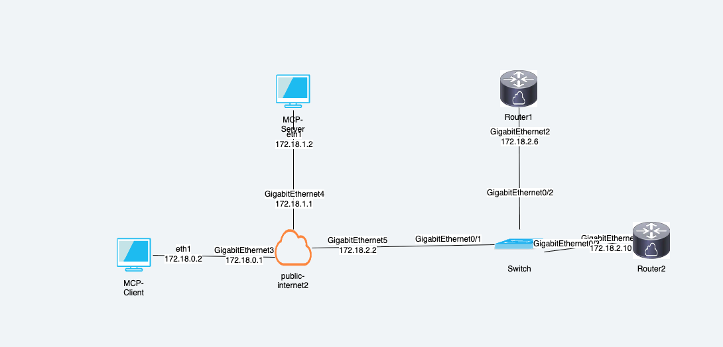
End-to-End Flow: User Types "Get Interfaces" in LibreChat
Step 1: User Input (LibreChat Web UI)
User types: "Show me the router interfaces"
Location: Browser at http://172.18.0.2:3080

Step 2: LibreChat Frontend → Backend
Browser sends HTTP POST request to:
→ LibreChat API container (Node.js)
→ Payload: {
"message": "Show me the router interfaces",
"model": "claude-3-5-sonnet",
"mcp_server": "cisco-router"
}

Step 3: LibreChat Connects to MCP Server
LibreChat API initiates SSE connection:
→ HTTP GET to http://172.18.1.2:8000/sse
→ Establishes Server-Sent Events stream
→ Keeps connection open for bidirectional communication
MCP Client responds:
{
"jsonrpc": "2.0",
"method": "tools/list",
"params": {}
}

Step 4: MCP Server Returns Available Tools
MCP Server (172.18.1.2:8000) sends back:
{
"tools": [
{
"name": "get_interfaces",
"description": "Get all router interfaces and their status",
"inputSchema": {}
},
{
"name": "configure_interface",
"description": "Configure an interface with IP address",
"inputSchema": {...}
}
]
}

Step 5: LibreChat Sends Request to Claude (Anthropic API)
LibreChat → Anthropic API (https://api.anthropic.com)
Request:
{
"model": "claude-3-5-sonnet-20241022",
"messages": [{
"role": "user",
"content": "Show me the router interfaces"
}],
"tools": [
{
"name": "get_interfaces",
"description": "Get all router interfaces and their status"
}
]
}

Step 6: Claude Decides to Use Tool
Claude analyzes the request and responds:
{
"content": [
{
"type": "tool_use",
"id": "toolu_123",
"name": "get_interfaces",
"input": {}
}
],
"stop_reason": "tool_use"
}
Claude says: "I need to call the get_interfaces tool"

Step 7: LibreChat Sends Tool Call to MCP Server
LibreChat → MCP Server (172.18.1.2:8000)
POST to /messages/ with JSON-RPC:
{
"jsonrpc": "2.0",
"method": "tools/call",
"params": {
"name": "get_interfaces",
"arguments": {}
}
}

Step 8: MCP Server Executes Tool (Python Code)
# In app/main.py on MCP Server
@mcp_server.call_tool()
async def call_tool(name: str, arguments: dict):
if name == "get_interfaces":
# Connect to Router1 via SSH
connection = ConnectHandler(**ROUTER_CONFIG)
output = connection.send_command("show ip interface brief")
connection.disconnect()
return [TextContent(type="text", text=output)]
What happens:
- Netmiko establishes SSH connection to Router1 (172.18.2.6)
- Sends command: show ip interface brief
- Router1 responds with interface data
- SSH connection closed

Step 9: Router1 Responds via SSH
Router1 (172.18.2.6) returns:
Interface IP-Address OK? Method Status Protocol
GigabitEthernet0/0 unassigned YES NVRAM administratively down down
GigabitEthernet0/1 192.168.1.1 YES NVRAM up up
GigabitEthernet0/2 10.0.0.1 YES NVRAM up up

Step 10: MCP Server Returns Tool Result
MCP Server → LibreChat
JSON-RPC Response:
{
"jsonrpc": "2.0",
"result": {
"content": [
{
"type": "text",
"text": "Interface IP-Address OK? Method Status Protocol\nGigabitEthernet0/0 unassigned YES NVRAM administratively down down\nGigabitEthernet0/1 192.168.1.1 YES NVRAM up up\nGigabitEthernet0/2 10.0.0.1 YES NVRAM up up"
}
]
}
}

Step 11: LibreChat Sends Tool Result Back to Claude
LibreChat → Anthropic API
Request:
{
"model": "claude-3-5-sonnet-20241022",
"messages": [
{
"role": "user",
"content": "Show me the router interfaces"
},
{
"role": "assistant",
"content": [{"type": "tool_use", "name": "get_interfaces"}]
},
{
"role": "user",
"content": [
{
"type": "tool_result",
"tool_use_id": "toolu_123",
"content": "Interface data from router..."
}
]
}
]
}

Step 12: Claude Formats Final Response
Claude analyzes tool result and generates natural language response:
"Here are the interfaces on Router1:
✅ **GigabitEthernet0/1**: Active (UP/UP)
- IP: 192.168.1.1
✅ **GigabitEthernet0/2**: Active (UP/UP)
- IP: 10.0.0.1
⚠️ **GigabitEthernet0/0**: Administratively down
- No IP assigned
All active interfaces are functioning properly."

Step 13: LibreChat Returns Response to User
LibreChat API → Browser (SSE stream)
Streams response token-by-token to frontend

Step 14: User Sees Formatted Response
Browser displays:
[Claude icon] Here are the interfaces on Router1:
✅ GigabitEthernet0/1: Active (UP/UP) - IP: 192.168.1.1
✅ GigabitEthernet0/2: Active (UP/UP) - IP: 10.0.0.1
⚠️ GigabitEthernet0/0: Administratively down - No IP assigned

Complete Flow Diagram
┌──────────┐ ┌───────────┐ ┌──────────┐ ┌──────────┐ ┌─────────┐
│ User │───▶│ LibreChat │───▶│ MCP │───▶│ Router1 │ │ Claude │
│ Browser │ │ (UI) │ │ Server │ │ Cisco │ │ API │
│172.18.0.2│ │172.18.0.2 │ │172.18.1.2│ │172.18.2.6│ │ Remote │
└──────────┘ └───────────┘ └──────────┘ └─────────┘ └─────────┘
│ │ │ │ │
│ 1. "get │ │ │ │
│ interfaces" │ │ │ │
│───────────────▶│ │ │ │
│ │ 2. SSE Connect │ │ │
│ │────────────────▶│ │ │
│ │ │ │ │
│ │ 3. List tools │ │ │
│ │◀────────────────│ │ │
│ │ │ │ │
│ │ 4. Send message + tools │ │
│ │─────────────────────────────────┼─────────────▶│
│ │ │ │ │
│ │ 5. Tool use decision │ │
│ │◀────────────────────────────────┼──────────────│
│ │ │ │ │
│ │ 6. Call tool │ │ │
│ │────────────────▶│ │ │
│ │ │ 7. SSH │ │
│ │ │──────────────▶│ │
│ │ │ 8. Interface │ │
│ │ │ data │ │
│ │ │◀──────────────│ │
│ │ │ │ │
│ │ 9. Tool result │ │ │
│ │◀────────────────│ │ │
│ │ │ │ │
│ │ 10. Tool result to Claude │ │
│ │─────────────────────────────────┼─────────────▶│
│ │ │ │ │
│ │ 11. Formatted response │ │
│ │◀────────────────────────────────┼──────────────│
│ │ │ │ │
│ 12. Display │ │ │ │
│ response │ │ │ │
│◀───────────────│ │ │ │

Key Protocols Used
Connection | Protocol | Port | Purpose
User → LibreChat | HTTPS/WebSocket | 3080 | Chat interface
LibreChat → MCP | SSE (HTTP) | 8000 | Tool communication
MCP → Router1 | SSH | 22 | Execute commands
LibreChat → Claude | HTTPS/REST | 443 | LLM processing

