1.Create a new React Application with the name “myfirstreact”, Run the application to print “welcome to the first session of React” as heading of that page.

npx create-react-app myfirstreact

cd myfirstreact

code .

**App.js**

import React from 'react';

function App() {

return (

<div>

<h1>Welcome to the first session of React</h1>

</div>

);

}

export default App;

**OUTPUT:**

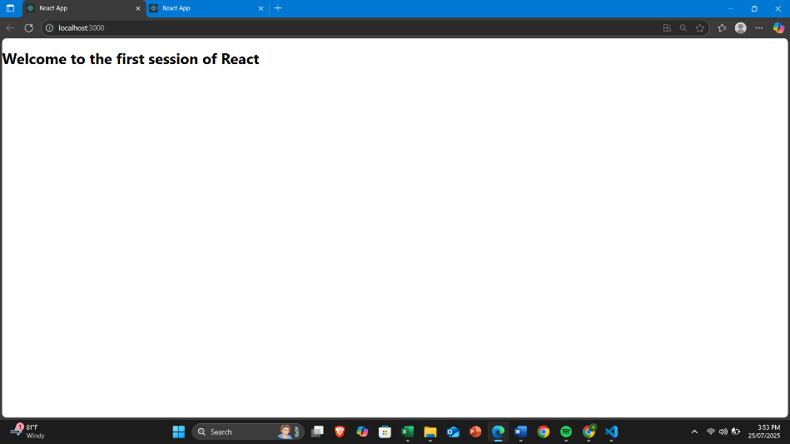

2.Create a react app for Student Management Portal named StudentApp and create a component named Home which will display the Message “Welcome to the Home page of Student Management Portal”. Create another component named About and display the Message “Welcome to the About page of the Student Management Portal”. Create a third component named Contact and display the Message “Welcome to the Contact page of the Student Management Portal”. Call all the three components.

npx create-react-app StudentApp

cd StudentApp

**src/Components/Home.js**

import React from 'react';

function Home() {

return (

<div>

<h1>Welcome to the Home page of Student Management Portal</h1>

</div>

);

}

export default Home;

**src/Components/About.js**

import React from 'react';

function About() {

return (

<div>

<h1>Welcome to the About page of the Student Management Portal</h1>

</div>

);

}

export default About;

src/Components/Contact.js

import React from 'react';

function Contact() {

return (

<div>

<h1>Welcome to the Contact page of the Student Management Portal</h1>

</div>

);

}

export default Contact;

src/App.js

import React from 'react';

import Home from './Components/Home';

import About from './Components/About';

import Contact from './Components/Contact';

function App() {

return (

<div>

<Home />

<About />

<Contact />

</div>

);

}

export default App;

**OUTPUT:**

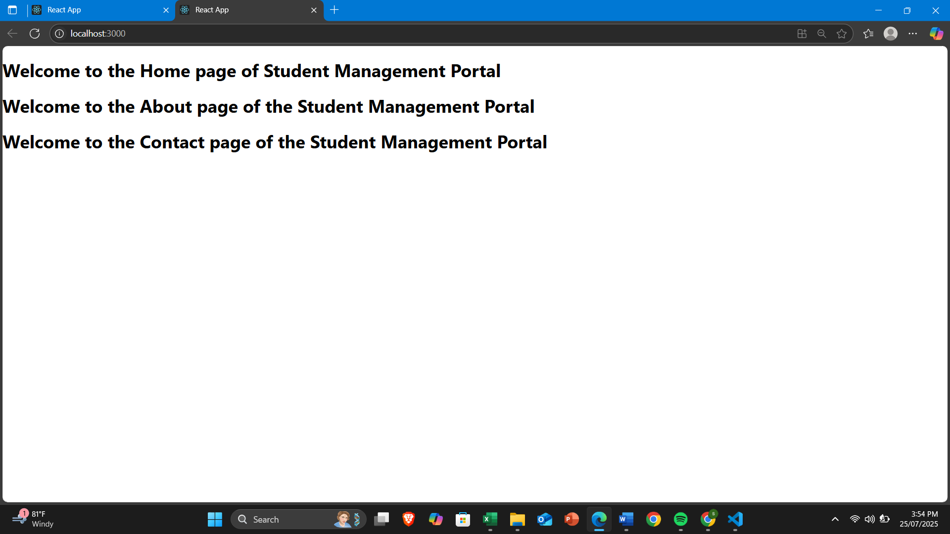

3.Create a react app for Student Management Portal named scorecalculatorapp and create a function component named “CalculateScore” which will accept Name, School, Total and goal in order to calculate the average score of a student and display the same.

npx create-react-app scorecalculatorapp

cd scorecalculatorapp

**Components/CalculateScore.js**

import React from 'react';

import '../Stylesheets/mystyle.css';

function CalculateScore(props) {

const average = props.total / props.goal;

return (

<div className="score-container">

<h2>Student Score Calculator</h2>

<p><strong>Name:</strong> {props.name}</p>

<p><strong>School:</strong> {props.school}</p>

<p><strong>Total Marks:</strong> {props.total}</p>

<p><strong>Goal Subjects:</strong> {props.goal}</p>

<p><strong>Average Score:</strong> {average}</p>

</div>

);

}

export default CalculateScore;

**../Stylesheets/mystyle.css**

.score-container {

width: 400px;

margin: 20px auto;

padding: 20px;

border: 2px solid #333;

border-radius: 10px;

background-color: #f0f0f0;

text-align: left;

font-family: Arial, sans-serif;

}

.score-container h2 {

color: #2c3e50;

}

.score-container p {

font-size: 16px;

line-height: 1.5;

}

**src/App.js**

import React from 'react';

import CalculateScore from './Components/CalculateScore';

function App() {

return (

<div>

<CalculateScore name="John Doe" school="ABC High School" total={450} goal={5} />

</div>

);

}

export default App;

**npm start**

**OUTPUT:**

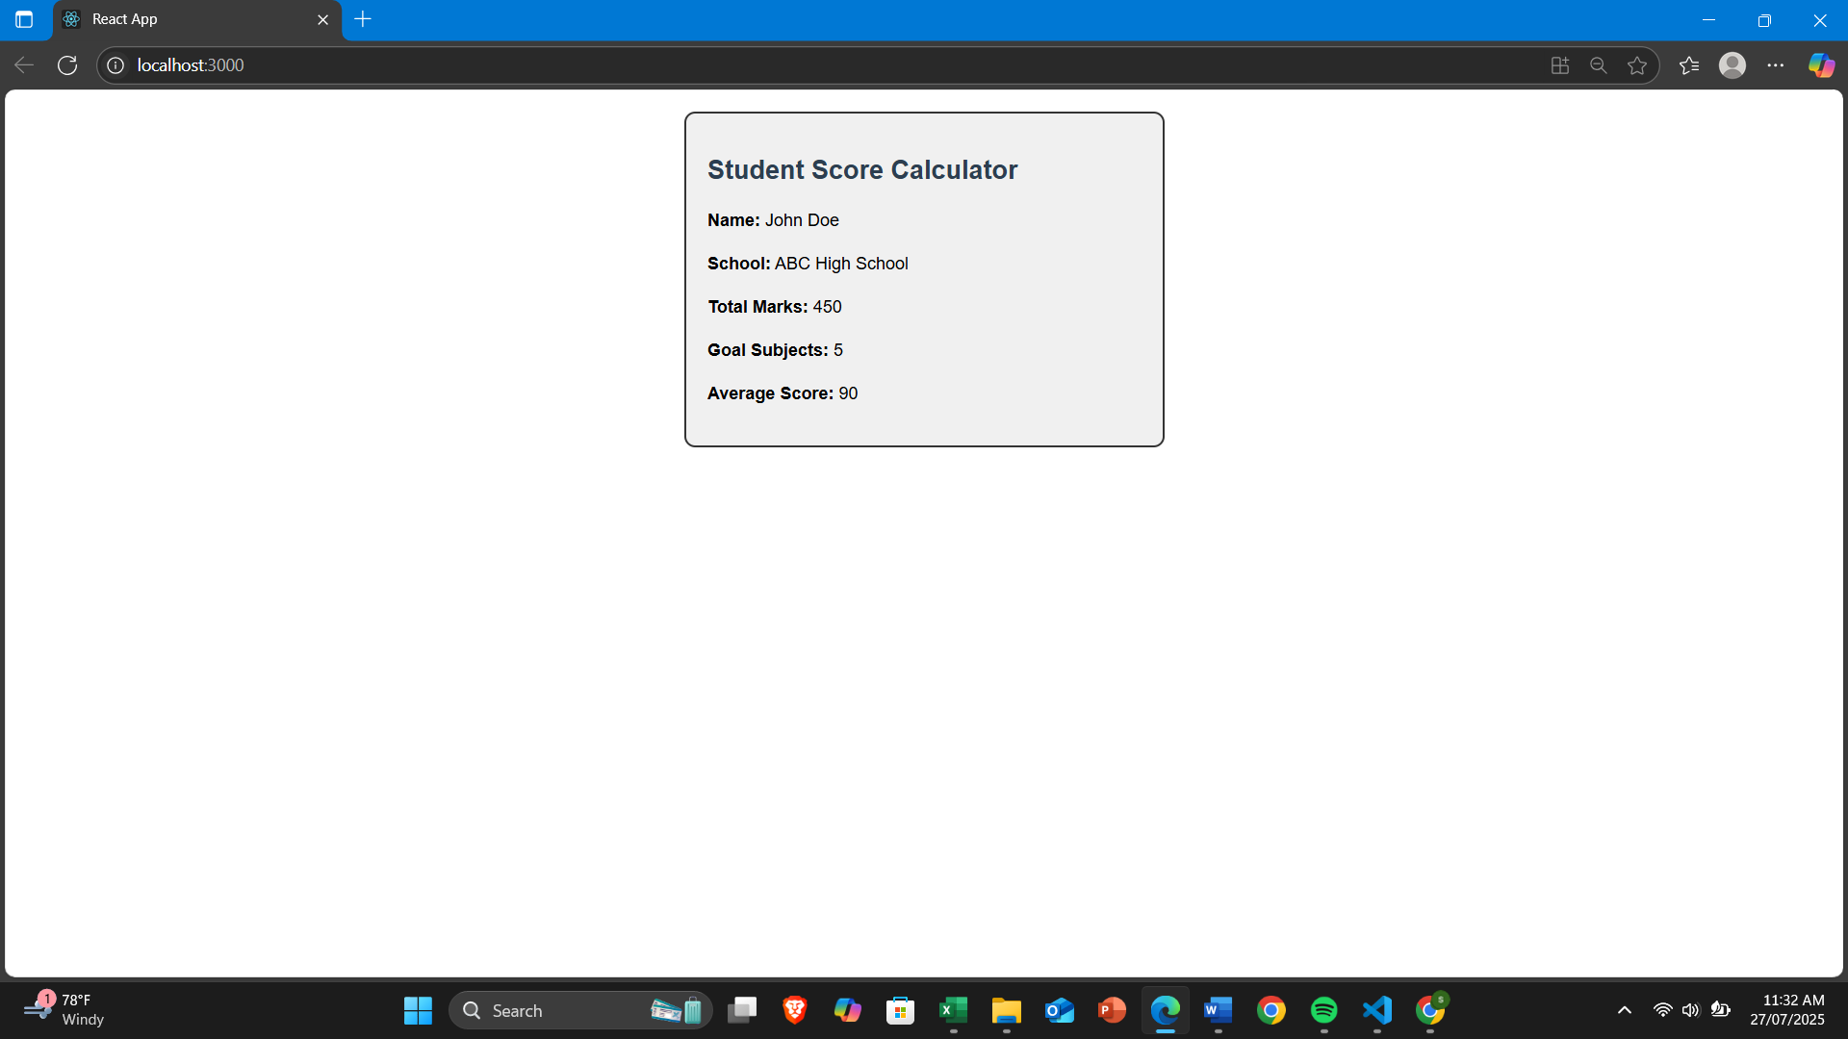

4. Create a new react application using *create-react-app* tool with the name as “blogapp”

npx create-react-app blogapp

cd blogapp

**src/Post.js**

// src/Post.js

import React from 'react';

class Post extends React.Component {

render() {

return (

<div>

<h2>{this.props.title}</h2>

<p>{this.props.body}</p>

</div>

);

}

}

export default Post;

**src/Posts.js**

// src/Posts.js

import React, { Component } from 'react';

import Post from './Post';

class Posts extends Component {

constructor(props) {

super(props);

this.state = {

posts: []

};

}

// Step 6: loadPosts() Method

loadPosts = () => {

fetch('https://jsonplaceholder.typicode.com/posts')

.then(response => response.json())

.then(data => this.setState({ posts: data }))

.catch(error => {

console.error('Error fetching posts:', error);

alert('Failed to load posts.');

});

};

// Step 7: componentDidMount

componentDidMount() {

this.loadPosts();

}

// Step 9: componentDidCatch

componentDidCatch(error, info) {

console.error('Error occurred:', error, info);

alert('An error occurred while rendering the component.');

}

// Step 8: render()

render() {

return (

<div>

<h1>Blog Posts</h1>

{this.state.posts.map(post => (

<Post key={post.id} title={post.title} body={post.body} />

))}

</div>

);

}

}

export default Posts;

**src/App.js**

// src/App.js

import React from 'react';

import Posts from './Posts';

function App() {

return (

<div className="App">

<Posts />

</div>

);

}

export default App;

npm start

**OUTPUT:**

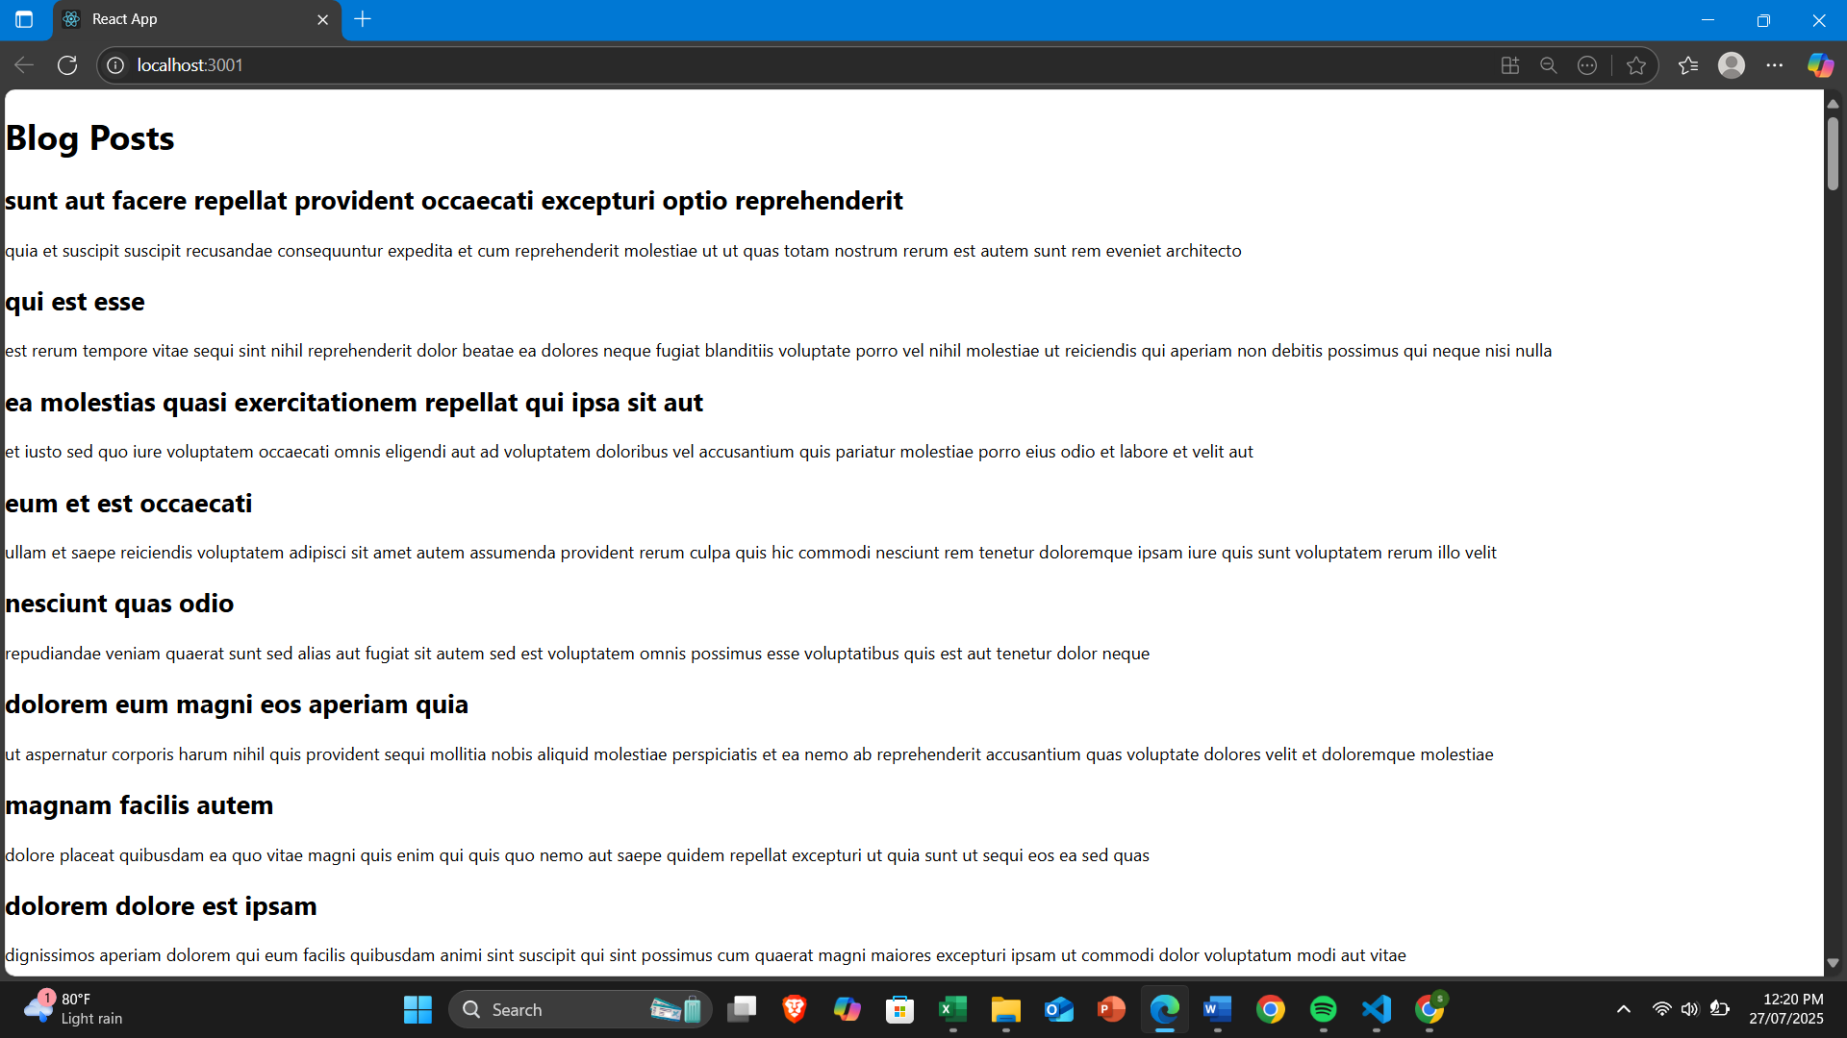

5. My Academy team at Cognizant want to create a dashboard containing the details of ongoing and completed cohorts. A react application is created which displays the detail of the cohorts using react component. You are assigned the task of styling these react components.

**Download the Fixed ZIP Project:** CohortDashboardApp_Fixed.zip

cd path_to_extracted_folder/CohortDashboardApp

npm install

npm start

**OUTPUT:**

