**9. Create a React Application named “cricketapp” with the following components:**

1. ListofPlayers

* Declare an array with 11 players and store details of their names and scores using the map feature of ES6

**App.js**

import React, { useState } from 'react';

import ListofPlayers from './components/ListofPlayers';

import IndianPlayers from './components/IndianPlayers';

function App() {

const [flag, setFlag] = useState(true);

return (

<div>

<button onClick={() => setFlag(!flag)}>

{flag ? 'Show Indian Players' : 'Show List of Players'}

</button>

{flag ? <ListofPlayers /> : <IndianPlayers />}

</div>

);

}

export default App;

**ListofPlayers.js**

import React from 'react';

function ListofPlayers() {

const players = [

{ name: 'Jack', score: 50 },

{ name: 'Michael', score: 70 },

{ name: 'John', score: 40 },

{ name: 'Alan', score: 61 },

{ name: 'Elisabeth', score: 61 },

{ name: 'Sachin', score: 95 },

{ name: 'Dhoni', score: 100 },

{ name: 'Virat', score: 84 },

{ name: 'Jadeja', score: 64 },

{ name: 'Raina', score: 75 },

{ name: 'Rohit', score: 80 },

];

const playersBelow70 = players.filter(item => item.score <= 70);

return (

<div>

<h2>List of Players</h2>

<ul>

{players.map((item, index) => (

<li key={index}>Mr. {item.name} <span>{item.score}</span></li>

))}

</ul>

<h2>List of Players having Scores Less than 70</h2>

<ul>

{playersBelow70.map((item, index) => (

<li key={index}>Mr. {item.name} <span>{item.score}</span></li>

))}

</ul>

</div>

);

}

export default ListofPlayers;

**components/IndianPlayers.js**

import React from 'react';

function OddPlayers({ players }) {

return (

<div>

<h3>Odd Players</h3>

<ul>

<li>First : {players[0]}</li>

<li>Third : {players[2]}</li>

<li>Fifth : {players[4]}</li>

</ul>

</div>

);

}

function EvenPlayers({ players }) {

return (

<div>

<h3>Even Players</h3>

<ul>

<li>Second : {players[1]}</li>

<li>Fourth : {players[3]}</li>

<li>Sixth : {players[5]}</li>

</ul>

</div>

);

}

function IndianPlayers() {

const T20Players = ["First Player", "Second Player", "Third Player"];

const RanjiTrophyPlayers = ["Fourth Player", "Fifth Player", "Sixth Player"];

const allPlayers = [...T20Players, ...RanjiTrophyPlayers];

return (

<div>

<OddPlayers players={allPlayers} />

<EvenPlayers players={allPlayers} />

<h3>List of Indian Players Merged:</h3>

<ul>

{allPlayers.map((player, index) => (

<li key={index}>Mr. {player}</li>

))}

</ul>

</div>

);

}

export default IndianPlayers;

**OUTPUT:**

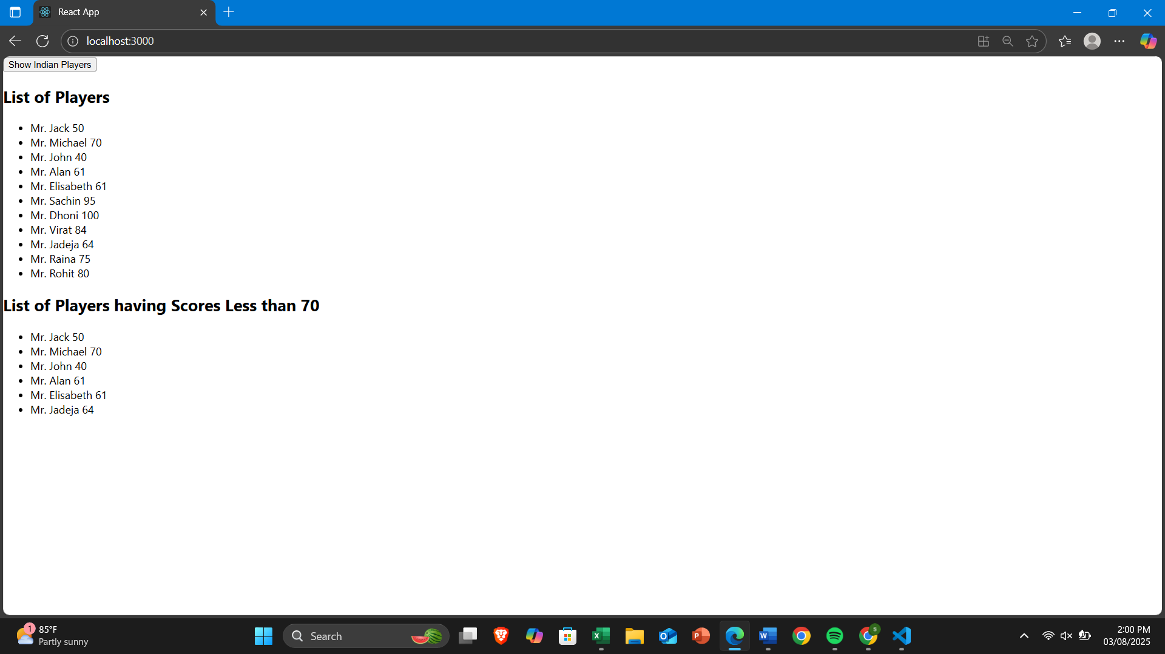

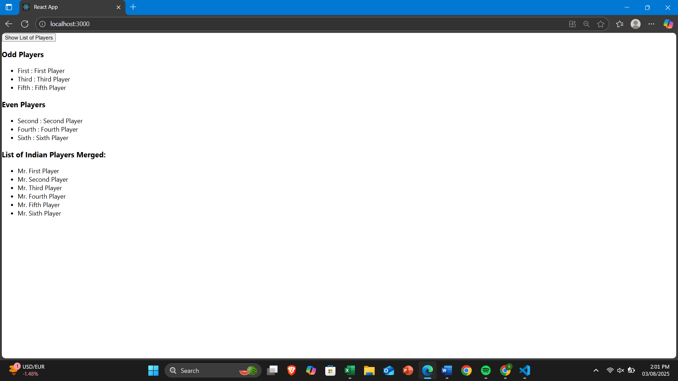

**10. Create a React Application named “officespacerentalapp” which uses React JSX to create elements, attributes and renders DOM to display the page.**

**src/App.js**

import React from 'react';

import './App.css';

import image1 from './images/download (1).jpeg';

import image2 from './images/download (2).jpeg';

import image3 from './images/download.jpeg';

function App() {

const officeSpaces = [

{ Name: "DBS", Rent: 50000, Address: "Chennai", Image: image1 },

{ Name: "WeWork", Rent: 75000, Address: "Bangalore", Image: image2 },

{ Name: "Regus", Rent: 55000, Address: "Hyderabad", Image: image3 }

];

return (

<div className="App">

<h1>Office Space, at Affordable Range</h1>

{officeSpaces.map((item, index) => {

let rentColor = item.Rent <= 60000 ? 'textRed' : 'textGreen';

return (

<div key={index} className="card">

<img src={item.Image} className="office-image" alt="Office Space" />

<h3>Name: {item.Name}</h3>

<h3 className={rentColor}>Rent: Rs. {item.Rent}</h3>

<h3>Address: {item.Address}</h3>

</div>

);

})}

</div>

);

}

export default App;

**src/App.css**

.App {

text-align: center;

font-family: Arial, sans-serif;

}

.card {

margin: 20px auto;

padding: 10px;

border: 1px solid #ccc;

width: 350px;

box-shadow: 2px 2px 10px rgba(0,0,0,0.1);

border-radius: 10px;

}

.office-image {

width: 300px;

height: auto;

object-fit: cover;

margin: 10px 0;

border-radius: 8px;

}

.textRed {

color: red;

}

.textGreen {

color: green;

}

**OUTPUT:**

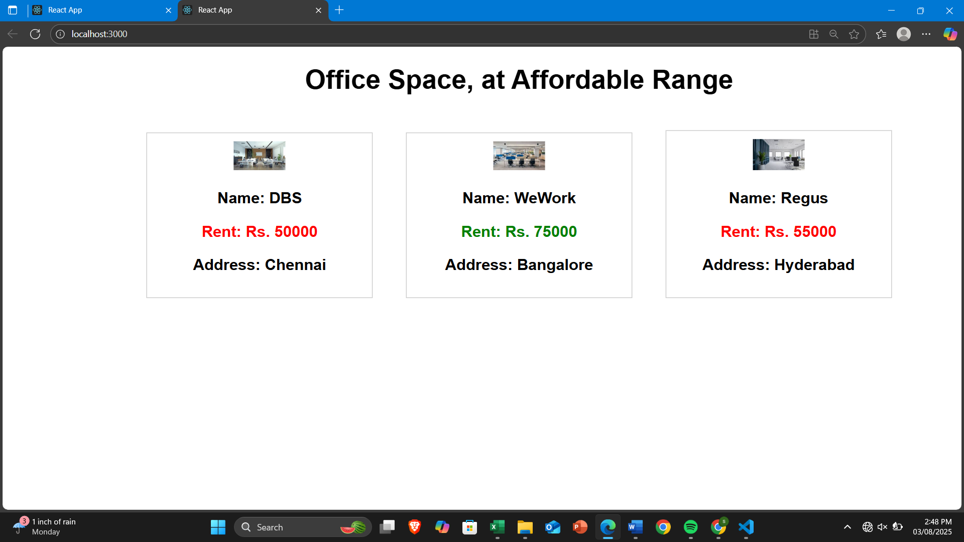

**11.** **Create a React Application “eventexamplesapp” to handle various events of the form elements in HTML.**

**App.js**

import React, { useState } from 'react';

import './App.css';

function App() {

const [count, setCount] = useState(0);

const [amount, setAmount] = useState('');

const increment = () => {

setCount(count + 1);

sayHello();

};

const decrement = () => {

setCount(count - 1);

};

const sayHello = () => {

alert("Hello! This is a static message.");

};

const sayWelcome = (message) => {

alert(`Welcome! ${message}`);

};

const handleClick = (e) => {

alert("I was clicked");

};

const handleSubmit = (e) => {

e.preventDefault();

const rupeeAmount = parseFloat(amount);

const euroAmount = rupeeAmount * 80; // Example conversion rate 1 Euro = 80 INR

alert(`Converting to Euro Amount is ${euroAmount}`);

};

return (

<div className="App">

<h2>{count}</h2>

<button onClick={increment}>Increment</button>

<button onClick={decrement}>Decrement</button>

<button onClick={() => sayWelcome("Welcome!")}>Say Welcome</button>

<button onClick={handleClick}>Click on me</button>

<h1 style={{ color: 'green' }}>Currency Convertor!!!</h1>

<form onSubmit={handleSubmit}>

<label>

Amount:

<input

type="text"

value={amount}

onChange={(e) => setAmount(e.target.value)}

/>

</label>

<br />

<label>

Currency:

<input type="text" value="Euro" readOnly />

</label>

<br />

<button type="submit">Submit</button>

</form>

</div>

);

}

export default App;

**OUTPUT:**

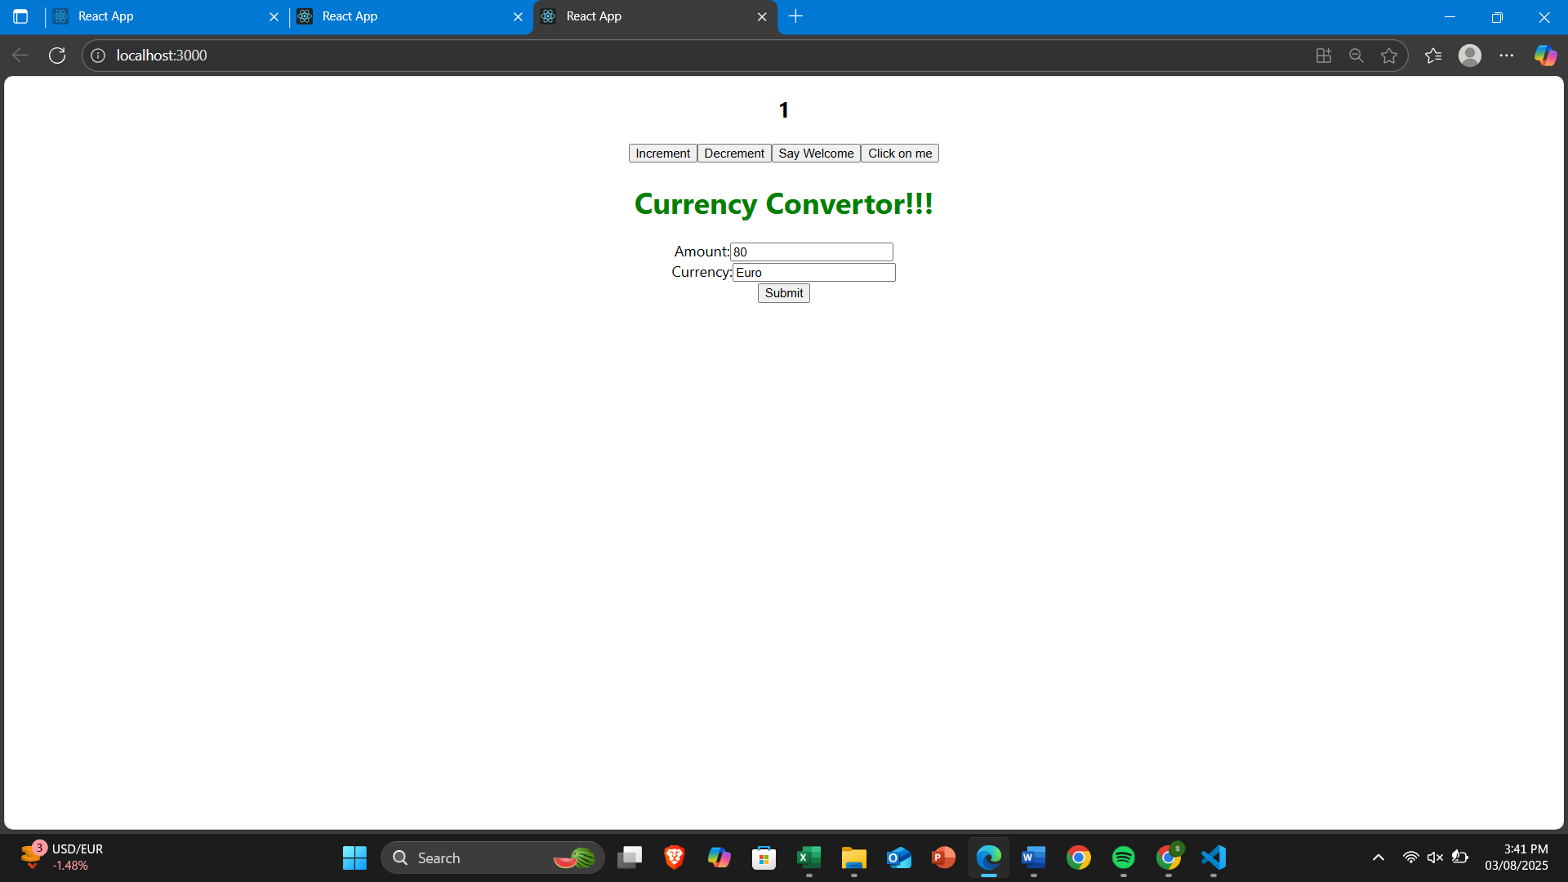

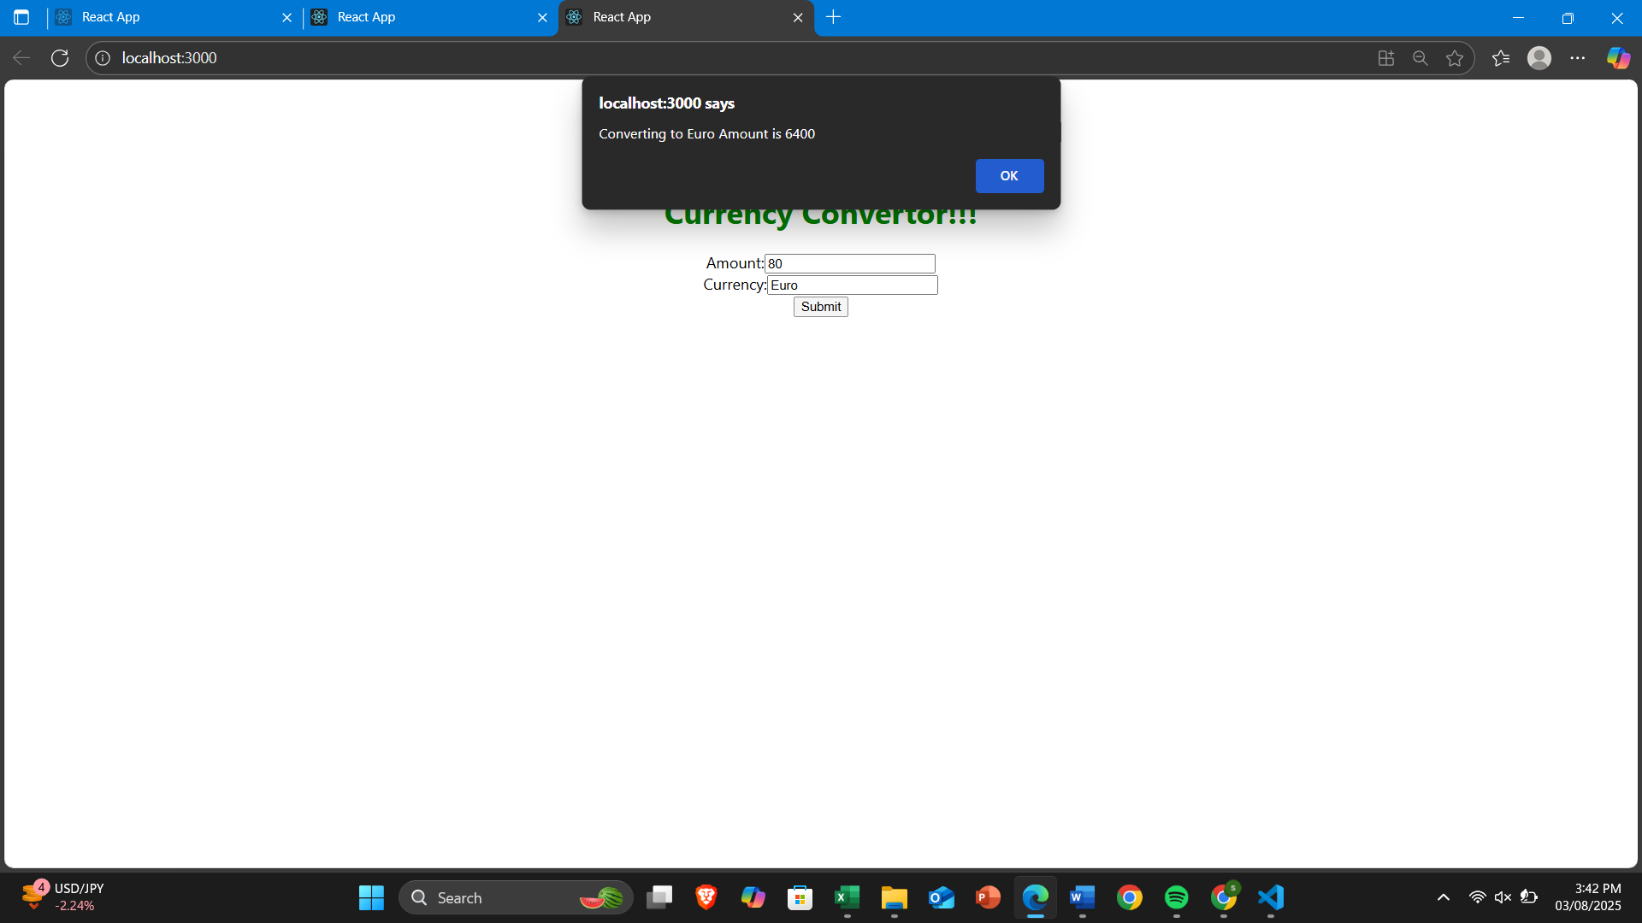

**12.Create a React Application named “ticketbookingapp” where the guest user can browse the page where the flight details are displayed whereas the logged in user only can book tickets.**

**components/GuestPage.js**

import React from 'react';

function GuestPage({ onLogin }) {

return (

<div>

<h2>Please sign up.</h2>

<button onClick={onLogin}>Login</button>

</div>

);

}

export default GuestPage;

**components/UserPage.js**

import React from 'react';

function UserPage({ onLogout }) {

return (

<div>

<h2>Welcome back</h2>

<h3>Flight Details:</h3>

<ul>

<li>Flight: AI-101 | Chennai to Delhi | 10:00 AM</li>

<li>Flight: AI-202 | Chennai to Mumbai | 12:30 PM</li>

</ul>

<button onClick={onLogout}>Logout</button>

</div>

);

}

export default UserPage;

**4. Main File (App.js)**

import React, { useState } from 'react';

import GuestPage from './components/GuestPage';

import UserPage from './components/UserPage';

function App() {

const [isLoggedIn, setIsLoggedIn] = useState(false);

const handleLogin = () => {

setIsLoggedIn(true);

};

const handleLogout = () => {

setIsLoggedIn(false);

};

return (

<div className="App">

{isLoggedIn ? (

<UserPage onLogout={handleLogout} />

) : (

<GuestPage onLogin={handleLogin} />

)}

</div>

);

}

export default App;

**OUTPUT:**

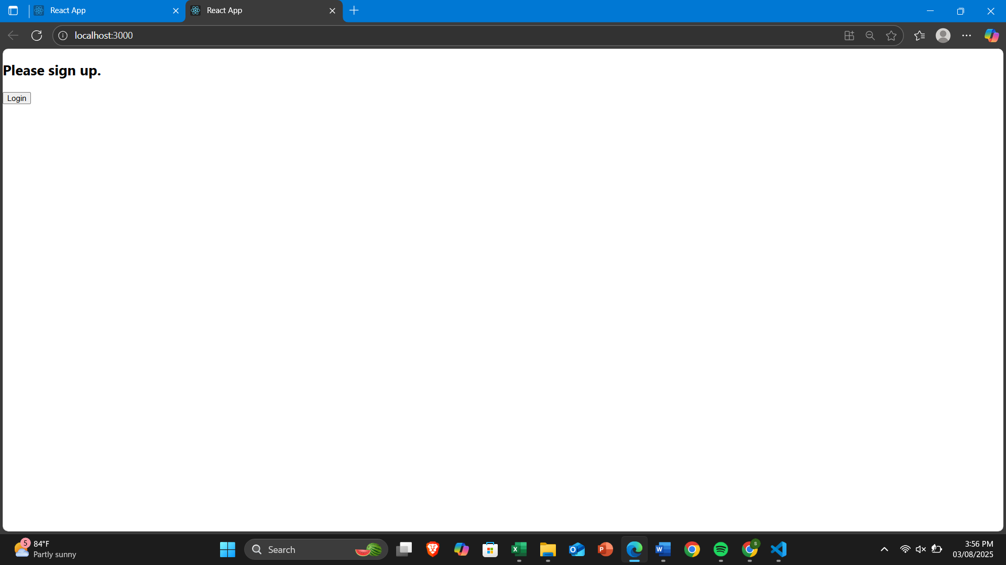

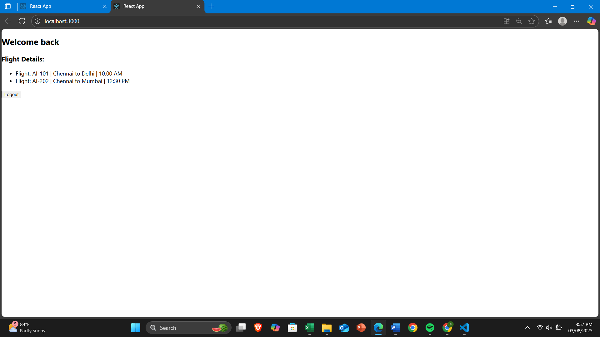

**13.Create a React App named “bloggerapp” in with 3 components.**

1. **Book Details**
2. **Blog Details**
3. **Course Details**

**components/BookDetails.js**

import React from 'react';

function BookDetails({ books }) {

return (

<div>

<h2>Book Details</h2>

{books.map((book) => (

<div key={book.id}>

<h3>{book.bname}</h3>

<h4>{book.price}</h4>

</div>

))}

</div>

);

}

export default BookDetails;

**components/BlogDetails.js**

import React from 'react';

function BlogDetails() {

return (

<div>

<h2>Blog Details</h2>

<h3>React Learning</h3>

<p>Stephen Biz</p>

<p>Welcome to learning React!</p>

<h3>Installation</h3>

<p>Schwezdenier</p>

<p>You can install React from npm.</p>

</div>

);

}

export default BlogDetails;

**components/CourseDetails.js**

import React from 'react';

function CourseDetails() {

return (

<div>

<h2>Course Details</h2>

<h3>Angular</h3>

<p>4/5/2021</p>

<h3>React</h3>

<p>6/3/20201</p>

</div>

);

}

export default CourseDetails;

**App.js**

import React, { useState } from 'react';

import BookDetails from './components/BookDetails';

import BlogDetails from './components/BlogDetails';

import CourseDetails from './components/CourseDetails';

import './App.css';

function App() {

const [activeTab, setActiveTab] = useState('courses');

const books = [

{ id: 1, bname: 'Master React', price: 670 },

{ id: 2, bname: 'Deep Dive into Angular 11', price: 800 },

{ id: 3, bname: 'Mongo Essentials', price: 450 }

];

return (

<div className="App">

<div>

<button onClick={() => setActiveTab('courses')}>Course Details</button>

<button onClick={() => setActiveTab('books')}>Book Details</button>

<button onClick={() => setActiveTab('blogs')}>Blog Details</button>

</div>

{/* Conditional Rendering using If-Else */}

{activeTab === 'courses' ? (

<CourseDetails />

) : activeTab === 'books' ? (

<BookDetails books={books} />

) : (

<BlogDetails />

)}

{/* Conditional Rendering using Logical && */}

<div>

{activeTab === 'courses' && <p>You are viewing Courses Section</p>}

{activeTab === 'books' && <p>You are viewing Books Section</p>}

{activeTab === 'blogs' && <p>You are viewing Blogs Section</p>}

</div>

</div>

);

}

export default App;

**OUTPUT:** 