**Placement Empowerment Program**

***Cloud Computing and DevOps Centre***

**TASK-1** Host a Static Website Locally: Set Up a Local Server Apache and Host a Simple HTML page with your name

Name:VASANTH S Department : CSE

**Introduction and Overview**

In this Proof of Concept (POC), we will explore hosting a static website locally using the Apache HTTP Server. This involves setting up a local web server and ensuring it is configured correctly. We will host a simple HTML page to demonstrate the process. By following these steps, you will gain hands-on experience in configuring and running a local Apache server.This foundational skill is essential for web hosting and server management.

**Objective**

The goal of this project is to:

1. Set up a local web server using Apache.

2. Configure the server to host static files.

3. Create and host a simple HTML page displaying your name.

**Importance of Local Hosting**

It provides several benefits, including:

**Practical Experience:** Learn server setup and configuration through hands-on practice.

**Safe Testing:** Debug and optimize websites before deploying them to a live server.

**Offline Development:** Work on web projects without relying on an active internet connection.

**Step-by-Step Overview:**

**Step 1:**

Search for "Apache Lounge" on Google and click the first link to access the official website.

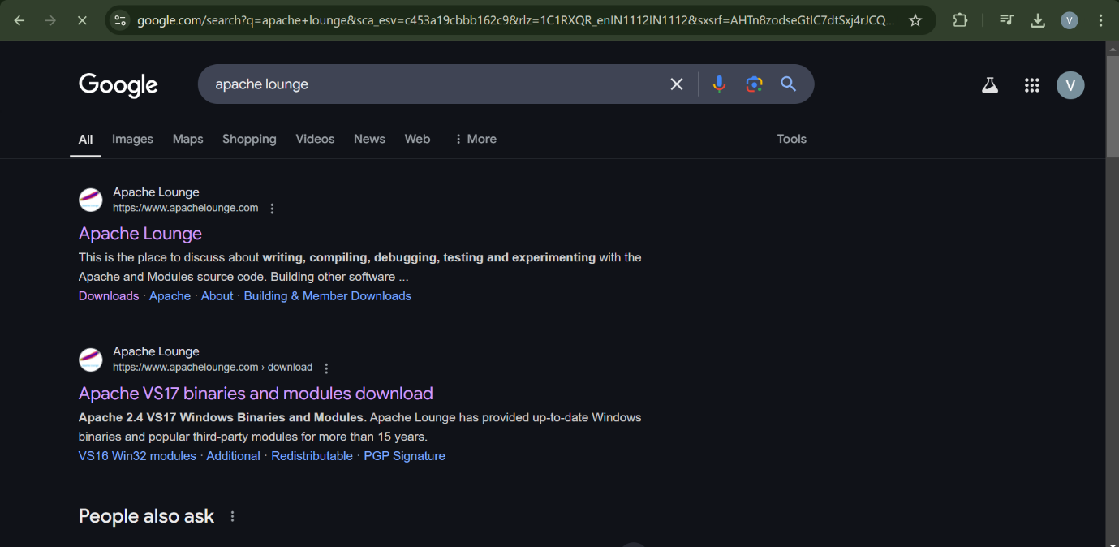

**Step 2:**

Click on the "Downloads" option located on the left-hand side of the Apache Lounge website.

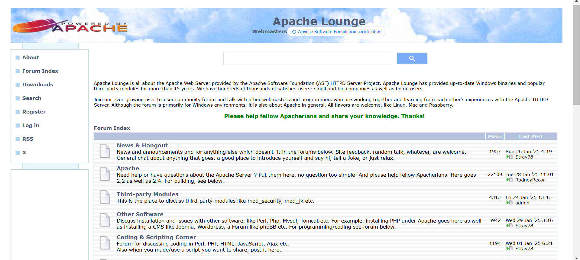

**Step 3:**

Click on the link **"Apache 2.4.62-240904 Win64"** (Windows version), download the file, and extract all its contents.

**Step 4:**

Open Command Prompt as Administrator (Windows + R, type cmd, right-click and select 'Run as Administrator') and use the command cd C:\path\to\apache\bin to set the path to the Apache bin folder.

**Step 5:**

Then Run the installation command :

**httpd.exe -k install**



**Step 6:**

Navigate to the Apache folder you downloaded, go to the **conf** folder, and right-click on the httpd.conf file; select 'Edit with Notepad'

(Apache/conf/httpd.conf)

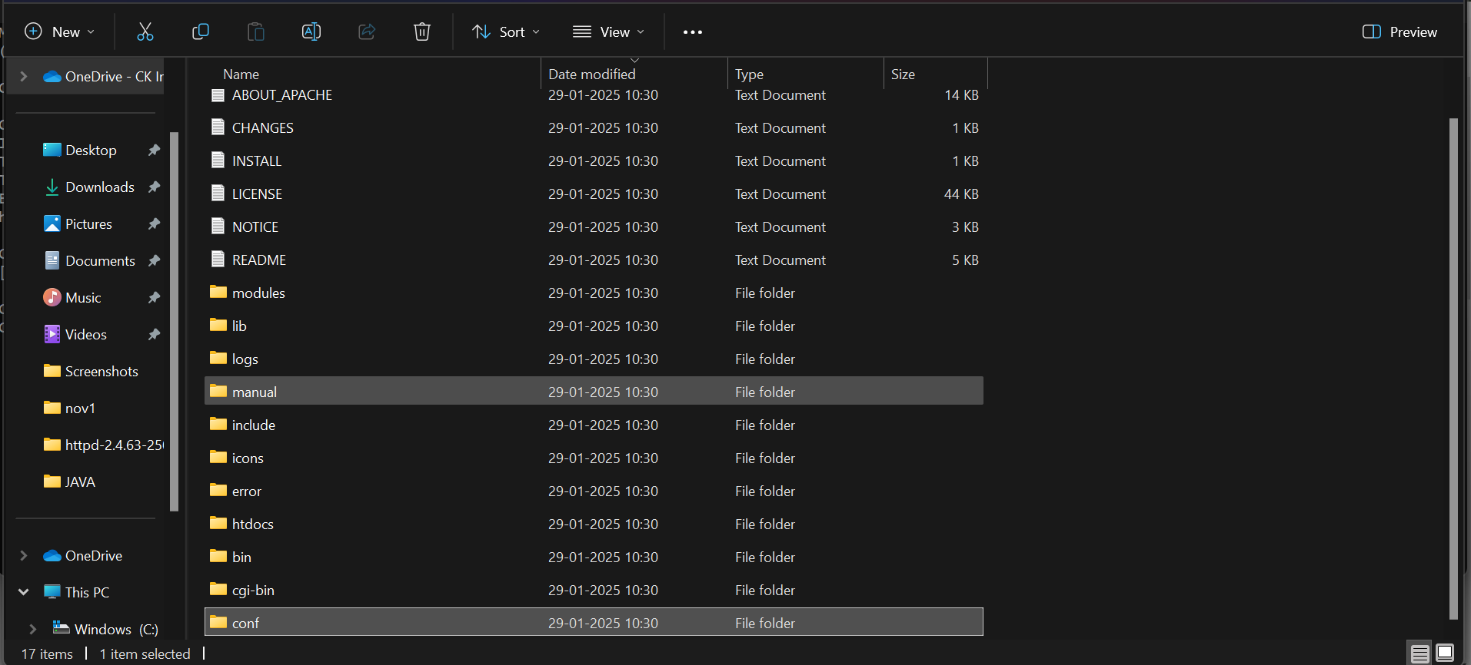

**Step 7:**

Inside the **httpd.conf** file, replace the content with the provided configuration. Ensure you update the SRVROOT directive with your Apache installation path. This configuration defines the server’s root directory, listening port, modules, document root for serving web files, logging paths, and basic permissions, ensuring Apache serves content correctly from the specified htdocs directory.

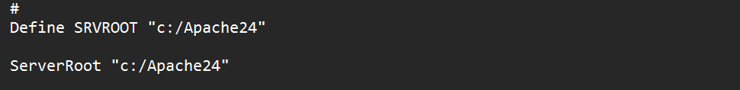

**Step 8:**

Use “ctrl+f” to search and there look for 80 there will be given like this in the image as shown.



**Step 9:**

Then to move to the file use cd <file path> and install httpd.exe

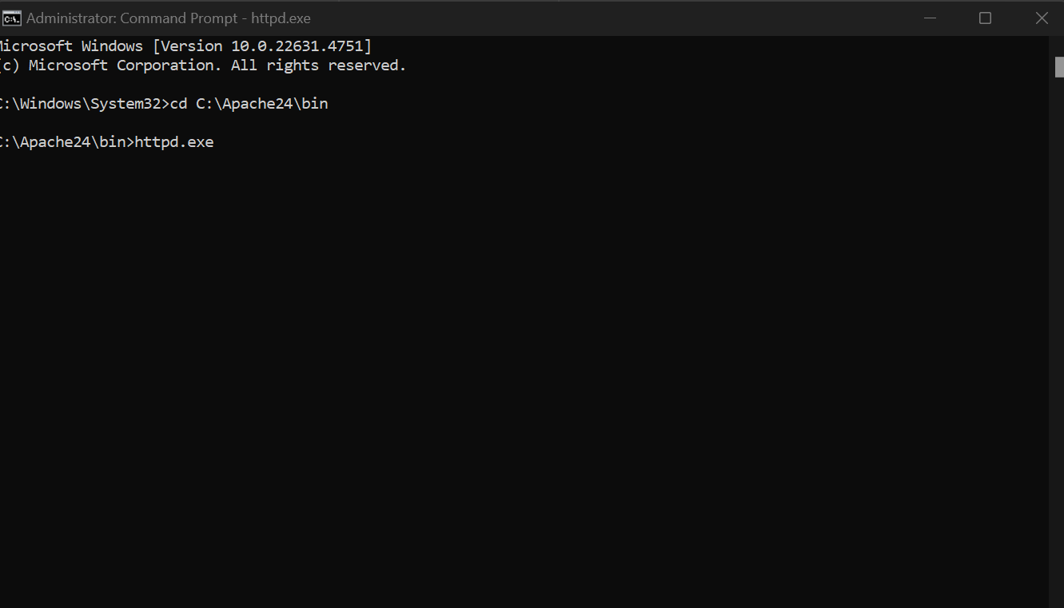

**Step 10:**

Copy your website files(HTML,CSS,JAVASCRIPT etc) to the c:\Apache24\htdocs directory.

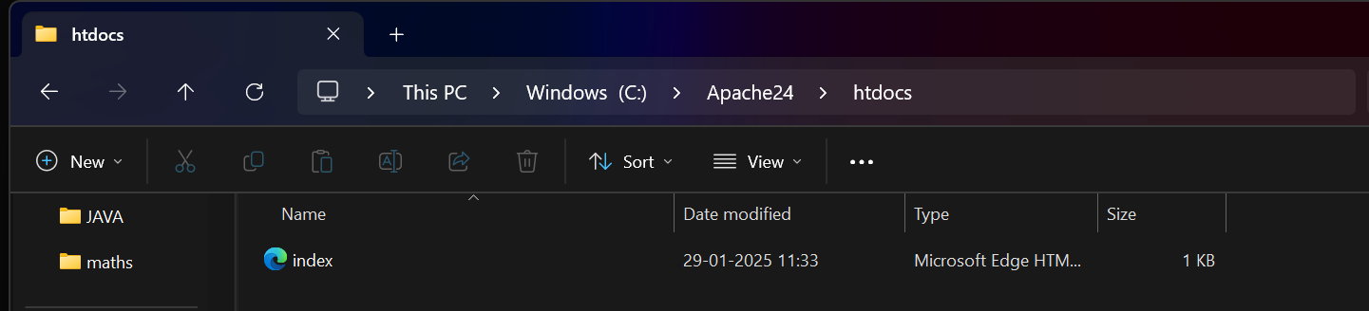

**Step 11:**

Open a web browser and go to <http://localhost> . Now your website will be hosted and displayed.

