**Placement Empowerment Program**

***Cloud Computing and DevOps Centre***

**TASK 11** Set Up IAM Roles and PermissionsCreate an IAM role on your cloud platform. Assign the role to your VM to restrict/allow specific actions.

NAME: VASANTH S DEPARTMENT: CSE

**NOTE:**

* **Azure** doesn't directly use the terminology "IAM Roles" like AWS does; instead, it uses **Azure Roles** with **Role-Based Access Control (RBAC)**. Below are steps to set up a role in Azure and assign it to a Virtual Machine (VM) to manage access.

**Objectives**

✅ **Create an IAM Role** – Define a role with specific permissions on your cloud platform (AWS, Azure, or GCP).  
✅ **Assign the Role to a Virtual Machine** – Attach the IAM role to a VM to control its access to cloud resources.  
✅ **Define Permission Policies** – Restrict or allow actions such as reading/writing from storage, accessing databases, or managing network settings.  
✅ **Enhance Security** – Implement the principle of least privilege to ensure the VM only has necessary permissions.  
✅ **Test Role Functionality** – Verify that the assigned role allows or restricts specific actions as intended.

**STEP BY STEP PROCESS:**

**STEP 1:**

LOGIN TO THE AZURE PORTAL.

STEP 2:

Navigate to your virtual machine that your created.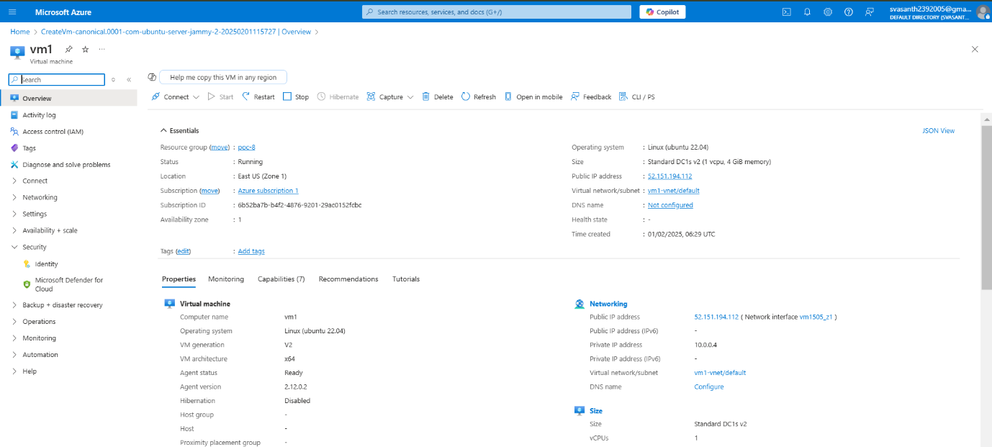

In your virtual machine search for security >>identity.

STEP 3:

Enable system assigned option “on”.

STEP 4:

Now search for Access control IAM.

STEP 5:

Click on add to add role assignment.

**STEP 6:**

Choose the roles according to your need .

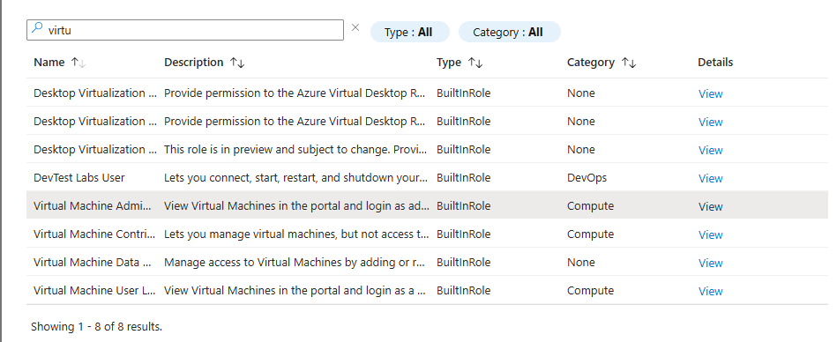

**STEP 7**:

Go to members option there your configure your role assignments and their works in description part.

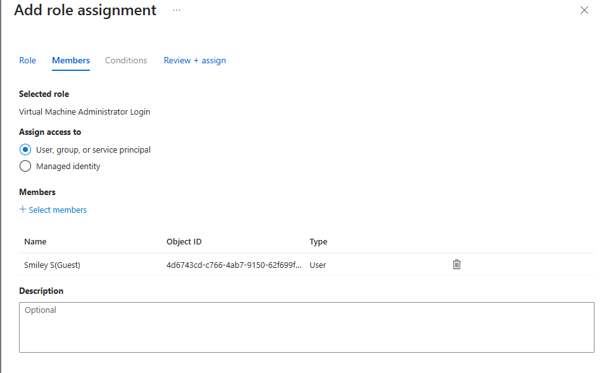

**STEP 8:**

Once you done go to “role assignments” and can check that the role is assigned or not.

