 

**Placement Empowerment Program**

***Cloud Computing and DevOps Centre***

**TASK-12** Use Cloud StorageCreate a storage bucket on your cloud platform and upload/download files. Configure access permissions for the bucket.

Name: VASANTH S Department: CSE



**Introduction:**

Cloud storage provides a **scalable, secure, and cost-effective** solution for managing files and data. It allows users to **store, retrieve, and share files** from anywhere, ensuring accessibility and reliability. By creating a **storage bucket**, you can **upload, download, and manage files** seamlessly while defining access permissions to control who can view or modify your data.

This Proof of Concept (PoC) focuses on setting up a cloud storage bucket, transferring files, and configuring **access permissions** to ensure **data security and controlled access**.

**Overview:**

In this PoC, we will **create a cloud storage bucket** on a cloud platform such as **AWS S3, Azure Blob Storage, or Google Cloud Storage** to store and manage files efficiently. The process involves:

1.**Creating a Storage Bucket** – Setting up a dedicated space in the cloud for file storage.  
2️. **Uploading & Downloading Files** – Storing and retrieving files securely.  
3️.**Configuring Access Permissions** – Defining user roles and restrictions to control who can read, write, or manage the stored files.

This ensures **scalability, security, and accessibility**, making cloud storage an ideal solution for **backup, collaboration, and large-scale data storage**.

**Advantages**

✅ **Scalability** – Easily expand storage capacity as your data grows without worrying about infrastructure limitations.

✅ **Accessibility** – Access files from anywhere, anytime, using the internet, enabling seamless collaboration.

✅ **Security** – Implement fine-grained access controls, encryption, and authentication to protect sensitive data.

✅ **Cost-Effectiveness** – Pay only for the storage you use, reducing upfront hardware costs.

✅ **Data Durability & Redundancy** – Cloud providers ensure high availability and replication across multiple data centers.

✅ **Automation & Integration** – Easily integrate with cloud services for backup, logging, and automated workflows.

✅ **Disaster Recovery** – Provides reliable backup solutions to prevent data loss due to failures or accidental deletions.

Using cloud storage buckets simplifies data management while ensuring security and efficiency. 🚀🔐

**Step-by-Step Overview**

**Step 1:**

Go to azure portal and search for “storage account” and click on “+create”

to create.

**Step 2:**

Choose

1.resource group

2.enter the storage name.

3.Enter Region

4.and set to files accordingly.

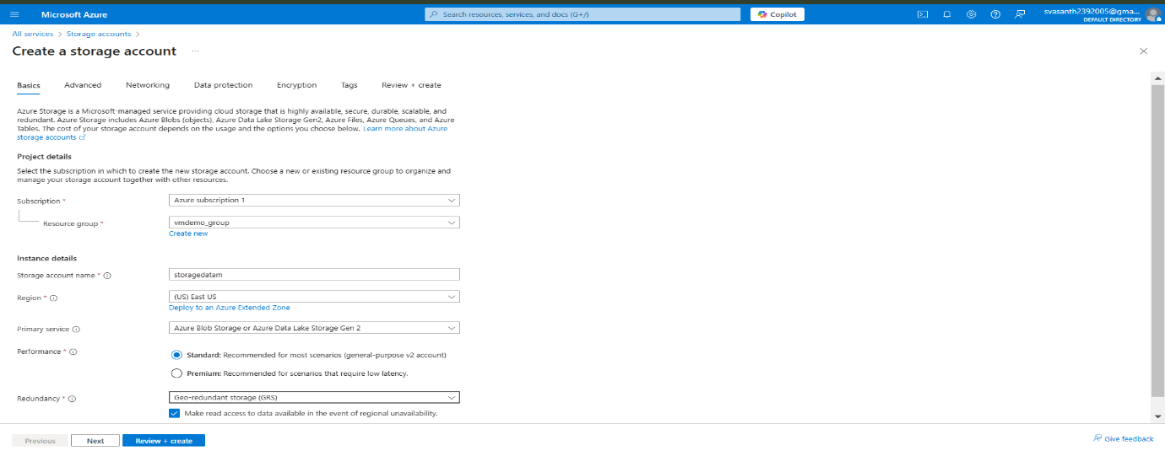

**Step 3:**

For encryption choose storing files accordingly.

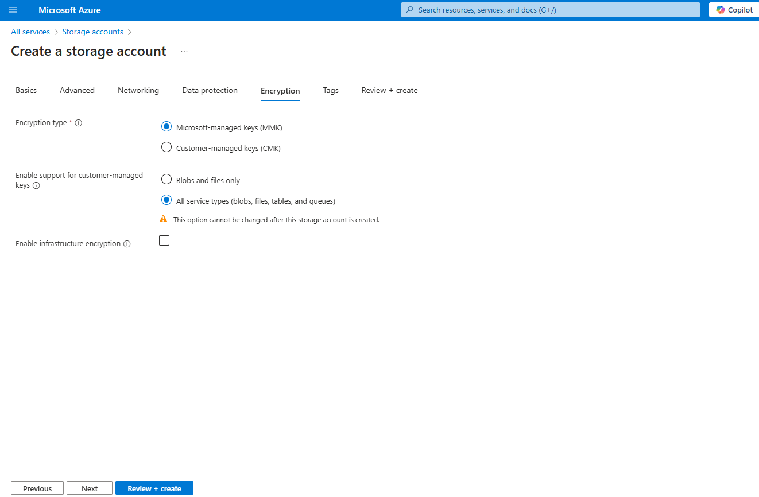

**Step 4:**

Next the storage account will be deployed.

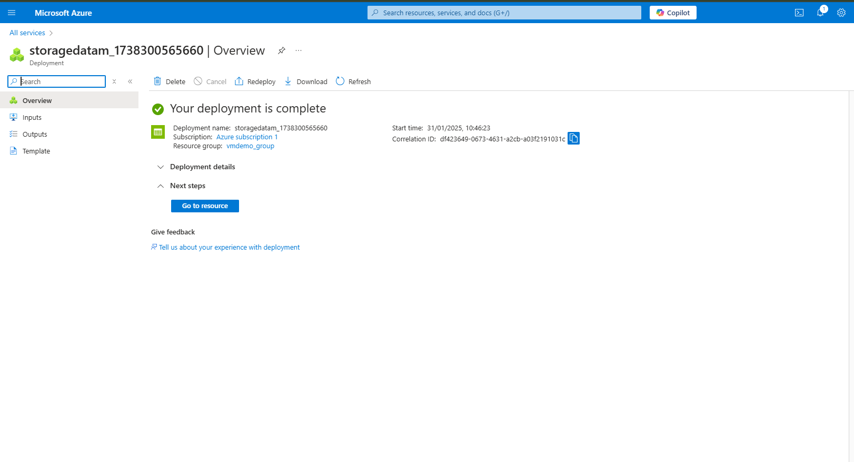

**Step 5:**

Then upload the files in blog container.

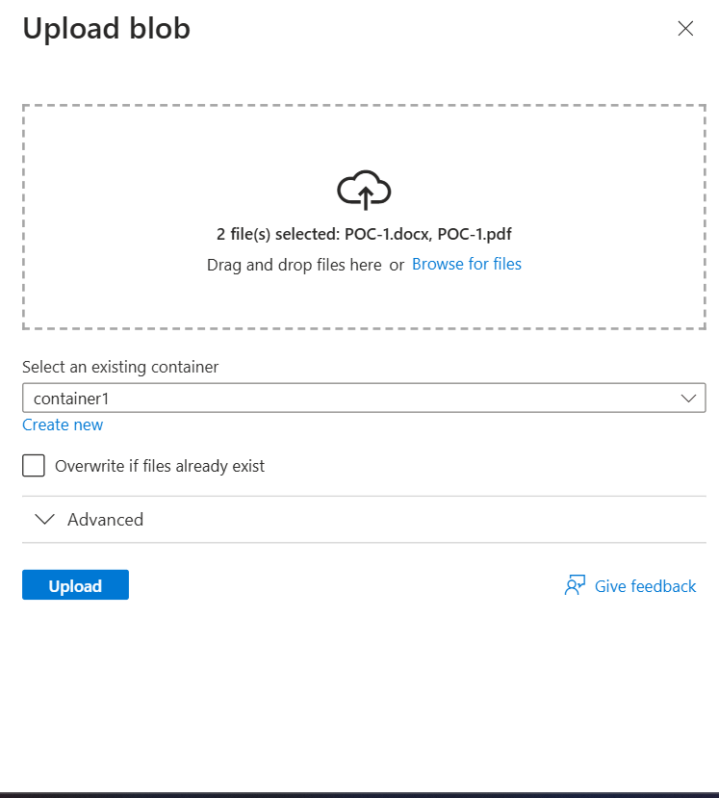

**Step 6:**

Create a container to be files stored in it.

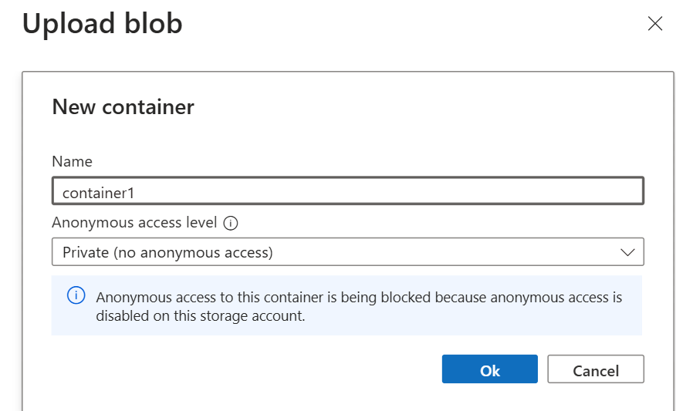

**Step 7:**

The files will be stored like this in the container you created.

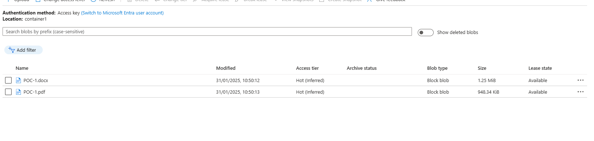

**Step 8:**

Set IAM access for the container that who can access the folders your assign user,permission,groups.

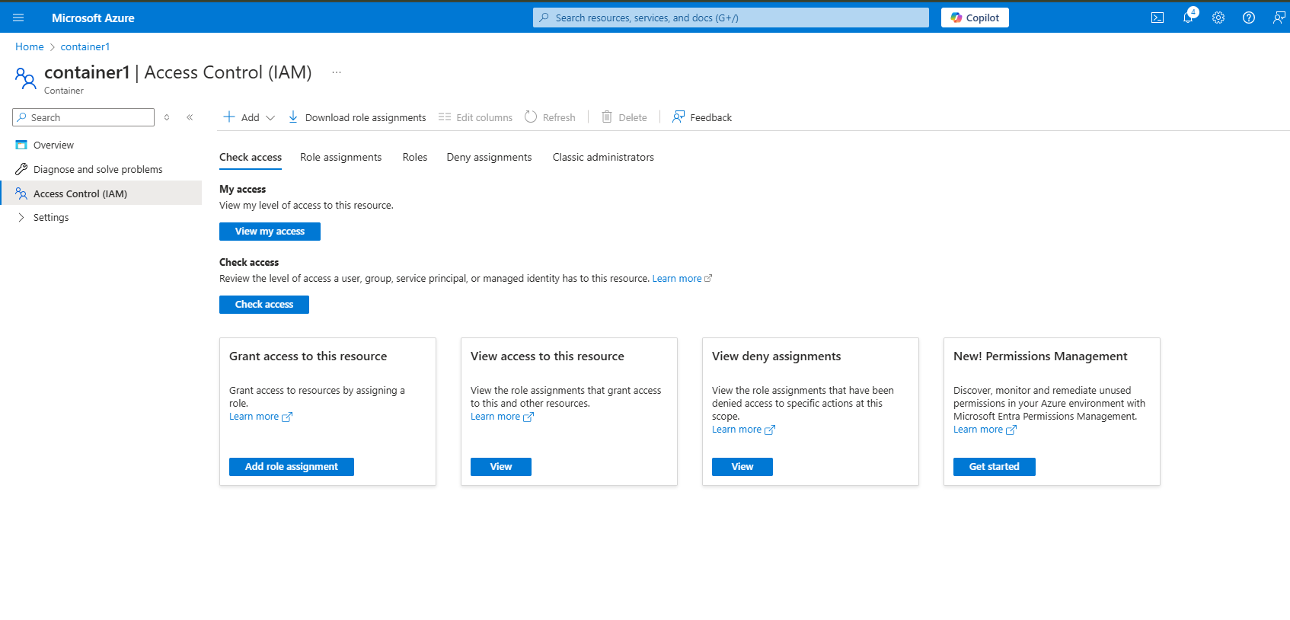

**Step 9:**

Add roles to the users with different roles.

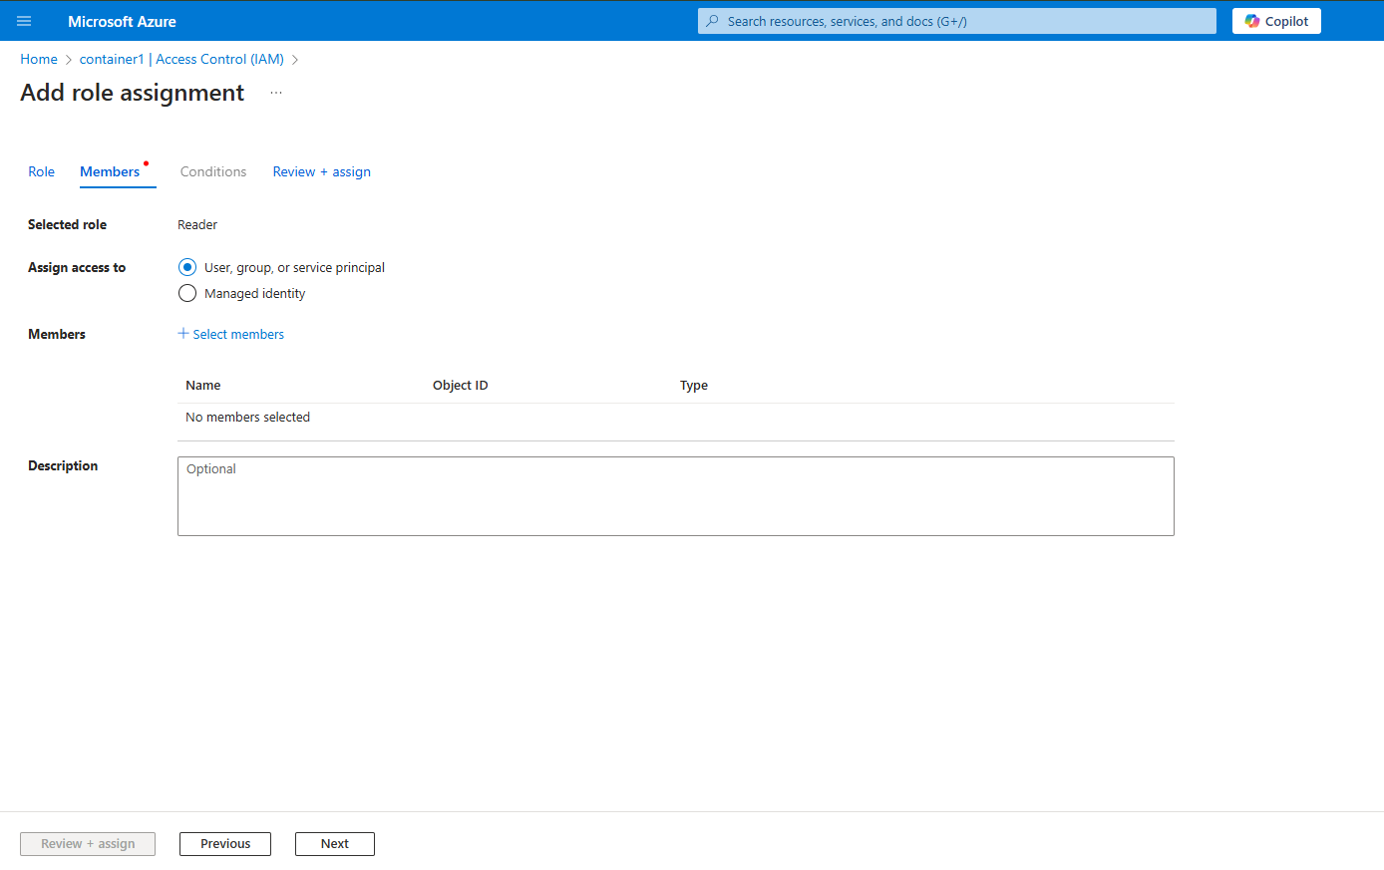

**Step 10:**

The assigned roles will be shown in the section like this

“create” it.

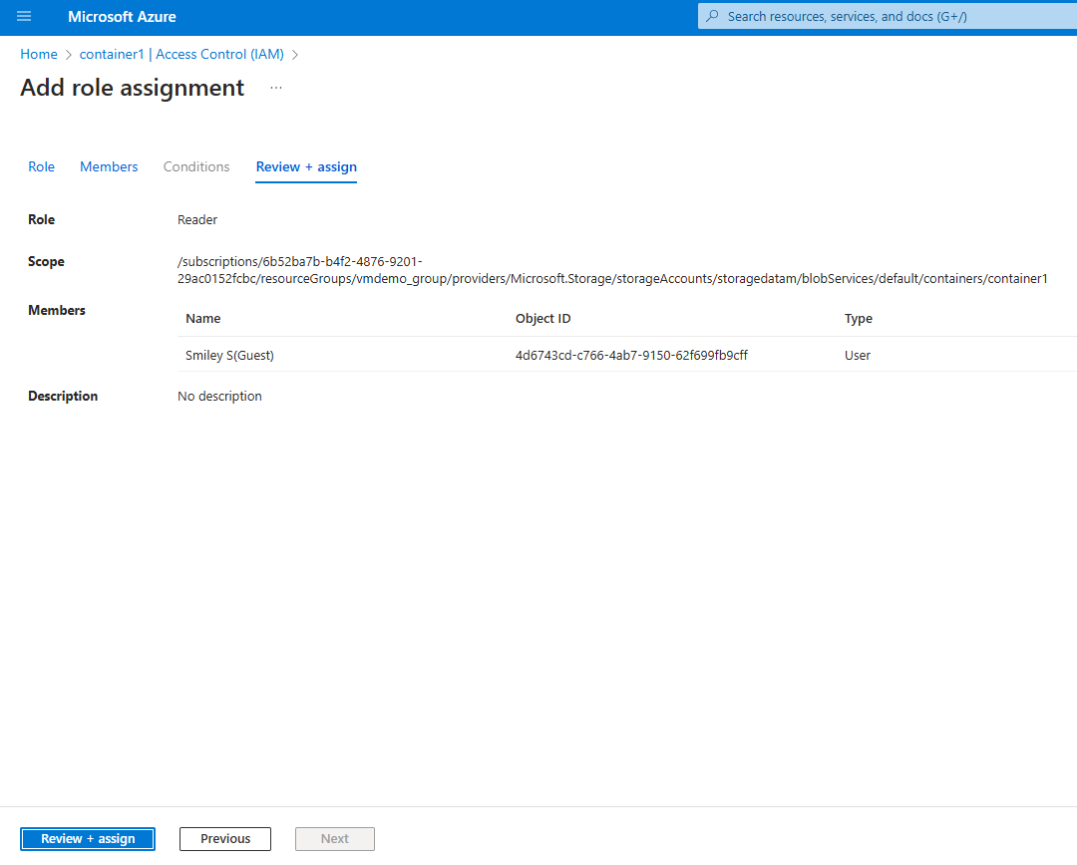

**Step 11:**

The assigned role will be shown here.

