**OVERVIEW:**

This guide will walk you through deploying a simple **Python Flask** application on an **Azure Virtual Machine (VM)** and configuring the firewall to allow **HTTP traffic**.

**STEP BY STEP PROCESS:**

**STEP 1:**

Create a virtual as given in the follows that are previously mentioned in the POC-9.

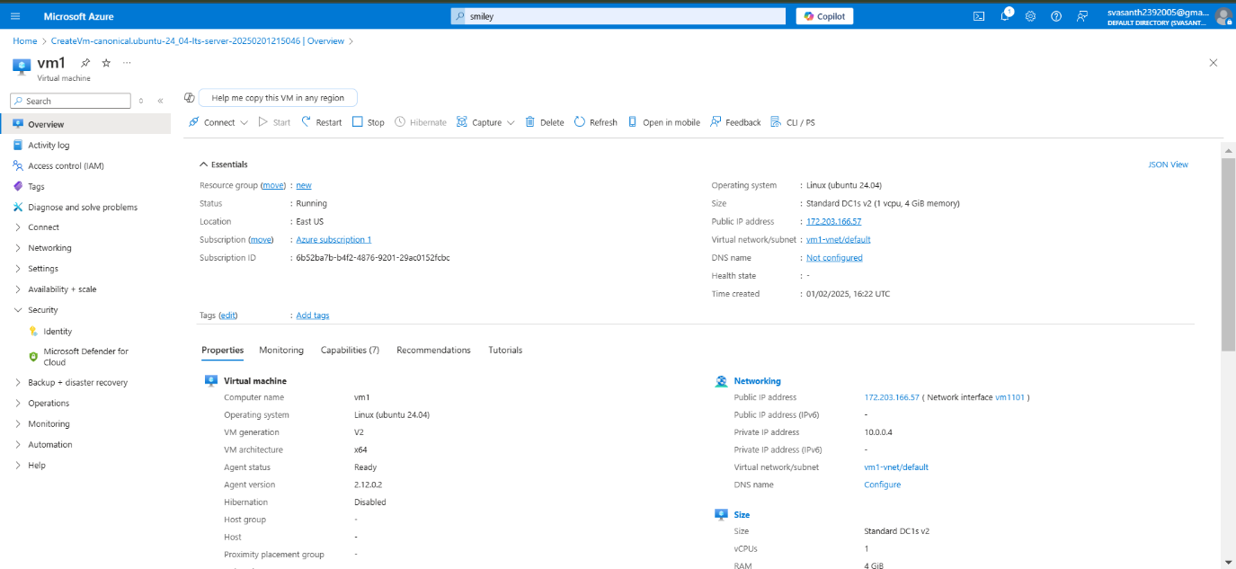

STEP 2:

Connect to the virtual machine via SSH using powershell

STEP 3:

Install the required dependencies.

1.update the package list use command

Command : sudo apt update && sudo apt upgrade -y

2.Install Python and Pip

Command: sudo apt install python3 python3-pip -y

3.Install flask

Command: pip3 install flask

STEP 4:

Create a Flask Web Application.

1.Create new folder >>command: **mkdir myapp && cd myapp**

2. Create a new Flask App File. >> command: **nano app.py**

**3. Add the following code:**

To save use CTRL+X, Then Y, and Enter.

STEP 5:

1.Allow Flask ports >> command: **sudo ufw allow 5000**

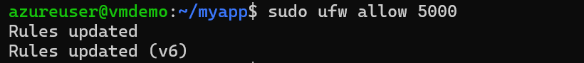

2.Check firewall status >> command: **sudo ufw status**



3.Enable the Firewall >> command**: sudo ufw enable**



**STEP 6:**

1.Start the Flask App> Command : **python3 app.py**

2. The application will start on port 5000.

3. To access the app, open a browser and go to:

**http://<your-vm-ip>:5000**

You should see **"Hello, Azure! Your Flask app is running on a VM."**

**STEP 7:**

Ensure that your virtual machine > networking

That setting had enabled for HTTP port.

Then you have successfully deployed your web application on the internet.

