**Placement Empowerment Program**

***Cloud Computing and DevOps Centre***

**TASK-15** Use Cloud CLI Tools Install the CLI for your cloud provider (e.g., AWS CLI). Use it to list resources, upload files to storage, and manage VMs.

Name: VASANTH S Department:CSE

**INTRODUCTION**

Installing the Azure CLI is the first step to accessing and automating tasks in your Azure environment. Once installed, you can use it to list and manage resources like virtual machines, storage accounts, and more.

STEP BY STEP PROCESS:

STEP 1:

Open your Azure Portal.

In the Right top corner > CLI option will be there.



STEP 2:

Enter the following command for creating a “Storage Account”.

Command: **az storage account create --name <your_storage_account_name> --resource-group <your_resource_group_name> --location <your_location> --sku Standard_LRS**



STEP 3:

Create a “Blob Container” for uploading files.

Command: **az storage container create --name <your_container_name> --account-name <your_storage_account_name>**



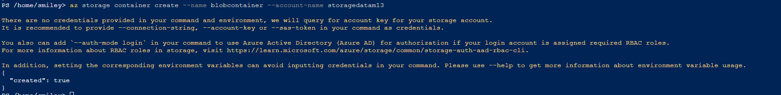

STEP 4:

Now you can see your created storage account and container in it.

STEP 5:

Upload files to the blob container in it. Click on “upload”



STEP 6:

Start the VM by running the Following command or you can open the portal, go to your VM and click on Start.

**Cmd: az vm start --name <your_vm_name> --resource-group <your_resource_group_name>**



**For stopping: az vm stop --name <your_vm_name> --resource-group <your_resource_group_name>**

