**Placement Empowerment Program**

***Cloud Computing and DevOps Centre***

**TASK-17 Set Up a Load Balancer in the Cloud: Configure a load balancer to distribute traffic across multiple VMs hosting your web application.**

**Name: VASANTH S Department:CSE**

**Overview: Setting Up a Load Balancer in Azure**

A **Load Balancer** is a crucial component in cloud architecture that helps distribute incoming traffic across multiple Virtual Machines (VMs) to ensure **high availability, scalability, and reliability**. In Azure, Load Balancers can be used to balance traffic for both **internet-facing** and **internal applications**, improving performance and fault tolerance.

This process involves:

1. **Creating Virtual Machines (VMs)** to act as backend servers.
2. **Deploying an Azure Load Balancer** to manage traffic distribution.
3. **Configuring a Backend Pool** to group VMs handling requests.
4. **Setting Up Health Probes** to monitor VM status and ensure availability.
5. **Defining Load Balancing Rules** to direct traffic based on protocols and ports.

By implementing an Azure Load Balancer, organizations can achieve **automatic failover**, **even distribution of requests**, and **better user experience** by preventing server overloads.

STEP BY STEP PROCESS:

STEP 1:

Create your virtual machine as created like with previous settings.

STEP 2:

Search for load balancer and create it.

STEP 3:

• In **Azure Portal**, search for **Load Balancers** and click **+ Create**.

• Select the **Subscription** and **Resource Group** (same as VMs).

• Configure:

* **Name**: MyLoadBalancer
* **Region**: Same as VMs
* **Type**: **Public** (for internet traffic) / **Internal** (for private traffic)
* **SKU**: Standard

• Click **Review + Create** → **Create**

STEP 4:

Now move on to the virtual machine that you created and in the overview search bar search for “load balancing”

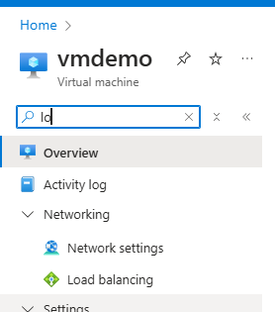

STEP 5:

Now connect to the load balancer that you created.

