**Placement Empowerment Program**

***Cloud Computing and DevOps Centre***

**TASK-18: Back Up and Restore a Cloud Instance :**Take a snapshot of your cloud VM. Terminate the VM and restore it from the snapshot.

Name: VASANTH S Department:CSE

**Overview: Backing Up and Restoring a Cloud Instance in Azure**

In this process, we will ensure the safety of our virtual machine (VM) by creating a backup and restoring it when needed. The steps involved are:

1. **Take a Snapshot of the VM's Disk** – Capture a point-in-time backup of the VM’s OS or data disk.
2. **Create a Managed Disk from the Snapshot** – Use the snapshot to create a new managed disk, which will be used to restore the VM.
3. **Deploy a New Virtual Machine** – Launch a new VM and attach the restored disk to it.
4. **Verify Restoration** – Ensure that the new VM is running correctly with the restored data and configurations.

This process helps in disaster recovery, system rollback, and quick restoration of cloud instances in case of failures.

STEP BY STEP PROCESS:

STEP 1:

1.Go to Azure Portal.

2.Create a “Virtual Machine” as the give follows.

STEP 2:

Now Go to “Disks” and select the OS disk attached to your VM.

Now create snapshot and it can be searched in search bar.

STEP 3:

Now terminate the previous Virtual Machine. And Go on to the snapshot that you created.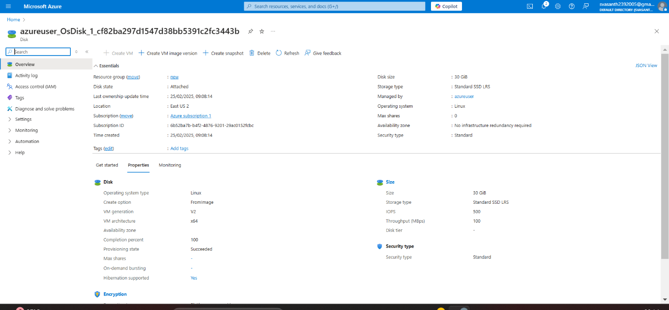

STEP 4:

From the snapshot create the Virtual machine.

**Verify the Restored VM**

1. **Go to Virtual Machines** and check if the new VM is running.
2. **Connect to the VM** using SSH (Linux) or RDP (Windows).
3. Ensure that the data and configurations are successfully restored.