**Placement Empowerment Program**

***Cloud Computing and DevOps Centre***

**TASK-19** **Set Up a Private Network in the Cloud**:

Create a Virtual Private Cloud (VPC) with subnets for your instances. Configure routing for internal communication between subnets.

Name: VASANTH S Department:CSE

**Objective**

The objective of this task is to create a **Virtual Private Cloud (VPC)** in Azure, known as a **Virtual Network (VNet)**, and set up **subnets** within it. The goal is to enable secure and efficient **internal communication** between resources in different subnets by configuring routing rules. This setup helps in **network segmentation**, **traffic control**, and **better resource organization** within the cloud infrastructure.

**STEP BY STEP PROCESS:**

**STEP 1:**

LOGIN INTO YOUR **AZURE PORTAL.** Search for virtual network.

**STEP 2:**

GO TO VIRTUAL NETWORKS “+ CREATE”.

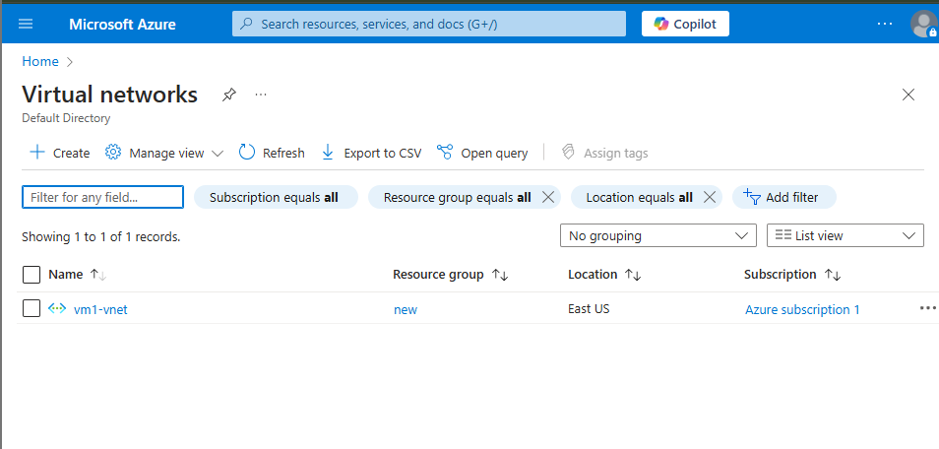

**STEP 3:**

GIVE THE FOLLOWING DETAILS:

Enter Resource group

Enter virtual network name

Enter Region.

And IP settings.

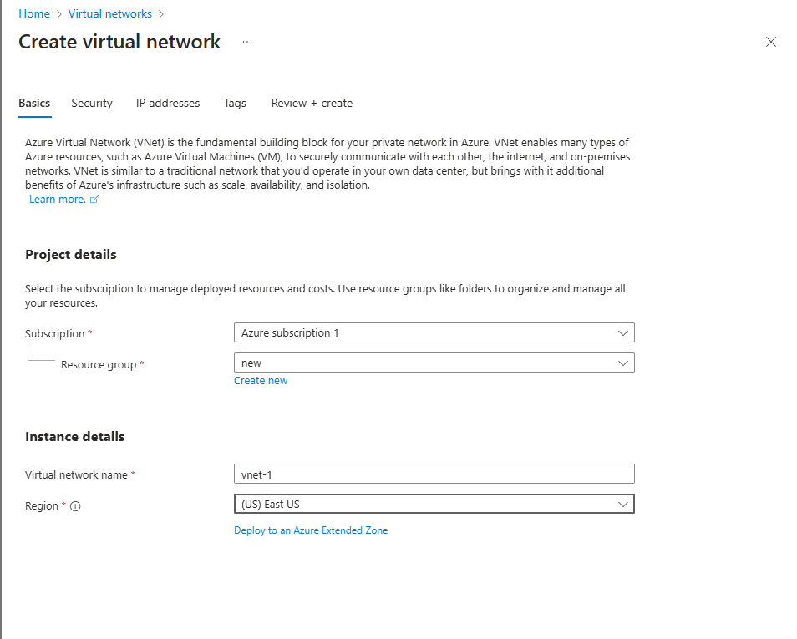

Once entered the details click on create for deployment.

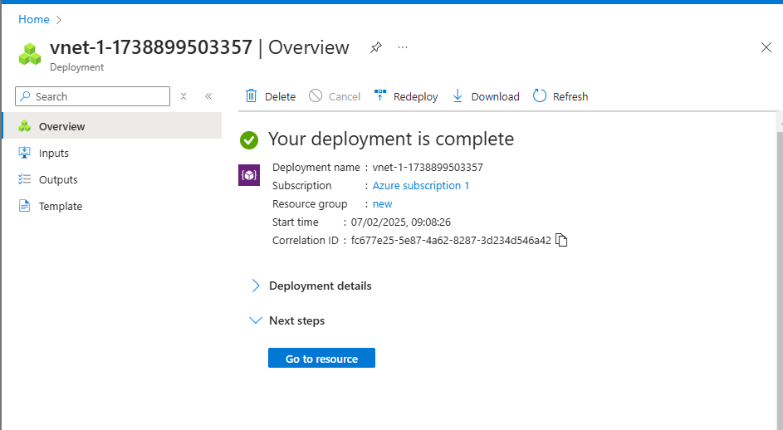

**Step 4:**

Search for Subnet and “create”

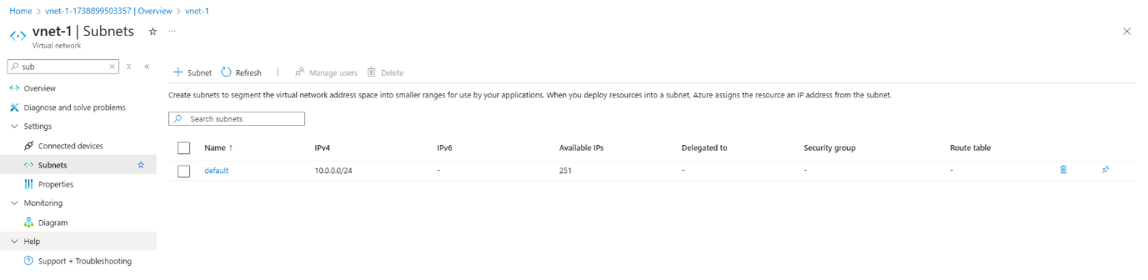

**Step 5:**

Add a subnet details and provide a ip address and click on “Add”.

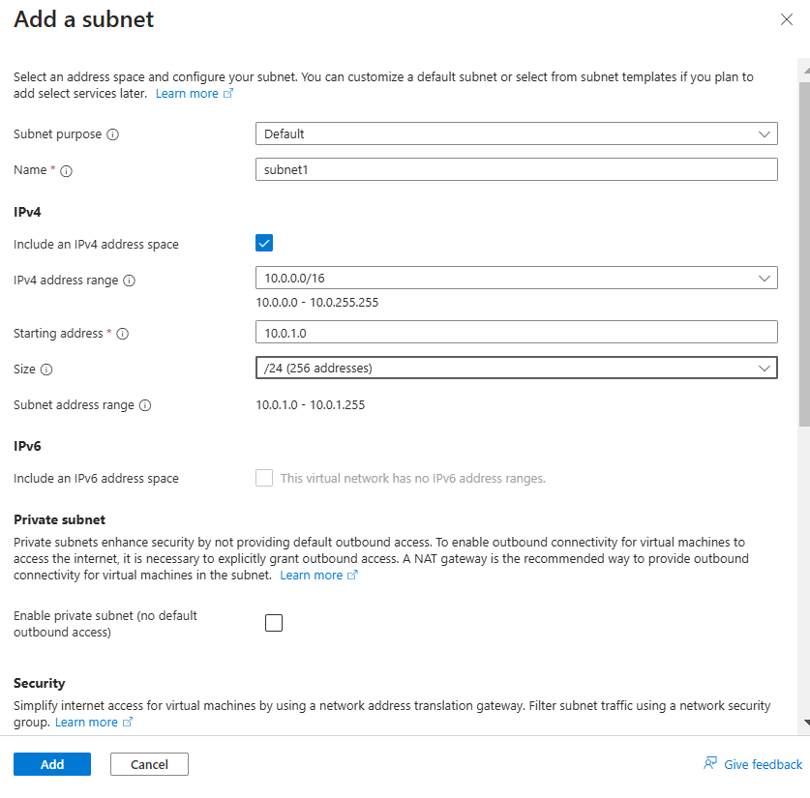

**STEP 6:**

Create two subnets.

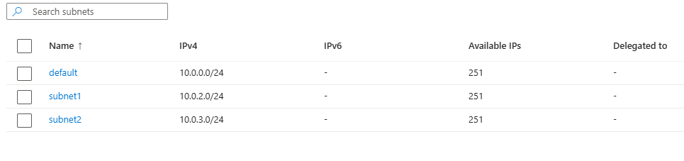

**Step 7:**

Search for “Route table” and click on “create”.

**Step 8:**

Enter route table details

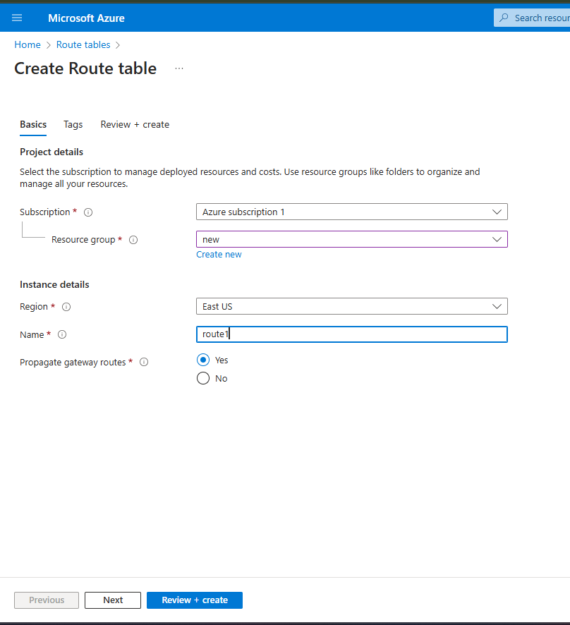

**Step 9:**

Add route with desired type**.** Do same for subnet2**.**

**Step 10:**

Now associate with virtualnetwork for subnet1 and subnet2.

**Step 11:**

Connect the virtual network using route table.

**Step 12:**

Now create a virtual machine with basic requirements.

And move to networking section in the following

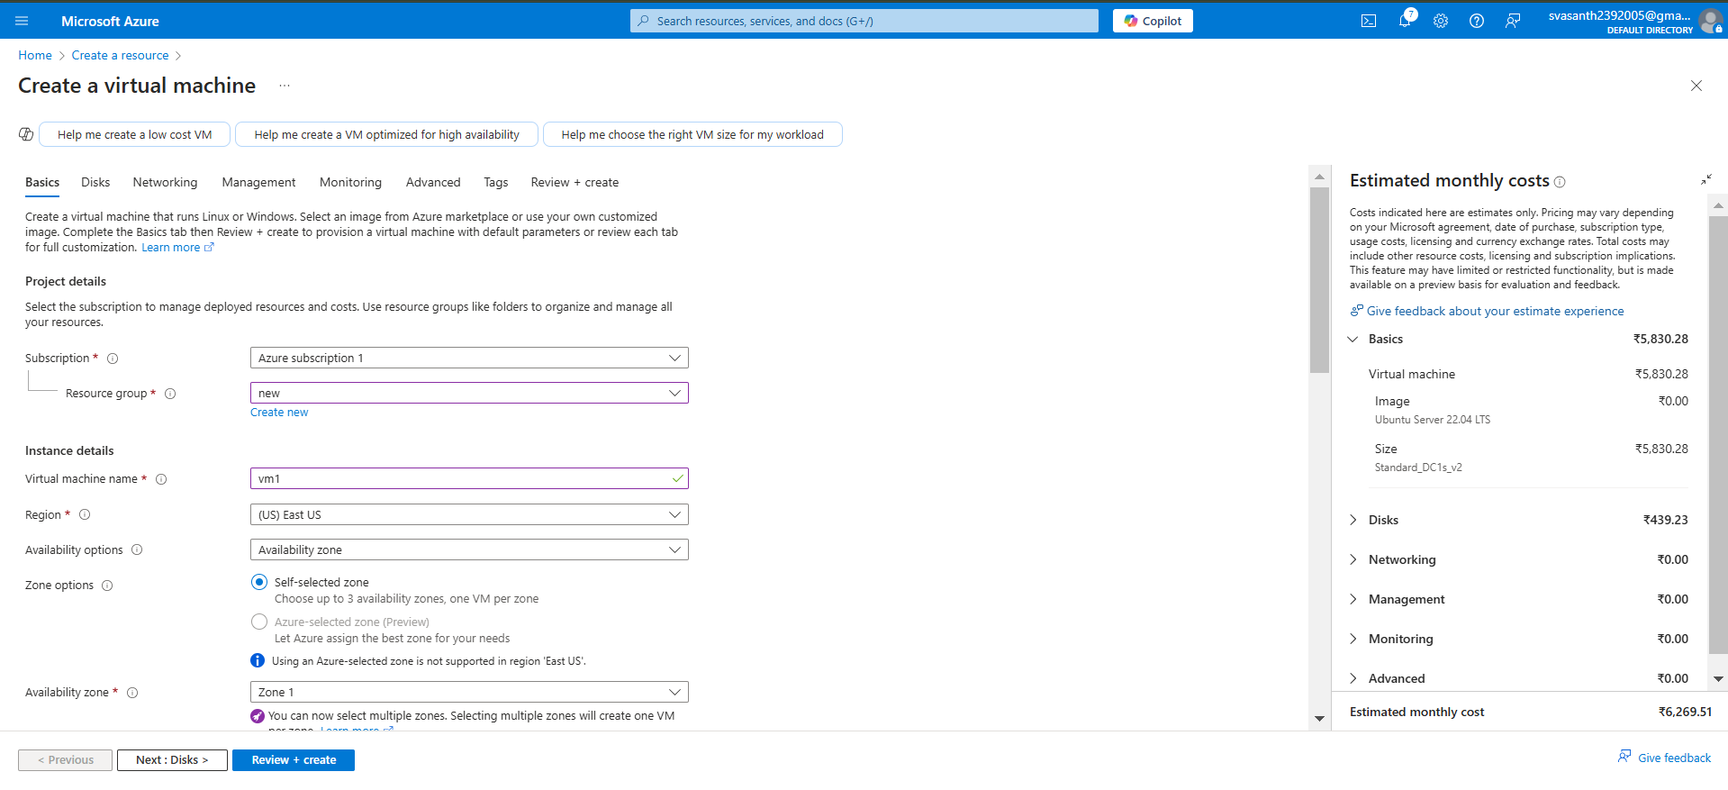

**STEP 13:**

In networking section add your vnet and subnet you created for connection**.**

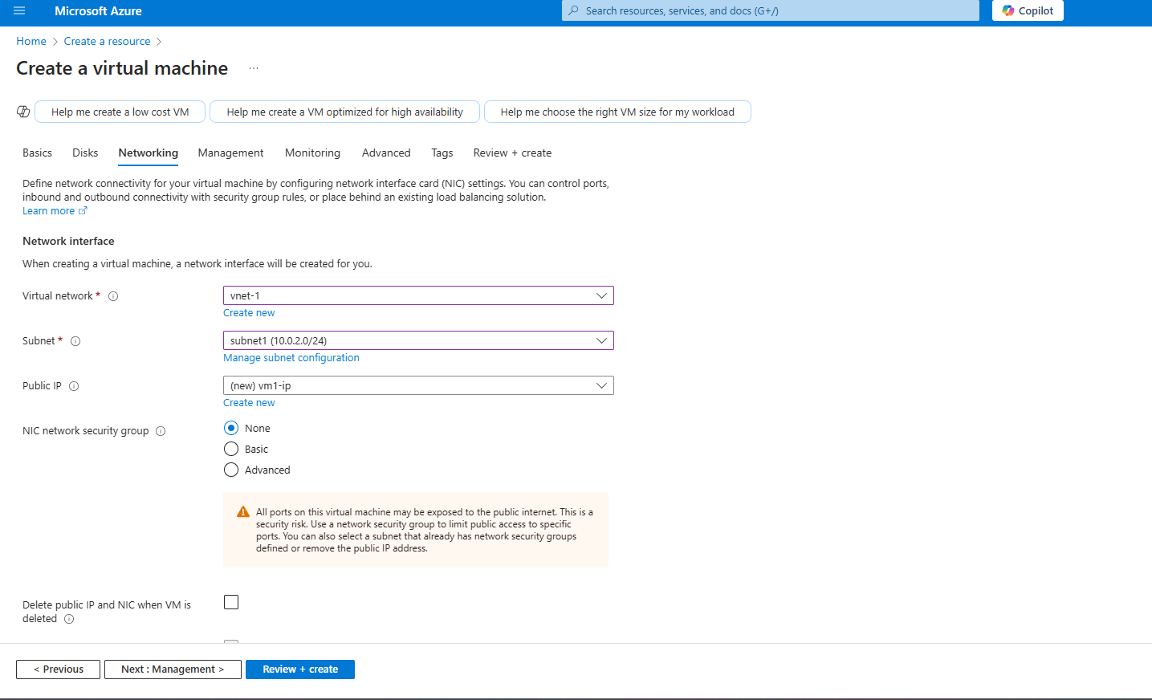

**STEP 14:**

Then create your virtual machine. That’s it your task is completed.

