**Placement Empowerment Program**

***Cloud Computing and DevOps Centre***

TASK-2 **: Automate File Copying with a Script**

Create a script to copy files from one folder to another automatically.

Name: VASANTH S Department: CSE

**Introduction**

In today's fast-paced digital world, managing and transferring files efficiently is crucial for ensuring productivity and data organization. Automating the process of copying files from one folder to another eliminates repetitive manual tasks, reduces errors, and saves valuable time. This Proof of Concept (PoC) demonstrates how to create a simple yet effective automation script that handles file copying seamlessly.

By leveraging scripting languages such as Python, PowerShell, or Bash, this solution can be customized to suit various scenarios, such as backing up important documents, syncing project files, or organizing media files. Automation not only enhances workflow efficiency but also provides consistency and reliability in file management processes.

**Overview**

The goal of this Proof of Concept (PoC) is to automate the process of copying files between folders, streamlining tasks such as backups, file synchronization, or data migration. This solution eliminates the need for manual intervention, ensuring accuracy, consistency, and efficiency in file handling.

Using scripting languages like **Python**, **PowerShell**, or **Bash**, the script can be tailored to meet specific requirements. For instance, you can configure the script to:

* Copy all files or only files with specific extensions. 📄🎥
* Skip files that already exist or overwrite them if needed. 🔄
* Automate scheduling with tools like **Task Scheduler** (Windows) or **cron** (Linux). ⏰
* Log all actions for better traceability and debugging. 📋

**Objectives**

• **Automate Repetitive Tasks**  
Eliminate manual effort by automating the process of copying files between folders, reducing human intervention. 🔄

• **Ensure File Consistency**  
Maintain consistent and accurate file copies across directories, preventing errors due to manual operations. ✅

• **Support Customization**  
Allow for flexibility in defining file types, conditions (e.g., overwrite or skip), and source/destination paths for specific requirements. 🎯

• **Enable Scheduled Operations**  
Integrate with scheduling tools like **Task Scheduler** (Windows) or **cron** (Linux) to perform file copying at regular intervals. ⏰

• **Enhance Productivity**  
Save time by automating time-consuming tasks, allowing users to focus on more critical activities. 🚀

• **Improve Traceability**  
Log every operation (success or failure) to ensure transparency and provide a mechanism for debugging if issues arise. 📋

• **Ensure Cross-Platform Compatibility**  
Develop scripts in languages like **Python**, **PowerShell**, or **Bash** to support different operating systems seamlessly. 🌐

**Step-by-Step Overview**

Step 1:

Create two folders named as source and destination.



Step 2:

Store some files inside it to automate it.

Step 3:

Open the note pad and type the code and make sure that in set **SOURCE** give your Source folder address and in set **DESTINATION** give your Destination Folder address.

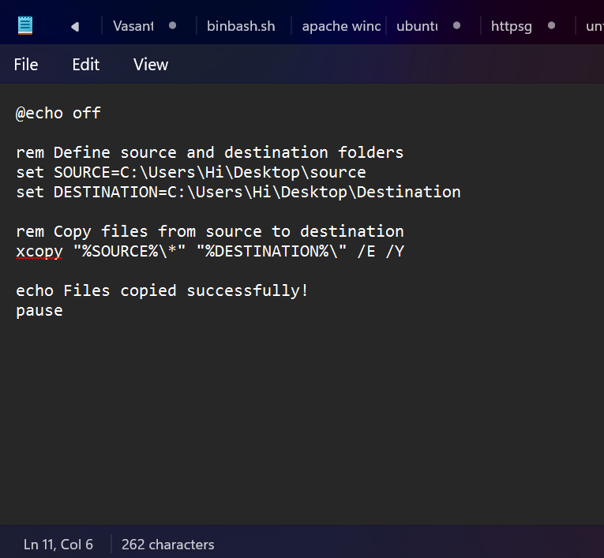

Step 4:

Then save the file in desktop with .bat extension (eg : index.bat) so the file looks like this given in the below image.

Step 5

Press **Win + R** on your keyboard.

A small "Run" dialog box will pop up.

Type **taskschd.msc** (without quotes) in the Run box.

Press Enter or click OK.This will open the Task Scheduler window

Step 6:

In the Task Scheduler window, look to the right-hand side for a button called **"**Create Basic Task**"** Click it. A wizard will open to guide you through the setup.

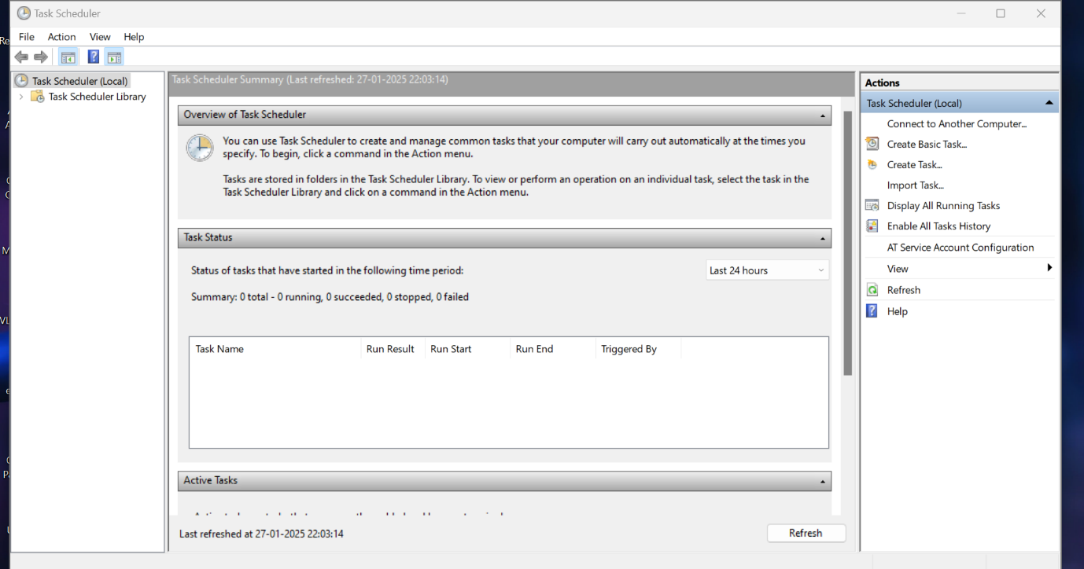

Step 7:

1.Enter a Name for the Task:

For example: "Automate File Copying".(This can be anything that helps you remember what the task does.)

Step 8:

Choose a Schedule:

You will see options like:

Daily (runs every day).

Weekly (runs once a week).

One time (runs only once at a specific time).

Choose what works for you (e.g., Daily) and click Next

Step 9:

Set the Time and Frequency:

If you chose Daily, specify:

The start date (it defaults to today).

The time (e.g., 10:00 AM).

Click Next to move on.

Step 10:

Set the Action , Now, we tell Task Scheduler what to do when it runs. Select "Start a Program": On the "Action" screen, select the option **"**Start a Program**"** and click Next. A screenshot of a computer

Step 11:

Point to the Program or Script:

In the Program/script field, click **Browse** and navigate to the location of your .bat file.

Example: If your script is named index.bat and saved on the desktop, navigate to that file and select it.

Click Next.

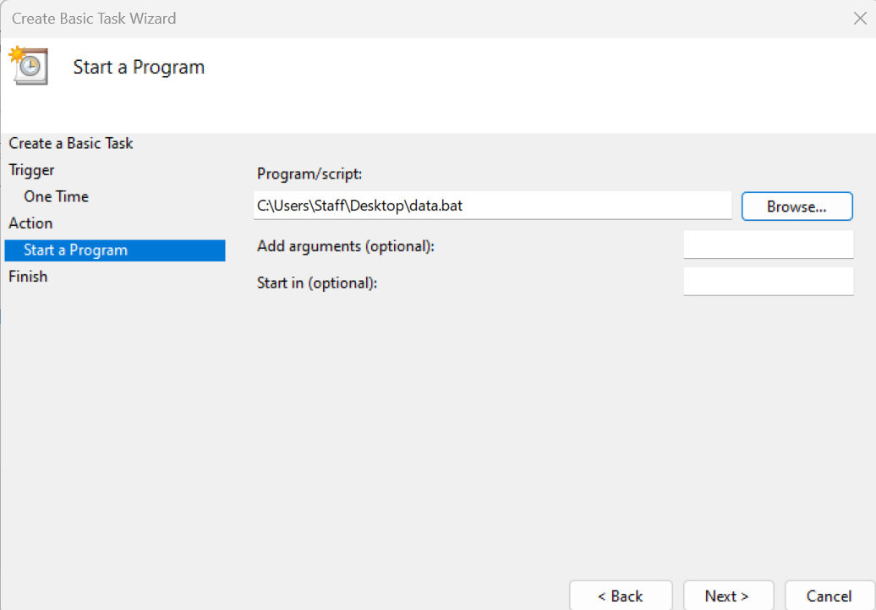

Step 12:

In Task Scheduler, go to the **Task Scheduler Library** (on the left-hand side).

Find your task (it should have the name you gave it, e.g., "Automate File Copying").

Right-click the task and select **Run**.

This will manually trigger the task immediately.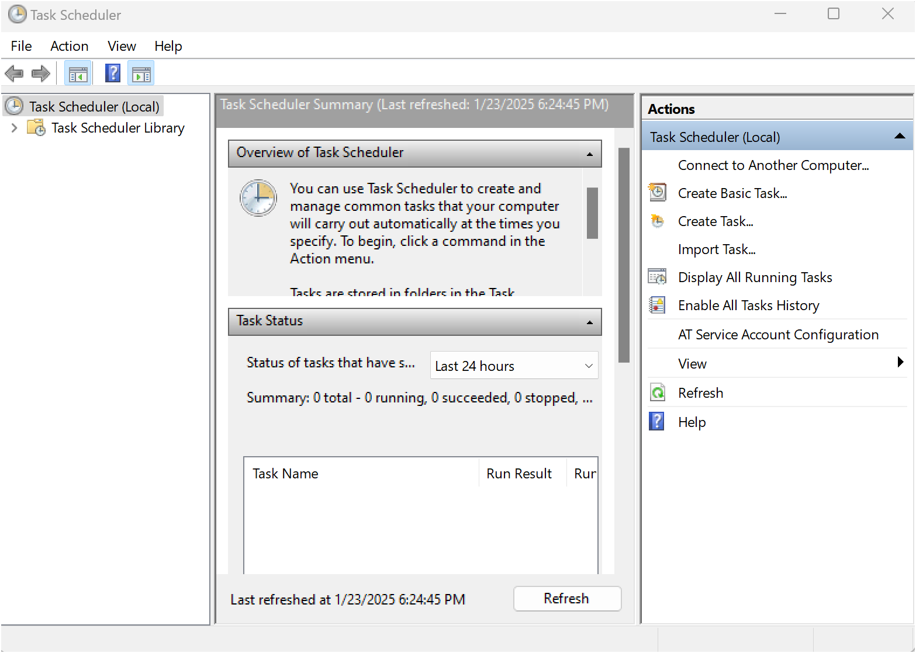

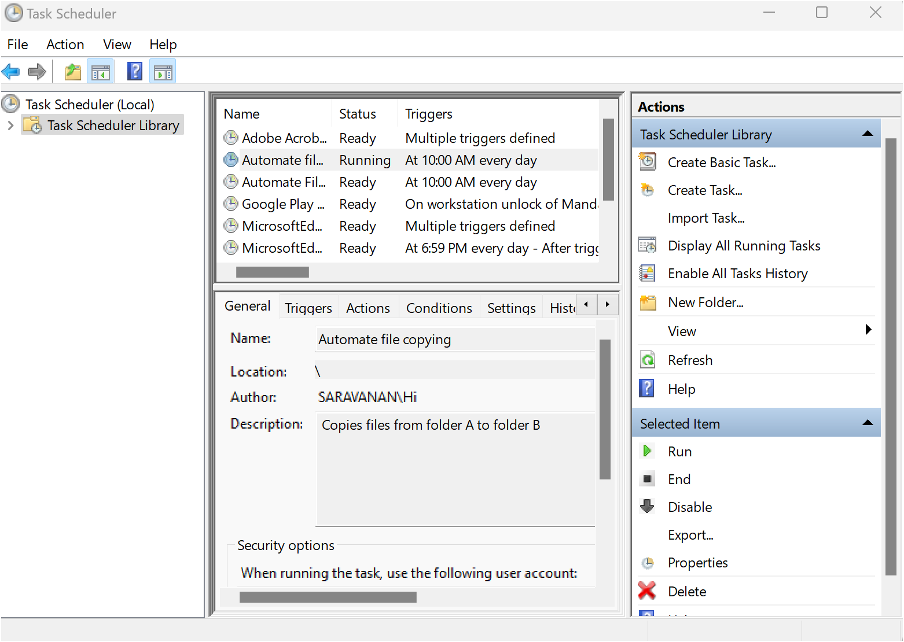

Step 13:

Then click on the .bat file to the connection that transfer files successfully.

Step 14:

If your task was set up to copy files, go to the destination folder and confirm that the files have been copied.



