**Placement Empowerment Program**

***Cloud Computing and DevOps Centre***

TASK-2 : Set Up a Local Git Repository: Initialize a Git repository locally and version control your static website

Name:VASANTH S Department:CSE

**Introduction**

In this POC, we’ll initialize a local Git repository to version control your static website. By doing so, you’ll be able to track changes to your project files, experiment with new features in a controlled way, and easily share your project with others if needed. Setting up a Git repository is a critical step towards maintaining a structured and reliable workflow, especially for developers and teams working on collaborative projects.

**Overview**

Here’s what we will cover in this setup:

**1. Installing Git**: Ensure Git is installed on your system and properly configured.

**2. Creating a Local Repository**: Initialize a Git repository in the root folder of your static website.

**3. Staging and Committing Files**: Add your project files to the staging area and commit them to the repository to save a snapshot of your work.

**4. Reviewing** : Use Git commands to check the status of your repository and verify that everything is tracked properly.

**Objectives**

By the end of this POC, you will:

**1. Understand the Basics of Version Control**: Gain insight into the importance of Git for managing and tracking changes in your projects.

**2. Set Up a Git Repository**: Learn how to initialize a Git repository to version control your static website locally.

**3. Track Changes Effectively**: Understand how to stage and commit files to ensure every change is logged.

4. **Organize Your Project**: Maintain a clean and structured workflow for your static website, with the ability to roll back changes when needed.

5. **Prepare for Collaboration**: Lay the groundwork to share your repository and collaborate with others using Git when required

**Step-by-Step Overview**

Step 1:

Search for "Git" in Chrome, download it, and click the "Downloads" option on the website.

Step 2 :

Click the **Windows** option on the download page and follow the installation wizard.

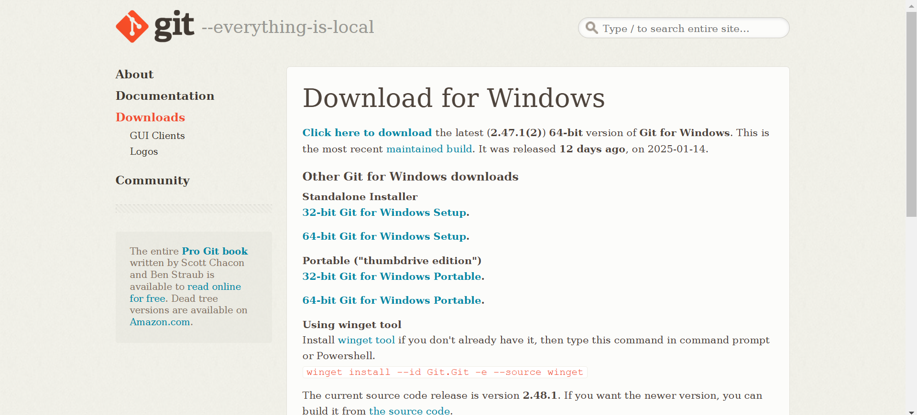

OR

Use the command given below in your command prompt to install Git.

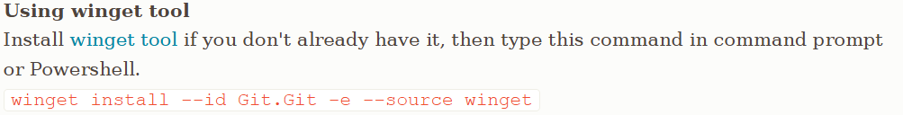

Step 3:

**Create a New Repository**:

Once you're logged in, click the green **"New"** button on the top- right of your GitHub homepage to create a new repository.

Give your repository a name, for example, my-website.

Leave the other settings as default, and click **"Create repository"**.

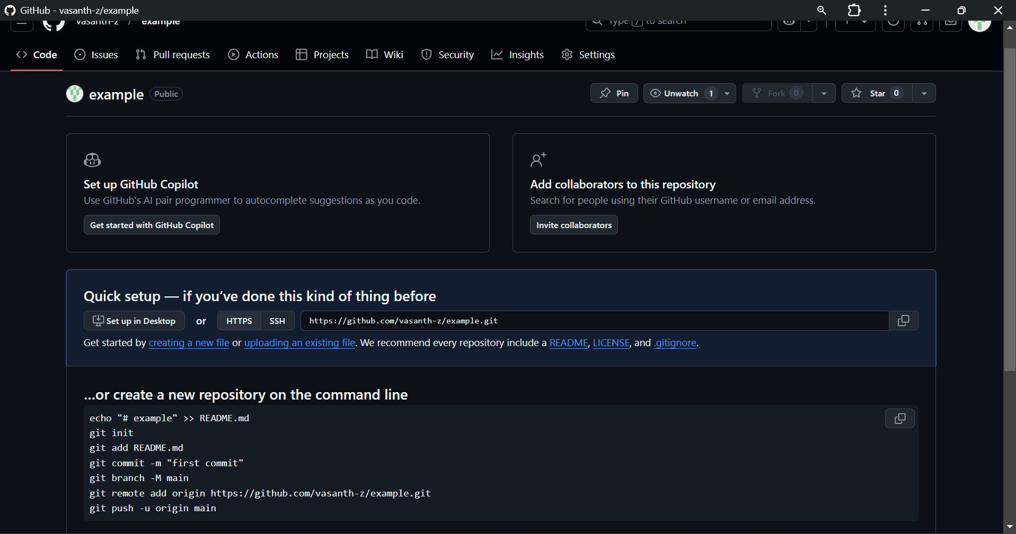

Step 4:

In your Desktop Create a folder named w for your static website

Inside that folder, create a simple HTML file named index.html. You can write some basic HTML



Step 5:

Type “cmd” on the search of the file to redirect to the command prompt of that file.

Step 6:

Enter the command “git init” to initialize the Git repository.



Step 7:

Enter the command "git add .” to track all the file from local repository.



Step 8:

Then enter the command "git commit -m “changes you did” .

The -m flag allows you to add a message about your changes.

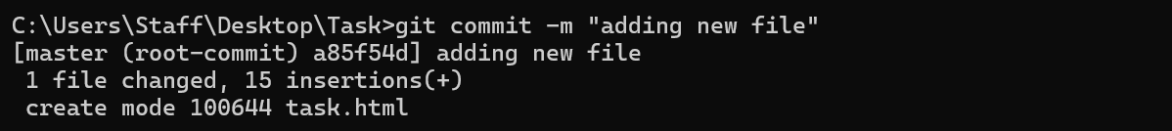

Step 9:

Go back to your Command Line and type the following:

**git remote add origin** [**https://github.com/yourusername/my-website.git**](https://github.com/yourusername/my-website.git)

Replace yourusername with your GitHub username and my-website with the name of your GitHub repository.



Step 10:

The command git **push -u origin main** is used to **push your local main branch to the remote repository (origin)** and set it as the upstream branch

Step 11:

Go to your GitHub Repository:

Open your web browser and navigate to your GitHub repository (e.g., https://github.com/yourusername/my-website).

You should see your website files there!

**OUTCOME:**

1. Successfully initialize a Git repository in your local static website folder.

2. Track changes made to your website files (HTML, CSS, etc.) using Git version control.

3. Understand the basic Git commands (git init, git add, git commit) for version control.

4. Commit your changes locally with a descriptive commit message.

5. Gain hands-on experience with Git and how it helps manage and track website file changes