**Placement Empowerment Program**

***Cloud Computing and DevOps Centre***

**TASK-4** Create a Simple Backup Script: Create a script that backs up your entire Git repository to a local folder daily.

Name: VASANTH S Department: CSE



**Introduction 🚀**

Backing up Git repositories is essential to safeguard your work from accidental deletions, hardware failures, or corruption. Automating this process saves time and ensures regular updates without manual effort.

**Overview 🔍**

This solution automates Git repository backups on a Windows machine using a batch script and Task Scheduler. The script pulls the latest changes daily, stores them in a backup directory, and compresses the repository with a timestamped archive for easy organization. This ensures your codebase and version history remain secure and accessible.

**Key Components**

**Batch Script**: A .bat file is used to execute commands such as cloning the repository, pulling updates, and compressing the backup.

**Task Scheduler**: A built-in Windows tool is used to automate the script, ensuring it runs daily without manual intervention.

**Step-by-Step Overview**

Step 1:

Create a folder named GitHub Backup Folder to store your Backup files

Step 2:

Open Notepad and type this script . Make sure that in set REPO_URL give the URL of the repository you want to backup and in set BACK_DIR give the file path of the folder which you created in first step . Then save it as **.bat format** (eg:backup.bat)A screenshot of a computer

Step 3:

Press **Win + R** on your keyboard.

A small "Run" dialog box will pop up.

Type **taskschd.msc** (without quotes) in the Run box.

Press Enter or click OK.This will open the Task Scheduler window.

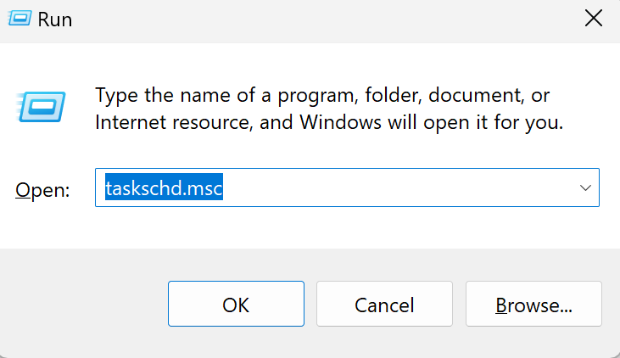

Step 4:

In the Task Scheduler window, look to the right-hand side for a button called **"**Create Basic Task**"**. Click it. A wizard will open to guide you through the setup.

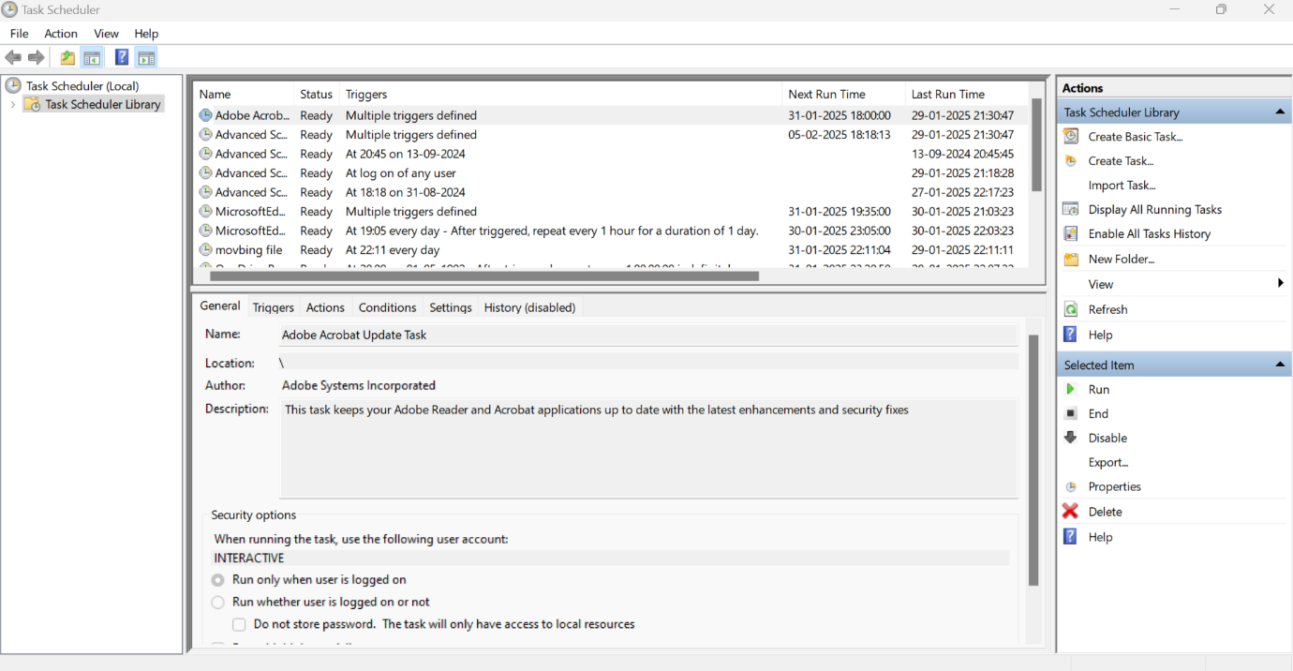

Step 5:

1.Enter a Name for the Task:

For example: "GitRepoBackup".(This can be anything that helps you remember what the task does.)

Optionally, you can add a description like "Backsup files daily".

Click Next to continue.

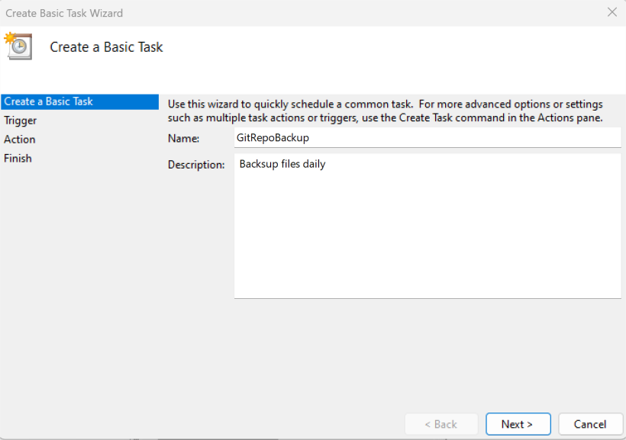

## Step 8:

Set the Action

Now, we tell Task Scheduler what to do when it runs.

Select "Start a Program":

On the "Action" screen, select the option **"**Start a Program**"** and click Next.

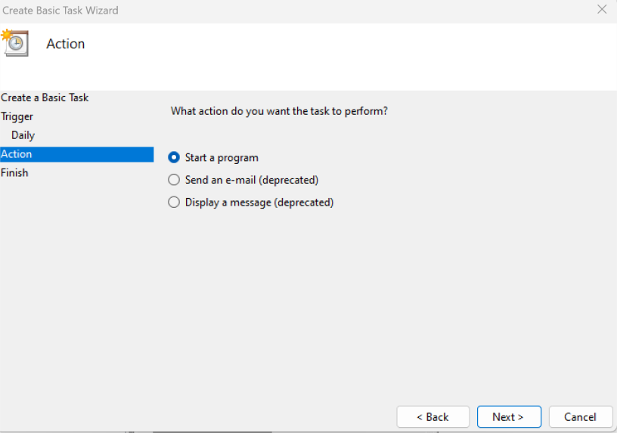

## Step 9:

Point to the Program or Script:

In the Program/script field, click **Browse** and navigate to the location of your .bat file.

Example: If your script is named backup.bat and saved on the desktop, navigate to that file and select it.

Click Next.

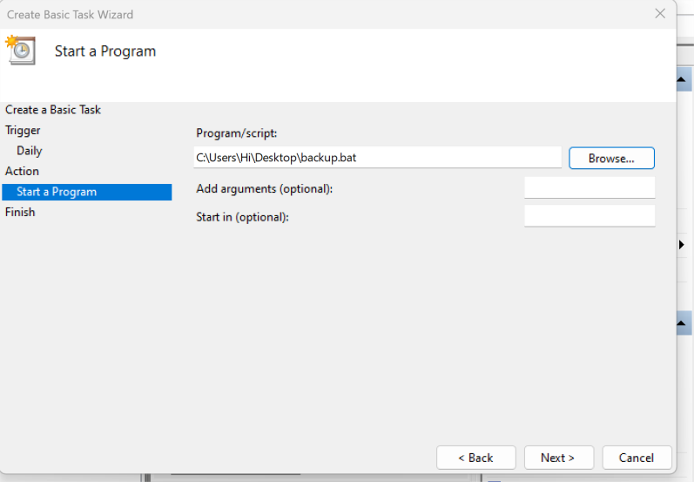

## Step 10:

Review and Finish

Click **Finish** to save and schedule the task.

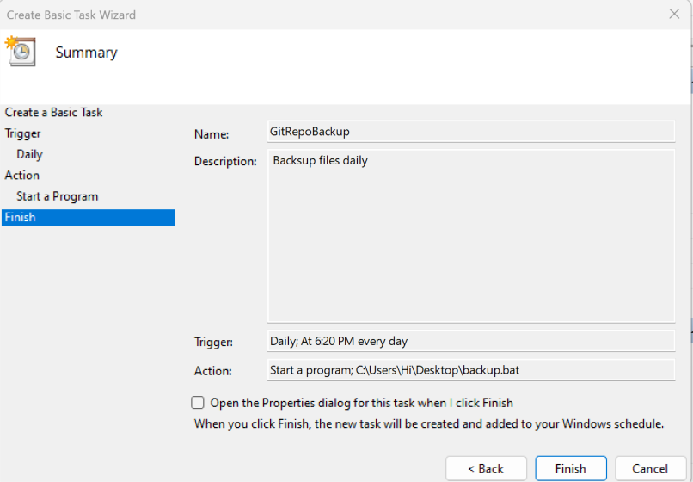

## Screenshot 2025-01-24 175500.pngStep 11:

In Task Scheduler, go to the **Task Scheduler Library** (on the left- hand side).

Find your task (it should have the name you gave it, e.g., "GitRepoBackup").

Right-click the task and select **Run**.

This will manually trigger the task immediately

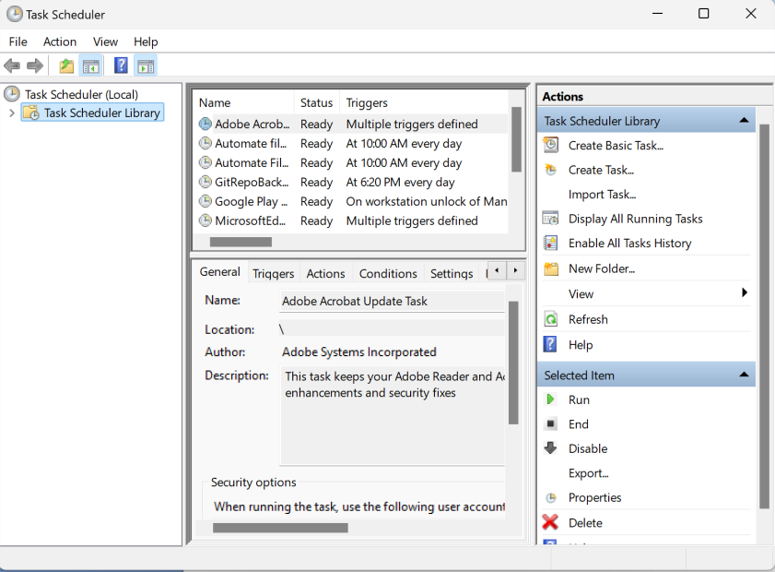

## Step 12:

Now u can see the folder which you created (GitHub Backup Folder) in the first step will now contains the files which is in your repository.

