**Placement Empowerment Program**

***Cloud Computing and DevOps Centre***

**TASK-5**

Create a new branch in your Git repositoryfor testing .Add a new feature and merge it

Name:VASANTH S Department:CSE

**Introduction:**

In this Proof of Concept (POC), Git is used for version control to manage the development workflow. Git allows developers to create separate branches for new features, isolate them from the main branch, and merge them back after completion. This ensures organized and collaborative development

**Overview:**

This POC demonstrates how to:

1. Initialize a Git repository.
2. Create and switch between branches.
3. Commit changes in different branches.
4. Merge feature branches into the main branch.
5. Delete branches after completing the work.

**Objectives:**

1. To initialize and set up a Git repository.
2. To create and manage feature branches (e.g., testing-feature).
3. To demonstrate adding, committing, and merging code.
4. To showcase how to delete branches after their purpose is served.
5. To learn how to resolve merge conflicts if any arise during the process.

# Step-by-Step Overview

## Step 1:

Create a folder and name it (Git_Branching).

## Step 2:

Set the path to the folder created in first step (Git_Branching).



## Step 3:

Initialize Git by typing this command:

**git init**

This command will create a .git folder inside your folder, which tells Git to start tracking your files



## Step 4:

Create a simple file to start the repository:



## Step 5:

Add the File to Git

Tell Git to track this file:



## Step 6:

Save this change in Git with a commit message.

## Step 7:

Create and switch to a new branch called testing-feature.

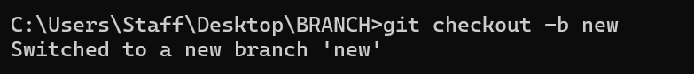

## Step 8:

Let’s add a new file for our feature:



## Step 9:

Now, stage the changes



## Step 10:

Commit the changes:

## Step 11:

Switch to the master Branch.

## Step 12:

Merge Changes from testing-feature to master.

## Step 13:

Once the merge is done, you can delete the testing-feature branch

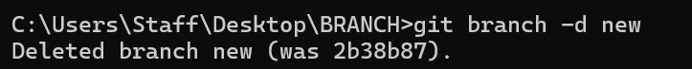

## Step 14:

Now, check the files in the folder:

