**Placement Empowerment Program**

***Cloud Computing and DevOps Centre***

**TASK-7** Deploy your static website using Github Pages: Host your local Git repository’s static website directly using Github pages

Name: VASANTH S Department:CSE

**Introduction**

GitHub Pages is a static site hosting service designed to publish your projects directly from a GitHub repository. It allows developers to showcase their work, create personal websites, or host documentation in an efficient, free, and straightforward way.

**Step-by-Step Overview**

Step 1:

**Create a New Repository**:

Once you're logged in, click the green **"New"** button on the top- right of your GitHub homepage to create a new repository.

Give your repository a name, for example, my-static-website. Leave the other settings as default, and click **"Create repository"**.

Step 2:

Create a folder (e.g., my-static-website) where you’ll keep all your website files.

Inside that folder, create the main file for your website, called

**index.html**.

Here’s a simple example of what to put in your index.html:

Step 3:

Open **Command Prompt** and navigate to the folder where your index.html file is saved. Use the cd command to navigate.



Step 4:

Initialize a Git repository by running:



Step 5:

Add your website files to the repository:



Step 6:

Save the changes in Git with a commit message:

Step 7:

Go to your GitHub repository (the one you created earlier). Copy the **repository URL**:

In your Command Prompt, link your local repository to the GitHub repository



Step 8:

Push your files to GitHub:

Step 9:

**Enable GitHub Pages**

1. Go to your repository on GitHub.
2. Click on the **Settings** tab (it’s near the top, next to Code, Issues, etc.).
3. Scroll down to the **Pages** section (on the left menu, under "Code and automation").
4. Under **Source**, select:
   * **Branch**: main
   * **Folder**: / (root)
5. Click **Save**

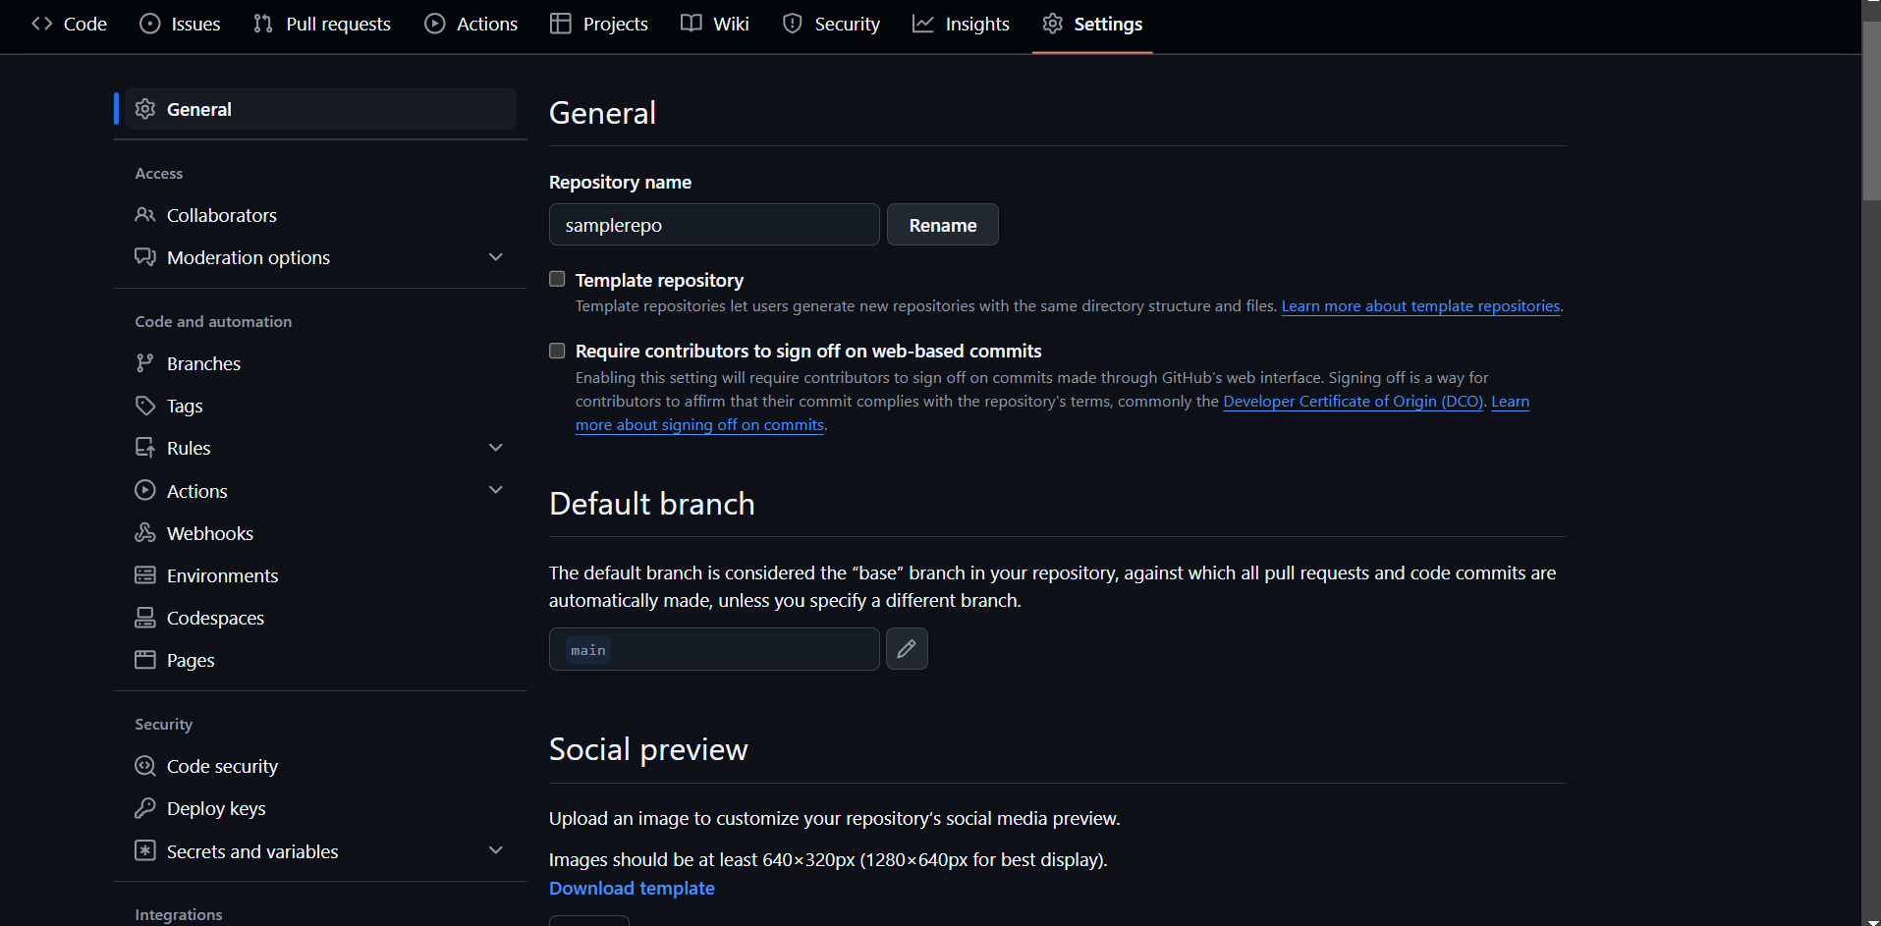

Step 10:

**Access Your Website**

Wait a few minutes for GitHub Pages to deploy your site. Visit your website at:

https://<your-username>.github.io/<your-repository>

