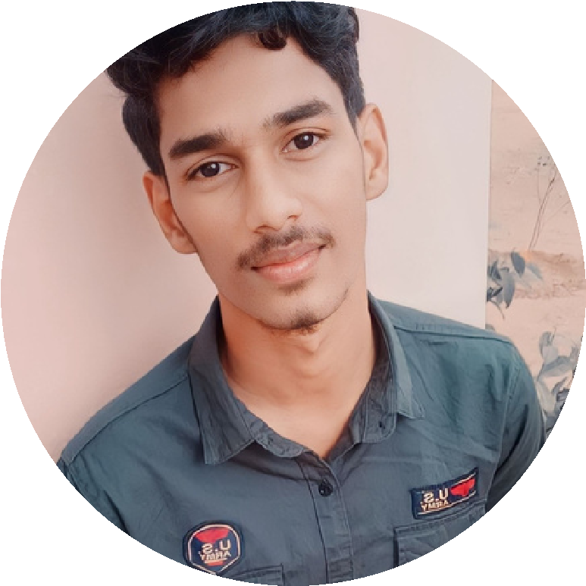

**PROFILE**

information technolgy

student.

I consider my self a

responsible and orderly

person.

I am looking foward for

my first work

experience.

**CONTACT ME**

9585478095

vasanth2004a@gmail.com

28

,lucky nagar main

road,pitchampalaya

m pudur,

tirupur.

**SKILLS**

video editor

photoshop

programming

desingner.

**EDUCATION**

**BHARATHIAR UNIVERSITY**

*cherraan’s arts science college,*

*Kangayam.*

*2021-2024*

**LANGUAGE**

Native Tamil.

Advanced English.

**COMPUTER SKILLS**

python

**A.VASANTH**

*B.sc information Technology*

java

microsoft excel