**DERIVE THE CLASS DIAGRAM FOR**

**FOREGIN TRADING SYSTEM**

Ex. No: 5

Date:

**Problem Statement**

Derive the class diagram for the Foreign trading system.

**Design approach**

**Class Diagram**

A class diagram is a UML visualization tool showing the structure of classes in a system, with rectangles representing classes, compartments displaying their attributes and methods, and lines indicating associations between classes. These diagrams aid in software design by illustrating relationships and structures, helping developers understand and plan complex systems.

**Objective**

The objective for the foreign trading system is to create an advanced tool that optimizes international market navigation, facilitates smooth cross-border transactions, minimizes risks, and maximizes returns. It aims to leverage technology and data insights to identify opportunities, adapt to regulations. Ultimately, it will be a key driver of sustainable growth and competitive advantage in the international trade landscape.

**Class Notation**

class notation is a graphical representation of classes and their relationships in object-oriented modelling**.**

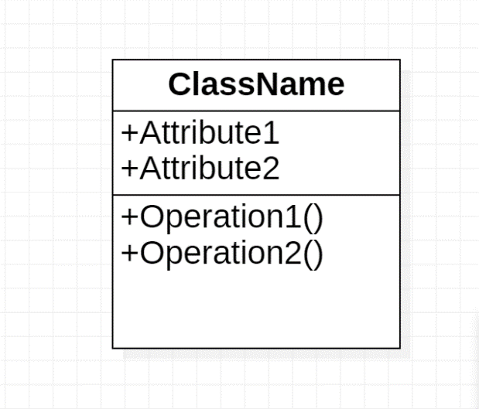

Figure 5.1 class notation

**Components**

* **Aggregation:** Aggregation is a specialized form of association that represents a  
  “whole-part” relationship.

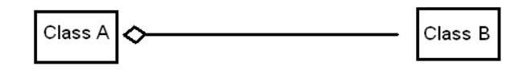

Figure 5.2 Aggregation

* **Association:** Represent relationship between the actor and a use case.

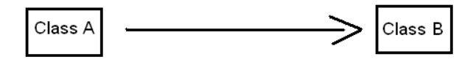

Figure 5.3 Association

* **Generalization:** Depicts a relationship between a base use case and a more specialized or specific use case.

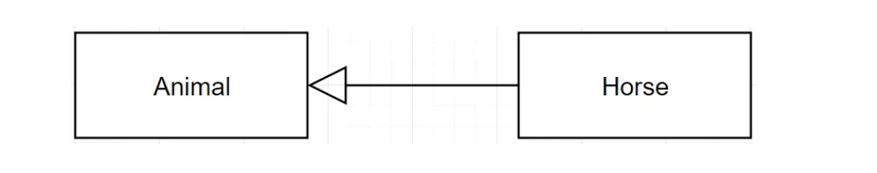

Figure 5.4 Generalization

* **Composition:** Composition is a stronger form of aggregation, indicating a more  
  significant ownership or dependency relationship.

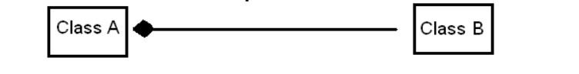

Figure 5.5 Composition

**Rules**

* Compliance Regulations: Ensure adherence to relevant laws and regulations, from import/export controls to international trade agreements.
* Transaction Procedures: Define clear steps for initiating, processing, and completing trades, including documentation and logistics.
* Risk Management: Implement protocols to identify and mitigate risks like currency fluctuations and geopolitical instability.
* Market Analysis: Establish methods for researching and evaluating market trends, potential partners, and competition.
* Trade Finance: Develop guidelines for financing options to facilitate transactions and manage financial risks effectively.
* Compliance Monitoring: Set up mechanisms to monitor and enforce adherence to regulations through audits and controls.
* Dispute Resolution: Define procedures for resolving disputes promptly to minimize disruptions and maintain relationships.
* Data Security: Establish protocols to safeguard sensitive information exchanged during transactions, ensuring cybersecurity and data privacy.
* Ethical Standards: Promote fair labor practices, environmental sustainability, and anti-corruption measures throughout operations.
* Continuous Improvement: Foster a culture of ongoing feedback, evaluation, and enhancement to optimize system efficiency over time.

**Class diagram**

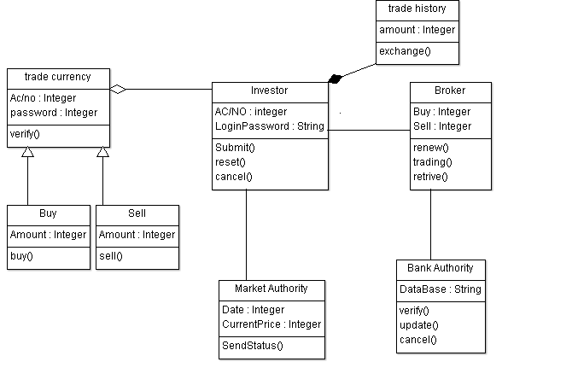

Figure 5.6 class diagram

**Conclusion:**

The identification of class diagram for Foreign trading system has identified and verified successfully.