**Write queries for the following**

1. Create the Customer table with the following columns.

CustomerId Number(5)

Cust_Name varchar2(20)

Address1 Varchar2(30)

Address2 Varchar2(30)

create table Customer (

CustomerId int ,

Cust_Name varchar(20),

Address1 varchar(30),

Address2 varchar(30)

);

insert into Customer values(11,'bopathy','metupalaym','chennai'),

(12,'prakash','taramani','chennai'), (13,'tilakvarma','pettaiyapuram','chennai');

select * from Customer;

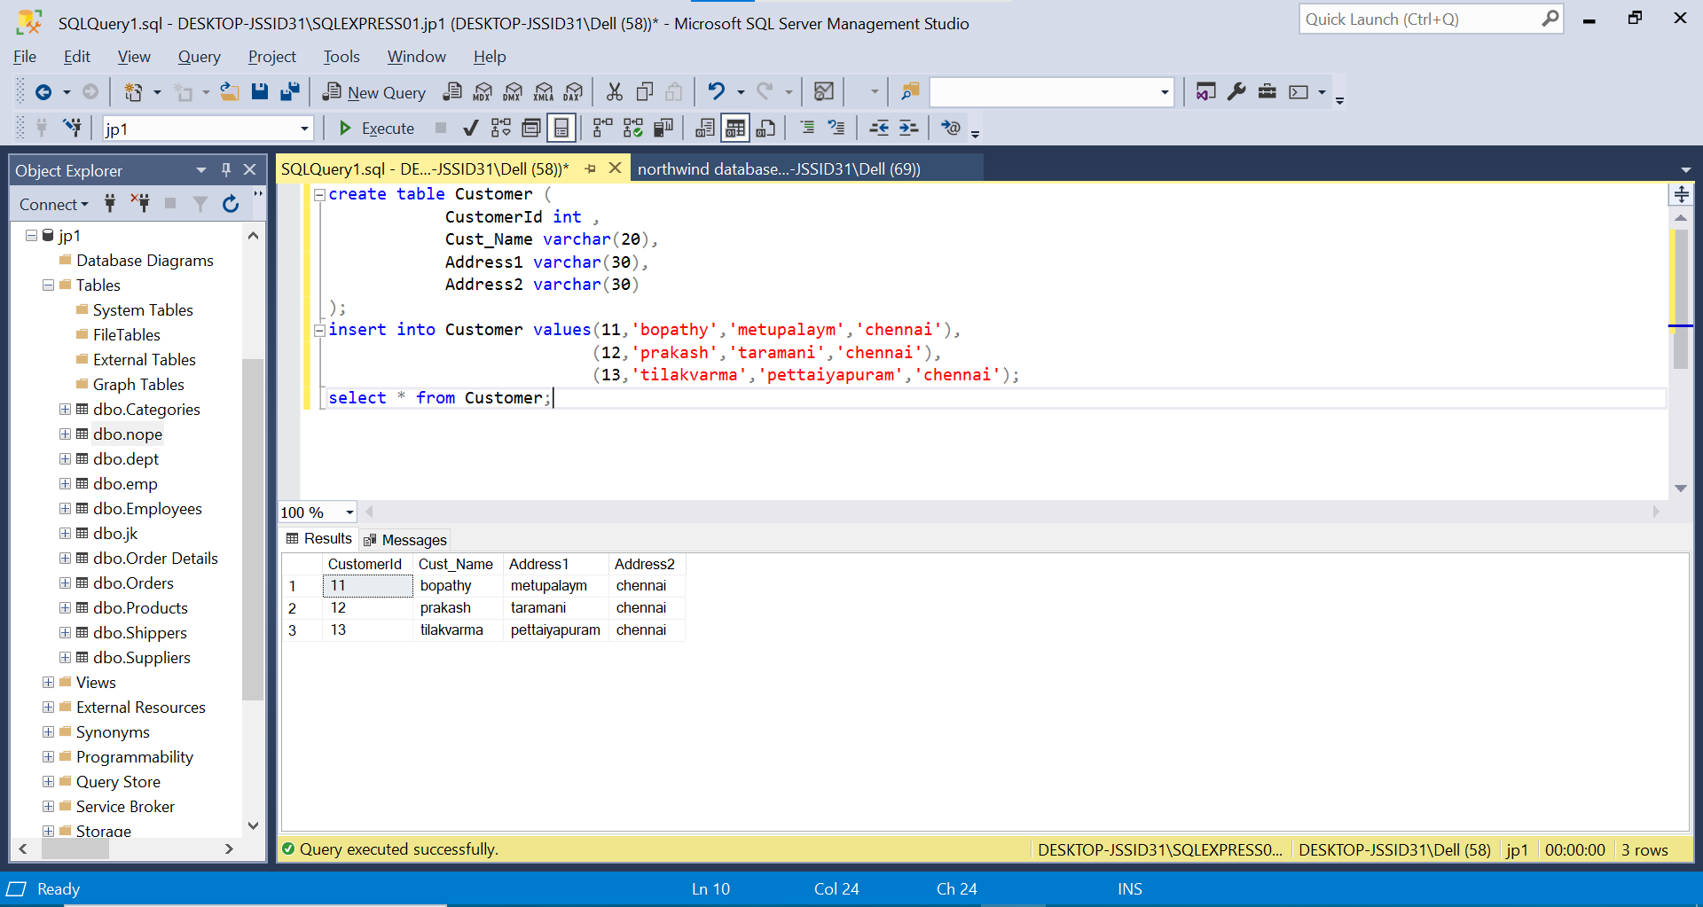

1. Modify the Customer table Cust_Name column of datatype with Varchar2(30), rename the column to CustomerName and it should not accept Nulls.

select * from Customer;

alter table customer

alter column Cust_Name varchar(30) not null;

exec sp_rename 'dbo.Customer.Cust_Name', 'CustomerName', 'COLUMN';

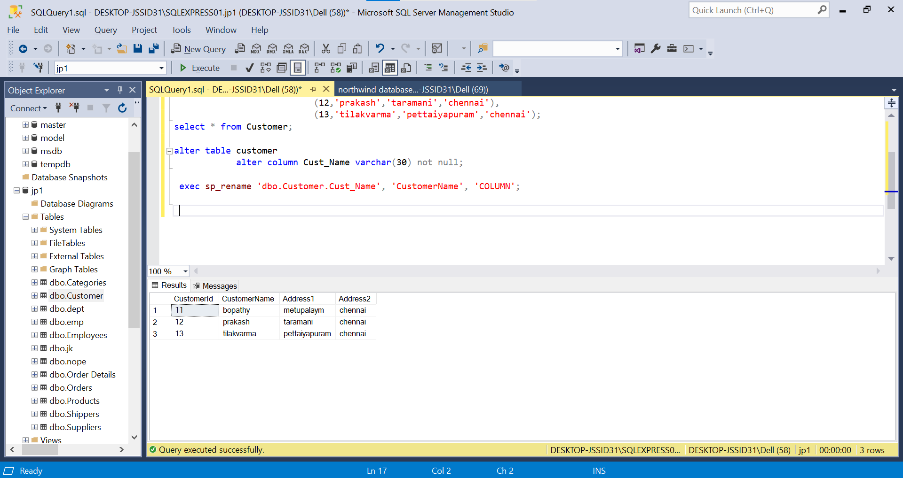

1. Add the following Columns to the Customer table.

Gender Varchar2(1)

Age Number(3)

PhoneNo Number(10)

alter table Customer

add Gender Varchar(1),

Age int,

PhoneNo int;

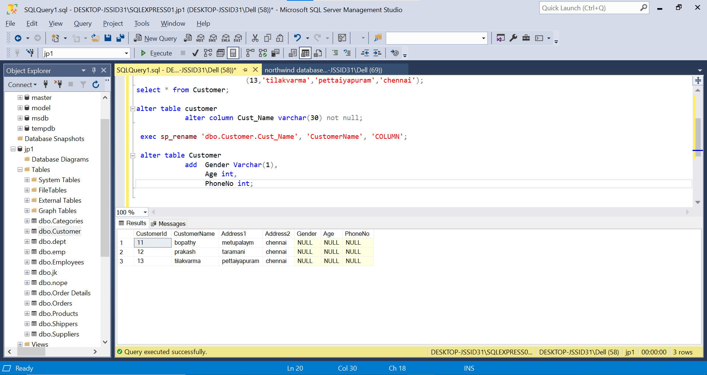

1. Add the below records to the Customer table:

(1000, ‘Allen’, ‘#115 Chicago’, ‘#115 Chicago’, ‘M’, ‘25, 7878776’)

1000, Allen, #115 Chicago, #115 Chicago, M, 25, 7878776

1001, George, #116 France, #116 France, M, 25, 434524

1002, Becker, #114 New York, #114 New York, M, 45, 431525

insert into customer values(1000, 'Allen','#115Chicago','#115Chicago','M',25,7878776),

(1001, 'George', '#116 France', '#116 France', 'M', 25, 434524),(1002, 'Becker', '#114 New York', '#114 New York', 'M', 45, 431525);

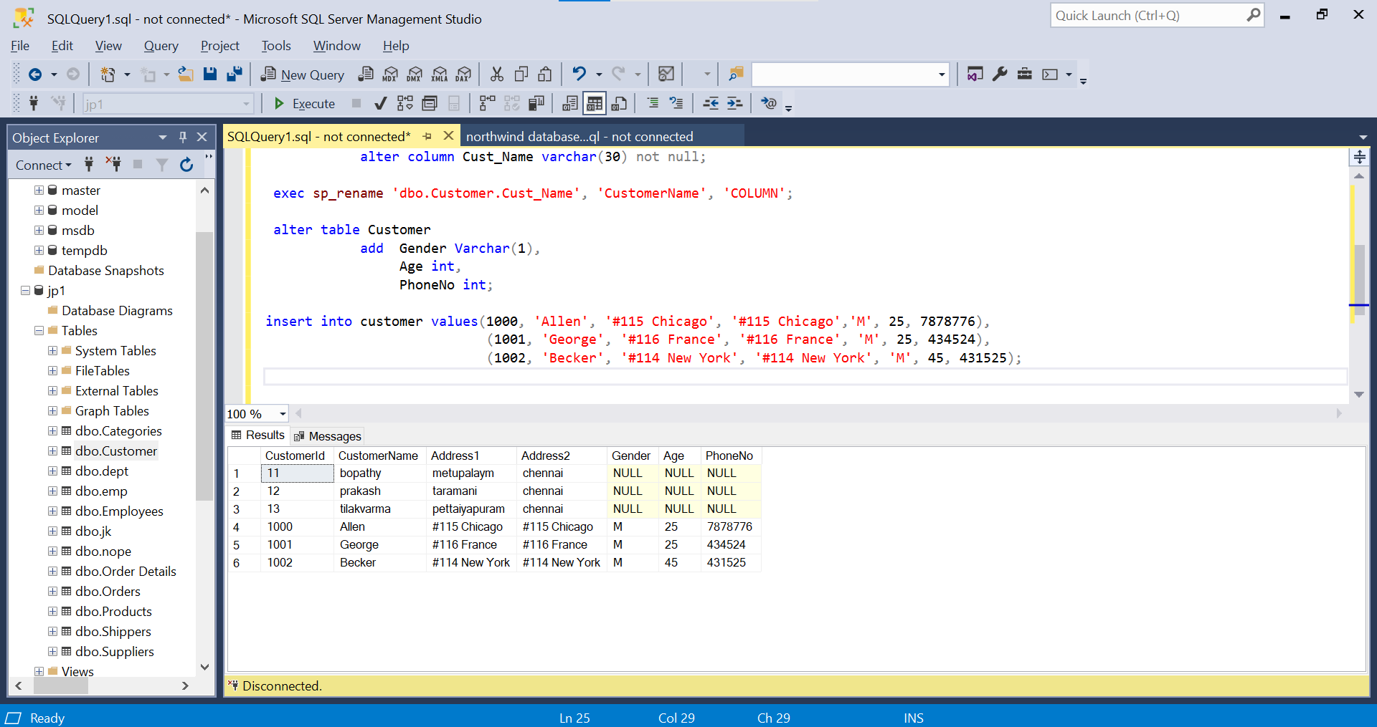

1. Add the Primary key constraint for Customerld with the name Custld_Prim.

alter table customer alter column CustomerId int not null;

alter table Customer add constraint CustId_Prim primary key (CustomerId);

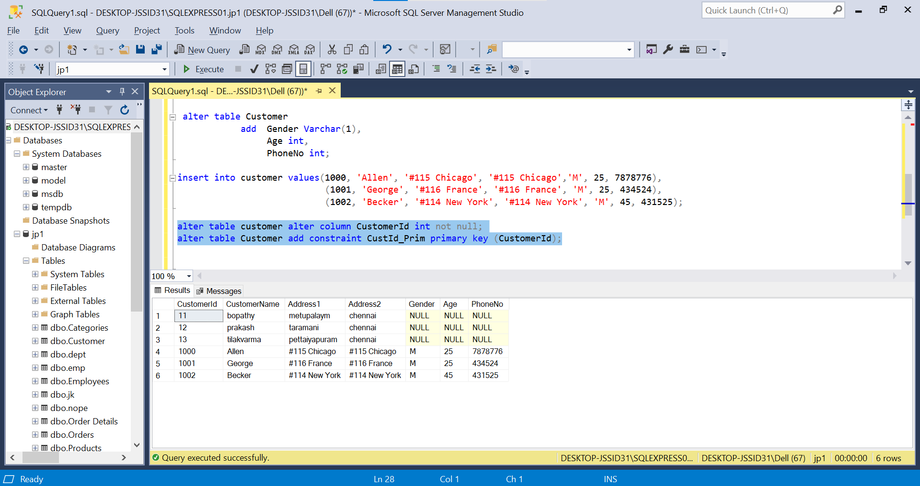

1. a) Disable the constraint on CustomerId, and insert the following data:

1002, Becker, #114 New York, #114 New york , M, 45, 431525

1003, Nanapatekar, #115 India, #115 India , M, 45, 431525

b) Drop the constraint Custld_Prim on CustomerId and insert the following Data.

alter table customer drop constraint CustId_prim ;

insert into customer values(1002, 'Becker', '#114 New York', '#114 New york' , 'M', 45, 431525),(1003, 'Nanapatekar', '#115 India', '#115 India' , 'M', 45, 431525);

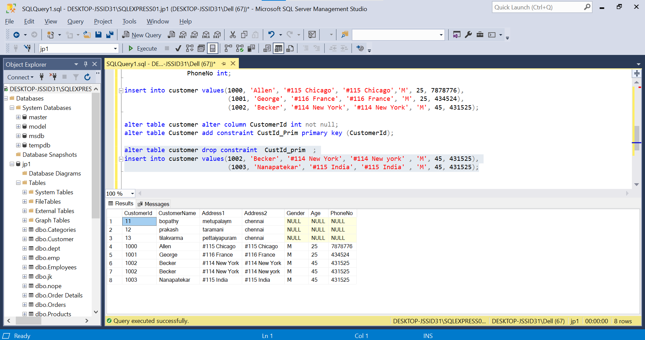

1. Alter Customer table, drop constraint Custid_Prim.

1002, Becker, #114 New York, #114 New york , M, 45, 431525, 15000.50

1003, Nanapatekar, #115 India, #115 India , M, 45, 431525, 20000.50

alter table customer add amount float;

update customer set amount=15000.50 where CustomerId=1002;

update customer set amount=20000.50 where CustomerId=1003; 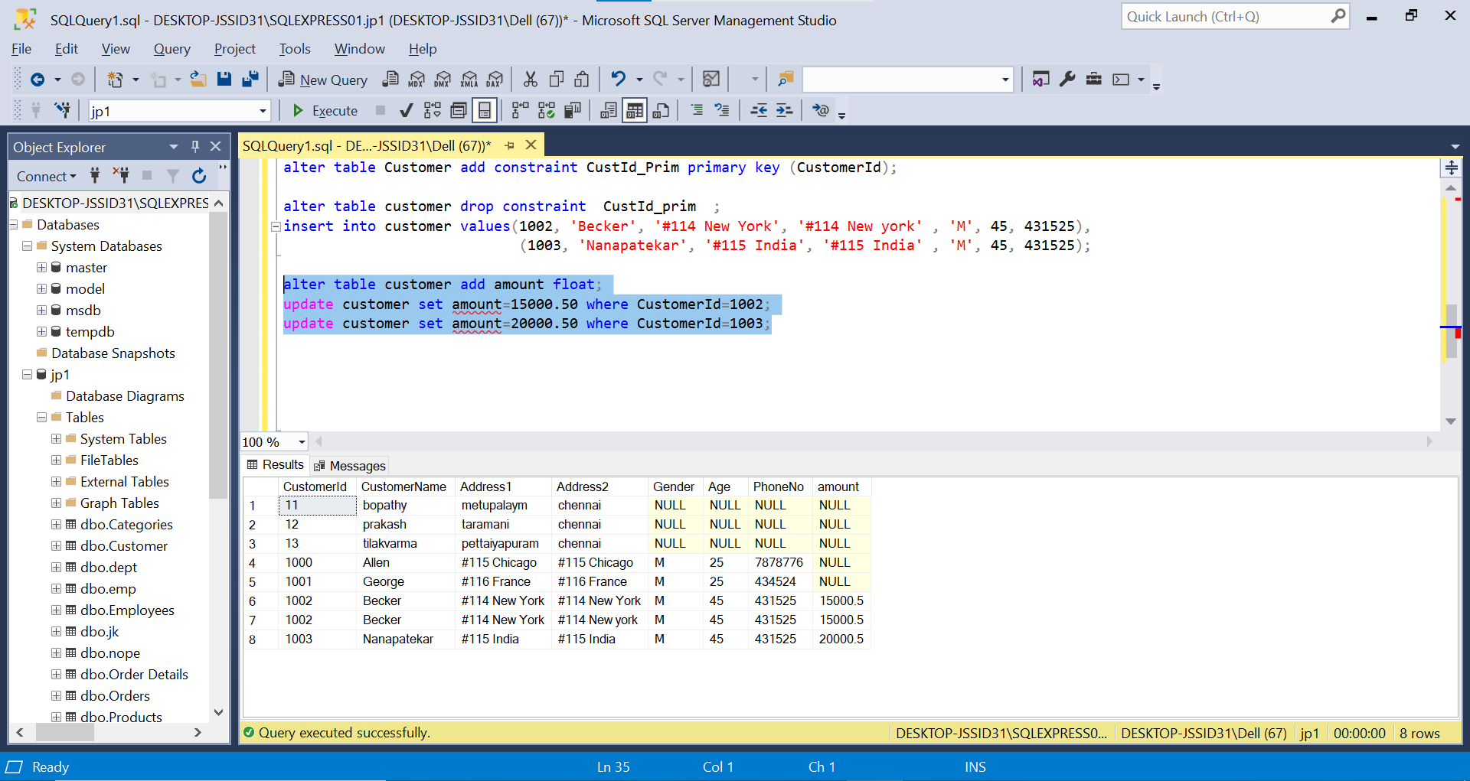

1. Create Employee table with same structure as EMP table.

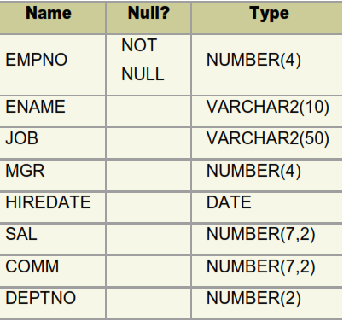

create table Employee (

empno int not null,

ename nvarchar(10),

job nvarchar(50),

mgr int,

hiredate date,

sal numeric(7, 2),

comm numeric(7, 2),

deptno int

);

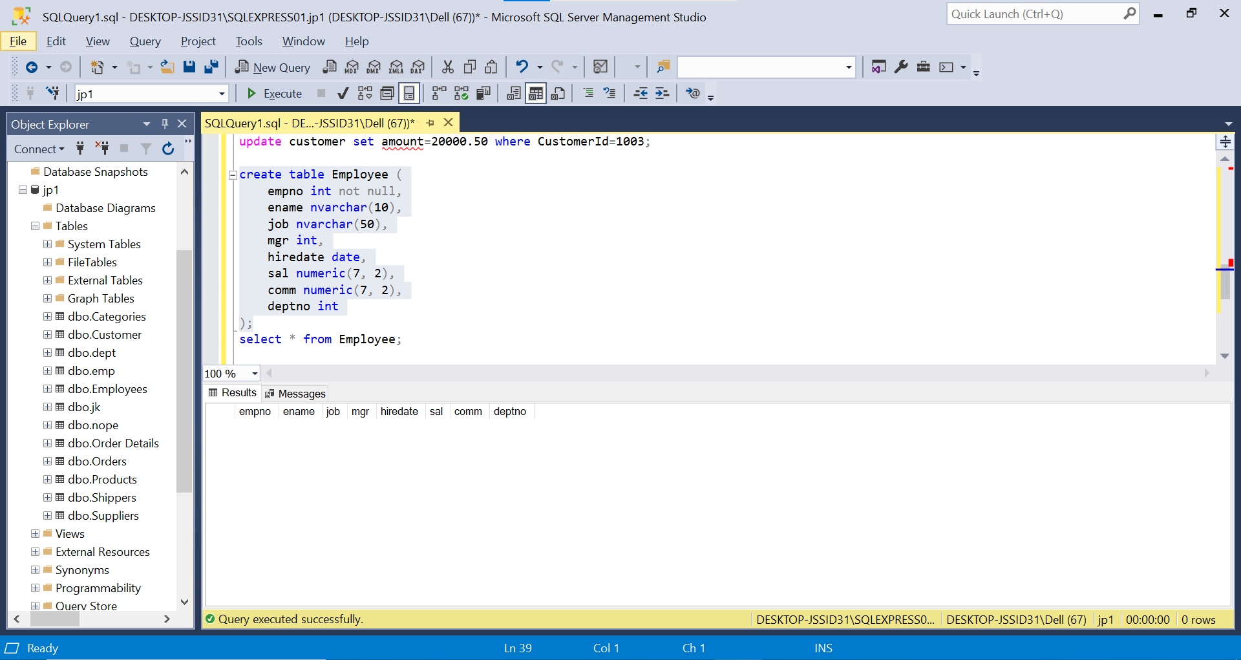

1. Insert the following data in the above table

insert into Employee (EMPNO,ENAME,SAL,DEPTNo)values

(7369,'SMITH',800,20),

(7499,'ALLEN',1600,30),

(7521,'WARD',1250,30),

(7566,'JONES',2975,20),

(7654,'MARTIN',1250,30),

(7698,'BLAKE',2850,30),

(7782,'CLARK',2450,10),

(7788,'SCOTT',3000,20),

(7839,'KING',5000,10),

(7844,'TURNER',1500,30),

(7876,'ADAMS',1100,20),

(7900,'JAMES',950,30),

(7902,'FORD',3000,20),

(7934,',MILLER',1300,10);

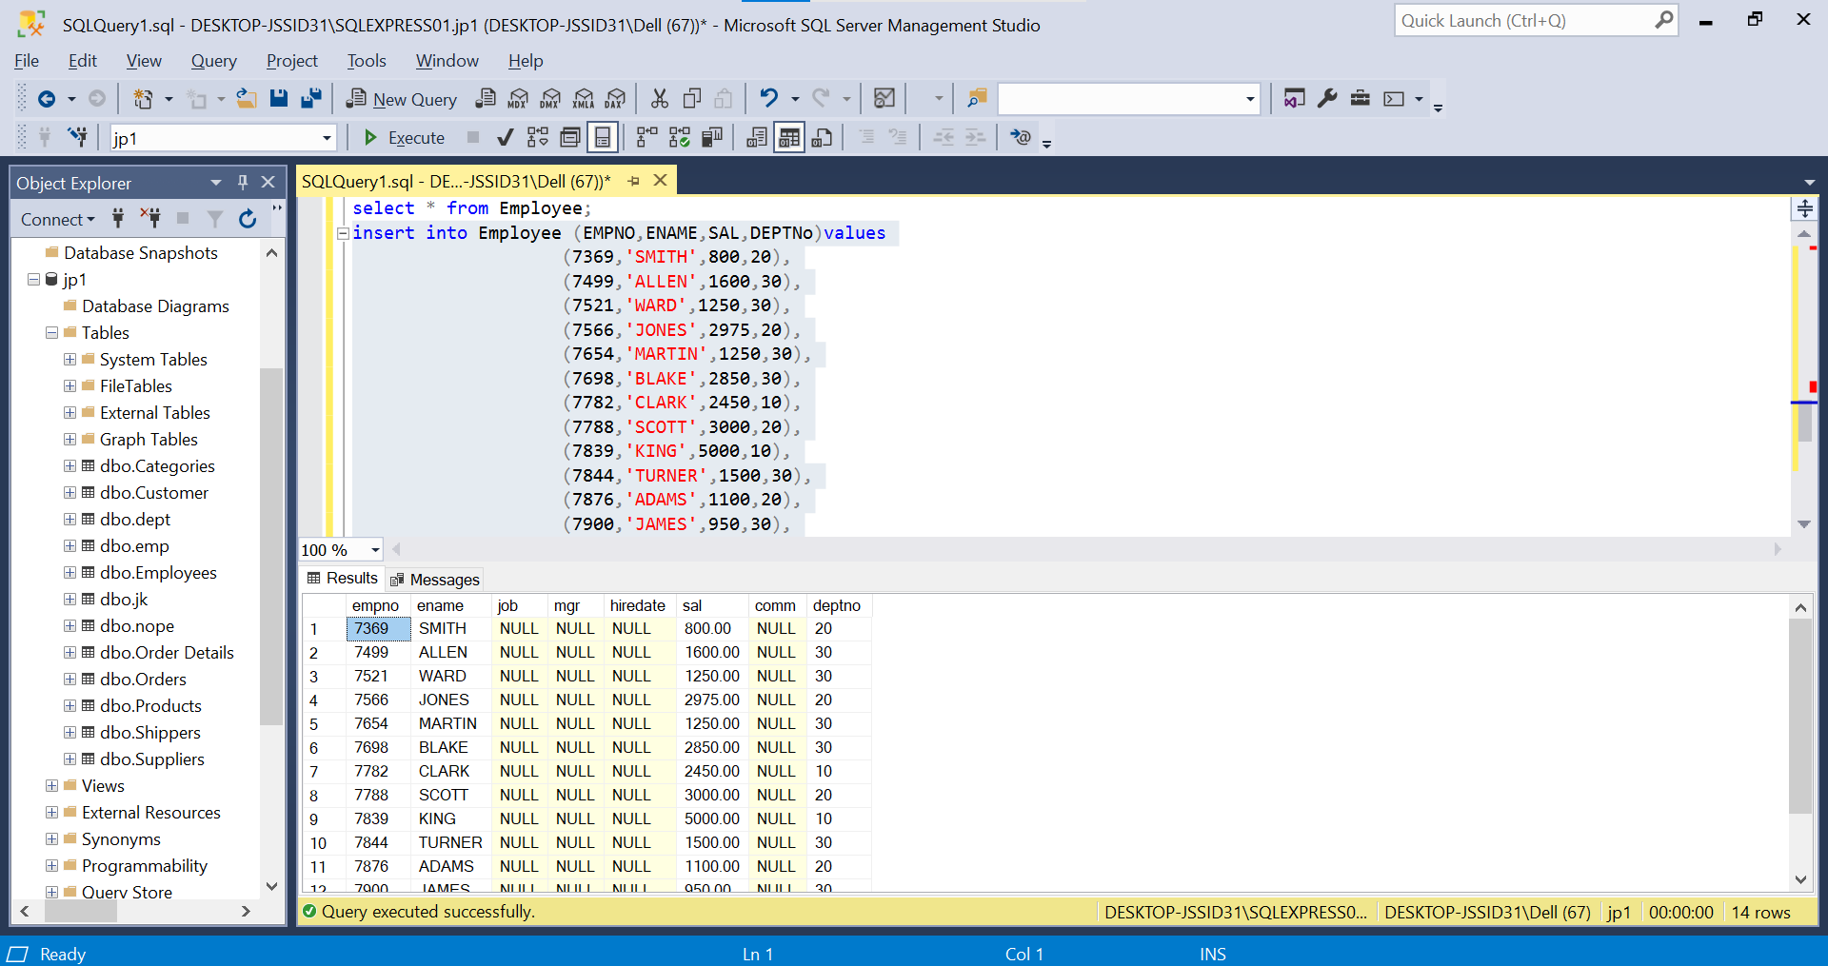

1. Write a query to populate Employee table using EMP table’s empno, ename, sal,, deptno columns.

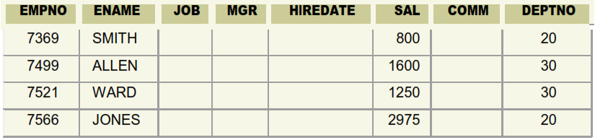

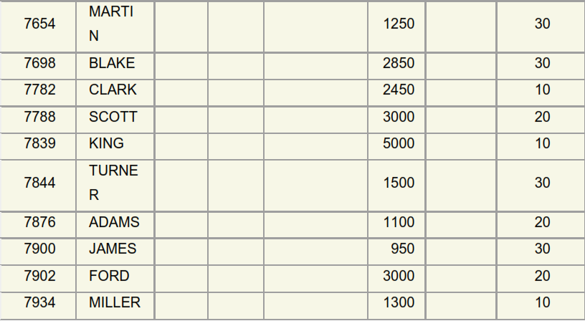

Select * from Employee;



1. a. Write a query to change the job and deptno of employee whose empno is 7698 to the job and deptno of employee having empno 7788.

b. Write a query to change the deptno of employee with empno 7788 to that of employee having empno 7698.

A). update employee set job=(select job from employee where empno=7788),

deptno=(select deptno from employee where empno=7788)

where empno=7698; 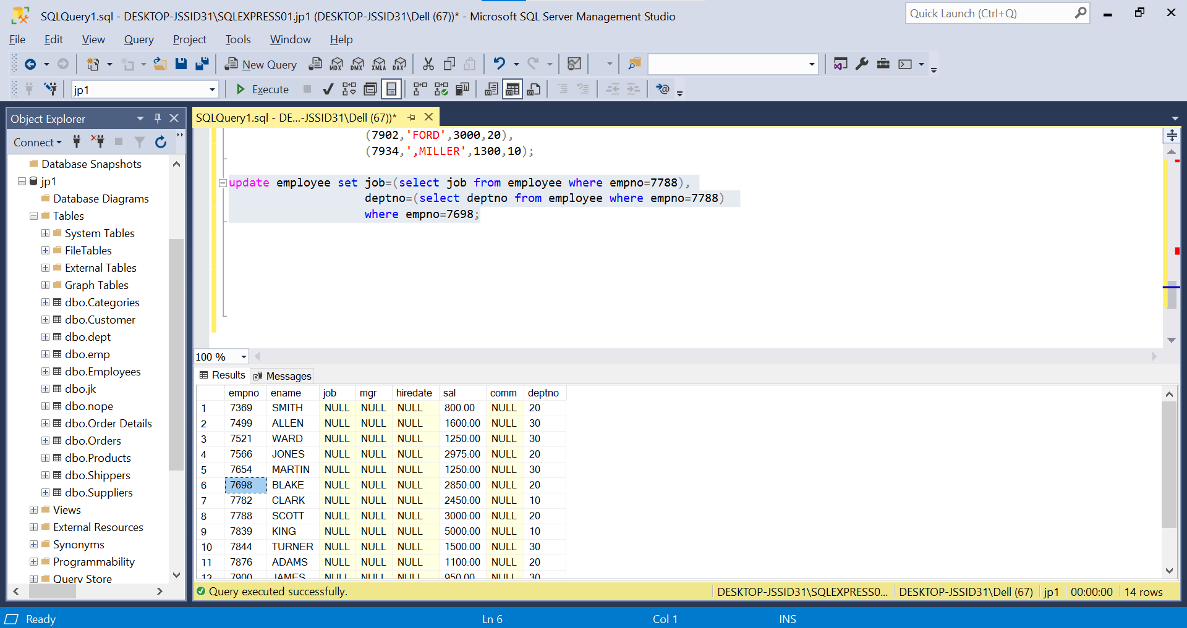

B). update employee set deptno=(select deptno from employee where empno=7698) where empno=7788;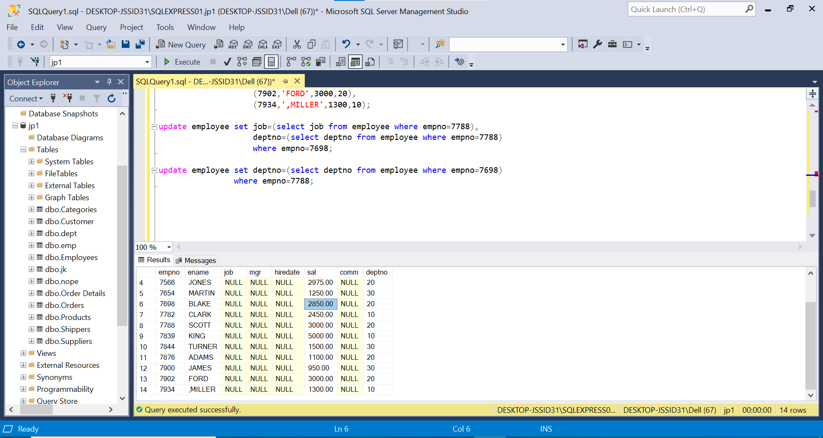

1. Delete the details of department whose department name is ‘SALES’.

alter table Employee add departmentname varchar(10);

update Employee set departmentname= 'sales' where DEPTNo=30;

update Employee set departmentname= 'sales' where DEPTNo=20;

delete from employee where departmentname like '%sales%';

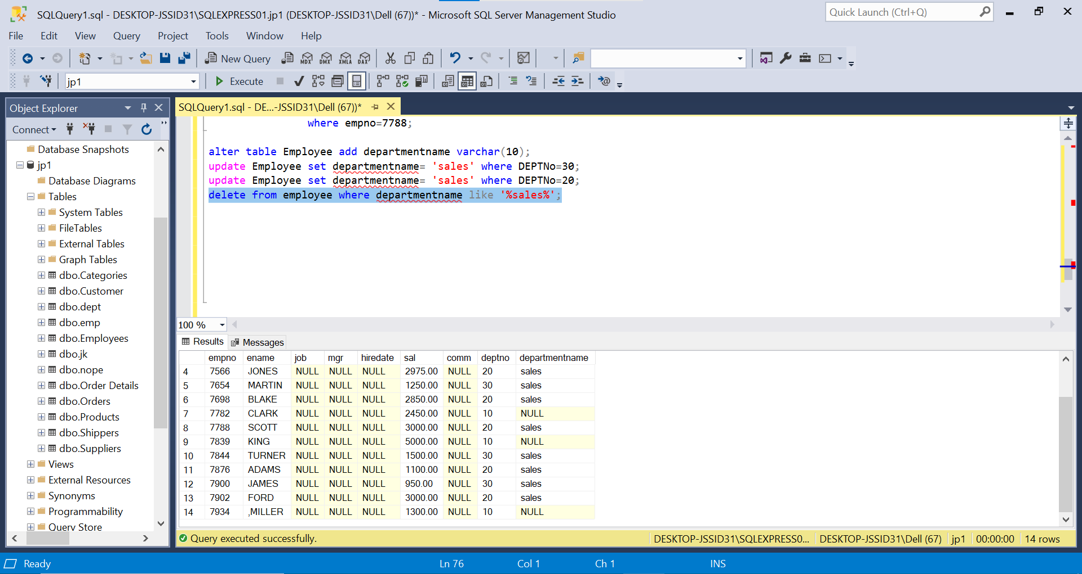 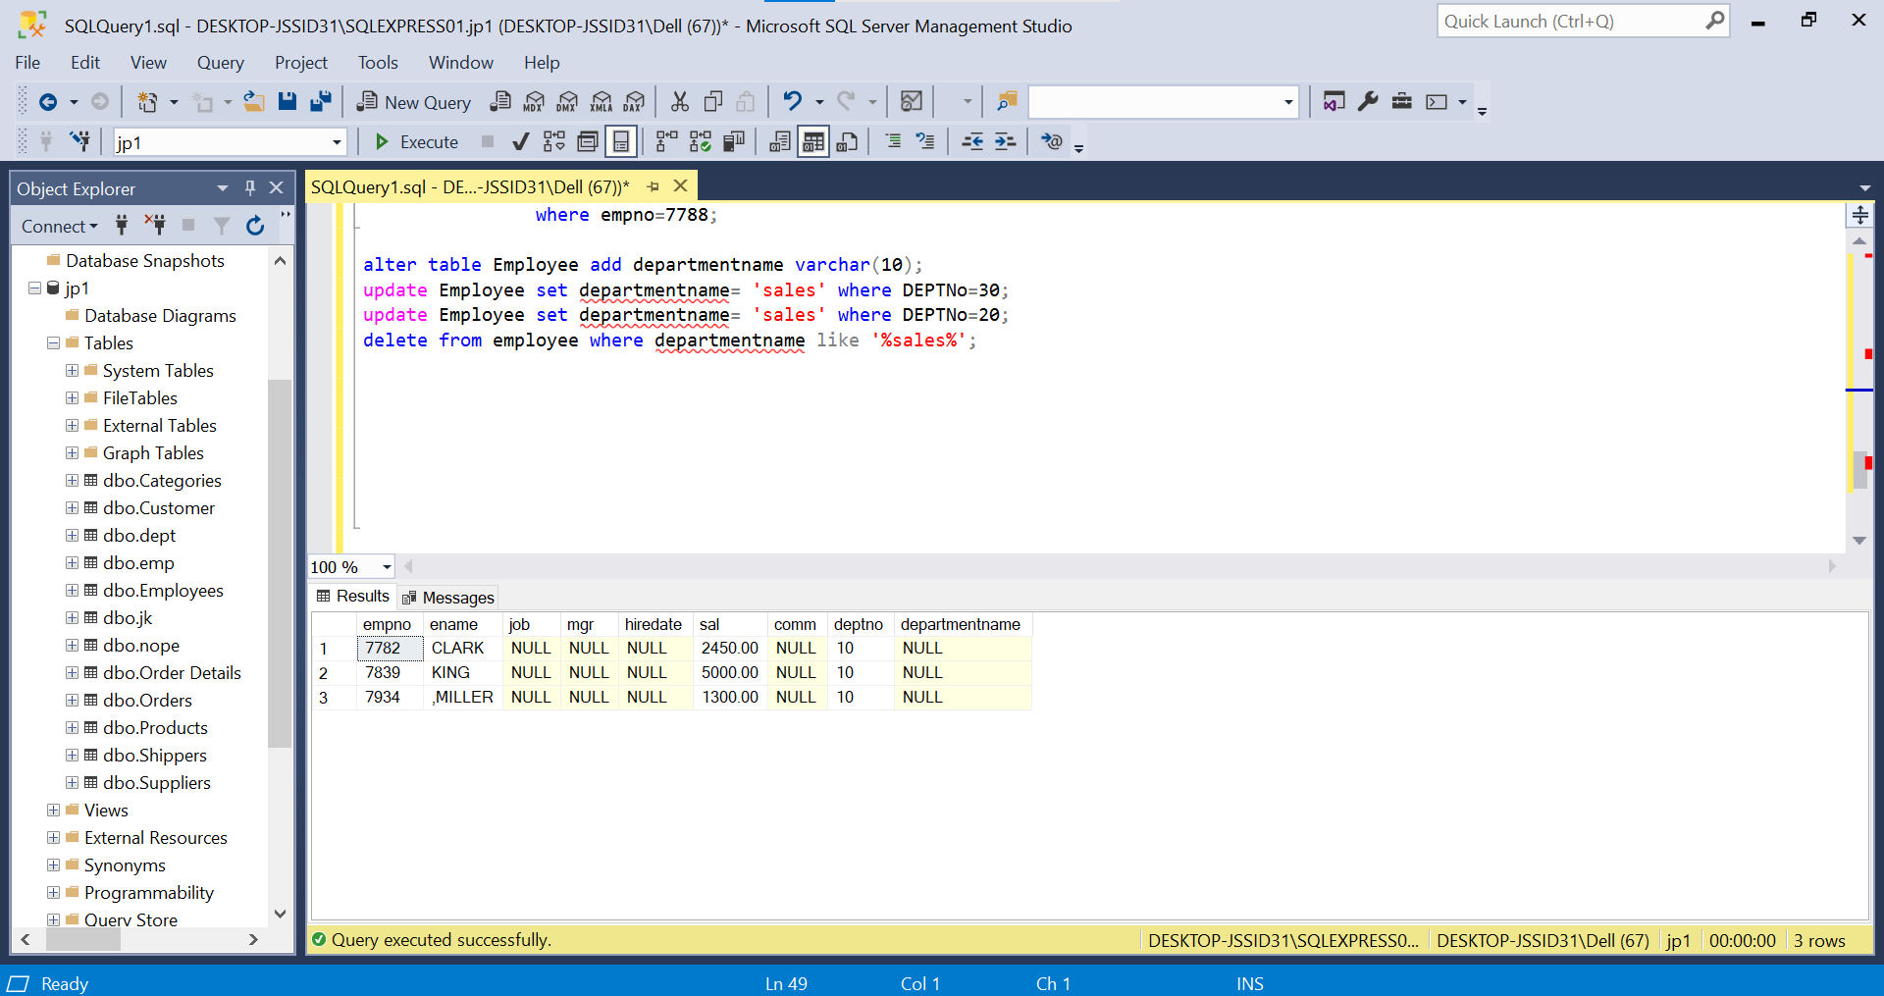

1. Insert the following rows to the Employee table

1000,Allen, Clerk,1001,12-jan-01, 3000, 2,10

1001,George, analyst, null, 08 Sep 92, 5000,0, 10

1002, Becker, Manager, 1000, 4 Nov 92, 2800,4, 20

1003, 'Bill', Clerk, 1002, 4 Nov 92,3000, 0, 20

alter table Employee drop column departmentname;

insert into Employee values

(1000, 'Allen', 'Clerk', 1001, '2001-01-12', 3000, 2, 10),

(1001, 'George', 'analyst', null, '1992-09-08', 5000, 0, 10),

(1002, 'Becker', 'Manager', 1000, '1992-11-04', 2800, 4, 20),

(1003, 'Bill', 'Clerk', 1002, '1992-11-04', 3000, 0, 20),

(1004, 'Gates', 'Sales', 1002, '1992-11-04', 3000, 0, 20);

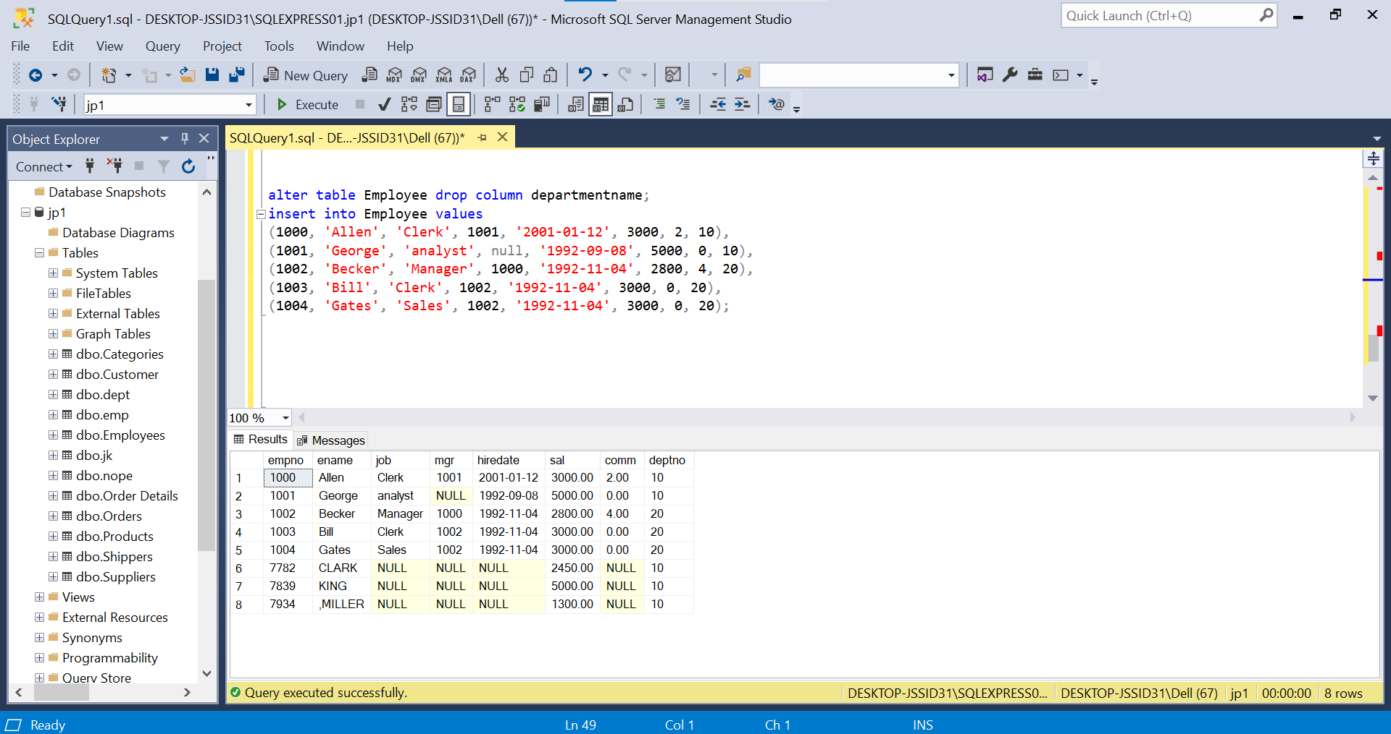

1. Create a Project Table with below structure

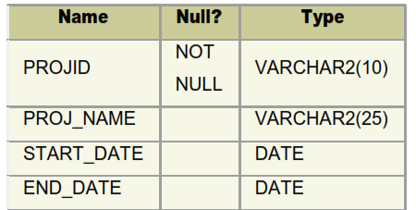

Create table Project (

PROJID varchar(10) not null,

PROJ_NAME varchar(25),

START_DATE date,

END_DATE date

);

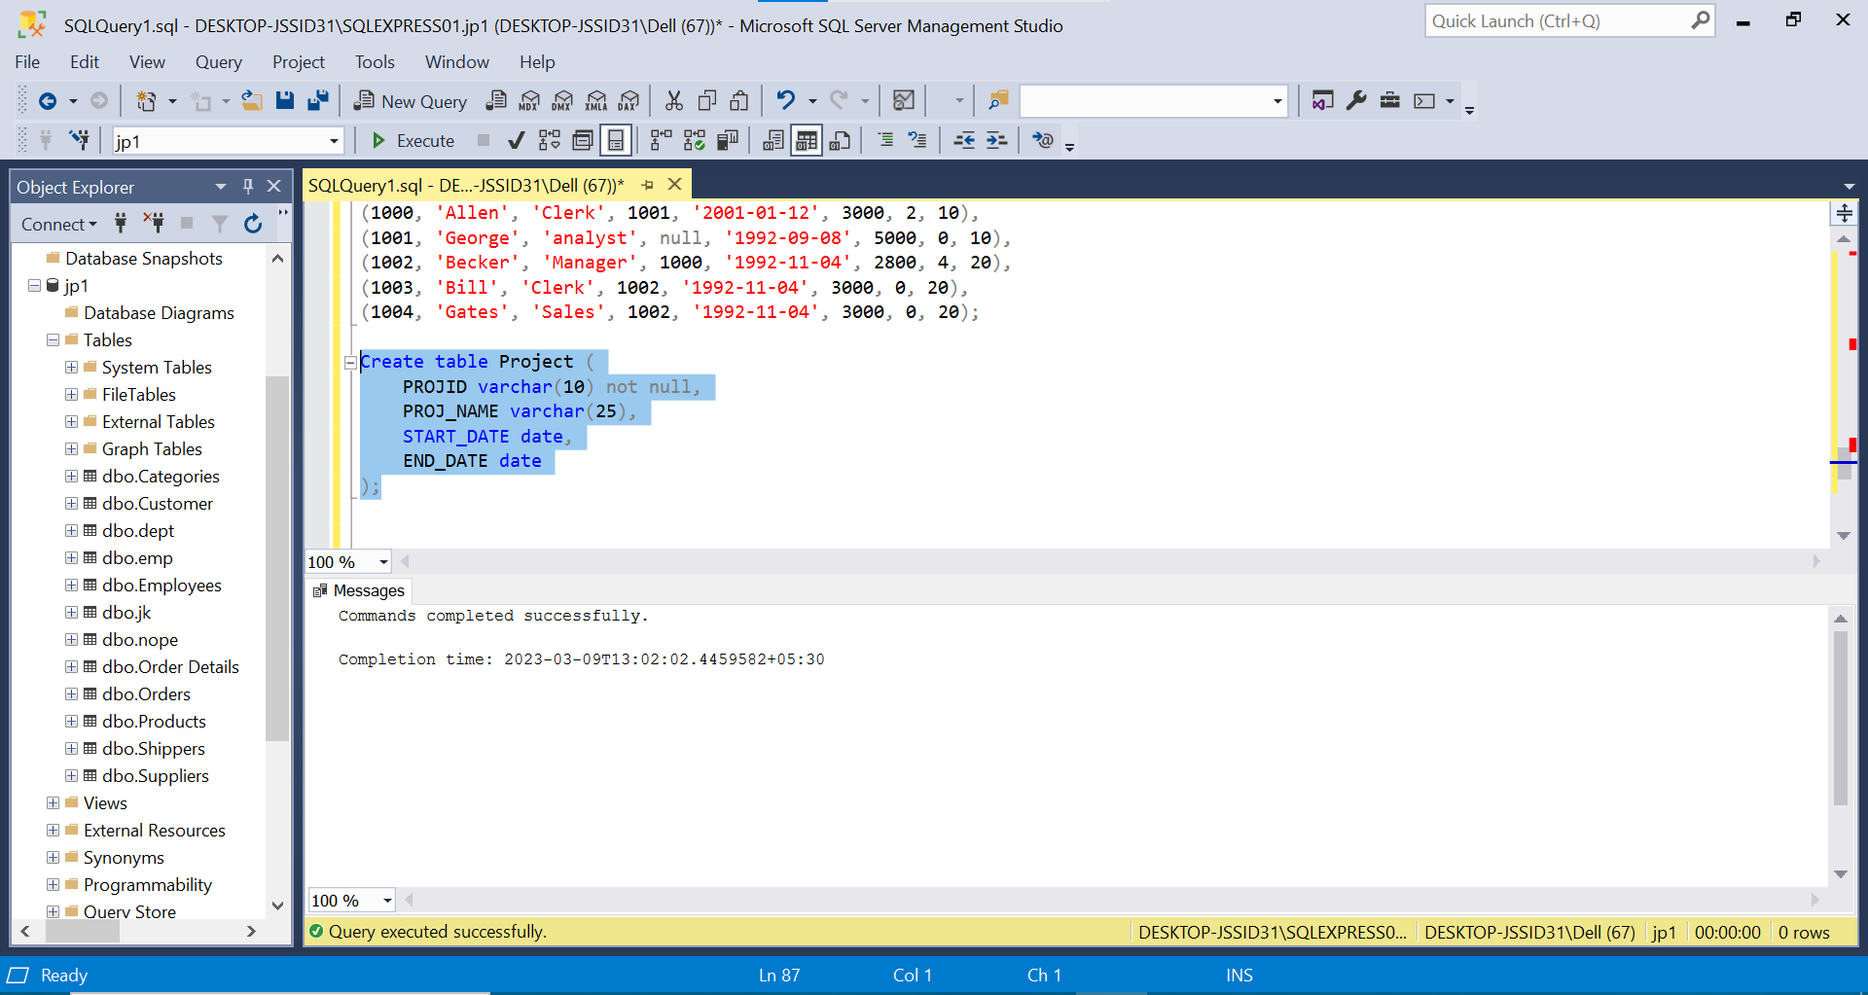

1. Insert Records into Project Table as deemed necessary and relevant

insert into Project values('prj1', 'railway system', '2023-05-01', '2023-10-01'),

('prj2', 'airlines system', '2023-07-12', '2023-12-12'),

('prj3', 'reservation system', '2023-05-01', '2023-10-01'),

('prj4', 'tour system', '2023-07-12', '2023-12-12');

