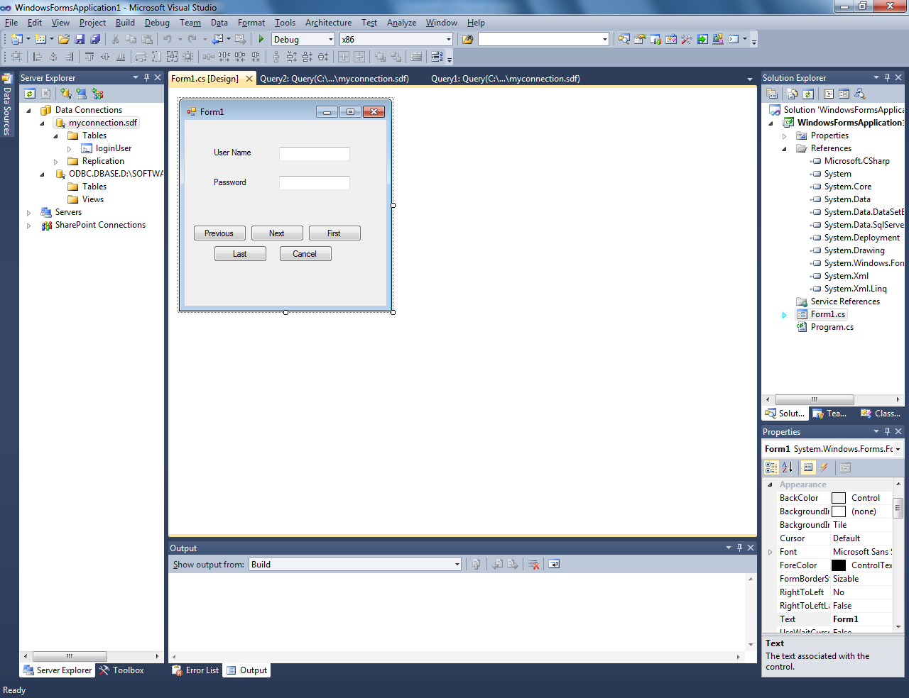

using System;

using System.Collections.Generic;

using System.ComponentModel;

using System.Data;

using System.Data.SqlClient;

using System.Drawing;

using System.Linq;

using System.Text;

using System.Windows.Forms;

using System.Data.SqlServerCe;

namespace WindowsFormsApplication1

{

public partial class Form1 : Form

{

public SqlCeConnection scon;

public SqlCeDataAdapter sda;

public SqlCeCommand scomm;

public DataSet ds;

public DataTable dt;

public int rno;

public Form1()

{

InitializeComponent();

}

private void button5_Click(object sender, EventArgs e)

{

Form1.ActiveForm.Close();

}

private void Form1_Load(object sender, EventArgs e)

{

String conString ="Data Source = C:\\Users\\Azeez GIS\\Documents\\myconnection.sdf;Password = sql@123;Persist Security Info=False";

scon = new SqlCeConnection(conString);

String queryString= "select * from loginUser";

//scomm = new System.Data.SqlClient.SqlCommand(queryString, scon);

sda = new SqlCeDataAdapter(queryString,scon);

scon.Open();

ds = new DataSet();

sda.Fill(ds);

dt = ds.Tables[0];

rno = dt.Rows.Count-1;

}

private void button1_Click(object sender, EventArgs e)

{

if (rno <= 0)

{

MessageBox.Show(" This is the First Record");

}

else

rno -= 1;

textBox1.Text = dt.Rows[rno][1].ToString();

textBox2.Text = dt.Rows[rno][2].ToString();

}

private void button2_Click(object sender, EventArgs e)

{

if (rno >= dt.Rows.Count - 1)

MessageBox.Show(" This is the Last Record");

else

rno += 1;

textBox1.Text = dt.Rows[rno][1].ToString();

textBox2.Text = dt.Rows[rno][2].ToString();

}

private void button3_Click(object sender, EventArgs e)

{

rno = 0;

textBox1.Text = dt.Rows[rno][1].ToString();

textBox2.Text = dt.Rows[rno][2].ToString();

}

private void button4_Click(object sender, EventArgs e)

{

rno = dt.Rows.Count-1;

textBox1.Text = dt.Rows[rno][1].ToString();

textBox2.Text = dt.Rows[rno][2].ToString();

}

}

}