* In the scrolling section under the banner in home page, spelling mistake in “ERP” please pix currently it is showing “ERmP”.
* Change “Our Services” into “Our Implementation” as in development version in scrolling section
* When clicking the **Latest News, news** items **read more** link all the news items read more are pointing the top most news item. But we should locate the exact news item using “#” tag
* In the inner pages right side column, Put **contact us** image in last
* When clicking Mr.Irfan Dhankot in Testimonials section it is not going to testimonials page. Also please give “#” hyperlink for all testimonials. Currently when clicking the testimonials all links are showing the top of the testimonials page.
* In the videos tab, currently we are showing only one video. We should provide option for showing multiple videos by using arrow keys
* I clicked the case studies links from home page, it’s going to case study section, then I have clicked the download link. It prompts name and email. But the download not happened. Please check and fix.
* Also when we click the case studies, we should locate the exact case studies using the “#” tag. Currently its just loading the top of the case studies page.
* In the presentation page, each download link has different alignment, please fix

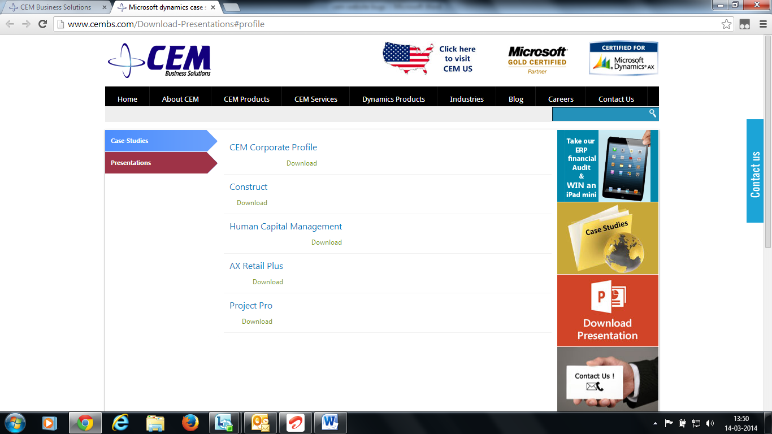

* I tried to download the presentation. But no response. Pleas check.
* Boucher section is not coming when we click from home page, please fix
* Add header and footer section in all job pages and job submitting page. Check the submitted resume is dropped into the hr email box.
* Add youtube icon in the footer section
* Apply to this job button not working in careers home page
* In the sitemap page, at the tail part we have a sitemap link, if we click that link it throws error. Please fix