1 echo "Setting Up Anisble"

2 yum install ansible -y

3 ansible version

4 ansible -version

5 ansible --version

6 ls

7 ping 10.142.0.2

8 ping 10.142.0.3

9 ls

10 cd devops-bs-repo/

11 ls

12 mkdir ansible

13 cd ansible/

14 ls

15 mkdir demo1

16 ls

17 cd demo1/

18 ls

19 vim inventory

20 ansible -i inventory -m ping -u root -k

21 ansible all -i inventory -m ping -u root -k

22 ssh root@10.142.0.2

23 ssh root@10.142.0.3

24 ping 10.142.0.3

25 ls

26 ansible all -i inventory -m ping -u root -k

27 ls

28 vim inventory

29 ansible prod -i inventory -m ping -u root -k

30 ls

31 vim webservice.yaml

32 ansible-doc -l

33 ansible-doc yum

34 vim webservice.yaml

35 ansible-playbook -i inventory webservice.yaml -u root

36 ansible-playbook -i inventory webservice.yaml -u root -k

37 vim webservice.yaml

38 ansible-playbook -i inventory webservice.yaml -u root -k

39 history > /var/www/html/ansile.txt

<https://github.com/amitvashist7/devops-bs-repo>

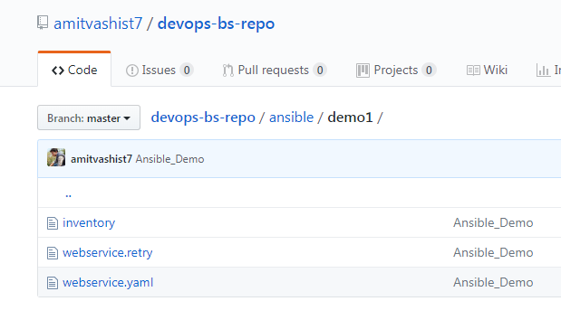

|  |
| --- |
| --- |
| Webservice.yaml |  |
|  | - hosts: prod |
|  | sudo: yes |
|  |  |
|  | tasks: |
|  | - name: Install Apache Packages |
|  | yum: name=httpd state=present |
|  |  |
|  | - name: Install Net-Tools Packages |
|  | yum: name=net-tools state=present |
|  |  |
|  | - name: Install JAVA Packages |
|  | yum: name=java state=present |
|  |  |
|  |  |
|  |  |
|  |  |
|  | - hosts: QA |
|  | sudo: yes |
|  |  |
|  | tasks: |
|  | - name: Install Apache Packages |
|  | apt: name=apache2 state=present |

[inventory](https://github.com/amitvashist7/devops-bs-repo/blob/master/ansible/demo1/inventory)

|  |
| --- |
| 10.142.0.2 |
|  | 10.142.0.3 |
|  |  |
|  |  |
|  | [prod] |
|  | 10.142.0.2 |
|  |  |
|  |  |
|  | [QA] |
|  | 10.142.0.3 |