DevOps

* Continuous Integration and continuous deployment is the DevOps methodology.
* Which enables the programmers to share their code in shared repository and then deploy the code more efficiently and quickly.

**Virtual Machine :**

* is an computer file , an image acts like an actual computer system. (creating the computer within the computer)
* It shares the hardware’s of the host system.
* There can be multiple VM’s can run simultaneously on single host.
* The VMs can call as guest and the actual system is known as host
* VMWare and Microsoft are main vendors to support VM.
* Each VM can run in Different OS(heterogeneous OS) . One in Linux and one in windows.
* It allows to run an operating system in an app window like an other applications.
* It is an process running on the current operationg system
* Virtual machine monitor(VMM) or hypervisor is an software which supports VM’s.
* It determines how virtual resources are mapped to physical resources.

**VM Architecture:**

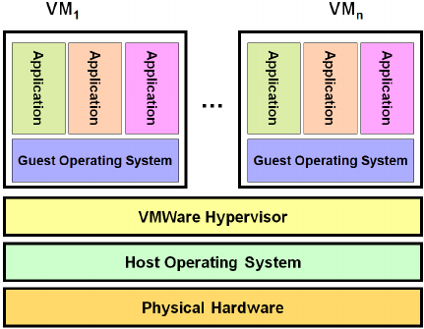

**Dockers :**

* Docker is a container management service
* It allows developers to easily develop the applications ship them into containers and deploy anywhere.
* The keywords of dockers are develop , ship and run.

**Features:**

* Dockers has the ability to reduce the size of development by giving the smaller footprint of the operating system via Conteiner.
* Docker container can be deployed anywhere on any physical machine or any virtual machines or any cloud machines.
* Docker containers are light weight and easily scalable.

**Components:**

* Docker for Mac : it allows one to run the docker container on any mac system
* Docker for Windows : it allows one to run the docker container on any windows system
* Docker for Linux : it allows one to run the docker container on any Linux system
* Docker Engine: it is used to buid the docker images and creating the docker containers
* Docker Hub: it is the registry which is used to host the docker images
* Docker Compose : it is used to define applications using multiple containers.

**Architecture :**

