Assignment 1
CV5570 – Computer Vision for Construction Engineering
Objective
The objective of this assignment is to build an image stitching pipeline in two different ways using classical feature matching methods (SIFT, ORB or SURF) and deep learning method and to compare and discuss their limitations.
Images/Dataset
These images are taken infront of ANRF National Facility for Cryo-Electron Microscopy Building at IIT Madras Campus with Samsung Galaxy S24 Ultra.
Image 1  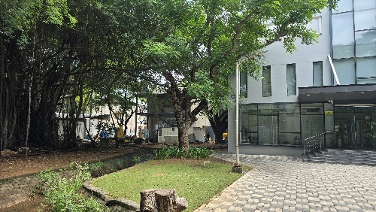 | Image 2  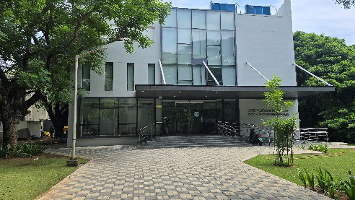 | Image 3  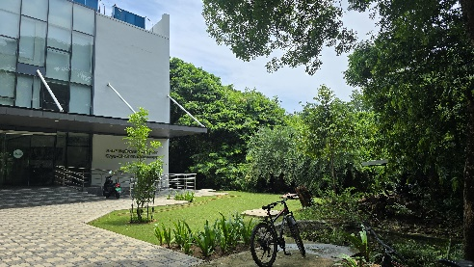

Image Metadata: Image 1 (9MP, ISO 12, 23 mm, 0.0ev, F1.7, 1/180s, size: 4.12 MB), Image 2 (9MP, ISO 12, 23mm, 0,0ev, F1.7, 1/585s, size: 3.65 MB), Image 3 (9MP, ISO 12, 23mm, 0.0ev, F1.7, 1/720s, size: 3.89 MB)
Classical Methods
Limitations
Conclusion
References

