 

**DESIGN AND FABRICATION**

**OF**

**A PEDALLING PADDY THRESHER**

**DESIGN AND FABRICATION**

**OF**

**A PEDALLING PADDY THRESHER**

Project Report

Submitted by

|  |  |
| --- | --- |
| GLADWIN JOHNDURAI.J | (721820114302) |
| KAVIYARASAN.M | (721820114303) |
| VASANTH KARUPPUSAMY.P | (721820114306) |
| YOGESHGUNAL.C | (721820114501) |
|  |  |
|  |  |

In partial fulfillment for the award of the degree

BACHELOR OF MECHANICAL ENGINEERING

DEPARTMENT OF MECHANICAL ENGINEERING

RATHINAM TECHNICAL CAMPUS

ANNA UNIVERSITY: CHENNAI 600 025

APRIL 2023

**BONAFIDE CERTIFICATE**

Certified that this project report “DESIGN AND FABRICATION A PEDALLING PADDY THRESHER” is the bonafide work of KAVIYARASAN.M (721820114303), VASANTH KARUPPUSAMY.P (721820114306), GLADWIN JOHNDURAI.J ( 721820114302), YOGESHGUNAL.C (72182011501) who carried out the project work under my supervision

|  |  |
| --- | --- |
| SIGNATURE  Prof. G. VIJAYASEKARAN  SUPERVISOR  Department of Mechanical Engineering  Rathinam Technical Campus,  Coimbatore-641021 | SIGNATURE  Dr. S. SEENIVASAN  HEAD OF THE DEPARTMENT  Department of Mechanical Engineering  Rathinam Technical Campus,  Coimbatore-641021 |

Submitted for the Project viva-voice examination held on . . . . . . . . . . . . . .

INTERNAL EXAMINER EXTERNAL EXAMINER

**ACKNOWLEDGEMENT**

The success of work depends on the team and its cooperation. We take this opportunity to express our gratitude and sincere thanks to everyone who helped us in our project. First and foremost, we would like to thank the Management for the excellent infrastructure, facilities and the constant support provided for the successful completion for the project work. We wish to express our heartfelt thanks and deep sense of gratitude to our chairman Dr. MADAN A SENDHIL M S, Ph.d, for this valuable guidance and continuous support.

We are indebted to Dr. B. NAGARAJ, Principal, Rathinam Technical Campus, for his continuous motivation, inspiring words and guidance throughout this project.

Our sincere thanks to our respected Prof. K.S. SATHISH KUMAR, Dean Academics, Rathinam Technical Campus for giving us the opportunity to display our professional skills through this project.

Our special thanks to Dr. S. SEENIVASAN, Head of the Department, Mechanical Engineering for his valuable guidance, continuous support and suggestions to improve the quality of the project work.

We are greatly thankful to our project coordinator and guide, Mr. G. VIJAYASEKARAN, Assistant Professor, Department of Mechanical Engineering We express our sincere thanks to our guide, Mr. P. SATISH KUMAR for his valuable guidance insightful and continuous support to carry out the project work.

We express our deep sense of gratitude to all the faculty members of the supporting staff for their continuous support in completing this project work successfully.

#### TABLE OF CONTENT

|  |  |  |
| --- | --- | --- |
| Chapter  No | Title | Page No |
| 1. | Abstract | 6 |
| 2. | Introduction | 7 |
| 3. | Literature Review | 8 |
| 4. | Working Principle | 10 |
| 5. | Major Components | 11 |
| 6. | Advantages and Applications | 51 |
| 7. | Material Used | 54 |
| 8. | Cost Estimation | 55 |
| 9. | 2D Layouts of Model | 56 |
| 10. | Photography | 57 |
| 11. | Conclusion | 58 |
| 12. | Reference | 59 |

**CHAPTER 1**

**ABSTRACT**

The main objective of this study was to design and fabricate a pedal powered thresher for threshing, separating, and cleaning rice paddies. The major components of the machine include threshing, separation and cleaning units. Threshing operation is achieved by rotational motion of a cylinder fitted with beater spikes above a stationary grid which results in the removal of the paddies from the bulk straws. After being beaten out, the grains fall into the cleaning unit which consists of a sieve that undergoes a reciprocating motion. The machine is simple, less bulky and the ergonomic considerations in the design allows for comfortable use and can easily be operated by either male or female. The designed and fabricated pedal powered paddy thresher fitted with winnowing equipment substantially reduces human drudgery in threshing at an affordable cost and also reduces the time used for threshing operation on small farms. Threshing was efficient for moisture content between 20% and 23%. Total power required by the machine was 84 watts operating at 400 rpm. This power is produced through human operated pedal mechanism. Performance test revealed that the efficiency of the machine was 92% with a through put of 90 kg per hour.

**CHAPTER 2**

**INTRODUCTION**

Rice (Oriza sp) is after wheat, the most widely cultivated cereal in the world and it is the most important food crop for almost half of the world’s population [1]. National rice consumption in Kenya is estimated at about 300,000 tonnes against an annual domestic production of between 45,000 to 80,000 tonnes. This huge gap between consumption and production is met through importation of rice. In 2008, rice imports into Kenya were valued at Ksh 7 billion [2]. To reduce this dependency on importation, include decreased consumption which is not a viable option, increasing tariffs on imported rice, increasing the area under current cultivation, increasing productivity and proper post-harvest practices to minimize loss and improve quality. Majority of farmers in Kenya grow rice in small scale, they therefore lack enough capacity to acquire appropriate equipment such as combine harvesters to be used for threshing. They therefore resort to manual means of threshing rice like: smashing ears of rice with hard objects to separate the paddies from the ears or straw sometimes pedal operated threshing drums are employed in fairly big farms, or even driving trucks or tractors on the un-threshed rice. Manual threshing is tedious, time consuming and above all results in too much post-harvest losses which can be in the range of 1-15%. According to Earth trend, [3], postharvest food loss translates not only to human hunger and financial losses to farmers but also results in tremendous environmental wastes. In Kenya, rice production has remained low both in quantity and quality. This research was conducted to determine ways of reducing post-harvest losses and tediousness resulting from traditional methods of rice threshing. The study involved designing of a pedal powered thresher from scrap metals and affordable power transmission element and to make the whole system affordable to the small scale farmers.

**LITERATURE REVIEW**

DESIGN AND FABRICATION OF PEDALLING PADDY THRESHER

The main objective of this study was to design and fabricate a pedal powered thresher for threshing, separating, and cleaning rice paddies. The major components of the machine include threshing, separation and cleaning units. Threshing operation is achieved by rotational motion of a cylinder fitted with beater spikes above a stationary grid which results in the removal of the paddies from the bulk straws. After being beaten out, the grains fall into the cleaning unit which consists of a sieve that undergoes a reciprocating motion. The machine is simple, less bulky and the ergonomic considerations in the design allows for comfortable use and can easily be operated by either male or female. The designed and fabricated pedal powered paddy thresher fitted with winnowing equipment substantially reduces human drudgery in threshing at an affordable cost and also reduces the time used for threshing operation on small farms. Threshing was efficient for moisture content between 20% and 23%. Total power required by the machine was 84 watts operating at 400 rpm. This power is produced through human operated pedal mechanism. Performance test revealed that the efficiency of the machine was 92% with a through put of 90 kg per hour.

Kavirayasan.M, Vasanth karuppusamy.P, Gladwin johndurai.J, Yogesh gunal.C.

PADDY THRESHING MACHINE BY PEDALLING METHOD:

Paddy is the most important and extensively grown food crop in the World. It is the staple food of more than 60 percent of the world population. Rice is mainly produced and consumed in the Asian region. India has the largest area under paddy in the world and ranks second in the production after China. With the increase in technology, it gives us a opportunity to develop agricultural equipment with latest technology having a DC motor and the transmission elements as required. The raw material is converted to finished product by various operations and treatments. The designed machine size is 50cm*50.25cm*60cm. By using the above designed machine, we obtain a increase of 5% in the efficiency per hour of operation. It also reduced the human effort by advance in the technology adopted.

“DESIGN AND FABRICATION OF PEDALLING PADDY THRESHER”

Threshing is an integral part of postharvest activities for cereal and legume crops. In many developing countries, threshing is carried out manually by farmers that lead to low quality of paddy rice and grain loss. When the rice production increases, consequently the manual threshing becomes arduous. In order to mechanize this process, a throwin type thresher based on a prototype of a manually operated thresher. The overall results are impressive and it will help improve drudgery and threshing challenges with small scale farmers.

Development and compare performance evaluation of traditional, pedal operated and modified pedal operated portable paddy thresher for small farmers.

Today there are various machines for performing various kinds of operations in farm as well as for doing every work, where considering our research we have found for study i.e.” Rice Threshing, here we found various problems that has to be noted and can be worked on. So this problems can be framed as the machines that are used for rice threshing are required more man power for threshing i.e. if one labour standing with rice plant for threshing behind the thresher it’s difficult to rotate rice plant continuously in standing position with rice plant. So, there need to develop new technique or machine that can be used solve the problem mentioned above. Currently, The Traditional, portable paddy thresher and Modified paddy thresher was tested for its performance in terms of threshing efficiency, grain damage and output capacity at different levels of factors namely concave clearance (15, 20 and 25 mm), cylinder peripheral and Comparing the maximum threshing efficiency, minimum grain damage and maximum output capacity in different combinations the minimum loss was achieved.

**CHAPTER 3**

**WORKING PRINCIPLE**

The threshing component works on the principle of impact force, while the screen uses the principle of reciprocating motion to cause the agitation of the paddy grain. The machine is operated by applying force through pedalling a bicycle which through the first chain converts higher speed to the middle shaft, the middle shaft consists of one larger sprocket of higher number of teeth and a smaller sprocket with lesser number of teeth which is connected to the rider sprocket. The larger sprocket transmits rotary motion to another smaller sprocket mounted on a second shaft thus causing the shaft to rotate an increased speed. This second shaft has a sprocket of same size mounted on it and is connected to the shaft at the threshing unit. The other sprocket connects to the larger sprocket on the first shaft. The shaft also has a fulcrum system that provides reciprocating motion to the screen. The threshing operation is achieved by rotational motion of a cylinder fitted with beater spikes above a stationary grid which results in the removal of the paddies from the bulk straws. After being beaten out, the grains fall through a concave grid into the cleaning unit which consists of a sieve that undergoes reciprocating motion. The grain, then get collected in the collecting tray which will hence direct them to the final collecting container for transportation.

**CHAPTER 4**

**MAJOR COMPONENTS**

1. SHAFT
2. MATAL STRIP
3. BALL BEARING
4. SPROCKET
5. DISK
6. METAL FRAM

**SHAFT**

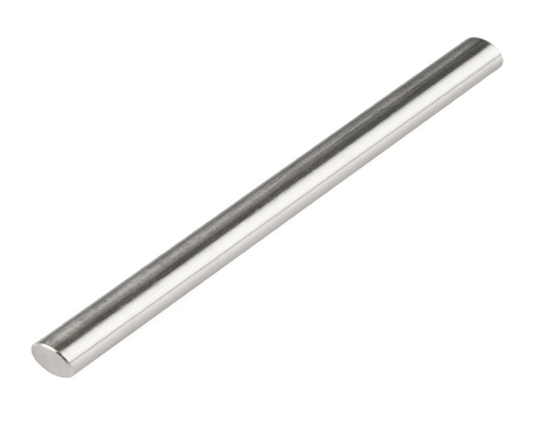

**Specifications**

Shaft diameter: 12mm

Material: mild steel

Length:26 inch

**Shaft**

Shaft is a common and important machine element. It is a rotating member, in general, has a circular cross-section and is used to transmit power. The shaft may be hollow or solid. The shaft is supported on bearings and it rotates a set of gears or pulleys for the purpose of power transmission. The shaft is generally acted upon by bending moment, torsion and axial force. Design of shaft primarily involves in determining stresses at critical point in the shaft that is arising due to aforementioned loading. Other two similar forms of a shaft are axle and spindle. Axle is a non-rotating member used for supporting rotating wheels etc. and do not transmit any torque. Spindle is simply defined as a short shaft. However, design method remains the same for axle and spindle as that for a shaft. 8.1.2 Standard sizes of Shafts Typical sizes of solid shaft that are available in the market are, Up to 25 mm 0.5 mm increments 25 to 50 mm 1.0 mm increments 50 to 100 mm 2.0 mm increments 100 to 200 mm 5.0 mm increments 8.1.3 Material for Shafts The ferrous, non-ferrous materials and non metals are used as shaft material depending on the application. Some of the common ferrous materials used for shaft are discussed below. Hot-rolled plain carbon steel. These materials are least expensive. Since it is hot rolled, scaling is always present on the surface and machining is required to make the surface smooth.

Since it is cold drawn it has got its inherent characteristics of smooth bright finish. Amount of machining therefore is minimal. Better yield strength is also obtained. This is widely used for general purpose transmission shaft.

**Alloy steels**

Alloy steel as one can understand is a mixture of various elements with the parent steel to improve certain physical properties. To retain the total advantage of alloying materials one requires heat treatment of the machine components after it has been manufactured. Nickel, chromium and vanadium are some of the common alloying materials. However, alloy steel is expensive. These materials are used for relatively severe service conditions. When the situation demands great strength then alloy steels are used. They have fewer tendencies to crack, warp or distort in heat treatment. Residual stresses are also less compared to CS (Carbon Steel). In certain cases the shaft needs to be wear resistant, and then more attention has to be paid to make the surface of the shaft to be wear resistant.

The common types of surface hardening methods are,

Hardening of surface

Case hardening and carburizing

Cyaniding and nitriding

**Design considerations for shaft**

For the design of shaft following two methods are adopted, Design based on Strength In this method, design is carried out so that stress at any location of the shaft should not exceed the material yield stress. However, no consideration for shaft deflection and shaft twist is included. Design based on Stiffness Basic idea of design in such case depends on the allowable deflection and twist of the shaft.

**Design based on Strength**

The stress at any point on the shaft depends on the nature of load acting on it. The stresses which may be present are as follows.

Basic stress equations:

**Bending stress**



Where,

M: Bending moment at the point of interest

do: Outer diameter of the shaft

k: Ratio of inner to outer diameters of the shaft ( k = 0 for a solid shaft because inner diameter is zero )

**Axial Stress**

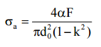

Where,

F: Axial force (tensile or compressive)

α: Column-action factor(= 1.0 for tensile load)

The term α has been introduced in the equation. This is known as column action factor. What is a column action factor? This arises due the phenomenon of buckling of long slender members which are acted upon by axial compressive loads.

Here, α is defined as,



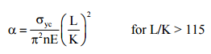

Where,

n = 1.0 for hinged end

n = 2.25 for fixed end

n = 1.6 for ends partly restrained, as in bearing

K = least radius of gyration,

L = shaft length

σyc = yield stress in compression

Stress due to torsion



Where,

T : Torque on the shaft

xy τ : Shear stress due to torsion

Combined Bending and Axial stress

Both bending and axial stresses are normal stresses, hence the net normal stress is given by,



The net normal stress can be either positive or negative. Normally, shear stress due to torsion is only considered in a shaft and shear stress due to load on the shaft is neglected.

Maximum shear stress theory

Design of the shaft mostly uses maximum shear stress theory. It states that a machine member fails when the maximum shear stress at a point exceeds the maximum allowable shear stress for the shaft material. Therefore,

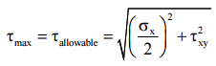

Substituting the values of σx and τxy in the above equation, the final form is,



Therefore, the shaft diameter can be calculated in terms of external loads and material properties. However, the above equation is further standardized for steel shafting in terms of allowable design stress and load factors in ASME design code for shaft.

**Specifications**

Shaft diameter: 12mm

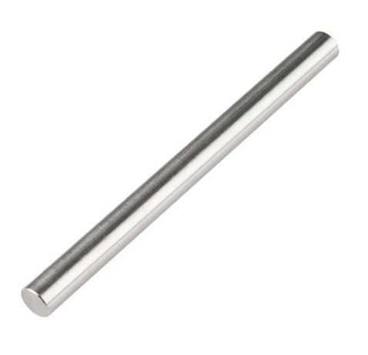Inner Diameter: 10mm

Material: mild steel



**BALL BEARING**

A ball bearing is a type of [rolling-element bearing](https://en.wikipedia.org/wiki/Rolling-element_bearing) that uses [balls](https://en.wikipedia.org/wiki/Ball_(bearing)) to maintain the separation between the [bearing](https://en.wikipedia.org/wiki/Bearing_(mechanical)) [races](https://en.wikipedia.org/wiki/Race_(bearing)).

The purpose of a ball bearing is to reduce rotational friction and support [radial](https://en.wikipedia.org/wiki/Radius) and [axial](https://en.wikipedia.org/wiki/Axis_of_rotation) loads. It achieves this by using at least three races to contain the balls and transmit the loads through the balls. In most applications, one race is stationary and the other is attached to the rotating assembly (e.g., a hub or shaft). As one of the bearing races rotates it causes the balls to rotate as well. Because the balls are rolling they have a much lower [coefficient of friction](https://en.wikipedia.org/wiki/Coefficient_of_friction) than if two flat surfaces were sliding against each other.

Ball bearings tend to have lower [load capacity](https://en.wikipedia.org/wiki/Structural_load) for their size than other kinds of rolling-element bearings due to the smaller contact area between the balls and races. However, they can tolerate some misalignment of the inner and outer races.

**SPECIFICATION**

INNER DIA :12mm

OUTER DIA : 37mm

**HISTORY**

Although bearings had been developed since ancient times, the first modern recorded patent on ball bearings was awarded to [Philip Vaughan](https://en.wikipedia.org/wiki/Philip_Vaughan), a Welsh inventor and [ironmaster](https://en.wikipedia.org/wiki/Ironmaster) who created the first design for a ball bearing in [Carmarthen](https://en.wikipedia.org/wiki/Carmarthen) in

1794. His was the first modern ball-bearing design, with the ball running along a groove in the axle assembly.

[Jules Suriray](https://en.wikipedia.org/wiki/Jules_Suriray), a Parisian bicycle mechanic, designed the first radial style ball bearing in 1869, which was then fitted to the winning bicycle ridden by [James Moore](https://en.wikipedia.org/wiki/James_Moore_(cyclist)) in the world's first bicycle road race, [Paris-Rouen](https://en.wikipedia.org/wiki/Paris%E2%80%93Rouen_(cycle_race)), in November 1869.

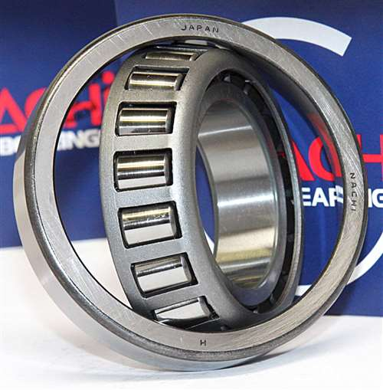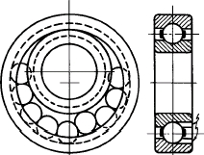

**DESIGN**

**ANGULAR CONTACT**

An angular contact ball bearing uses axially [asymmetric](https://en.wikipedia.org/wiki/Asymmetry) races. An axial load passes in a straight line through the bearing, whereas a radial load takes an oblique path that acts to separate the races axially. So the angle of contact on the inner race is the same as that on the outer race. Angular contact bearings better support combined loads (loading in both the radial and axial directions) and the contact angle of the bearing should be matched to the relative proportions of each. The larger the contact angle (typically in the range 10 to 45 degrees), the higher the axial load supported, but the lower the radial load. In high speed applications, such as turbines, jet engines, and dentistry equipment, the centrifugal forces generated by the balls changes the contact angle at the inner and outer race. Ceramics such as [silicon nitride](https://en.wikipedia.org/wiki/Silicon_nitride) are now regularly used in such applications due to their low density (40% of steel). These materials significantly reduce centrifugal force and function well in high temperature environments. They also tend to wear in a similar way to bearing steel—rather than cracking or shattering like glass or porcelain.

Most bicycles use angular-contact bearings in the headsets because the forces on these bearings are in both the radial and axial direction.

**AXIAL**

An axial or thrust ball bearing uses side-by-side races. An axial load is transmitted directly through the bearing, while a radial load is poorly supported and tends to separate the races,so that a larger radial load is likely to damage the bearing.

**DEEP-GROOVE**

In a deep-groove radial bearing, the race dimensions are close to the dimensions of the balls that run in it. Deep-groove bearings support higher loads than a shallower groove. Like angular contact bearings, deep-groove bearings support both radial and axial loads, but without a choice of contact angle to allow choice of relative proportion of these load capacities.

**PRELOADED PAIRS**

The above basic types of bearings are typically applied in a method of preloaded pairs, where two individual bearings are rigidly fastened along a rotating shaft to face each other. This improves the axial runout by taking up (preloading) the necessary slight clearance between the bearing balls and races. Pairing also provides an advantage of evenly distributing the loads, nearly doubling the total load capacity compared to a single bearing. Angular contact bearings are almost always used in opposing pairs: the asymmetric design of each bearing supports axial loads in only one direction, so an opposed pair is required if the application demands support both directions. The preloading force must be designed and assembled carefully, because it deducts from the axial force capacity of the bearings, and can damage bearings if applied excessively. The pairing mechanism may simply face the bearings together directly, or separate them with a shim, bushing, or shaft feature

**CONSRUCTIVE TYPE**

**CONRAD**

The Conrad-style ball bearing is named after its inventor, [Robert Conrad](https://en.wikipedia.org/w/index.php?title=Robert_Conrad_(inventor)&action=edit&redlink=1), who was awarded British patent 12,206 in 1903 and U.S. patent 822,723 in 1906. These bearings are assembled by placing the inner ring into an eccentric position relative to the outer ring, with the two rings in contact at one point, resulting in a large gap opposite the point of contact. The balls are inserted through the gap and then evenly distributed around the bearing assembly, causing the rings to become concentric. Assembly is completed by fitting a cage to the balls to maintain their positions relative to each other. Without the cage, the balls would eventually drift out of position during operation, causing the bearing to fail. The cage carries no load and serves only to maintain ball position.

Conrad bearings have the advantage that they are able to withstand both radial and axial loads, but have the disadvantage of lower load capacity due to the limited number of balls that can be loaded into the bearing assembly. Probably the most familiar industrial ball bearing is the deep-groove Conrad style. The bearing is used in most of the mechanical industries.

**SLOT-FILL**

In a slot-fill radial bearing, the inner and outer races are notched on one face so that when the notches are aligned, balls can be slipped in the resulting slot to assemble the bearing.  A slot-fill bearing has the advantage that more balls can be assembled (even allowing a full complement design), resulting in a higher radial load capacity than a Conrad bearing of the same dimensions and material type.  However, a slot-fill bearing cannot carry a significant axial load, and the slots cause a discontinuity in the races that can have a small but adverse effect on strength.

**RELIEVED RACE**

Relieved race ball bearings are 'relieved' as the name suggests by basically have either the OD of the inner ring reduced on one side, or the ID of the outer ring increased on one side. This allows a greater number of balls to be assembled into either the inner or outer race, and then press fit over the relief. Sometimes the outer ring will be heated to facilitate assembly. Like the slot-fill construction, relieved race construction allows a greater number of balls than Conrad construction, up to and including full complement, and the extra ball count gives extra load capacity. However, a relieved race bearing can only support significant axial loads in one direction ('away from' the relieved race).

**FRACTURED RACE**

Another way of fitting more balls into a radial ball bearing is by radially 'fracturing' (slicing) one of the rings all the way through, loading the balls in, re-assembling the fractured portion, and then using a pair of steel bands to hold the fractured ring sections together in alignment. Again, this allows more balls, including full ball complement, however unlike with either slot fill or relieved race constructions, it can support significant axial loading in either direction.

**ROWS**

There are two row designs: single-row bearings and double-row bearings. Most ball bearings are a single-row design, which means there is one row of bearing balls. This design works with radial and thrust loads.

A double-row design has two rows of bearing balls. Their disadvantage is they need better alignment than single-row bearings.

**FLANGED**

Bearings with a flange on the outer ring simplify axial location. The housing for such bearings can consist of a through-hole of uniform diameter, but the entry face of the housing (which may be either the outer or inner face) must be machined truly normal to the hole axis. However such flanges are very expensive to manufacture. A more cost effective arrangement of the bearing outer ring, with similar benefits, is a snap ring groove at either or both ends of the outside diameter. The snap ring assumes the function of a flange.

**CAGED**

Cages are typically used to secure the balls in a Conrad-style ball bearing. In other construction types they may decrease the number of balls depending on the specific cage shape, and thus reduce the load capacity. Without cages the tangential position is stabilized by sliding of two convex surfaces on each other. With a cage the tangential position is stabilized by a sliding of a convex surface in a matched concave surface, which avoids dents in the balls and has lower friction. Caged roller bearings were invented by [John Harrison](https://en.wikipedia.org/wiki/John_Harrison) in the mid-18th century as part of his work on chronographs.

**HYBRID BALL BEARINGS USING CERAMIC BALLS**

Ceramic bearing balls can weigh up to 40% less than steel ones, depending on size and material. This reduces centrifugal loading and skidding, so hybrid ceramic bearings can operate 20% to 40% faster than conventional bearings. This means that the outer race groove exerts less force inward against the ball as the bearing spins. This reduction in force reduces the friction and rolling resistance. The lighter balls allow the bearing to spin faster, and uses less energy to maintain its speed.

The ceramic balls are typically harder than the race. Due to wear, with time they will form a groove in the race. This is preferable to the balls wearing which would leave them with possible flat spots significantly harming performance.

While ceramic hybrid bearings use ceramic balls in place of steel ones, they are constructed with steel inner and outer rings; hence the hybrid designation. While the ceramic material itself is stronger than steel, it is also stiffer, which results in increased stresses on the rings, and hence decreased load capacity. Ceramic balls are electrically insulating, which can prevent 'arcing' failures if current should be passed through the bearing. Ceramic balls can also be effective in environments where lubrication may not be available (such as in space applications).

In some settings only a thin coating of ceramic is used over a metal ball bearing.

**FULLY CERAMIC BEARINGS**

These bearings make use of both ceramic balls and race. These bearings are impervious to corrosion and rarely require lubrication if at all. Due to the stiffness and hardness of the balls and race these bearings are noisy at high speeds. The stiffness of the ceramic makes these bearings brittle and liable to crack under load or impact. Because both ball and race are of similar hardness wear can lead to chipping at high speeds of both the balls and the race this can cause sparking.

**SELF-ALIGNING**

[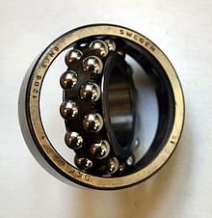](https://en.wikipedia.org/wiki/File:Wingquist_bearing00.jpg)

Self-aligning ball bearings, such as the [Wingquist](https://en.wikipedia.org/wiki/Sven_Gustaf_Wingqvist" \o "Sven Gustaf Wingqvist) bearing shown in the picture, are constructed with the inner ring and ball assembly contained within an outer ring that has a spherical raceway. This construction allows the bearing to tolerate a small angular misalignment resulting from shaft or housing deflections or improper mounting. The bearing was used mainly in bearing arrangements with very long shafts, such as transmission shafts in textile factories. One drawback of the self-aligning ball bearings is a limited load rating, as the outer raceway has very low osculation (radius is much larger than ball radius). This led to the invention of the [spherical roller bearing](https://en.wikipedia.org/wiki/Spherical_roller_bearing), which has a similar design, but use rollers instead of balls. Also the [spherical roller thrust bearing](https://en.wikipedia.org/wiki/Spherical_roller_thrust_bearing) is an invention that derives from the findings by [Wingquist](https://en.wikipedia.org/wiki/Sven_Gustaf_Wingqvist" \o "Sven Gustaf Wingqvist).

**OPERATING CONDITION**

**LIFESPAN**

Further information: [Rolling-element_bearing § Bearing_failure](https://en.wikipedia.org/wiki/Rolling-element_bearing#Bearing_failure)

The calculated life for a bearing is based on the load it carries and its operating speed. The industry standard usable bearing lifespan is inversely proportional to the bearing load cubed. Nominal maximum load of a bearing, is for a lifespan of 1 million rotations, which at 50 Hz (i.e., 3000 RPM) is a lifespan of 5.5 working hours. 90% of bearings of that type have at least that lifespan, and 50% of bearings have a lifespan at least 5 times as long.

The industry standard life calculation is based upon the work of Lundberg and Palmgren performed in 1947. The formula assumes the life to be limited by [metal fatigue](https://en.wikipedia.org/wiki/Fatigue_(material)) and that the life distribution can be described by a [Weibull distribution](https://en.wikipedia.org/wiki/Weibull_distribution). Many variations of the formula exist that include factors for material properties, lubrication, and loading. Factoring for loading may be viewed as a tacit admission that modern materials demonstrate a different relationship between load and life than Lundberg and Palmgren determined .

**FAILURE MODES**

If a bearing is not rotating, maximum load is determined by force that causes plastic deformation of elements or raceways. The indentations caused by the elements can concentrate stresses and generate cracks at the components. Maximum load for not or very slowly rotating bearings is called "static" maximum load.

Also if a bearing is not rotating, oscillating forces on the bearing can cause impact damage to the bearing race or the rolling elements, known as [brinelling](https://en.wikipedia.org/wiki/Brinelling). A second lesser form called [false brinelling](https://en.wikipedia.org/wiki/False_brinelling) occurs if the bearing only rotates across a short arc and pushes lubricant out away from the rolling elements.

For a rotating bearing, the dynamic load capacity indicates the load to which the bearing endures 1,000,000 cycles.

If a bearing is rotating, but experiences heavy load that lasts shorter than one revolution, static max load must be used in computations, since the bearing does not rotate during the maximum load.

If a sideways torque is applied to a deep groove radial bearing, an uneven force in the shape of an ellipse is applied on the outer ring by the rolling elements, concentrating in two regions on opposite sides of the outer ring. If the outer ring is not strong enough, or if it is not sufficiently braced by the supporting structure, the outer ring will deform into an oval shape from the sideways torque stress, until the gap is large enough for the rolling elements to escape. The inner ring then pops out and the bearing structurally collapses.

A sideways torque on a radial bearing also applies pressure to the cage that holds the rolling elements at equal distances, due to the rolling elements trying to all slide together at the location of highest sideways torque. If the cage collapses or breaks apart, the rolling elements group together, the inner ring loses support, and may pop out of the center.

**MAXIMUM LOAD**

In general, maximum load on a ball bearing is proportional to outer diameter of the bearing times the width of the bearing (where width is measured in direction of axle).[[7]](https://en.wikipedia.org/wiki/Ball_bearing#cite_note-leerboek-7)

Bearings have static load ratings. These are based on not exceeding a certain amount of plastic deformation in the raceway. These ratings may be exceeded by a large amount for certain applications.

**LUBRICATION**

For a bearing to operate properly, it needs to be lubricated. In most cases the lubricant is based on [elastohydrodynamic](https://en.wikipedia.org/wiki/Lubrication" \o "Lubrication) effect (by oil or grease) but working at extreme temperatures [dry lubricated](https://en.wikipedia.org/wiki/Dry_lubricant) bearings are also available.

For a bearing to have its nominal lifespan at its nominal maximum load, it must be lubricated with a lubricant (oil or grease) that has at least the minimum dynamic viscosity

For a bearing where average of outer diameter of bearing and diameter of axle hole is 50 mm, and that is rotating at 3000 RPM, recommended dynamic viscosity is 12 mm²/s.

Note that dynamic viscosity of oil varies strongly with temperature: a temperature increase of 50–70 °C causes the viscosity to decrease by factor 10.

If the viscosity of lubricant is higher than recommended, lifespan of bearing increases, roughly proportional to square root of viscosity. If the viscosity of the lubricant is lower than recommended, the lifespan of the bearing decreases, and by how much depends on which type of oil being used. For oils with EP ('extreme pressure') additives, the lifespan is proportional to the square root of dynamic viscosity, just as it was for too high viscosity, while for ordinary oils lifespan is proportional to the square of the viscosity if a lower-than-recommended viscosity is used.

Lubrication can be done with a grease, which has advantages that grease is normally held within the bearing releasing the lubricant oil as it is compressed by the balls. It provides a protective barrier for the bearing metal from the environment, but has disadvantages that this grease must be replaced periodically, and maximum load of bearing decreases (because if bearing gets too warm, grease melts and runs out of bearing). Time between grease replacements decreases very strongly with diameter of bearing: for a 40 mm bearing, grease should be replaced every 5000 working hours, while for a 100 mm bearing it should be replaced every 500 working hours.

Lubrication can also be done with an oil, which has advantage of higher maximum load, but needs some way to keep oil in bearing, as it normally tends to run out of it. For oil lubrication it is recommended that for applications where oil does not become warmer than 50 °C, oil should be replaced once a year, while for applications where oil does not become warmer than 100 °C, oil should be replaced 4 times per year. For car engines, oil becomes 100 °C but the engine has an oil filter to maintain oil quality; therefore, the oil is usually changed less frequently than the oil in bearings.

**DIRECTION OF LOAD**

Most bearings are meant for supporting loads perpendicular to axle ("radial loads"). Whether they can also bear axial loads, and if so, how much, depends on the type of bearing. [Thrust bearings](https://en.wikipedia.org/wiki/Thrust_bearings) (commonly found on [lazy susans](https://en.wikipedia.org/wiki/Lazy_susan)) are specifically designed for axial loads.

For single-row deep-groove ball bearings, SKF's documentation says that maximum axial load is circa 50% of maximum radial load, but it also says that "light" and/or "small" bearings can take axial loads that are 25% of maximum radial load

For single-row edge-contact ball bearings, axial load can be about 2 times max radial load, and for cone-bearings maximum axial load is between 1 and 2 times maximum radial load.

Often Conrad-style ball bearings will exhibit contact ellipse truncation under axial load. That means that either the ID of the outer ring is large enough, or the OD of the inner ring is small enough, so as to reduce the area of contact between the balls and raceway. When this is the case, it can significantly increase the stresses in the bearing, often invalidating general rules of thumb regarding relationships between radial and axial load capacity. With construction types other than Conrad, one can further decrease the outer ring ID and increase the inner ring OD to guard against this.

If both axial and radial loads are present, they can be added vectorially, to result in the total load on bearing, which in combination with nominal maximum load can be used to predict lifespan. However, in order to correctly predict the rating life of ball bearings the ISO/TS 16281 should be used with the help of a calculation software.

**AVOIDING UNDESIRABLE AXIAL LOAD**

The part of a bearing that rotates (either axle hole or outer circumference) must be fixed, while for a part that does not rotate this is not necessary (so it can be allowed to slide). If a bearing is loaded axially, both sides must be fixed.

If an axle has two bearings, and temperature varies, axle shrinks or expands, therefore it is not admissible for both bearings to be fixed on both their sides, since expansion of axle would exert axial forces that would destroy these bearings. Therefore, at least one of bearings must be able to slide.

A 'freely sliding fit' is one where there is at least a 4 µm clearance, presumably because surface-roughness of a surface made on a lathe is normally between 1.6 and 3.2 µm.

**FIT**

Bearings can withstand their maximum load only if the mating parts are properly sized. Bearing manufacturers supply [tolerances](https://en.wikipedia.org/wiki/Tolerance_(engineering)) for the fit of the shaft and the housing so that this can be achieved. The material and [hardness](https://en.wikipedia.org/wiki/Hardness) may also be specified.

Fittings that are not allowed to slip are made to diameters that prevent slipping and consequently the mating surfaces cannot be brought into position without force. For small bearings this is best done with a press because tapping with a hammer damages both bearing and shaft, while for large bearings the necessary forces are so great that there is no alternative to heating one part before fitting, so that thermal expansion allows a temporary sliding fit.[[7]](https://en.wikipedia.org/wiki/Ball_bearing#cite_note-leerboek-7)

**AVOIDING TORSIONAL LOADS**

If a shaft is supported by two bearings, and the center-lines of rotation of these bearings are not the same, then large forces are exerted on the bearing that may destroy it. Some very small amount of misalignment is acceptable, and how much depends on type of bearing. For bearings that are specifically made to be 'self-aligning', acceptable misalignment is between 1.5 and 3 degrees of arc. Bearings that are not designed to be self-aligning can accept misalignment of only 2–10 minutes of arc.

**APPLICATION**

In general, ball bearings are used in most applications that involve moving parts. Some of these applications have specific features and requirements:

* [Hard drive](https://en.wikipedia.org/wiki/Hard_drive) bearings used to be highly spherical, and were said to be the best spherical manufactured shapes, but this is no longer true, and more and more are being replaced with [fluid bearings](https://en.wikipedia.org/wiki/Fluid_bearing).
* German ball bearing factories were often a target of allied [aerial bombings during World War II](https://en.wikipedia.org/wiki/Strategic_bombing_during_World_War_II); such was the importance of the ball bearing to the German war industry.[[8]](https://en.wikipedia.org/wiki/Ball_bearing#cite_note-8)
* In [horology](https://en.wikipedia.org/wiki/Horology), the company [Jean Lassale](https://en.wikipedia.org/wiki/Jean_Lassale) designed a watch movement that used ball bearings to reduce the thickness of the movement. Using 0.20 mm balls, the Calibre 1200 was only 1.2 mm thick, which still is the thinnest mechanical watch movement.
* [Aerospace bearings](https://en.wikipedia.org/wiki/Aerospace_bearings) are used in many applications on commercial, private and military aircraft including pulleys, gearboxes and [jet engine](https://en.wikipedia.org/wiki/Jet_engine) shafts. Materials include M50 tool steel (AMS6491), Carbon chrome steel (AMS6444), the corrosion resistant AMS5930, 440C stainless steel, [silicon nitride](https://en.wikipedia.org/wiki/Silicon_nitride) (ceramic) and [titanium carbide](https://en.wikipedia.org/wiki/Titanium_carbide)-coated 440C.
* A [skateboard](https://en.wikipedia.org/wiki/Skateboard) wheel contains two bearings, which are subject to both axial and radial time-varying loads. Most commonly bearing 608-2Z is used (a deep groove ball bearing from series 60 with 8 mm bore diameter)
* [Yo-Yos](https://en.wikipedia.org/wiki/Yo-Yos), there are ball bearings in the center of many new, ranging from beginner to professional or competition grade, Yo-Yos.
* Many [fidget spinner](https://en.wikipedia.org/wiki/Fidget_spinner) toys use multiple ball bearings to add weight, and to allow the toy to spin.

**SPROCKET**

**Chain drive** is a way of transmitting mechanical power from one place to another. It is often used to convey power to the wheels of a vehicle, particularly bicycles and motorcycles. It is also used in a wide variety of machines besides vehicles.

Most often, the power is conveyed by a [roller chain](https://en.wikipedia.org/wiki/Roller_chain), known as the **drive chain** or **transmission chain**, passing over a [sprocket](https://en.wikipedia.org/wiki/Sprocket) gear, with the teeth of the gear meshing with the holes in the links of the chain. The gear is turned, and this pulls the chain putting mechanical force into the system.

Sometimes the power is output by simply rotating the chain, which can be used to lift or drag objects. In other situations, a second gear is placed and the power is recovered by attaching shafts or hubs to this gear. Though drive chains are often simple oval loops, they can also go around corners by placing more than two gears along the chain; gears that do not put power into the system or transmit it out are generally known as idler-wheels. By varying the diameter of the input and output gears with respect to each other, the gear ratio can be altered. For example, when the bicycle pedals' gear rotate once, it causes the gear that drives the wheels to rotate more than one revolution.

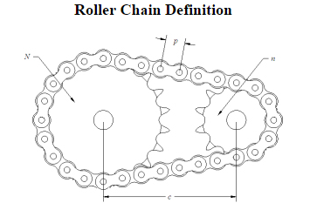**Characteristics:**

• High axial stiffness

• Low bending stiffness

• High efficiency

• Relatively cheap

**SPECIFICATION OF AXLE:**

|  |  |
| --- | --- |
| Material | **Mild Steel** |
| Shape | Cylindrical rod |
| Length | 50mm |
| Diameter | 13mm |
| Inner diameter of supporting axle | 15 mm |
| Outer diameter of supporting axle | 17mm |
| Length | 30mm |
| Thickness | 3mm |

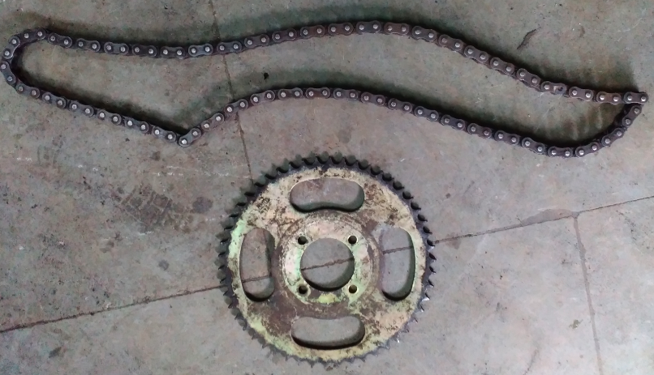

**CHAIN SPROCKET**

|  |  |
| --- | --- |
| Material | High Carbon Steel |
| Pitch | 12.7mm |
| Width | 30mm |
| Teeth | 16 |
| Balls | High carbon high chromium steel balls |

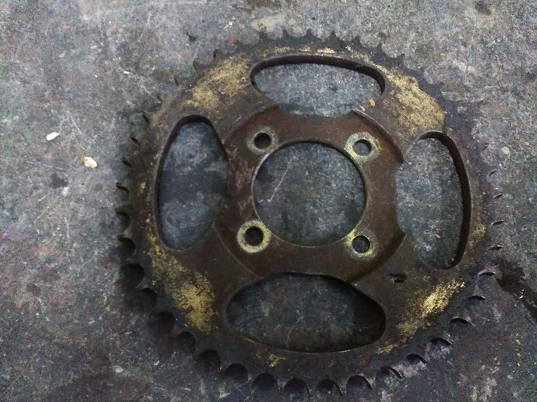

**Chain drive design calculation:**

Chain length and centre distance

* Chain must contain even integer number of links
* Hence cannot pick an arbitrary centre distance and chain pitch
* Nearest chain lengths (in pitches) for a contemplatedcentre distance, *CC*, are calculated by empirical formulae like (for a two sprocket system:

L = N1+N2/2 + 2Cc/p + (N2-N1) ^2/4pi^2Cc

Where *N*1 and *N*2 are the numbers of teeth on sprockets and *P* is the chain pitch

**Inertial force in chain**

* In addition to the tension required to transmit power, chain tension
* also provides centripetal force to move links around sprockets
* The extra inertial force, Fcf, is given by: F = mr ^2w ^2

A sprocket or sprocket-wheel is a profiled [wheel](https://en.wikipedia.org/wiki/Wheel) with teeth, or cogs, that mesh with a [chain](https://en.wikipedia.org/wiki/Roller_chain), [track](https://en.wikipedia.org/wiki/Caterpillar_track) or other perforated or indented material. The name 'sprocket' applies generally to any wheel upon which radial projections engage a chain passing over it. It is distinguished from a [gear](https://en.wikipedia.org/wiki/Gear) in that sprockets are never meshed together directly, and differs from a [pulley](https://en.wikipedia.org/wiki/Pulley) in that sprockets have teeth and pulleys are smooth.

Sprockets are used in [bicycles](https://en.wikipedia.org/wiki/Bicycle), [motorcycles](https://en.wikipedia.org/wiki/Motorcycle), [cars](https://en.wikipedia.org/wiki/Automobile), [tracked vehicles](https://en.wikipedia.org/wiki/Continuous_track), and other [machinery](https://en.wikipedia.org/wiki/Machine) either to transmit rotary motion between two shafts where gears are unsuitable or to impart linear motion to a track, tape etc. Perhaps the most common form of sprocket may be found in the bicycle, in which the pedal shaft carries a large sprocket-wheel, which drives a chain, which, in turn, drives a small sprocket on the axle of the rear wheel . Early automobiles were also largely driven by sprocket and chain mechanism, a practice largely copied from bicycles.

[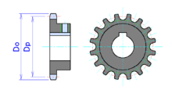](https://en.wikipedia.org/wiki/File:Sprocket16.png)

16 tooth sprocket. Do = Sprocket diameter. Dp = Pitch diameter

[](https://en.wikipedia.org/wiki/File:Chain.gif)

Sprockets are of various designs, a maximum of efficiency being claimed for each by its originator. Sprockets typically do not have a [flange](https://en.wikipedia.org/wiki/Flange). Some sprockets used with [timing belts](https://en.wikipedia.org/wiki/Toothed_belt) have flanges to keep the timing belt centered. Sprockets and chains are also used for power transmission from one shaft to another where slippage is not admissible, sprocket chains being used instead of belts or ropes and sprocket-wheels instead of pulleys. They can be run at high speed and some forms of chain are so constructed as to be noiseless even at high speed.

**ETYMOLOGY**

The term 'sprocket' originally applied to the projection from the wheel that caught on the chain and provided the drive to it. The overall wheel was then termed a 'sprocket wheel'. With time and common use of these devices, the overall wheel became known as a sprocket. The earlier uses would now be seen as archaic.

**TRANSPORTATION**

In the case of bicycle chains, it is possible to modify the overall [gear ratio](https://en.wikipedia.org/wiki/Gear_ratio) of the chain drive by varying the diameter (and therefore, the tooth count) of the sprockets on each side of the [chain](https://en.wikipedia.org/wiki/Bicycle_chain). This is the basis of [derailleur gears](https://en.wikipedia.org/wiki/Derailleur_gears). A multi-speed bicycle, by providing two or three different-sized driving sprockets and up to 11 (as of 2014) different-sized driven sprockets, allows up to 33 different gear ratios. The resulting lower gear ratios make the bike easier to pedal up hills while the higher gear ratios make the bike more powerful to pedal on flats and downhills. In a similar way, manually changing the sprockets on a motorcycle can change the characteristics of acceleration and top speed by modifying the final drive gear ratio.

**TRACKED VECHILE**

In the case of vehicles with [caterpillar tracks](https://en.wikipedia.org/wiki/Caterpillar_tracks) the engine-driven toothed-wheel transmitting motion to the tracks is known as the drive sprocketand may be positioned at the front or back of the vehicle, or in some cases both. There may also be a third sprocket, elevated, driving the track.

Moving picture mechanism from 1914. The sprocket wheels a, b, and c engage and transport the film. a and b move with uniform velocity and c indexes each frame of the film into place for projection.

Sprockets are used in the film transport mechanisms of [movie projectors](https://en.wikipedia.org/wiki/Movie_projector) and [movie cameras](https://en.wikipedia.org/wiki/Movie_camera). In this case, the sprocket wheels engage [film perforations](https://en.wikipedia.org/wiki/Film_perforations) in the [film](https://en.wikipedia.org/wiki/Film) stock. Sprocket feed was also used for [punched tape](https://en.wikipedia.org/wiki/Punched_tape) and is used for [paper](https://en.wikipedia.org/wiki/Paper) feed to some [computer printers](https://en.wikipedia.org/wiki/Computer_printer).

Chain drive is a way of transmitting mechanical power from one place to another. It is often used to convey power to the wheels of a vehicle, particularly [bicycles](https://en.wikipedia.org/wiki/Bicycle) and [motorcycles](https://en.wikipedia.org/wiki/Motorcycle). It is also used in a wide variety of machines besides vehicles.

Most often, the power is conveyed by a [roller chain](https://en.wikipedia.org/wiki/Roller_chain), known as the drive chain or transmission chain, passing over a [sprocket](https://en.wikipedia.org/wiki/Sprocket) gear, with the teeth of the gear meshing with the holes in the links of the chain. The gear is turned, and this pulls the chain putting mechanical force into the system. Another type of drive chain is the Morse chain, invented by the Morse Chain Company of [Ithaca, New York](https://en.wikipedia.org/wiki/Ithaca,_New_York), United States. This has inverted teeth.

Sometimes the power is output by simply rotating the chain, which can be used to lift or drag objects. In other situations, a second gear is placed and the power is recovered by attaching shafts or hubs to this gear. Though drive chains are often simple oval loops, they can also go around corners by placing more than two gears along the chain; gears that do not put power into the system or transmit it out are generally known as [idler-wheels](https://en.wikipedia.org/wiki/Idler-wheel). By varying the diameter of the input and output gears with respect to each other, the [gear ratio](https://en.wikipedia.org/wiki/Gear_ratio) can be altered. For example, when the bicycle pedals' gear rotate once, it causes the gear that drives the wheels to rotate more than one revolution.

The first continuous and endless power-transmitting chain was depicted in the written [horological](https://en.wikipedia.org/wiki/Horology) treatise of the [Song Dynasty](https://en.wikipedia.org/wiki/Song_Dynasty) (960–1279) [Chinese](https://en.wikipedia.org/wiki/History_of_China) engineer [Su Song](https://en.wikipedia.org/wiki/Su_Song" \o "Su Song) (1020-1101 AD), who used it to operate the [armillary sphere](https://en.wikipedia.org/wiki/Armillary_sphere) of his [astronomical](https://en.wikipedia.org/wiki/Astronomical_clock) [clock tower](https://en.wikipedia.org/wiki/Clock_tower) as well as the clock jack figurines presenting the time of day by mechanically banging gongs and drums. The chain drive itself was given power via the hydraulic works of Su's water clock tank and waterwheel, the latter which [acted as a large gear](https://en.wikipedia.org/wiki/Escapement).

**ROLLER CHAIN**

Roller chain and sprockets is a very efficient method of power transmission compared to (friction-drive) [belts](https://en.wikipedia.org/wiki/Belt_(mechanical)), with far less frictional loss.

Although chains can be made stronger than belts, their greater mass increases drive train [inertia](https://en.wikipedia.org/wiki/Inertia).

Drive chains are most often made of metal, while belts are often rubber, plastic, urethane, or other substances.

Drive belts can slip unless they have [teeth](https://en.wikipedia.org/wiki/Toothed_belt), which means that the output side may not rotate at a precise speed, and some work gets lost to the [friction](https://en.wikipedia.org/wiki/Friction) of the belt as it bends around the pulleys. Wear on rubber or plastic belts and their teeth is often easier to observe, and chains wear out faster than belts if not properly lubricated.

One problem with roller chains is the variation in speed, or surging, caused by the acceleration and deceleration of the chain as it goes around the sprocket link by link. It starts as soon as the pitch line of the chain contacts the first tooth of the sprocket. This contact occurs at a point below the pitch circle of the sprocket. As the sprocket rotates, the chain is raised up to the pitch circle and is then dropped down again as sprocket rotation continues. Because of the fixed pitch length, the pitch line of the link cuts across the chord between two pitch points on the sprocket, remaining in this position relative to the sprocket until the link exits the sprocket. This rising and falling of the pitch line is what causes chordal effect or speed variation.

In other words, conventional roller chain drives suffer the potential for vibration, as the effective radius of action in a chain and sprocket combination constantly changes during revolution ("Chordal action"). If the chain moves at constant speed, then the shafts must accelerate and decelerate constantly. If one sprocket rotates at a constant speed, then the chain (and probably all other sprockets that it drives) must accelerate and decelerate constantly. This is usually not an issue with many drive systems; however, most motorcycles are fitted with a rubber bushed rear wheel hub to virtually eliminate this vibration issue. Toothed belt drives are designed to avoid this issue by operating at a constant pitch radius.

Chains are often narrower than belts, and this can make it easier to shift them to larger or smaller gears in order to vary the gear ratio. Multi-speed bicycles with [derailleurs](https://en.wikipedia.org/wiki/Derailleur_gears) make use of this. Also, the more positive meshing of a chain can make it easier to build gears that can increase or shrink in diameter, again altering the gear ratio. However, some newer synchronous belts claim to have "equivalent capacity to roller chain drives in the same width".

Both can be used to move objects by attaching pockets, buckets, or frames to them; chains are often used to move things vertically by holding them in frames, as in industrial toasters, while belts are good at moving things horizontally in the form of [conveyor belts](https://en.wikipedia.org/wiki/Conveyor_belt). It is not unusual for the systems to be used in combination; for example the rollers that drive conveyor belts are themselves often driven by drive chains.

[Drive shafts](https://en.wikipedia.org/wiki/Drive_shaft) are another common method used to move mechanical power around that is sometimes evaluated in comparison to chain drive; in particular belt drive vs chain drive vs shaft drive is a key design decision for most motorcycles. Drive shafts tend to be tougher and more reliable than chain drive, but the bevel gears have far more friction than a chain. For this reason virtually all high-performance motorcycles use chain drive, with shaft-driven arrangements generally used for non-sporting machines. Toothed-belt drives are used for some (non-sporting) models.

**USES IN VEHICLES**

Chain drive was the main feature which differentiated the [safety bicycle](https://en.wikipedia.org/wiki/Safety_bicycle) introduced in 1885, with its two equal-sized wheels, from the [direct-drive](https://en.wikipedia.org/wiki/Direct_Drive_Mechanism) [penny-farthing](https://en.wikipedia.org/wiki/Penny-farthing) or "high wheeler" type of bicycle. The popularity of the chain-driven safety bicycle brought about the demise of the penny-farthing, and is still a basic feature of bicycle design today.

### AUTOMOBILES

[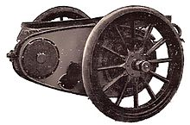](https://en.wikipedia.org/wiki/File:Side_chain_gear.jpg)

[Mack](https://en.wikipedia.org/wiki/Mack_Trucks) AC delivery truck at the [Petersen Automotive Museum](https://en.wikipedia.org/wiki/Petersen_Automotive_Museum) with chain drive visible

Chain drive was a popular power transmission system from the earliest days of the [automobile](https://en.wikipedia.org/wiki/Automobile). It gained prominence as an alternative to the [Système Panhard](https://en.wikipedia.org/wiki/Syst%C3%A8me_Panhard" \o "Système Panhard) with its rigid [Hotchkiss](https://en.wikipedia.org/wiki/Hotchkiss_drive) [driveshaft](https://en.wikipedia.org/wiki/Driveshaft) and [universal joints](https://en.wikipedia.org/wiki/Universal_joint).

A chain-drive system uses one or more [roller chains](https://en.wikipedia.org/wiki/Roller_chain) to transmit power from a [differential](https://en.wikipedia.org/wiki/Differential_(mechanics)) to the rear [axle](https://en.wikipedia.org/wiki/Axle). This system allowed for a great deal of vertical axle movement (for example, over bumps), and was simpler to design and build than a rigid driveshaft in a workable suspension. Also, it had less unsprung weight at the rear wheels than the Hotchkiss drive, which would have had the weight of the driveshaft and differential to carry as well. This meant that the vehicle would have a smoother ride. The lighter unsprung mass would allow the suspension to react to bumps more effectively.

[Frazer Nash](https://en.wikipedia.org/wiki/Frazer_Nash) were strong proponents of this system using one chain per gear selected by dog clutches. The Frazer Nash chain drive system, (designed for the [GN Cyclecar Company](https://en.wikipedia.org/wiki/GN_(car)) by [Archibald Frazer-Nash](https://en.wikipedia.org/wiki/Archibald_Frazer-Nash) and [Henry Ronald Godfrey](https://en.wikipedia.org/wiki/Henry_Ronald_Godfrey)) was very effective, allowing extremely fast gear selections. The Frazer Nash (or GN) transmission system provided the basis for many "special" racing cars of the 1920s and 1930s, the most famous being [Basil Davenport](https://en.wikipedia.org/wiki/Basil_Davenport)'s Spider which held the outright record at the [Shelsley Walsh Speed Hill Climb](https://en.wikipedia.org/wiki/Shelsley_Walsh_Speed_Hill_Climb" \o "Shelsley Walsh Speed Hill Climb) in the 1920s.

The last popular chain drive automobile was the [Honda S600](https://en.wikipedia.org/wiki/Honda_S600) of the 1960s.

#### IN ENGINES

[Internal combustion engines](https://en.wikipedia.org/wiki/Internal_combustion_engine) often use a [timing chain](https://en.wikipedia.org/wiki/Timing_chain) to drive the [camshaft](https://en.wikipedia.org/wiki/Camshaft)(s). This is an area in which chain drives frequently compete directly with [timing belt](https://en.wikipedia.org/wiki/Timing_belt_(camshaft)) drive systems, particularly when the engine has one or more [overhead camshafts](https://en.wikipedia.org/wiki/Overhead_camshaft), and provides an excellent example of some of the differences and similarities between the two approaches. For this application, chains last longer, but are often harder to replace, as they must be enclosed in a space into which lubricating oil can be introduced. Being heavier, the chain robs more power, but is also less likely to fail. The camshaft of a four stroke engine rotates at half crankshaft speed, so the camshaft sprocket has twice as many teeth as the crankshaft sprocket. Less common alternatives to timing chain drives include [spur gears](https://en.wikipedia.org/wiki/Spur_gear) or [bevel gears](https://en.wikipedia.org/wiki/Bevel_gear) combined with a shaft.

### **TRANSFER CASES**

Today, inverted tooth drive chains are commonly used in [passenger car](https://en.wikipedia.org/wiki/Automobile) and [light truck](https://en.wikipedia.org/wiki/Light_truck) [transfer cases](https://en.wikipedia.org/wiki/Transfer_case).

### **MOTORCYCLES**

Chain drive versus belt drive or use of a [driveshaft](https://en.wikipedia.org/wiki/Driveshaft) is a fundamental design decision in motorcycle design; nearly all motorcycles use one of these three designs.

**SEE ALSO**

* [Roller chain](https://en.wikipedia.org/wiki/Roller_chain) (or "sprocket chain")
* [Rack and pinion](https://en.wikipedia.org/wiki/Rack_and_pinion)
* [Toothed belt](https://en.wikipedia.org/wiki/Toothed_belt)
* [Gear train](https://en.wikipedia.org/wiki/Gear_train)
* [Chain drive](https://en.wikipedia.org/wiki/Chain_drive)
* [Bicycle gearing](https://en.wikipedia.org/wiki/Bicycle_gearing)
* [Cogset](https://en.wikipedia.org/wiki/Cogset) (as used in bicycle gearing)
* [Bicycle chain](https://en.wikipedia.org/wiki/Bicycle_chain)
* [Cycling terminology](https://en.wikipedia.org/wiki/Glossary_of_cycling)
* [Mechanical advantage](https://en.wikipedia.org/wiki/Mechanical_advantage)
* [Bicycle chain](https://en.wikipedia.org/wiki/Bicycle_chain)
* [Chain pump](https://en.wikipedia.org/wiki/Chain_pump)
* [Chainsaw](https://en.wikipedia.org/wiki/Chainsaw)

**DISK**

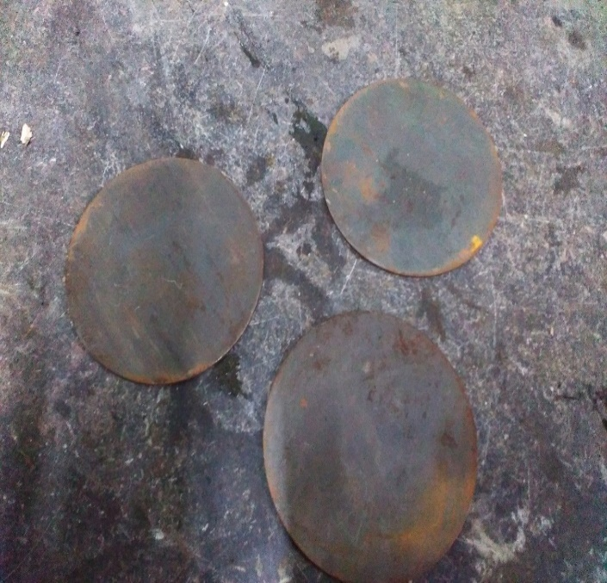

Material: Mild steel

Outer diameter: 250mm

Thickness: 5mm

In geometry, a diskis the region in a plane bounded by a circle. A disk is said to be closed if it contains the circle that constitutes its boundary.

The disk has circular symmetry.

The open disk and the closed disk are not topologically equivalent (that is, they are not homeomorphic), as they have different topological properties from each other. For instance, every closed disk is compact whereas every open disk is not compact. However from the viewpoint of algebraic topology they share many properties: both of them are contractible and so are homotopic equivalent to a single point. This implies that their fundamental groups are trivial, and all homology groups are trivial except the 0th one, which is isomorphic to **Z**. The Euler characteristic of a point (and therefore also that of a closed or open disk) is 1.

Every continuous map from the closed disk to itself has at least one fixed point; this is the case n=2 of the Brouwer fixed point theorem. The statement is false for the open disk:

Consider for example the function

{\displaystyle f(x,y)=\left({\frac {x+{\sqrt {1-y^{2}}}}{2}},y\right)}

Which maps every point of the open unit disk to another point on the open unit disk to the right of the given one. But for the closed unit disk it fixes every point on the half circle

{\displaystyle x^{2}+y^{2}=1,x>0.}

**TORQUE CALCULATION ON A CIRCULAR DISC**

* Diameter(d)=300 mm
* Thick(t)= 5 mm
* RPM(N)=100
* Let, Y.S. of mild steel(Y)=250 N/mm^2
* Now ,Allowable Shear Stress(S)=Y*0.5 =250*0.5 =125 N/mm^2
* Let, F.O.S.(F)=2.5
* Therefore, Allowable Shear Stress=S/F =125/2.5 = 50 N/mm^2
* Also, Let Polar moment of Inertia is "J" and the Radius of shaft "R"(also the maximum distance from center)  
    
  Now, the formula for torque is,  
  **Torque(T)= (J*S)/R**  
  Now, J= (3.14*d^4)/32  
  = (3.14*300^4)/32  
  = 794812500 mm^4  
    
  Now, substitute all the values,  
  T= (794812500*50)/150  
  = 264937500 N-mm  
  **T = 265 KN-M**  
  Now, The formula for power required,  
  **Power(P) = T*W**  
  where, W= angular velocity  
    
  Now, W= (2*3.14*N)/60  
  = (2*3.14*100)/60  
  = 10.5 RPS  
    
  now substitute the values,  
  P= (265*10.5)  
  = 2774 KN-m/s  
  **P= 2774 KW**

**METAL FRAME**

The metal frame is generally made of mild steelbars for machining, suitable for lightly stressed components including studs, bolts, gears and shafts. It can be case-hardened to improve wear resistance. They are available in bright rounds, squares and flats, and hot rolled rounds

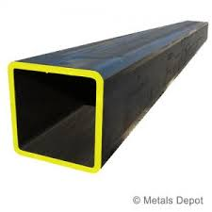

Suitable machining allowances should therefore be added when ordering. It does not contain any additions for enhancing mechanical or machining properties. Bright drawn mild steel is an improved quality material, free of scale, and has been cold worked (drawn or rolled) to size. It is produced to close dimensional tolerances. Straightness and flatness are better than black steel. It is more suitable for repetition precision machining. Bright drawn steel has more consistent hardness, and increased tensile strength. Bright steel can also be obtained in precision turned or ground form if desired.

**MANUFACTURING PROCESS**

Manufacturing processes are the steps through which raw materials are transformed into a final product. The manufacturing process begins with the creation of the materials from which the design is made. These materials are then modified through manufacturing processes to become the required part. Manufacturing processes can include treating (such as heat treating or coating), machining, or reshaping the material. The manufacturing process also includes tests and checks for quality assurance during or after the manufacturing, and planning the production process prior to manufacturing.

**SAWING:**

Cold saws are saws that make use of a circular saw blade to cut through various types of metal, including sheet metal. The name of the saw has to do with the action that takes place during the cutting process, which manages to keep both the metal and the blade from becoming too hot. A cold saw is powered with electricity and is usually a stationary type of saw machine rather than a portable type of saw.

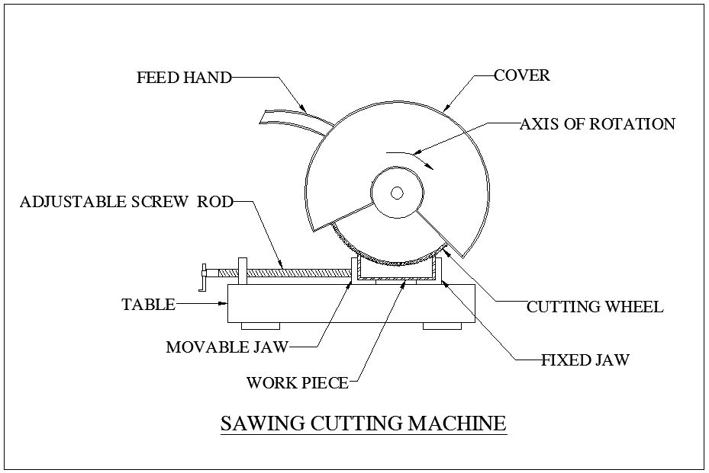

The circular saw blades used with a cold saw are often constructed of high speed steel. Steel blades of this type are resistant to wear even under daily usage. The end result is that it is possible to complete a number of cutting projects before there is a need to replace the blade.High speed steel blades are especially useful when the saws are used for cutting through thicker sections of metal.

**WELDING:**

Welding is a process for joining similar metals. Welding joins metals by melting and fusing **1,** the base metals being joined and **2,** the filler metal applied. Welding employs pinpointed, localized heat input. Most welding involves ferrous-based metals such as steel and stainless steel.Weld joints are usually stronger than or as strong as the base metals being joined.

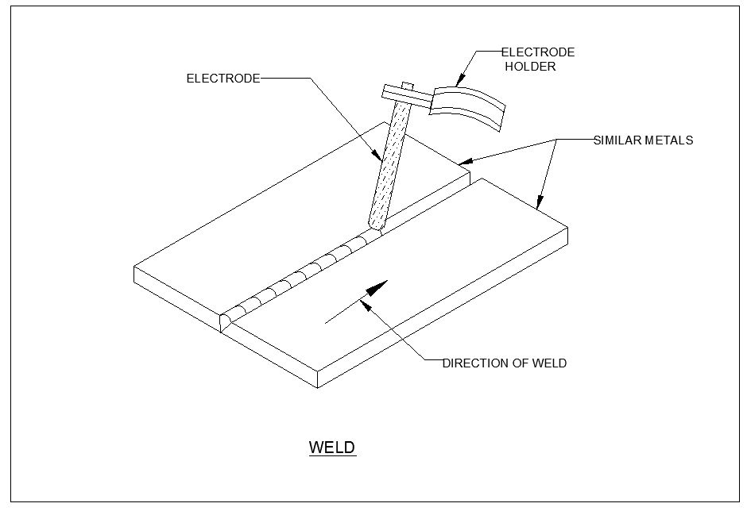

Welding is used for making permanent joints. It is used in the manufacture of automobile bodies, aircraft frames, railway wagons, machine frames, structural works, tanks, furniture, boilers, general repair work and ship building.

**OPERATION:**

Several welding processes are based on heating with an electric arc, only a few are considered here, starting with the oldest, simple arc welding, also known as shielded metal arc welding (SMAW) or stick welding.

In this process an electrical machine (which may be DC or AC, but nowadays is usually AC) supplies current to an electrode holder which carries an electrode which is normally coated with a mixture of chemicals or flux. An earth cable connects the work piece to the welding machine to provide a return path for the current. The weld is initiated by tapping ('striking') the tip of the electrode against the work piece which initiates an electric arc. The high temperature generated (about 6000oC) almost instantly produces a molten pool and the end of the electrode continuously melts into this pool and forms the joint.The operator needs to control the gap between the electrode tip and the work piece while moving the electrode along the joint.

**DRILLNG:**

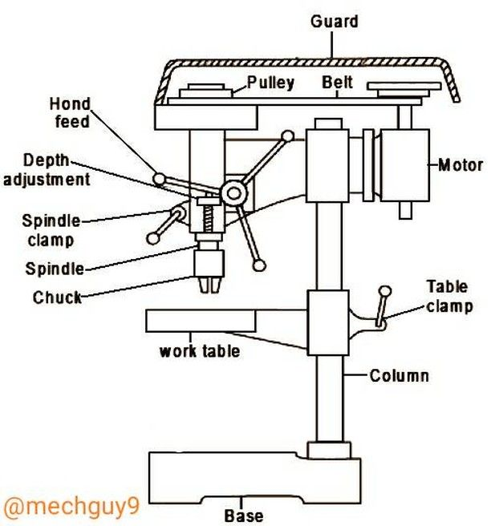

Drilling is a cutting process that uses a drill bit to cut or enlarge a hole of circular cross-section in solid materials. The drill bit is a rotary cutting tool, often multipoint. The bit is pressed against the work piece and rotated at rates from hundreds to thousands of revolutions per minute. This forces the cutting edge against the work piece, cutting off chips (sward) from the hole as it is driller.

**CHAPTER 5**

**ADVANTAGES AND APPLICATIONS**

**ADVANTAGES**

* Cost-effective: Pedal-powered machines are generally cheaper to build and maintain compared to motorized machines. They do not require fuel or electricity to operate, which can result in lower operational costs, making them more affordable for small-scale farmers or those in rural areas with limited access to electricity or fuel.
* Environmentally friendly: Pedal-powered machines do not produce harmful emissions or contribute to air or noise pollution, making them eco-friendly. They are powered by human energy, which is renewable and sustainable, reducing the carbon footprint and environmental impact compared to machines powered by fossil fuels.
* Health benefits: Pedal-powered machines provide an opportunity for physical exercise, promoting healthy living for the operators. Pedaling can help improve cardiovascular fitness, muscle strength, and endurance, providing health benefits for those who operate the machine regularly.
* Local empowerment: Pedal-powered machines can be built and repaired locally using readily available materials, tools, and skills. This promotes local entrepreneurship and empowers local communities by providing them with the means to build and maintain their own machines, creating employment opportunities and enhancing local skills and knowledge.
* Accessibility: Pedal-powered machines can be operated in remote areas with limited or no access to electricity or fuel. This makes them suitable for small-scale farmers in rural or off-grid areas, providing them with a means to mechanize their farming operations and improve productivity.
* Versatility: Pedal-powered machines can be designed and fabricated for various agricultural tasks, including threshing, milling, dehusking, and grinding of paddy rice. They can also be adapted for other crops or applications, making them versatile and adaptable to different farming needs.
* Low maintenance: Pedal-powered machines are generally simple in design, with fewer moving parts compared to motorized machines, which can result in lower maintenance requirements. This can reduce the need for specialized skills or expensive spare parts, making maintenance more accessible and affordable.
* Sustainability: Pedal-powered machines promote sustainable agriculture by reducing dependence on fossil fuels, minimizing environmental impact, and promoting local empowerment. They can contribute to sustainable farming practices by providing a low-cost, eco-friendly, and accessible solution for small-scale farmers.
* Overall, designing and fabricating a pedal-powered paddy rice machine can offer several advantages, including cost-effectiveness, environmental friendliness, health benefits, local empowerment, accessibility, versatility, low maintenance, and sustainability, making them a viable option for small-scale farmers or those in remote or off-grid areas.

**APPLICATION**

* Pedal Power Mechanism: The main source of power for the thresher is human pedal power. A pedal system is designed to transfer the energy from the pedaling action of the operator to the thresher unit, which is responsible for separating the rice grains from the husks.
* Thresher Unit: The thresher unit consists of a drum or a cylinder with spikes or teeth that rotate when the pedal is operated. The harvested paddy rice stalks are fed into the thresher unit, and the rotating spikes or teeth separate the rice grains from the husks.
* Husk Separation Mechanism: Once the rice grains are separated from the husks by the thresher unit, a mechanism is designed to separate the husks from the rice grains. This can involve the use of screens, blowers, or other methods to separate the lighter husks from the heavier rice grains.

**CHAPTER 6**

**MATERIAL USED**

|  |  |  |  |
| --- | --- | --- | --- |
| S.No | DESCIRPTION | QTY | MATERIAL |
| 1 | CHAIN DRIVE | 1 | STAINLESS STEEL |
| 2 | DISC | 1 | MILD STEEL |
| 3 | BEARING | 8 | STAINLESS STEEL |
| 4 | FRAME | AS PER REQUIRMENT | MILD STEEL |
| 5 | SHAFT | AS PER REQUIRMENT | MILD STEEL |
| 6 | METAL STRIP | AS PER REQUIRMENT | MILD STEEL |

**CHAPTER 7**

**COST ESTIMATION**

|  |  |  |
| --- | --- | --- |
| SL.NO | DISCRIPTION | COST Rs: |
| 1 | WELDING MACHINE | 1000 |
| 2 | GRINDING MACHINE | 1500 |
| 3 | CUTING MACHINE | 1000 |
| 4 | WELDIJNG ROD | 650 |
| 5 | CUTTING WHEEL | 350 |
| 6 | PINT AND BRUSH | 500 |
| 7 | CHINE AND BEARING | 600 |
| 8 | METAL PLATE | 400 |
| 9 | METAL SQUARE TUBE | 1800 |
| 10 | METAL BENDING | 800 |
| 11 | SPROCKET | 400 |
|  | TOTAL | 9000 |

**CHAPTER 8**

**2D LAYOUTS OF MODEL**

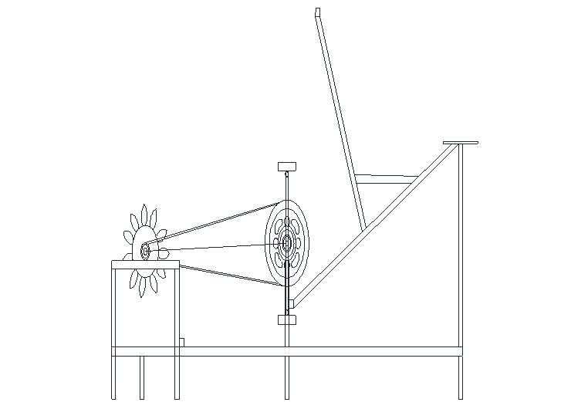

**CHAPTER 9**

**PHOTOGRAPHY**

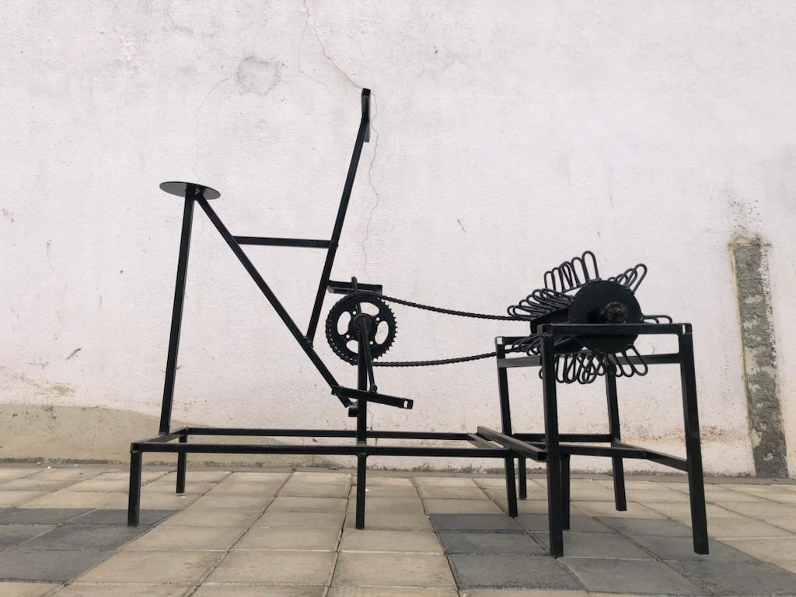

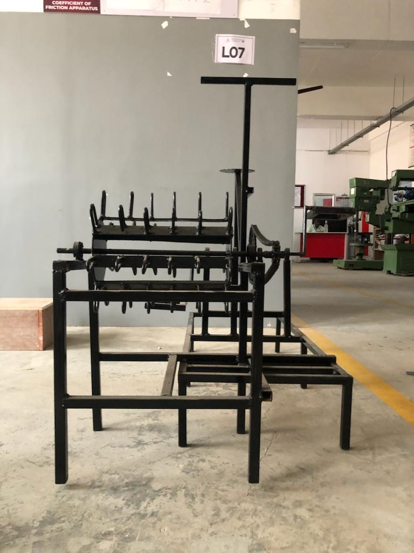

**CHAPTER 10**

**CONCLUSION**

The thresher substantially reduces the human labour involved in threshing at an affordable cost and also reduces the time used for threshing operation on small farms. The machine further reduces the post- harvest losses experienced in small scale rice growing field which is a bigger challenge in most of the developing countries. For ease the removal of the paddy grain from the stalk, threshing was efficient for rice with moisture content between 20% and 23%. Total power required by the machine was 84 watts operating at 400 rpm. This power is produced through human operated pedal mechanism. Performance test revealed that the efficiency of the machine was 92% with a through put of 90 kg per hour.

**CHAPTER 11**

**REFERENCE**

1. Rice Policy-World Rice Statistics (WRS). International Rice Research Institute, IRRI web. http://www.irri.org/science/ricestat, 2009
2. National rice development strategic plan Government of Kenya, Ministry of Agriculture, 2016.
3. Earth trends 28 (2) : 37 – 40 , (2018) web. <http://www.earthtrendswri.org/pdf_> library/feature/agr_fea_ dissapear pdf
4. https://en.wikipedia.org/wiki/Human_power
5. K. N. Agrawal, E. V. Effect of thresher drive linkage design on human physiological. Agric Eng Int: CIGR Journal, 2013. 1-9.
6. Olumuyiwa B. Ajayi1 Buliaminu Kareem, O. R. Comparative Quality And Performance Analysis Of Manual. Ondo State: Innovative Systems Design and Engineering. 2014.
7. Satapathy, G. C., and S. K. Mohanty. Ergonomical Evaluation of Pedal Operated Paddy Thresher. Progress Report of All India Coordinated Research Project on Ergonomics and Safety in Agriculture (Bhubneswar Centre). Orissa University of Agriculture and Technology, Bhubneswar. 2005