**Prognostics of Lithium-ion Battery: A Data-Driven Model Perspective on Remaining Useful Life Time Prediction**

*Report submitted to the SASTRA Deemed to be University as the requirement for the course*

**Course Code: MAT 499**

*Submitted by*

**Thirumalaivasan K**

**(Reg. No.: 124150048)**

**November 2023**



**SCHOOL OF ARTS, SCIENCES, HUMANITIES AND EDUCATION**

**THANJAVUR, TAMIL NADU, INDIA – 613 401**



**SCHOOL OF ARTS, SCIENCES, HUMANITIES AND EDUCATION**

**THANJAVUR – 613 401**

## Bonafide Certificate

This is to certify that the report titled “**Prognostics of Lithium-ion Battery: A Data-Driven Model Perspective on Remaining Useful Life Time Prediction**” submitted as a requirement for the course, **Course Code: MAT 499** for M.Sc. Data Science programme, is a bonafide record of the work done by **Mr.Thirumalaivasan K (Reg.No.124150048**) during the academic year 2022-23, in the School of Arts, Sciences, Humanities and Education, under my supervision.

**Signature of Project Supervisor :**

**Name with Affiliation :**

**Date :**

Project *Viva voc*e held on ________________

**Examiner 1 Examiner 2**



**SCHOOL OF ARTS, SCIENCES, HUMANITIES AND EDUCATION**

**THANJAVUR – 613 401**

## Declaration

I declare that the report titled “**Prognostics of Lithium-ion Battery: A Data-Driven Model Perspective on Remaining Useful Life Time Prediction**” submitted by me is an original work done by me under the guidance of **Dr. V.Swaminathan, Asst.Professor - II, School of Arts, Science, Humanities and Education, SASTRA Deemed to be University** during the third semester of the academic year 2022-23, in the **School of Arts, Science, Humanities and Education**. The work is original and wherever I have used materials from other sources, I have given due credit and cited them in the text of the report. This report has not formed the basis for the award of any degree, diploma, associate-ship, fellowship or other similar title to any candidate of any University.

**Signature of the candidate(s) :**

**Name of the candidate(s) : THIRUMALAIVASAN K**

**Date :**

**Acknowledgements**

My sincere thanks to Prof **R. Sethuraman**, Chancellor, Shanmugha Arts, Science, Technology & Research Academy (SASTRA Deemed to be University) for facilitating us to do this project.

I am grateful to our Vice Chancellor **Dr. S. Vaidhyasubramaniam**, Shanmugha Arts, Science, Technology & Research Academy (SASTRA Deemed to be University) for being a source of inspiration.

I thank our Registrar **Dr. R. Chandramoulli**, Shanmugha Arts, Science, Technology & Research Academy (SASTRA Deemed to be University) for encouraging and supporting myself in this project.

I sincerely thank our Dean **Dr. K. Uma Maheswari**, Dept. of SASHE, Shanmugha Arts, Science, Technology & Research Academy (SASTRA Deemed to be University) for encouraging our endeavors for this project.

I am grateful to my project guide **Dr. V. Swaminathan**, Dept. of SASHE**,** Shanmugha Arts, Science, Technology & Research Academy (SASTRA Deemed to be University) for his valuable suggestions, guidance, constant supervision, and support in all stages for the successful completion of this project.

I gratefully acknowledge all the contributions and encouragement from my family and friends resulting in the successful completion of this project. I thank you all for providing me with an opportunity to showcase my skills through this project.

# Table of Contents

**Title Page No.**

1. Introduction 9
   1. Motivation 9
   2. Why Remaining Useful Life 10
   3. Significance of this study 10
   4. Importance of Li-ion Batteries 11
   5. Battery Management System 12
2. Literature Review 13
3. Objectives 15
4. Methodology 16
   1. Work Flow 16
   2. Feature Extraction 17
   3. Data-Driven Models 18
5. Results and Discussion 21
6. Conclusion and Future Work 22
7. References 23
   1. Similarity Check Report

# List of Figures

|  |  |  |
| --- | --- | --- |
| **Figure No.** | **Title** | **Page No.** |
| 1 | Lithium-ion 18650 Batteries | 9 |
| 2 | Battery States | 12 |
| 3 | Work Flow | 17 |
| 4 | Feature Selection Heat-map | 19 |
| 5 | Regression | 19 |
| 6 | SVR-Linear | 20 |
| 7 | SVR-RBF | 20 |
| 8 | MLP Architecture | 21 |
| 9 | RMSE Comparison | 22 |

# List of Tables

|  |  |  |
| --- | --- | --- |
| **Table No.** | **Table name** | **Page No.** |
| 1 | Metrics Value | 22 |

# Abstract

Lithium-ion (Li-ion) batteries have found wide-ranging applications in various industrial sectors. Accurate battery evaluation is critical for assessing battery life and ensuring safe and reliable operation, particularly in electric vehicles (EVs). In this work, we presented a method for precise Remaining Useful Life (RUL) prediction of Li-ion batteries using a Data-Driven Model.

The Hawaii Natural Energy Institute conducted an extensive analysis of Li-ion batteries at a temperature 25°C. Specifically, they examined 14 NMC-LCO 18650 batteries, each with a nominal capacity of 2.8 Ah, subjecting them to more than 1000 charge-discharge cycles.

This study leverages Data-Driven Model techniques to predict RUL, focusing on Support Vector Regression (SVR) with both linear and Radial Basis Function (RBF) kernels, as well as Multilayer Perceptron (MLP) regression. To enhance model performance, feature selection was carried out using the correlation method, utilizing data associated with voltage and cycle index. The models were meticulously trained and rigorously tested to ascertain their predictive accuracy. Upon applying the trained models to experimental data, the results demonstrate the efficacy of the algorithms in accurately forecasting battery RUL. To quantify the performance of the RUL predictions, a regression analysis was performed using the Root Mean Square Error (RMSE). This evaluation metric provides a reliable measure of how well the models perform in predicting the Remaining Useful Life of the batteries.

*Keywords: Lithium-ion Battery, Remaining Useful Life, support vector regression, multi-layer perceptron.*

**CHAPTER 1**

# INTRODUCTION

This study's primary goal is to predict a lithium-ion battery's (LIB) Remaining Useful Life (RUL) in real time while the EV is being driven. Various variables, including voltage, current, temperature, state of charge (SOC), state of health (SOH), and cycle index, are considered to determine the expected lifespan of a lithium-ion battery. This study employs data-driven models to make real-time predictions of a lithium-ion battery's RUL.

**1.1 Motivation**

The main energy source for conventional cars, sometimes referred to as internal combustion engine vehicles or ICEVs, is hydrocarbon fuel. But when these fuels burn in internal combustion engines (ICEVs), they release toxic gases like carbon dioxide, nitrous oxide, and methane into the atmosphere. These pollutants contribute to both air pollution and global warming. Furthermore, the extensive use of ICEVs has accelerated the depletion of fossil fuels. The desire for eco-friendly, alternative cars that run on sustainable energy sources like electricity is rising as a result.

Due to their all-green, eco-friendly operation, electric vehicles (EVs) have seen a sharp increase in popularity in recent years. The market has seen the entry of numerous automakers, which has increased demand for electric vehicles. EVs frequently employ lithium-ion batteries to store and supply energy.

Real-world usage of lithium-ion batteries exposes them to a variety of variables, such as load variations and temperature swings, which have an immediate effect on their degradation. It's important to remember that lithium-ion batteries have a limited lifespan and that utilizing them longer than intended can be dangerous. Lithium-ion battery overuse can result in potentially dangerous events like explosions or fires. There have been instances of electric car fires that happened while the vehicle was in motion, even though the majority of these accidents were documented during the battery charging procedure. The risks associated with these battery fires are further increased by the hazardous fumes released during the occurrence, which can represent a major threat to the safety of drivers and passengers.

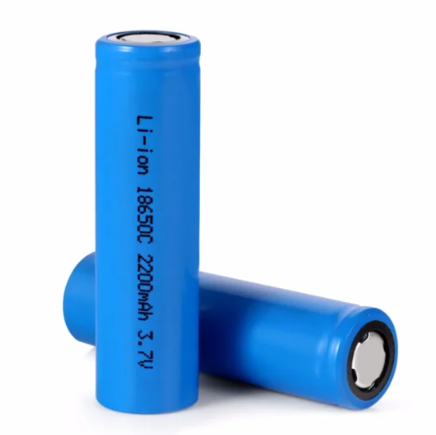

Fig.1 Lithium-ion 18650 Batteries [[1]](https://www.iotwebplanet.com/product/18650-li-ion-rechargeable-battery/)

**1.2 Why Remaining Useful Life**

Remaining Useful Life (RUL) helps in predicting when a battery should be replaced, thereby aiding in the maintenance of optimal performance and safety.

**Performance Optimization:** The best use of a battery is made possible by knowing its RUL. It guarantees that batteries are changed when they are still operating at peak efficiency, avoiding performance deterioration and unplanned breakdowns.

**Economic Efficiency:** Cost savings can result from handling battery replacement and maintenance effectively. It might be expensive to replace batteries that still have life remaining in them, but prolonging their lifespan can save a lot of money.

**Environmental Effects:** There are environmental effects associated with lithium-ion batteries. Premature battery disposal adds to the waste generated by electronics, and the production of new batteries uses energy and resources. Estimating RUL cuts down on waste and lowers the battery's environmental impact.

**Energy Storage:** Accurate RUL prediction is essential for applications like as electric vehicles and renewable energy storage systems. Battery energy storage powers these systems, and being aware of the RUL guarantees a consistent and dependable energy source.

**Consumer confidence:** Customer trust is fostered by anticipating RUL and guaranteeing the safe and dependable operation of electric vehicles. Reliability and safety are important considerations when adopting electric cars and other green energy sources.

**1.3 Significance of this study**

This study is significant in two ways:

**Environmental Impact:** Accurate estimation of the remaining usable life (RUL) of lithium-ion batteries is essential given the rising demand for electric vehicles (EVs) and the shift to sustainable transportation. By facilitating effective battery management, which prolongs battery life and lessens the environmental impact by reducing the disposal of prematurely abandoned batteries, this research helps to reduce battery waste.

Safety and Reliability: Ensuring the safety and dependability of electric cars is of utmost importance. By lowering the possibility of battery-related events like fires and explosions, developing a Data-Driven Model for RUL prediction improves driver and passenger safety. Additionally, it increases EVs' dependability and performance, boosting consumer confidence in this emerging sector.

**1.4 Importance of li-ion Batteries:**

For a variety of reasons, lithium-ion (Li-ion) batteries are extremely important, and their widespread use has revolutionised numerous sectors and daily areas of life. The following main ideas emphasise how crucial Li-ion batteries are:

**Portable Electronics:** Li-ion batteries are used to power a variety of portable electronics, including cameras, computers, tablets, and smartphones. These gadgets provide long-lasting power and are lightweight and compact because of their high energy density, which makes them extremely portable and practical.

**Electric Vehicles (EVs):** Li-ion batteries are an essential part of electric vehicles, or EVs for short. Because of their high power-to-weight ratio, electric vehicles (EVs) can store and supply the energy needed for driving, lowering their dependency on fossil fuels and greenhouse gas emissions.

**Renewable Energy Storage:** Li-ion batteries are used for the storage of energy produced by renewable resources, such as wind turbines and solar panels. This makes it possible to store extra energy generated by the sun or wind and use it later on when these sources aren't supplying electricity.

**Grid Stabilisation:** By offering quick-response energy storage options, Li-ion batteries can support grid stability. In addition to enhancing grid resilience and facilitating the incorporation of intermittent renewable energy sources into the power system, they aid in the balance of energy supply and demand.

**Consumer Electronics:** Li-ion batteries are used in a variety of consumer electronics, such as smart watches, wireless earbuds, and cordless power tools, in addition to laptops and cell phones. This increases the versatility and convenience of these gadgets.

**Medical Devices:** Li-ion batteries power a range of medical devices that give patients greater mobility and independence and enhance their quality of life, such as insulin pumps, prosthetic limbs, and portable oxygen concentrators.

**Space Exploration:** Spacecraft and rovers on far-off planets and moons, as well as space probes, rely on Li-ion batteries as a dependable power source.

**Military Applications:** Li-ion batteries are extensively used in the military for a variety of purposes, such as unmanned aerial vehicles (UAVs), portable electronics, and communication equipment.

**Environmental Benefits:** Because Li-ion batteries have fewer harmful materials, a longer lifespan, and higher efficiency than conventional lead-acid batteries, they are more environmentally friendly. By integrating renewable energy sources and electrifying vehicles, they significantly contribute to the reduction of greenhouse gas emissions.

**1.5 Battery Management System**

A Battery Management System (BMS), an essential part of modern battery technology, must monitor and regulate a battery pack's numerous states and characteristics to ensure safe and efficient operation. Some of the vital circumstances and functions that a BMS monitors are as follows:

Fig.2 Battery States

**State of Charge (SoC):** The BMS keeps an eye on the SoC, which shows how much energy the battery has left. It aids in avoiding deep draining and overcharging, which shorten battery life.

**State of Health (SoH):** The SoH shows the battery's general health and remaining capacity. By performing routine diagnostics, the BMS evaluates SoH and assists in estimating the battery's remaining life.

**Remaining Useful Life (RUL):** Remaining useful life (RUL) is a measure of how long the battery is expected to last before it needs to be replaced.

**End-of-Life State (EoL):** A battery reaches the end of its useful life when it can no longer store enough energy or when it can no longer be used. In this state, managing batteries in an environmentally responsible manner requires proper disposal and recycling.

**State of Energy (SoE):** An essential concept for comprehending available capacity and optimising energy use, the SoE shows how much energy is stored in a battery or energy storage device.

# Chapter 2

# LITERATURE REVIEW

This literature survey examines various studies on battery state, with a specific focus on approaches that address the challenges of RUL prediction for the Li-ion Battery, a ground-breaking technology that has gained importance in recent years.

1. "Batteries for plug-in hybrid electric vehicles (PHEVs): goals and the state of technology circa 2008."This technical report likely discusses the state of battery technology for plug-in hybrid electric vehicles in 2008.

2. "Energy and environmental costs for electric vehicles using CO2-neutral electricity in Sweden." This article explores the energy and environmental costs associated with electric vehicles using CO2-neutral electricity in Sweden.

3. "Energy efficiency analysis of a series plug-in hybrid electric bus with different energy management strategies and battery sizes." This paper likely focuses on the energy efficiency analysis of a series plug-in hybrid electric bus with various energy management strategies and battery sizes.

4. "A modified model-based state of charge estimation of power lithium-ion batteries using the unscented Kalman filter." This article discusses a modified model for estimating the state of charge of power lithium-ion batteries, using the unscented Kalman filter as a tool.

5. "Review and recent advances in battery health monitoring and prognostics technologies for electric vehicle (EV) safety and mobility.” This article provides a review of recent advances in battery health monitoring and prognostics technologies, particularly in the context of electric vehicle safety and mobility.

6. "Use of lithium-ion batteries in electric vehicles." This article likely discusses the use of lithium-ion batteries in electric vehicles.

7. "Online model identification of lithium-ion battery for electric vehicles." This paper likely covers the online model identification of lithium-ion batteries for electric vehicles.

8. "Methods for state-of-charge determination and their applications.” This article discusses various methods for determining the state of charge of batteries and their applications.

9. "A review on the key issues for lithium-ion battery management in electric vehicles.” This review article likely provides an overview of the key issues related to the management of lithium-ion batteries in electric vehicles.

10. "Health diagnosis and remaining useful life prognostics of lithium-ion batteries using data-driven methods.” This article likely focuses on the health diagnosis and remaining useful life prognostics of lithium-ion batteries, utilizing data-driven methods.

**CHAPTER 3**

# OBJECTIVES

* The goal of the work is to provide accurate models for predicting the Remaining Useful Life (RUL) of lithium-ion batteries (LIBs) in electric vehicles (EVs).
* To predict RUL for 14 NMC-LCO lithium-ion batteries, it uses Multi-Layer Perceptron (MLP) and Support Vector Regression (SVR) models.
* The study's scope is restricted to data obtained solely from the Hawaii Natural Energy Institute (HNEI), with a particular emphasis on batteries that are kept at a constant 25°C.
* The major goal is to deliver precise RUL point forecasts so that proactive battery replacement and maintenance plans can be implemented to improve safety and lengthen battery life.
* The electric vehicles sector can benefit from this work, which emphasises sustainability, efficiency, and safety.

**CHAPTER 4**

**METHODOLOGY**

**4.1 Work Flow**

The systematic strategy and set of methods used to carry out research, gather data, and analyse information in a structured and organised way are referred to as methodology.

Fig.3 Work Flow

**4.2 Data Collection:**

The Hawaii Natural Energy Institute's GitHub repository provided the dataset used in this study. It's critical to comprehend the parameters and circumstances surrounding the data collection process. Based on the details you submitted, the following are some salient features of the dataset:

**4.2.1** **Data Description:**

* The Hawaii Natural Energy Institute provided the dataset. Data on 14 NMC-LCO 18650 batteries is included in the dataset.
* The storage capacity of these batteries is indicated by their nominal capacity of 2.8 Ah. The batteries underwent more than a thousand cycles of charging and discharging.
* A CC-CV (Constant Current-Constant Voltage) charge rate of C/2 and a 1.5C discharge rate were used for the charging process. A constant temperature of 25°C was used for the tests. Lithium-ion battery behavior and performance can be greatly impacted by temperature.

**4.3 Data preprocessing**

The dataset was carefully examined at the data preprocessing stage to guarantee data purity and quality. The first thing that was done was to look for missing values. It's important to highlight that there were no null values found in the dataset. Because of this, the dataset utilized in this work is regarded as full and clean, offering a strong basis for further analysis and modelling.  
  
**4.4 Feature Selection**

The correlation approach and heatmap analysis were utilised in the process of choosing features to determine which factors were most relevant in predicting Remaining Useful Life (RUL). Because of their significant correlation with the objective variable, RUL, three essential feature variables were chosen: "Max. Voltage Discharge (V)," "Min. Voltage Charge (V)," and "Cycle Index." This technique successfully decreased the dataset's dimensionality and made sure that only the most important aspects were taken into account for further modelling.

The choice of "Max. Voltage Discharge (V)" and "Min. Voltage Charge (V)" is very crucial since these values reflect how well the battery performs during these cycles, which are crucial markers of its longevity and health. "Cycle_Index" was added to record the battery's cycle history, which is important data for RUL prediction.

Strong correlations were easier to spot thanks to the heat-map visual depiction of the feature-variable relationships. The predictive model was optimized by concentrating on these three crucial elements, which produced more precise and effective RUL forecasts.

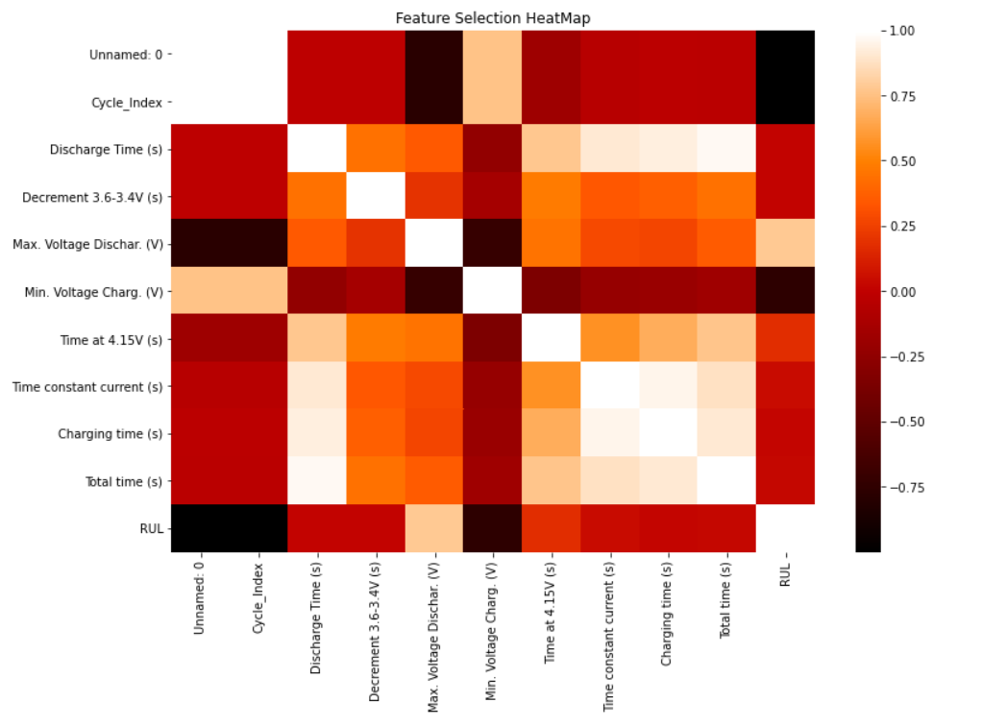

Fig.4 Feature Selection Heat-Map

**4.5 Data-Driven Models:**

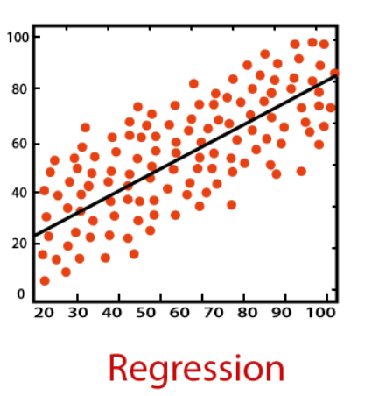In this study, Remaining Useful Life (RUL) was predicted using a data-driven method. Support Vector Regression with a linear kernel (SVR-linear), Support Vector Regression with a radial basis function kernel (SVR-RBF), and Multilayer Perceptron (MLP) regressor were the three different machine learning models that were used. The selection of these models were based on their capacity to represent intricate non-linear relationships and patterns found in the data.

**4.5.1 SVR:**

The Data-driven approach known as Support Vector Regression (SVR) is used for regression tasks. It is a variant of the widely used Support Vector Machine (SVM) technique, which is primarily applied to problems involving classification. SVR, on the other hand, is appropriate for regression problems since it is made to predict continuous output values.

Fig.5 Regression [[2]](https://www.analyticsvidhya.com/blog/2021/06/support-vector-machine-better-understanding/)

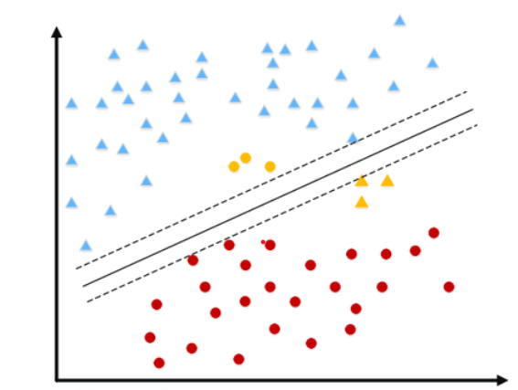**Linear Kernel**: Datasets with linear connections between input features and the target variable are good candidates for the linear kernel. To model the data, it creates a linear decision boundary in feature space. When features such as voltage, cycle index, and RUL have primarily linear correlations, this kernel may perform well in the context of battery RUL prediction.

Fig.5 SVR-Linear [[3]](https://www.analyticsvidhya.com/blog/2021/06/support-vector-machine-better-understanding/)

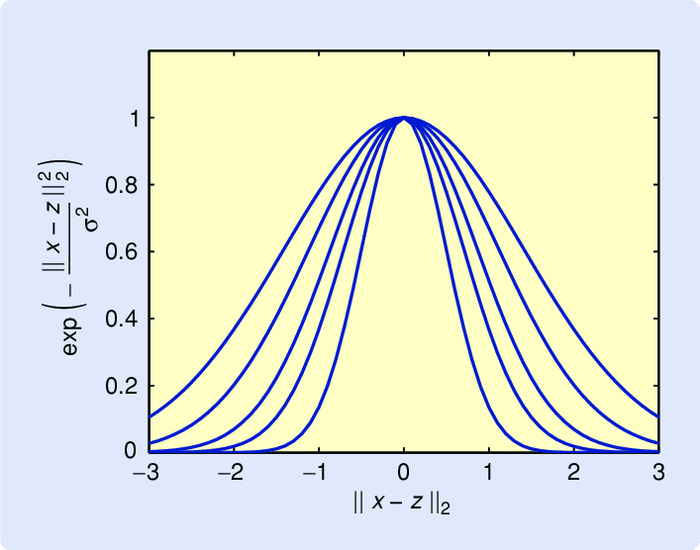**RBF Kernel:** When there are nonlinear relationships in the data, the RBF kernel is especially helpful. It produces a decision boundary that can capture intricate patterns and fluctuations in the data without being limited to a linear shape. This kernel can take into consideration nonlinear influences in battery behavior while predicting battery RUL.

Fig.6 SVR-RBF [[4]](https://www.researchgate.net/figure/Example-of-a-kernel-function-The-Gaussian-radial-basis-function-kernel-is-shown-here-for_fig1_3207903)

**4.5.2 MLP**

A kind of artificial neural network (ANN) used in machine learning and deep learning is called an MLP, or multilayer perceptron. Because it is a feed-forward neural network, information passes via one or more hidden layers and flows in a single direction, from input to output.

**Multilayer Structure:** An input layer, an output layer, and one or more hidden layers make up an MLP. Because battery records frequently contain complicated patterns and correlations, these networks' ability to learn complex interactions within the data is especially useful.

**Nonlinearity:** The model can capture and depict complex, nonlinear relationships in the data because of the activation functions inside the hidden layers, which create nonlinearity.

**Training:** To reduce the error between the anticipated and actual RULs, MLPs are trained using optimization techniques such as back propagation, which modifies the weights in the network.

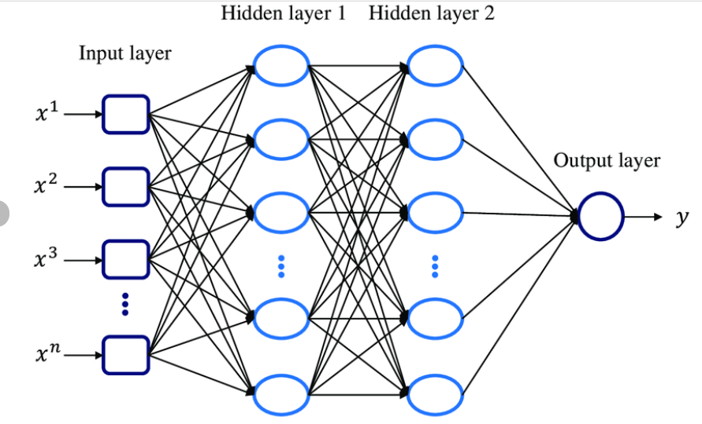

Fig.7 MLP Architecture [[5]](https://www.researchgate.net/figure/Multilayer-perceptron-MLP-architecture-with-two-hidden-layers-and-one-prediction-output_fig1_349630467)

**CHAPTER 5**

**RESULTS AND DISCUSSION**

Root Mean Square Error (RMSE) is a commonly used metric to evaluate the accuracy of predictions, including predictions for Remaining Useful Life (RUL) in various applications. The formula for RMSE in the context of RUL prediction can be expressed as follows:

RMSE = $\sqrt{\sum_{i=1}^{n}{\left|x^{'}-x\right|²}}$/n

Where:

n : The total number of data points or predictions.

$(x)$ Predicted: The predicted RUL values generated by the RUL prediction model.

${(x}^{'})$ Actual: The actual RUL values from the dataset or ground truth.

|  |  |  |  |
| --- | --- | --- | --- |
| **Algorithm** | **RMSE** | **MSE** | **R²** **_score** |
| SVR-Linear | 99.25 | 9852.40 | 0.904 |
| SVR-RBF | 107.03 | 11457.50 | 0.889 |
| MLP | 14.62 | 213.82 | 0.997 |

Table.1 Metrics value (14 NMC-LCO 18650 Batteries)

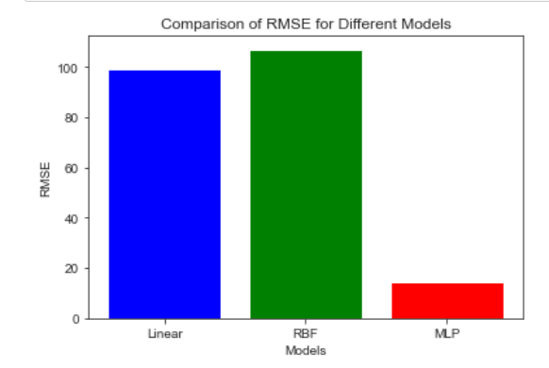

The RMSE, MSE and R² Score of the predicted results for the batteries with the profiles of charge and discharge, by comparing it with a regression analysis, we find the Multi-Layer Perceptron regressor has a lower error rate.

Fig.8 RMSE Comparison

**CHAPTER 6**

**CONCLUSION AND FUTURE WORK**

**5.1 Conclusion**

* In summary, this mini-project utilized Data-Driven Model techniques, including Support Vector Regression (SVR) with linear and Radial Basis Function (RBF) kernels, as well as Multilayer Perceptron (MLP) regression, to predict the Remaining Useful Life (RUL) of batteries. Feature selection was conducted using the correlation method, focusing on voltage and cycle index data, resulting in improved model performance.
* A Data-Driven Model for Li-ion battery RUL prediction is presented in this work. This study highlights the accurately forecasting battery RUL, with the MLP model being the standout performer. The findings underscore the value of machine learning in predictive maintenance and resource optimization for battery-dependent systems, offering potential cost savings and efficiency improvements.

**5.2 Future Work**

* Further work can be conducted under a higher number of aging cycles.
* Building more machine learning/deep learning models and compare the results based on various influential factors.

**CHAPTER 7**

**REFERENCES**

1. Axsen J, Burke A, Kurani K. Batteries for plug-in hybrid electric vehicles (PHEVs): goals and the state of technology circa 2008. Tech Rep UCD-ITS RR08e14, Institute of Transportation Studies, University of California Davis; 2008.
2. Johansson B, Martensson A. Energy and environmental costs for electric vehicles using CO2-neutral electricity in Sweden. Energy 2000;25:777–92.
3. Hu X, Nikolce M, Johannesson L, Egardt B. Energy efficiency analysis of a series plug-in hybrid electric bus with different energy management strategies and battery sizes. Appl Energy 2013;111:1001–9.
4. Tian Y, Xia B, Sun W, Xu Z, Zheng W. A modified model based state of charge estimation of power lithium-ion batteries using unscented Kalman filter. J Power Sources 2014;270:619–26.
5. Rezvanizaniani SM, Liu Z, Chen Y, Lee J. Review and recent advances in battery health monitoring and prognostics technologies for electric vehicle (EV) safety and mobility. J Power Sources 2014;256:110–24.
6. Aaldering, L.J., Leker, J., Song, C.H., 2019. Analysis of technological knowledge stock and prediction of its future development potential: the case of lithium-ion batteries. J. Clean. Prod. 223, 301e311.
7. Afzal, A., Ramis, M.K., 2020. Multi-objective optimization of thermal performance in battery system using genetic and particle swarm algorithm combined with fuzzy logics. J. Energy Storage 32, 101815.
8. Altaf, F., Egardt, B., Mårdh, L.J., 2016. Load management of modular battery using model predictive control: thermal and state-of-charge balancing. IEEE Trans. Contr. Syst. Technol. 25, 47e62.
9. Alvarez Ant on, J.C., García Nieto, P.J., de Cos Juez, F.J., S anchez Lasheras, F., Gonz alez Vega, M., Roquení Guti ~ errez, M.N., 2013. Battery state-of-charge estimator using the SVM technique. Appl. Math. Model. 37, 6244e6253.
10. Amine, K., Liu, J., Belharouak, I., 2005. High-temperature storage and cycling of CLiFePO4/graphite Li-ion cells. Electrochem. Commun. 7, 669e673.