

DETAILED KEY AND SCHEME OF EVALUATION

NAME OF THE EXAMINATION: III-B.Tech. II-Semester (R23) Regular Examinations April-2026
NAME OF THE SUBJECT:
SUBJECT CODE:
SUBJECT EXPERT NAME:
Q.No | Sub Q.No | Detailed Answer | Marks allotted
1 | a) | - Separate memory for instructions and data  - Separate buses for instruction fetch and data transfer  - Among common computer architectures, the Harvard Architecture is generally faster than the Von Neumann Architecture because it uses separate memory and separate buses for instructions and data.
1 | b) | - Uses LIFO (Last In, First Out) principle for managing calls  - Saves the current program state (like registers, flags if needed)  - Allows nested subroutine calls without losing track of execution
1 | c) | - RISC uses simple, fixed-length instructions that usually execute in one clock cycle, making operations faster than CISC  - Uniform instruction format enables efficient pipelining, allowing multiple instructions to be processed simultaneously and improving speed
1 | d) | - Addressing mode is the method used by a microprocessor to specify the location of an operand (data) in an instruction  - In the instruction MOV AX, [BX+DI], the addressing mode is Indexed Addressing Mode (also called based-indexed), where the effective address is obtained by adding BX (base) and DI (index) registers
1 | e) | 1. Control Word Format (I/O mode):  D7 = 1 (I/O mode)  D6–D5 = Group A mode (00 → Mode 0)  D4 = Port A (1 → Input)  D3 = Port C upper (0 → Output, assumed)  D2 = Group B mode (0 → Mode 0)  D1 = Port B (0 → Output)  D0 = Port C lower (0 → Output, assumed)  2. Final Control Word:  Binary: 10010000  Hexadecimal: 90H
1 | f) | 1. CPU involvement:  - Interrupt-driven I/O: CPU handles every data transfer after each interrupt → higher CPU usage.  - DMA (Direct Memory Access): DMA controller transfers data directly between memory and device → minimal CPU involvement.  2. Speed and efficiency:  - Interrupt-driven I/O: Slower due to frequent interrupts and context switching.  - DMA: Faster and more efficient for large data transfers since bulk data is moved without CPU intervention.
1 | g) | Physical Address = (CS × 10H) + IP  = (1200H × 10H) + 2500H  = 12000H + 2500H  = 14500H  Physical Address = 14500H
1 | h) | - Mode 1 automatically reloads the timer value after overflow, which makes it easy to generate a continuous square wave (like 2 kHz) without reloading the timer each time.  - This reduces CPU overhead and ensures stable frequency generation.
1 | i) | - In the Intel 8086, memory segmentation divides memory into logical segments (CS, DS, SS, ES), each up to 64 KB, and the physical address is formed using a segment register and an offset.  - It allows access to up to 1 MB memory with 16-bit registers and helps organize code, data, and stack efficiently for better memory management.
1 | j) | - In the Intel 8086, when an interrupt occurs, the CPU completes the current instruction, then pushes the FLAGS, CS, and IP onto the stack and disables further interrupts.  - It then fetches the interrupt service routine (ISR) address from the interrupt vector table, executes the ISR, and finally uses the IRET instruction to restore the saved values and resume the main program.
2 | a) | Pipelining is a technique where instruction execution is divided into stages (like fetch, decode, execute), and multiple instructions are processed overlapping in time—much like an assembly line.  Instead of finishing one instruction completely before starting the next, the CPU works on different stages of multiple instructions simultaneously:  - One instruction is being fetched  - Another is being decoded  - Another is being executed  This improves throughput (instructions completed per unit time), though not the latency of a single instruction.  - Basic Idea of Pipelining  It works like an assembly line in a factory.  Example stages of an instruction:  - Fetch – Get instruction from memory  - Decode – Understand the instruction  - Execute – Perform operation  - Memory Access – Read/write memory  - Write Back – Store result  While one instruction is executing, another can be decoding and another fetching.  Stages of Pipelining  Pipelining divides instruction execution into several stages. Each stage performs a specific task.  1. Instruction Fetch (IF)  - The processor fetches the instruction from memory.  - The instruction is stored in the instruction register.  2. Instruction Decode (ID)  - The fetched instruction is decoded.  - The processor identifies the operation to be performed and required operands.  3. Execute (EX)  - The Arithmetic Logic Unit (ALU) performs the required operation such as addition, subtraction, comparison, etc.  4. Memory Access (MEM)  - If needed, data is read from or written to memory.  5. Write Back (WB)  - The final result is written back into a register.  Given Data  - Number of instructions = 20  completed per unit time), Fetch = 5 cycles  - Execution = 3 cycles  So, each instruction requires:  $$5+3=8\text{ cycles}$$  1. Without Pipelining  Each instruction completes fully before the next begins:  $$\text{Total cycles}=20×8=160\text{ cycles}$$  2. With Ideal Pipelining  Pipeline stages:  - Stage 1: Fetch (5 cycles)  - Stage 2: Execute (3 cycles)  In an ideal pipeline, the clock cycle is determined by the slowest stage:  $$\text{Pipeline cycle time}=5\text{ cycles}$$
3 | a) | A Microprocessor is an important part of a computer architecture without which you will not be able to perform anything  - on your computer.  - It is a programmable device that takes in input performs some arithmetic and logical operations over it and produces the desired output.  A microprocessor is a small electronic chip that functions as the Central Processing Unit (CPU) of a computer system. It is called the “brain of the computer” because it controls and performs all processing operations. A microprocessor accepts input data, processes it according to the instructions stored in memory, and produces the required output. It performs arithmetic operations like addition and subtraction, logical operations like comparison, and control operations to manage system activities.  The main parts of a microprocessor are the Arithmetic Logic Unit (ALU), Control Unit, and registers. The ALU performs mathematical and logical calculations, the Control Unit controls the sequence of operations, and registers temporarily store data and instructions. The microprocessor works on the Fetch–Decode–Execute cycle, where instructions are fetched from memory, decoded, and executed step by step.  Microprocessors are widely used in computers, laptops, smartphones, calculators, communication systems, traffic control systems, and industrial automation. They provide high processing speed, accuracy, reliability, and flexibility. Examples of microprocessors include Intel 8085, Intel 8086, and Intel Pentium Processor.  - A microprocessor is fabricated using VLSI (Very Large Scale Integration) technology, which allows millions of transistors to be placed on a single chip.  - Microprocessors are classified based on word length such as:  - 4-bit  - 8-bit  - 16-bit  - 32-bit  - 64-bit  Higher word length means better processing capability.  - A microprocessor requires external components like:  - Memory (RAM/ROM)  - Input devices  - Output devices  - Clock generator  - The speed of a microprocessor is measured in:  - Hertz (Hz)  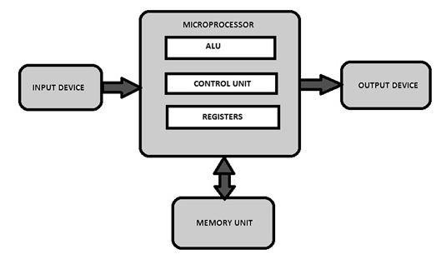  - Megahertz (MHz)  - Gigahertz (GHz)  - Modern microprocessors support:  - Multitasking  - Pipelining  - Cache memory  - Multiprocessing  - Cache memory is used to store frequently used data for faster access.  - Microprocessors communicate with other devices through:  - Address bus  - Data bus  - Control bus  - Important characteristics of a microprocessor:  - Clock speed  - Word length  - Instruction set  - Processing power  - Power consumption  - Difference between microprocessor and microcontroller:  - A microprocessor only contains the CPU.  - A microcontroller contains CPU, memory, and input/output ports on a single chip.  - Applications of advanced microprocessors include:  - Artificial Intelligence systems  - Robotics  - Medical equipment  - Space technology  - Automotive control systems
3 | b) | 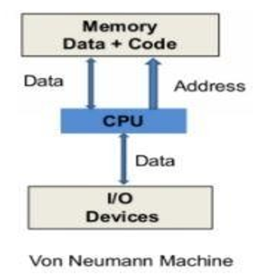  Calculation (Von Neumann architecture):  Each instruction = 4 cycles (fetch) + 6 cycles (execute) = 10 cycles  For 10 instructions = 10 × 10 = 100 cycles  Comparison with Harvard architecture:  In Harvard architecture, instruction fetch and execution can overlap, so total cycles ≈ 4 + (10 × 6) = 64 cycles (pipeline effect), making it faster than Von Neumann due to parallelism.  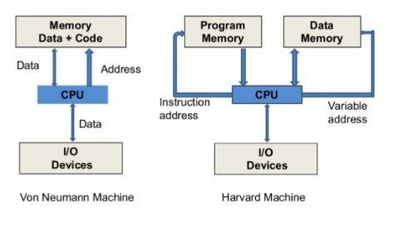
  - Von Neumann | Harvard
  - It is ancient computer architecture based on stored program computer concept. | - It is modern computer architecture based on Harvard Mark I relay based model.
  - Same physical memory address is used for instructions and data. | - Separate physical memory address is used for instructions and data.
  - There is common bus for data and instruction transfer. | - Separate buses are used for transferring data and instruction.
  - Two clockcyclesare required | - An instruction is executed in a
  to execute single instruction. | single cycle.
  - It is cheaper in cost. | - It is costly than Von Neumann Architecture.
  - CPU can not access instructions and read/write at the same time. | - CPU can access instructions and read/write at the same time.
  - It is used in personal computers and small computers. | - It is used in micro controllers and signal processing.
4 | a) | 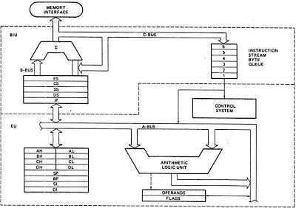  8086 has two blocks BIU and EU.  - The BIU performs all bus operations such as instruction fetching, reading and writing operands for memory and calculating the addresses of the memory operands. The instruction bytes are transferred to the instruction queue.  - EU executes instructions from the instruction byte queue.  Bus Interface Unit:  - It provides full 16 bit bidirectional data bus and 20 bit address bus.  - The BIU is responsible for performing all external bus operations.  - The EU accesses the queue from the output end.  It reads one instruction byte after the other from the output of the queue.  Execution Unit:  The EU extracts instructions from top of the queue in the BIU, decodes them, generates operands if necessary, passes them to the BIU and requests it to perform the read or write bus cycles to memory or I/O and perform the operation specified by the instruction on the operand.  During the execution of the instruction, the EU tests the status and control flags and updates them based on the results of executing the instruction  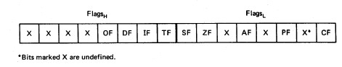  Carry  Parity  Auxiliary  Carry  Zero  Overflow  Direction  Interrupt  enable  Trap  6  are status flags  Out of nine flags, six are condition flags and three are control flags.  The control flags • are TF (Trap), IF (Interrupt) and DF (Direction) flags, which can be set/reset by the programmer.  while the condition flags [OF (Overflow), SF (Sign), ZF (Zero), AF (Auxiliary • Carry), PF (Parity) and CF (Carry)] are set/reset depending on the results of some arithmetic or logical operations during program execution.  - CF is set if there is a carry out of the MSB position resulting from an addition operation or if a borrow is needed out of the MSB position during subtraction.
4 | b) | ASSUME CS:CODE, DS:DATA  DATA SEGMENT  OPR1 DW 1234H  OPR2 DW 2341H  RESULT DW ?  DATA ENDS  CODE SEGMENT  START:  MOV AX, DATA ;  MOV DS, AX  MOV AX, OPR1 ;  ADD AX, OPR2 ;  MOV RESULT, AX ;  HLT ;  CODE ENDS  END START  RESULT:  0001 0010 0011 0100  0010 0011 0100 0001  ---------------------------------  0011 0101 0111 0101
5 | a) | - DB (Define Byte) is an assembler directive that tells the assembler to reserve 1 byte of memory and optionally initialize it. Here, NUM DB 25H stores the hexadecimal value 25H in one byte.  - It affects memory allocation by allocating exactly 1 byte for NUM in the data segment, making it a byte-sized variable (unlike DW, which would allocate 2 bytes).  - It allows defining multiple byte values or arrays, e.g., ARR DB 10H, 20H, 30H, which allocates consecutive memory locations for each byte.  - It determines the data size for operations, so NUM must be accessed using 8-bit registers (like AL, BL), ensuring correct instruction usage and avoiding size mismatch errors.  - In Assembly Language Programming (ALP), DB stands for Define Byte. It is an assembler directive used to reserve memory space and store 8-bit data values in memory locations.  - The DB directive is commonly used to define variables, constants, arrays, characters, and strings. Each value defined by DB occupies one byte of memory, and multiple values are stored in consecutive memory locations.  - For example, NUM DB 25H stores the hexadecimal value 25H in one byte, while MSG DB 'HELLO$' stores a string in memory.  - DB is widely used for data initialization in assembly programs and helps the programmer organize and access data efficiently.  - In Assembly Language Programming (ALP), DB (Define Byte) is an assembler directive used to allocate memory and store byte-sized data in memory locations.  - Each data item defined by DB occupies 8 bits or one byte of memory. It is mainly used for defining variables, constants, arrays, characters, and strings required in a program.  - The DB directive can store numerical values in binary, decimal, or hexadecimal form, as well as ASCII characters. Multiple data values defined using DB are stored in consecutive memory locations.  - Since DB is an assembler directive, it does not execute any operation but only helps in reserving and initializing memory during program assembly.  - It is one of the most commonly used directives in microprocessor assembly language programs for efficient data storage and organization.
5 | b) | DATA SEGMENT  ARR DB 10H, 25H, 05H, 40H, 30H  COUNT DB 05H  LARGEST DB ?  DATA ENDS  CODE SEGMENT  ASSUME CS:CODE, DS:DATA  START:  MOV AX, DATA  MOV DS, AX  MOV SI, 0 ;  MOV CL, COUNT ;  MOV AL, ARR[SI] ;  DEC CL ;  NEXT:  INC SI  CMP AL, ARR[SI] ;  JNC SKIP ;  MOV AL, ARR[SI] ;  SKIP:  LOOP NEXT  MOV LARGEST, AL ;  HLT  CODE ENDS  END START  RESULT:  ARR DB 10H, 25H, 05H, 40H, 30H  LARGEST = 40H
6 | a) | 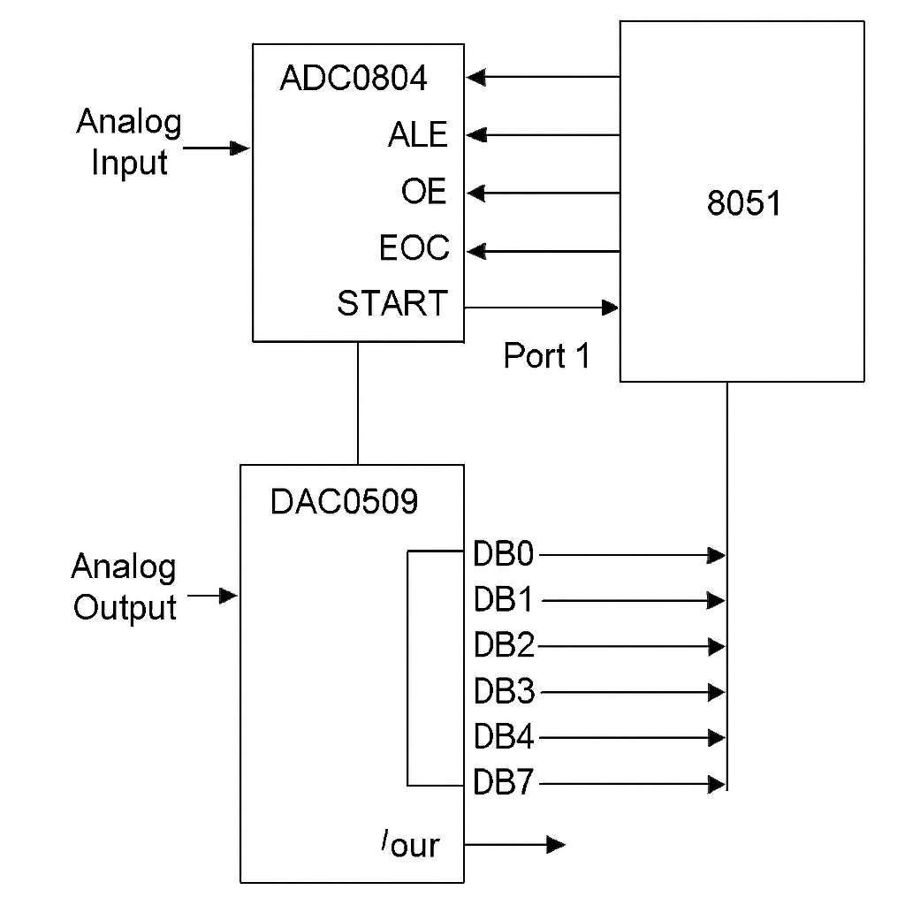  - The analog to digital converter chips 0808 and 0809 are 8-bit CMOS, successive approximation converters.  - This technique is one of the fast techniques for analog to digital conversion. The conversion delay is 100μs at a clock frequency of 640 KHz, which is quite low as compared to other converters.  - An Analog to Digital Converter (ADC) is an electronic device that converts continuous analog signals into digital data that can be processed by computers, microprocessors, and microcontrollers.  - Real-world signals such as temperature, sound, pressure, and light are usually analog in nature, meaning they vary continuously with time. Since digital systems can understand only binary data (0s and 1s), an ADC is used to convert these analog signals into digital form.  - The conversion process generally involves three steps: sampling, quantization, and encoding. ADCs are widely used in digital communication systems, medical instruments, audio and video devices, industrial automation, and embedded systems.  - Important characteristics of an ADC include resolution, accuracy, conversion speed, and sampling rate. Common types of ADCs are Flash ADC, Successive Approximation ADC, Dual Slope ADC, and Counter Type ADC.  - Analog signals are continuous signals obtained from real-world sources such as microphones, sensors, temperature measuring devices, and pressure instruments.  - Since microprocessors, microcontrollers, and computers operate only with digital data, ADCs act as an interface between analog systems and digital systems.  - The conversion process includes sampling the analog signal at regular intervals, quantizing the sampled values into discrete levels, and encoding them into binary form.  - The performance of an ADC depends on factors such as resolution, sampling rate, accuracy, and conversion time. Higher resolution provides more precise digital output.  - ADCs are widely used in data acquisition systems, communication systems, digital voltmeters, robotics, biomedical instruments, audio recording devices, and control systems.  - Different types of ADCs include Flash ADC, Successive Approximation ADC, Ramp Type ADC, and Dual Slope ADC, each designed for specific speed and accuracy requirements.
6 | b) | PORTA EQU 00H  PORTB EQU 02H  PORTC EQU 04H  CTRL EQU 06H  DATA SEGMENT  DATA ENDS  CODE SEGMENT  ASSUME CS:CODE  START:  MOV AL, 80H ;  OUT CTRL, AL  MOV AL, 01H ;  AGAIN:  OUT PORTA, AL ;  CALL DELAY ;  ROL AL, 1 ;  JMP AGAIN  ; Delay subroutine  DELAY:  MOV CX, 0FFFFH  D1: DEC CX  JNZ D1  RET  CODE ENDS  END START
7 |  | 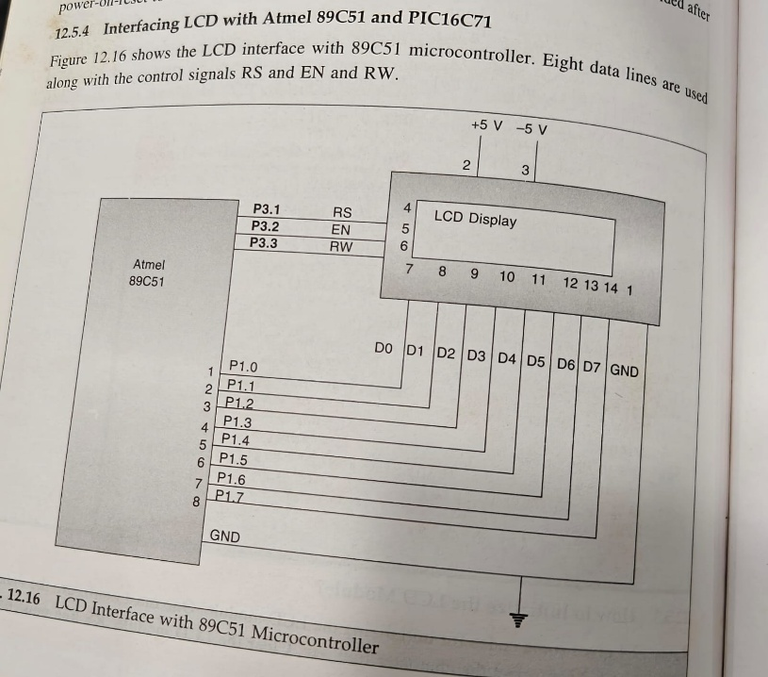  - Alphanumeric Liquid Crystal Displays (LCDs) provide a better user interface by displaying text that shows what the system is doing, including diagnostic information.  - They allow users to enter instructions and receive responses in text form, which helps in fault finding and debugging.  - It is important to justify the use of LCDs instead of LED displays. LEDs generally consume more power.  - LCD interfacing is the process of connecting a Liquid Crystal Display (LCD) with a microprocessor or microcontroller to display data, characters, numbers, and messages. LCDs are widely used in embedded systems because they consume less power, are compact in size, and provide clear output display.  - A typical LCD module such as the HD44780 LCD Controller based 16×2 LCD contains data pins, control pins, and power supply pins. The main control pins are RS (Register Select), RW (Read/Write), and EN (Enable). Data pins are used to send commands and display data to the LCD. The LCD can operate in 4-bit mode or 8-bit mode depending on the number of data lines used.  - During interfacing, the microcontroller sends commands to initialize the LCD, control cursor position, clear the screen, and display characters. LCD interfacing is commonly used in calculators, digital clocks, medical instruments, industrial control systems, and embedded applications to provide visual information to the user. The advantages of LCDs include low power consumption, low cost, lightweight structure, and easy interfacing with digital systems.
8 | i) | 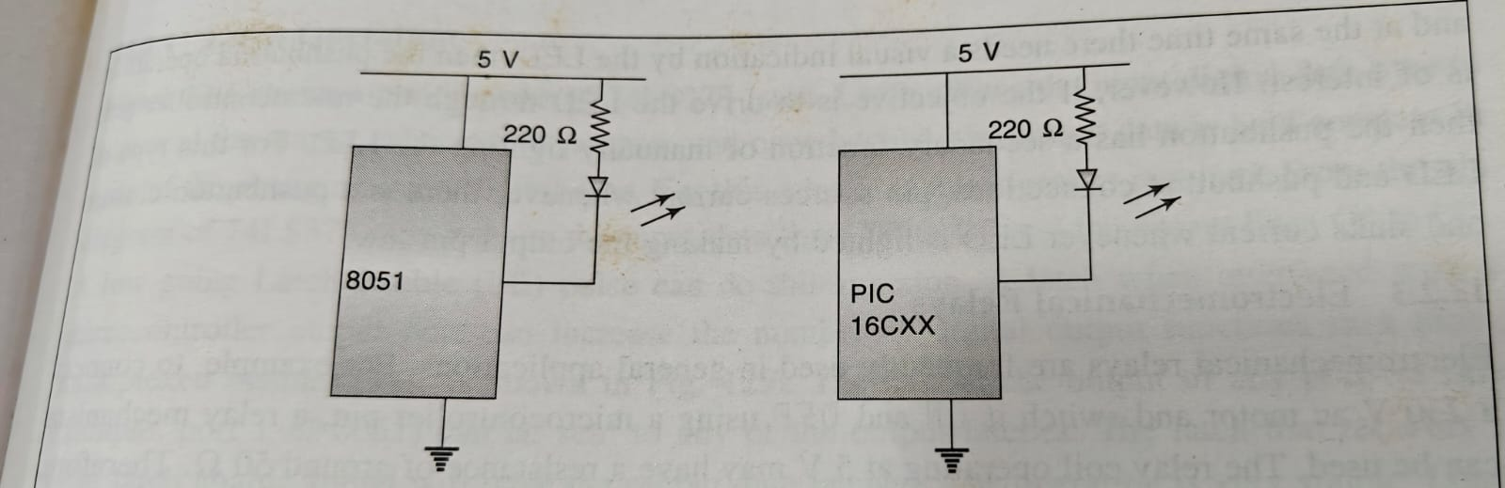  Hardware  - 8051 microcontroller (AT89S52/AT89C51 etc.)  - 6 LEDs (2 roads × 3 lights) or actual lamps via drivers/relays  - 220Ω–330Ω resistors for LEDs  Timing Logic  - Red ON → Wait 10 seconds  - Green ON → Wait 10 seconds  - Yellow ON → Wait 2 seconds  - A traffic light Assembly Language Program (ALP) works by controlling the sequence of red, yellow, and green lights using a microprocessor or microcontroller.  - The program sends output signals to the traffic lights through output ports connected to LEDs or relay circuits. Initially, the program turns ON the green light for one direction while keeping the red light ON for the other directions.  - After a specific delay time, the green light turns OFF and the yellow light turns ON for a short duration to indicate caution. Then the red light becomes active, and the green signal is provided to another road direction.  - This sequence repeats continuously to manage vehicle movement safely and efficiently.  - The ALP uses instructions for data transfer, timing delay generation, looping, and port control. Delay routines are used to maintain each signal for a required time interval.  - In advanced traffic systems, interrupts and sensors may also be included to handle emergency vehicles, pedestrian crossing requests, or traffic density control.  - Traffic light ALP programs are commonly used in embedded systems and automation applications to provide reliable and automatic traffic management.  - Working Principle of Traffic Light System  - The working principle of a traffic light system is based on controlling the flow of vehicles and pedestrians using red, yellow, and green signals in a fixed sequence.  - A microprocessor or microcontroller controls the operation by sending signals to the traffic lights according to a programmed timing sequence.  - Initially, the green light is turned ON for one road direction to allow vehicles to move, while the red light remains ON for the other directions to stop traffic.  - After a fixed delay time, the yellow light turns ON to warn drivers that the signal is about to change. Then the red light becomes active, stopping traffic in that direction, and the green light is given to another road direction. This cycle repeats continuously to regulate traffic safely and reduce accidents.  - The system uses timers, delay circuits, sensors, and control programs for automatic operation. In advanced systems, interrupts and vehicle sensors are used to control traffic according to traffic density or emergency vehicle movement.  - The main objective of the traffic light system is to ensure smooth traffic flow, reduce congestion, and improve road safety.
8 | ii) | - External interrupts (INT0/INT1) can be used to detect emergency signals (e.g., ambulance sensor).  - When triggered, the normal sequence is paused, and control immediately switches to give a green signal to the required lane.  - The current state is saved, and after the emergency passes, the system resumes normal sequencing.  - In traffic signal systems, an interrupt is used to immediately respond to important or emergency events without waiting for the normal signal sequence to finish. Interrupts help the controller give quick attention to high-priority situations.  - For example, when an ambulance, fire engine, or police vehicle approaches a traffic junction, a sensor or switch generates an interrupt signal to the microcontroller. The controller temporarily stops the normal traffic light operation and gives a green signal to the emergency route. After the emergency passes, the system returns to normal operation.  - Interrupts are also used in pedestrian crossing buttons, railway crossing signals, and vehicle detection systems. They improve traffic management, reduce delays, and increase road safety by allowing the controller to respond instantly to external events. Modern traffic control systems commonly use microcontrollers such as ARM Cortex-M3 for handling interrupts efficiently.  - Interrupts play an important role in automatic traffic signal control systems by allowing the controller to react immediately to special events or urgent conditions.  - Normally, traffic lights operate according to a fixed timing sequence, but when an interrupt occurs, the microcontroller temporarily pauses the current operation and executes a special service routine to handle the event.  - After completing the required task, the controller returns to the normal traffic signal sequence.  - In traffic systems, interrupts are commonly generated by emergency vehicle sensors, pedestrian crossing buttons, vehicle density sensors, railway crossing alerts, or accident detection systems.  - For example, if an ambulance approaches a junction, a sensor sends an interrupt signal to the controller, which immediately changes the traffic light to green for the ambulance route.  - Similarly, when a pedestrian presses a crossing switch, an interrupt informs the controller to safely stop vehicles and allow pedestrians to cross the road.  - Interrupt-based traffic control systems improve efficiency, reduce waiting time, provide faster emergency response, and increase public safety.  - Microcontrollers and embedded processors such as ARM Cortex-M3 are widely used in intelligent traffic management systems because they can process interrupts quickly and reliably.
9 | a) | 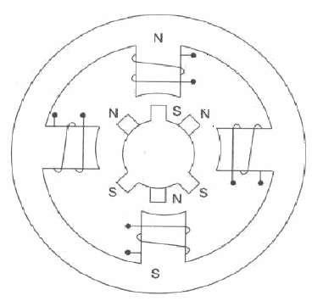  Fig.1 Internal schematic of a four winding stepper motor  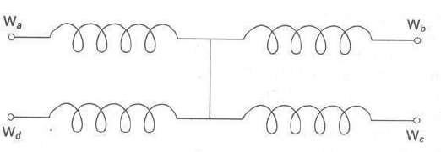  Fig.2 Winding arrangement of a stepper motor.  - A stepper motor is a device used to obtain an accurate position control of rotating shafts.  - It employs rotation of its shaft in terms of steps, rather than continuous rotation as in case of AC or DC motors.  - To rotate the shaft of the stepper motor, a sequence of pulses is needed to be applied to the windings of the stepper motor, in a proper sequence.  - The number of pulses required for one complete rotation of the shaft of the stepper motor is equal t0 its number of internal 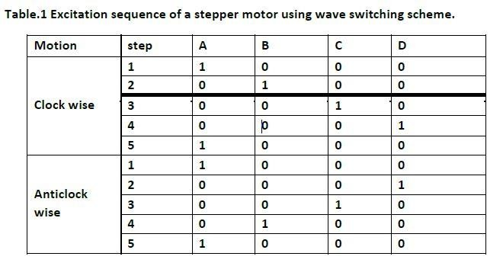teeth on its rotor.  - A stepper motor is an electromechanical device that converts electrical pulses into precise mechanical rotation.  - Unlike ordinary motors, a stepper motor rotates in fixed angular steps, allowing accurate control of position, speed, and direction.  - Each electrical pulse supplied to the motor causes the shaft to move one step forward, making it highly suitable for applications requiring precise movement.  - Stepper motors are widely used in robotics, CNC machines, printers, industrial automation systems, medical instruments, and computer peripherals.  - They are controlled using microcontrollers or microprocessors by supplying pulse sequences to the motor windings.  - The movement can be clockwise or anticlockwise depending on the sequence of pulses applied.  - The main parts of a stepper motor are the stator, rotor, and windings. Common types of stepper motors include Permanent Magnet Stepper Motor, Variable Reluctance Stepper Motor, and Hybrid Stepper Motor.  - Important characteristics of a stepper motor are step angle, torque, speed, and accuracy. The major advantages of stepper motors are precise positioning, easy speed control, good reliability, and the ability to operate without feedback systems. However, they may produce vibration and consume more power compared to some other motors.  - Rotation of Stepper Motor  - The rotation of a stepper motor takes place in small fixed steps instead of continuous rotation. Each electrical pulse given to the motor causes the rotor to rotate by a specific angle called the step angle.  - For example, if the step angle is 1.8°, the motor rotates 1.8° for every input pulse. To complete one full rotation:  - So, the motor requires 200 pulses for one complete revolution.  - The direction of rotation depends on the sequence of pulses applied to the motor windings:  - Clockwise sequence → Clockwise rotation  - Reverse sequence → Anticlockwise rotation  - The speed of rotation depends on the frequency of input pulses. Higher pulse frequency increases motor speed. Because of its precise step-by-step rotation, the stepper motor is widely used in robotics, CNC machines, printers, and automation systems where accurate positioning is required.
10 |  | ARM instruction set :  - ARM uses a RISC (Reduced Instruction Set Computer) design (e.g., ARM architecture), meaning most instructions are simple, fixed-length, and execute in a single cycle. It supports data processing (ADD, SUB, MOV), memory access (LDR, STR), branch (B, BL), and logical operations (AND, ORR, EOR).  - It also supports conditional execution (e.g., ADDEQ, SUBNE), reducing branch instructions and improving efficiency.  - ARM instructions are generally classified into different categories such as data processing instructions, data transfer instructions, branch instructions, and control instructions.  - Data processing instructions perform arithmetic and logical operations like addition, subtraction, AND, OR, and comparison.  - Data transfer instructions move data between registers and memory locations. Branch instructions are used to change the sequence of program execution and implement loops or decision-making operations.  - An important feature of the ARM instruction set is that most instructions can be executed conditionally using condition codes, which improves program efficiency.  - ARM processors also support the Thumb and Thumb-2 instruction sets that provide better code density and reduced memory usage.  - The instruction set uses registers extensively, reducing memory access time and increasing execution speed.  - Examples of ARM instructions include:  - ADD → Addition  - SUB → Subtraction  - MOV → Move data  - LDR → Load data from memory  - STR → Store data to memory  - B → Branch instruction  - The ARM instruction set is widely used in embedded systems, smartphones, robotics, automotive electronics, and portable devices because of its simplicity, efficiency, and low power consumption.  Addressing modes in ARM:  - Immediate addressing: Operand is a constant (e.g., MOV R0, #10)  - Register addressing: Operand is in a register (e.g., ADD R0, R1, R2)  - Direct/absolute addressing: Memory address is specified  - Register indirect: Address held in register (e.g., LDR R0, [R1])  - Indexed addressing: Base register + offset (e.g., LDR R0, [R1, #4])  - Addressing modes are the different methods used by a processor to specify the location of operands or data required for an instruction.  - They determine how the CPU accesses data from registers, memory, or immediate values. Addressing modes help in efficient memory utilization and simplify programming.  - Common addressing modes include Immediate Addressing Mode, where the actual data is directly given in the instruction; Register Addressing Mode, where operands are stored in processor registers; and Direct Addressing Mode, where the memory address of the operand is specified directly in the instruction.  - In Indirect Addressing Mode, the instruction contains a register or memory location that holds the actual address of the operand. Indexed Addressing Mode uses an index register along with an address for accessing arrays and tables, while Relative Addressing Mode is mainly used in branch instructions.  - Different addressing modes provide flexibility, reduce instruction length, improve execution speed, and support complex data handling operations in microprocessors and microcontrollers.  Program to read sensor data and store in memory (example):  AREA PROGRAM, CODE, READONLY  ENTRY  START:  LDR R1, =0x40000000 ;\  LDR R0, [R1] ;  LDR R2, =0x20000000 ;  STR R0, [R2] ;  B START ;  END
11 |  | 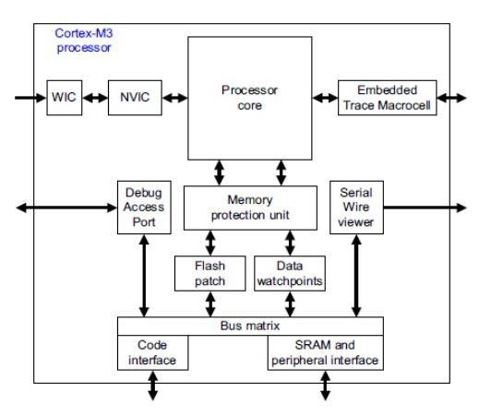  - The ARM Cortex™-M3 processor is the industry-leading 32-bit processor for highly deterministic real-time applications, specifically developed to enable developers to develop high-performance low-cost platforms for a broad range of devices including microcontrollers, automotive body systems, industrial control systems and wireless networking and sensors.  - The processor is highly configurable enabling a wide range of implementations from those requiring memory protection and powerful trace technology to cost sensitive devices requiring minimal area.  - The ARM Cortex-M3 architecture is a 32-bit RISC processor architecture designed for embedded systems and real-time applications.  - It is widely used in microcontrollers because of its high performance, low power consumption, and efficient interrupt handling.  - The Cortex-M3 processor is based on the Harvard architecture, which uses separate buses for instructions and data to improve processing speed.  - It includes important components such as the CPU core, Nested Vectored Interrupt Controller (NVIC), memory system, registers, timers, and input/output interfaces.  - The processor supports pipelining, which increases execution speed by overlapping instruction operations.  - The Cortex-M3 uses a 3-stage pipeline consisting of:  - Fetch  - Decode  - Execute  - It contains 13 general-purpose registers, stack pointer registers, program counter, and status registers.  - The architecture supports both Thumb and Thumb-2 instruction sets, which improve code density and performance.  - One of the important features of Cortex-M3 is the NVIC, which provides fast and efficient interrupt handling with priority control.  - It also supports low-power operating modes, making it suitable for battery-powered devices.  - Applications of Cortex-M3 include:  - Industrial automation  - Robotics  - Medical devices  - Consumer electronics  - Automotive systems  - Embedded control systems  - The Cortex-M3 architecture provides high speed, low cost, low power consumption, and reliable real-time performance, making it one of the most popular embedded processor architectures.

PREPARED BY
Faculty Name:
Designation:
Department:
Signature:

