ASSIGNMENT 4

Vasanthakumar Kalaikkovan

2021-04-21

# Markdown Basics

## Favorite Foods

1. Briyani
2. Pizza
3. Burger

## Images

image: 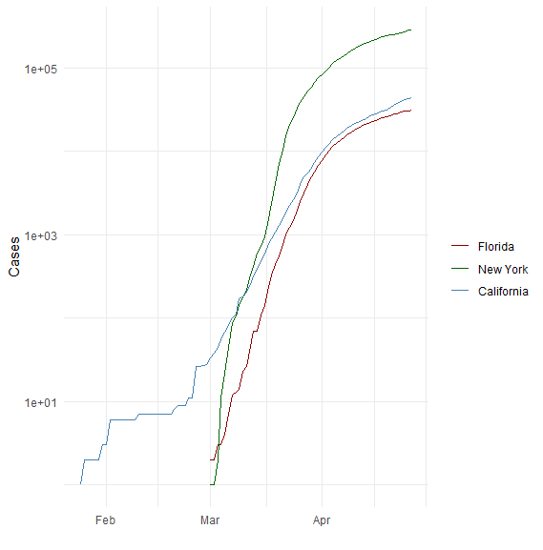

## Add a Quote

It is very easy to defeat someone, but very difficult to win someone

## Add an Equation

$A=π*r^{2}$

## Add a Footnote

This is a footnote

## Add Citations

* R for Everyone
* Discovering Statistics Using R

# Inline Code

library(ggplot2)

## Warning: package 'ggplot2' was built under R version 4.0.5

theme_set(theme_minimal())  
covid_df <- read.csv("E:/Repos/StatisticsR/DSC520-Statistics/data/nytimes/covid-19-data/us-states.csv")  
heights_df <- read.csv("E:/Repos/StatisticsR/DSC520-Statistics/data/r4ds/heights.csv")  
ggplot(heights_df, aes(x=sex, y=earn)) + geom_point()+ geom_boxplot()

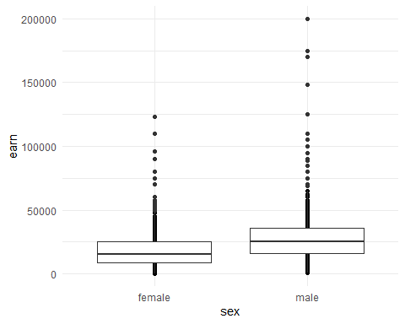

covid_df <- read.csv("E:/Repos/StatisticsR/DSC520-Statistics/data/nytimes/covid-19-data/us-states.csv")  
covid_df$date <- as.Date(covid_df$date)  
california_df <- covid_df[ which( covid_df$state == "California"), ]  
ny_df <- covid_df[ which( covid_df$state == "New York"), ]  
florida_df <- covid_df[ which( covid_df$state == "Florida"), ]

## NY Times COVID-19 Data

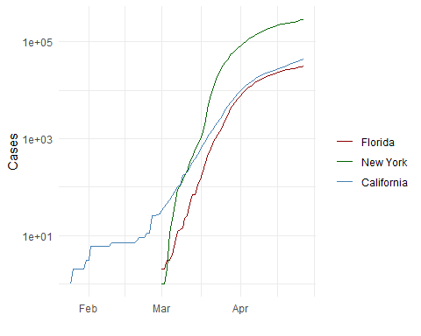

## R4DS Height vs Earnings

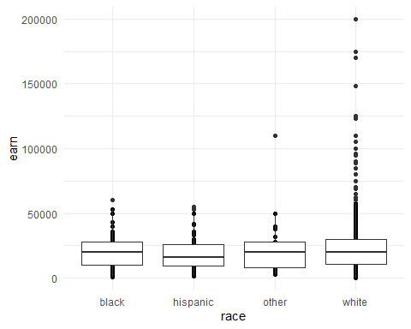

# Tables

## Knitr Table with Kable

names<-c("Aragon","Bilbo","Frodo","Sam","Sauron")  
race<-c("Men","Hobbit","Hobbit","Hobbit","Maia")  
fellow<-c("Yes","No","Yes","Yes","No")  
ring<-c("No","Yes","Yes","Yes","Yes")  
age<-c("88","129","51","36","7052")  
lord_of_ring<-cbind(names,race,fellow,ring,age)  
colnames(lord_of_ring)<-c("Name","Race","In Fellowship?","Is Ring Bearer?","Age")  
knitr::kable(lord_of_ring, "pipe",caption="One Ring to Rule Them All")

One Ring to Rule Them All

|  |  |  |  |  |
| --- | --- | --- | --- | --- |
| Name | Race | In Fellowship? | Is Ring Bearer? | Age |
| Aragon | Men | Yes | No | 88 |
| Bilbo | Hobbit | No | Yes | 129 |
| Frodo | Hobbit | Yes | Yes | 51 |
| Sam | Hobbit | Yes | Yes | 36 |
| Sauron | Maia | No | Yes | 7052 |

## Pandoc Table

pandoc.table(lord_of_ring, style = ‘grid’)

# References