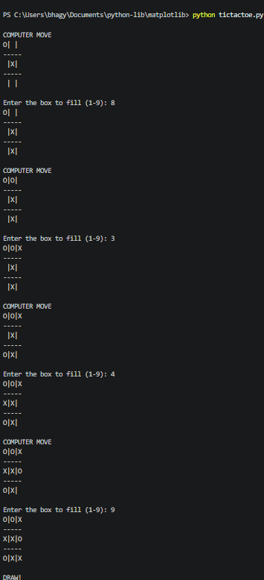
OUTPUT: TIC TAC TOE GAME
OUTPUT: VACUUM CLEANER AGENT
