OUTPUT:
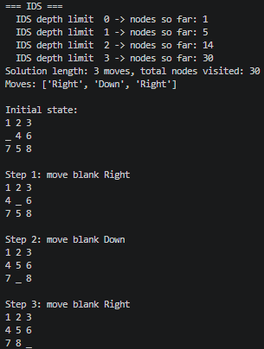
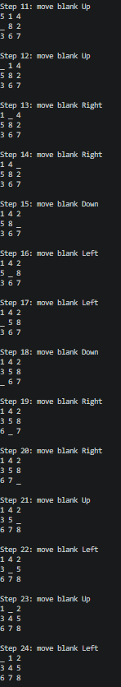
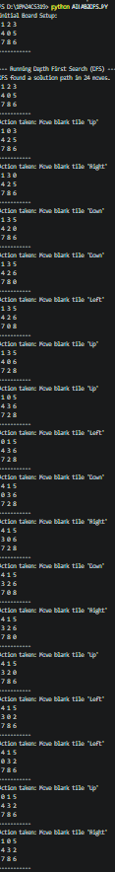
a)DFS b)IDS

