OUTPUT
WEEK 4 HIIL CLIMBING

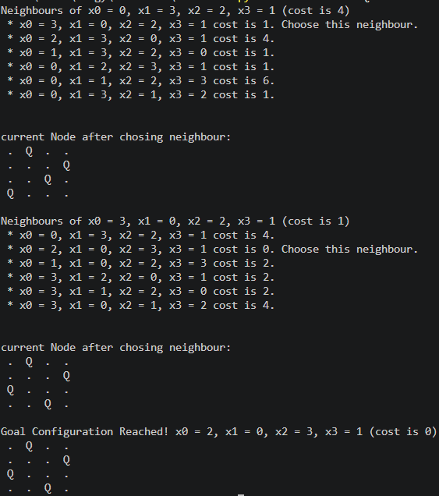
WEEK 5 SIMULATED ANNEALING


