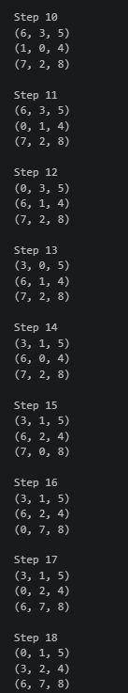
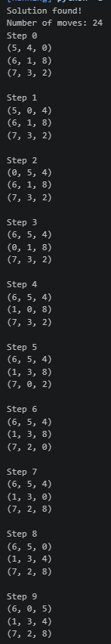
OUTPUT
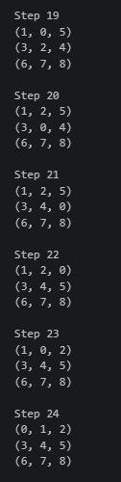
WEEK3_A_STAR_MISPLACETILES

WEEK_3_STAR_MANHATTANDISTANCE


