Date: 18-11-2025
Roll No: CB.EN.U4CCE23062
Web Design - HTML
Portfolio / Resume
A portfolio or resume website should contain the following sections:
- About me / Executive Summary
- Education details
- Skills (technical and soft skills)
- Achievements and Certifications
- Projects (include GitHub link, live link, and video demo if available)
What should a good web page design look like or what it should have?
- User-centric design
- Mobile responsiveness
- Fast loading performance
- Clear visual hierarchy (proper spacing, headings, layout)
- Easy and intuitive navigation
Note: Login Page or Registration is considered basic and simple, do not claim it as a major achievement. A secure login module for a banking or financial website can be considered important.
Poor Web Design Characteristics
- Poor navigation (no proper menu structure)
- Slow loading speed
- Non-responsive design
- Poor grammar and typography
- Too many pop-ups or advertisements
- Cluttered page layout
- No clear call-to-action
- Complicated registration process
Functional and Nonfunctional Requirements
Functional Requirements
Functional requirements describe the specific functions and actions the system must perform.
Examples:
- User authentication (login and registration)
- Search functionality to find products or information
- Adding items to a shopping cart
- Posting content on a social media platform
Non-Functional Requirements
Non-functional requirements describe the quality and performance of a system.
Examples:
- Performance: The website should load within 2 seconds
- Security: Sensitive information must be encrypted
- Usability: The website should be easy to use and navigate
- Scalability: The system should support a large number of users at the same time
- Reliability: The system should be available 99.9% of the time

HTML Tags
- Doctype

Its primary purpose is to inform the browser about the version of HTML being used in the document, specifically HTML5 in this case

- Header

The <header> element represents a container for introductory content or a set of navigational links.

A <header> element typically contains:
- one or more heading elements (<h1> - <h6>)
- logo or icon
- authorship information

- Body

The <body> tag defines the document's body.

The <body> element contains all the contents of an HTML document, such as headings, paragraphs, images, hyperlinks, tables, lists, etc.

- Note : <font> tag is actually not available in HTML5

- HTML Links – Syntax

The HTML <a> tag defines a hyperlink. It has the following syntax:
<a href="url">link text</a>

- HTML Symbol Entities
Symbols or letters that are not present on your keyboard can be added to HTML using entities.
To add such symbols to an HTML page, you can use the entity name or the entity number (a decimal or a hexadecimal reference) for the symbol:
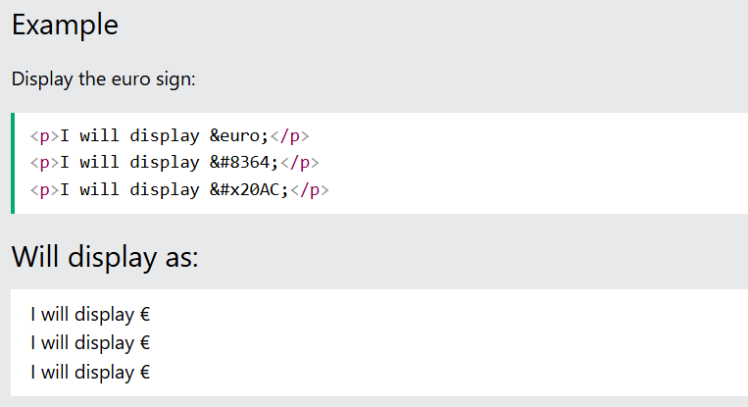

- HTML Formatting Elements
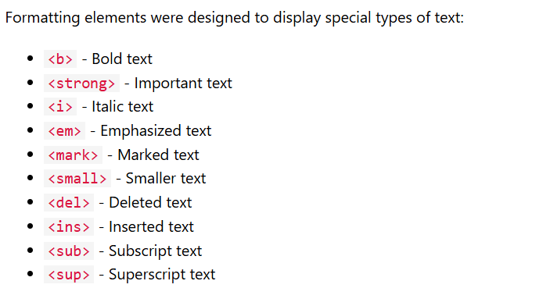

HTML Forms
An HTML form is used to collect user input. The user input is most often sent to a server for processing.
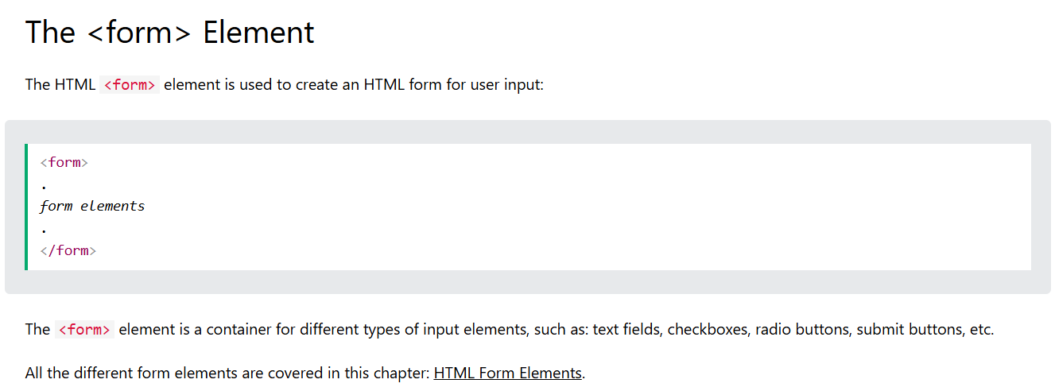

The <input> Element
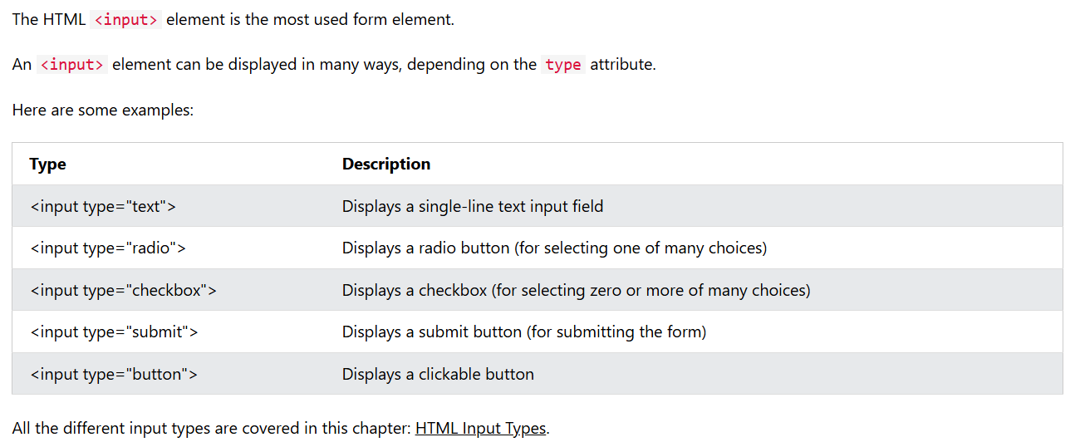

Text Fields
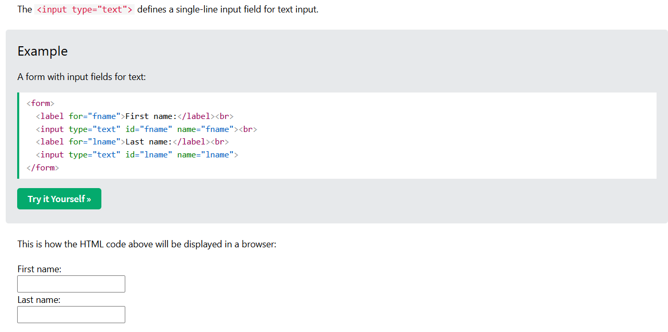
The <label> Element
- Notice the use of the <label> element in the example above.
- The <label> tag defines a label for many form elements.
- The <label> element is useful for screen-reader users, because the screen-reader will read out loud the label when the user focuses on the input element.
- The <label> element also helps users who have difficulty clicking on very small regions (such as radio buttons or checkboxes) - because when the user clicks the text within the <label> element, it toggles the radio button/checkbox.
- The for attribute of the <label> tag should be equal to the id attribute of the <input> element to bind them together.

Radio Buttons
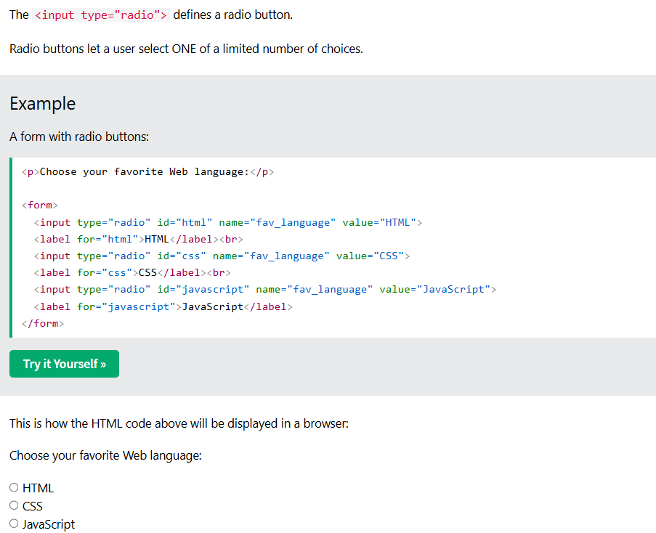

Checkboxes
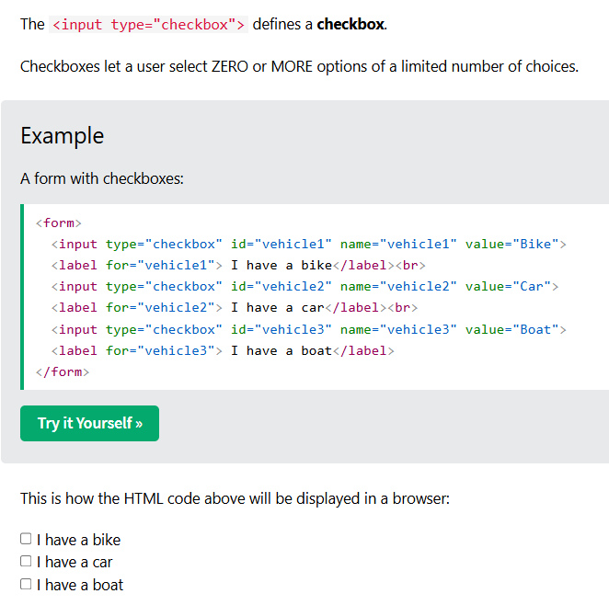

The Submit Button
- The <input type="submit"> defines a button for submitting the form data to a form-handler.
- The form-handler is typically a file on the server with a script for processing input data.
- The form-handler is specified in the form's action attribute.

HTML Tables
HTML tables allow web developers to arrange data into rows and columns.
Table Cells
- Each table cell is defined by a <td> and a </td> tag.
- td stands for table data.
- Everything between <td> and </td> is the content of a table cell.

Table Rows
- Each table row starts with a <tr> and ends with a </tr> tag.
- tr stands for table row.

Table Headers
- Sometimes you want your cells to be table header cells. In those cases use the <th> tag instead of the <td> tag:
- th stands for table header.

