SECMS
Student Enrollment & Course Management System Built on the Salesforce Platform

Phase 5: Project Development
Project Name | SECMS
Platform | Salesforce Developer Edition (Lightning Experience)
Phase | 5 of 8 - Project Development
Team Name / Members | Member 1: Vasanthakumar R | Team Lead  Member 2: Saravanan V  Member 3: Syed Kutbudeen S  Member 4: Raji P  Member 5: Sriram S

1. Overview
This phase documents how SECMS was built in Salesforce using declarative (no-code) tools. Each step below includes a description and a screenshot from the org.

2. Development Steps
Step | Activity | Salesforce Tool
1 | Create custom objects: Student, Course, Instructor, Enrollment | Object Manager
2 | Add fields and relationships (Text Area, Lookup, etc.) | Fields & Relationships
3 | Create the Student Enrollment Lightning app | App Manager
4 | Add validation rule for institutional student email | Validation Rules
5 | Automate enrollment with 5 record-triggered flows | Flow Builder
6 | Configure approval process for enrollment requests | Approval Processes
7 | Create reports: New Students, New Enrollments, Fees Paid | Reports
8 | Create Student Management Dashboard | Dashboards

3. Implementation Details

3.1 Custom Objects
Four custom objects were created in Object Manager: Student, Course, Instructor and Enrollment.
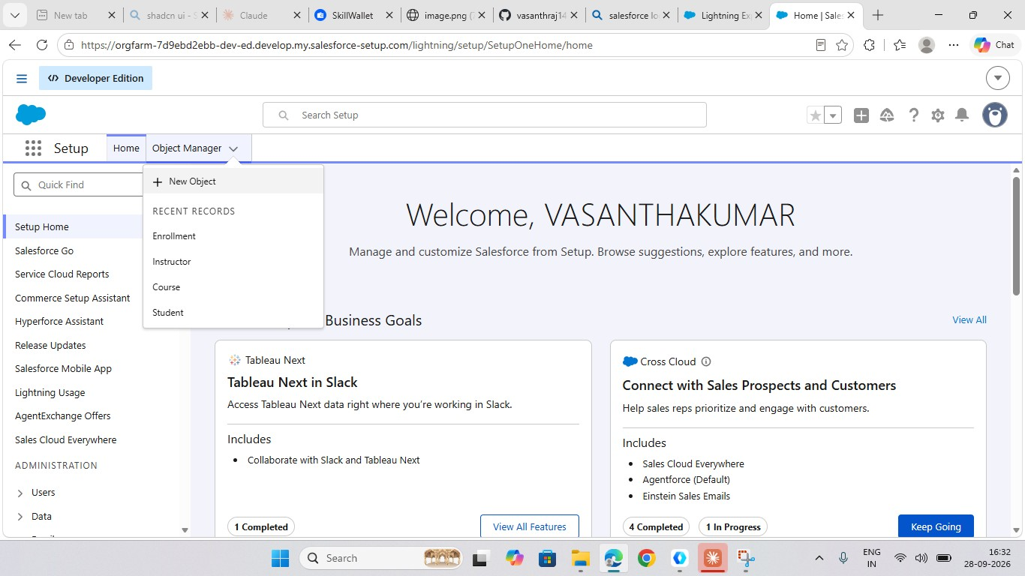
Figure 1: Custom objects in Object Manager
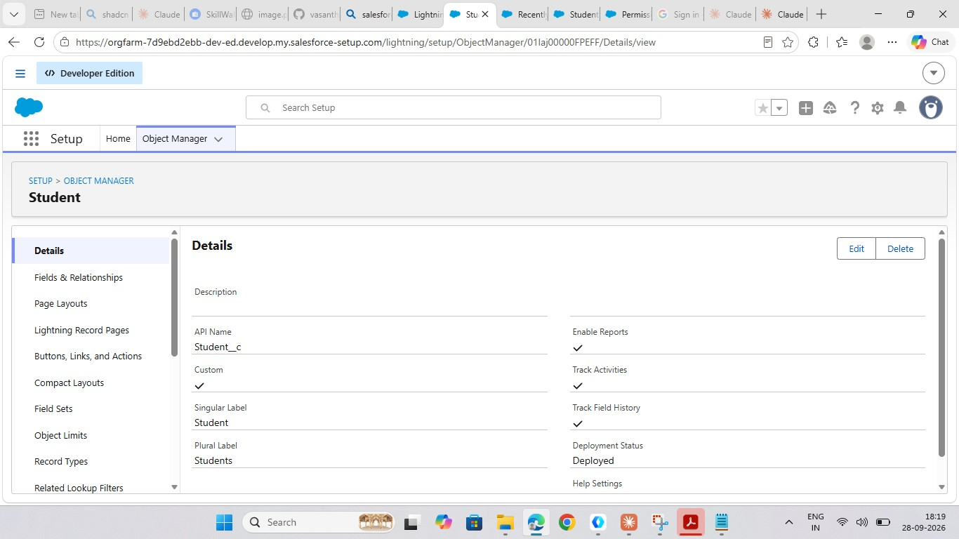
Figure 2: Student object details (Student__c, deployed)
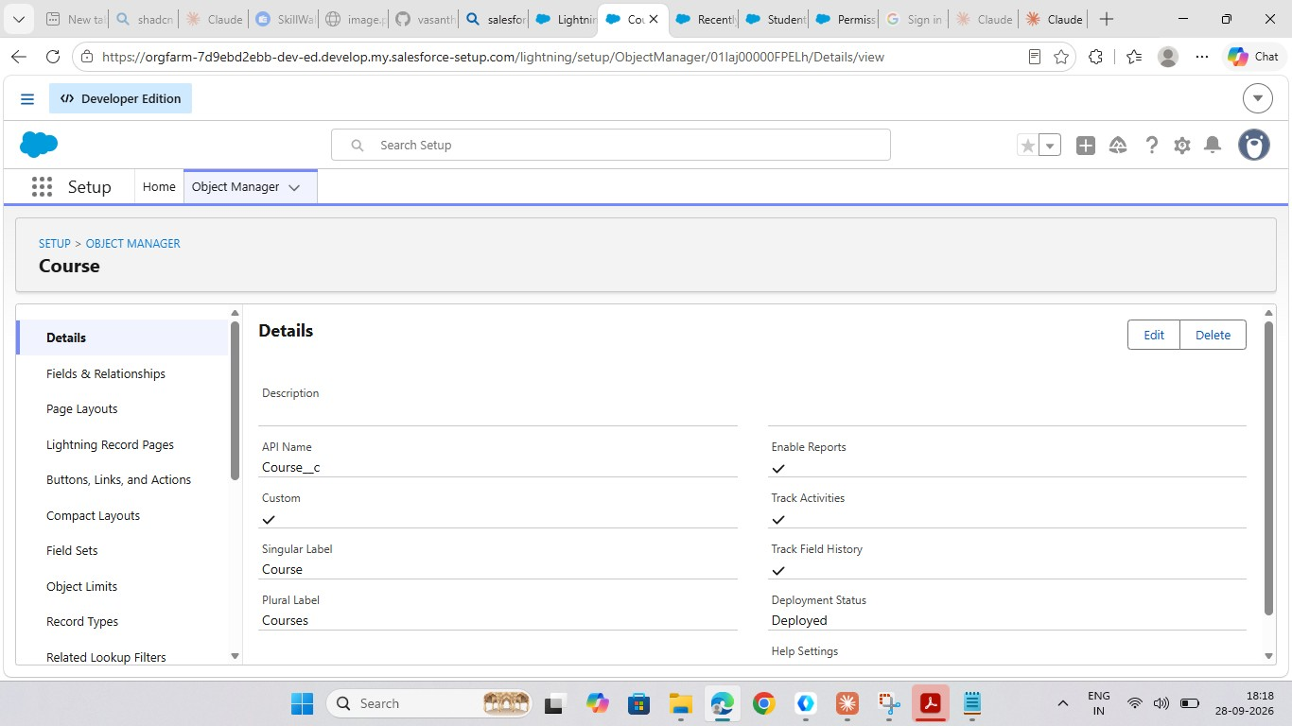
Figure 3: Course object details (Course__c, deployed)

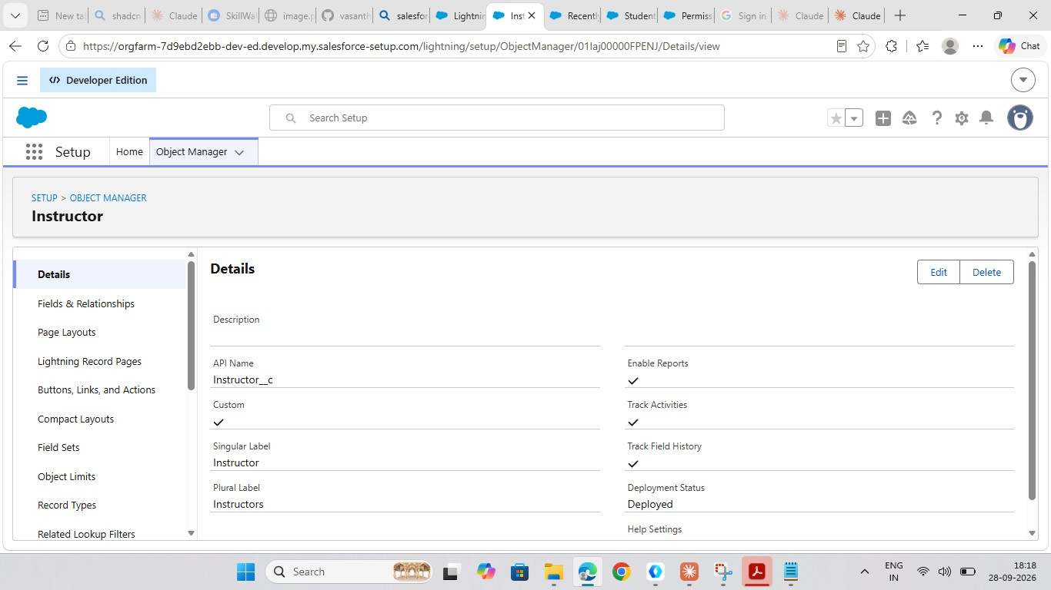
Figure 4: Instructor object details (Instructor__c, deployed)
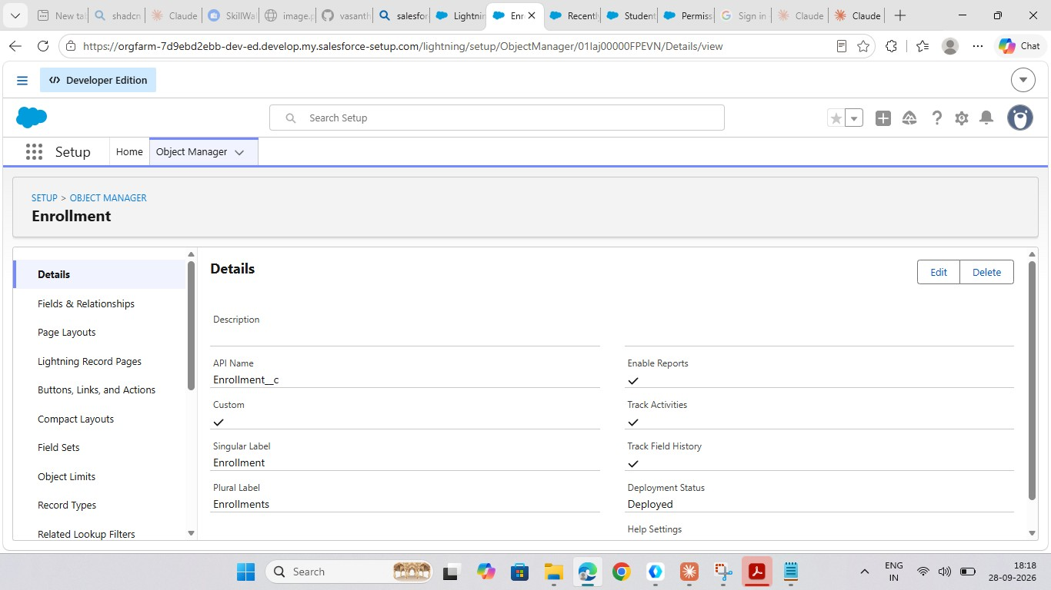
Figure 5: Enrollment object details (Enrollment__c, deployed)

3.2 Fields and Relationships
Fields were added to each object, and Lookup relationships link Enrollment with Student, Course and Instructor.
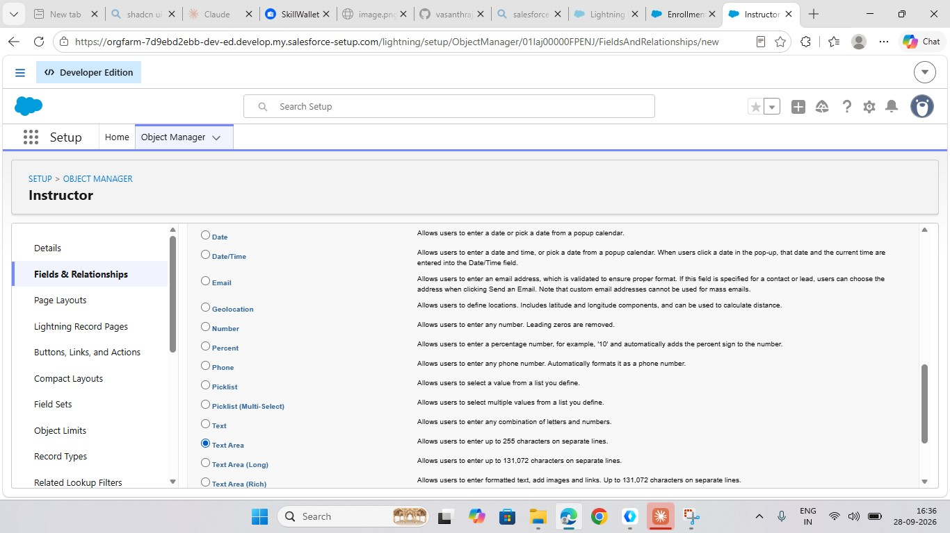
Figure 6: Creating a new field on the Instructor object (Text Area)
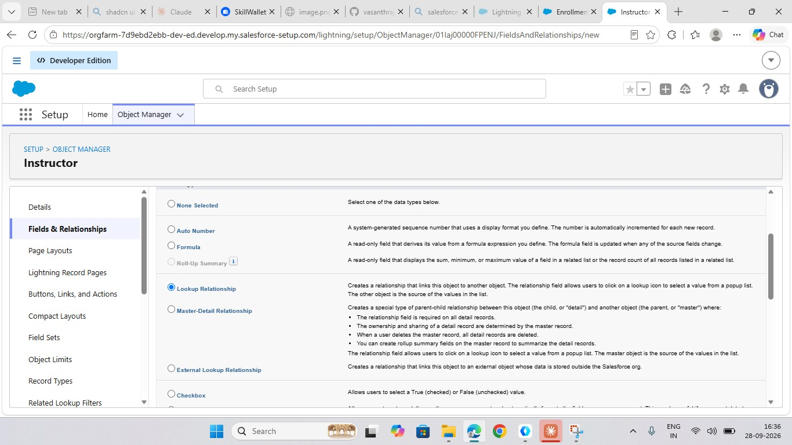
Figure 7: Selecting Lookup Relationship as the field type
3.3 Lightning App
Figure 8: Student Enrollment app created in App Manager

3.4 Validation Rule
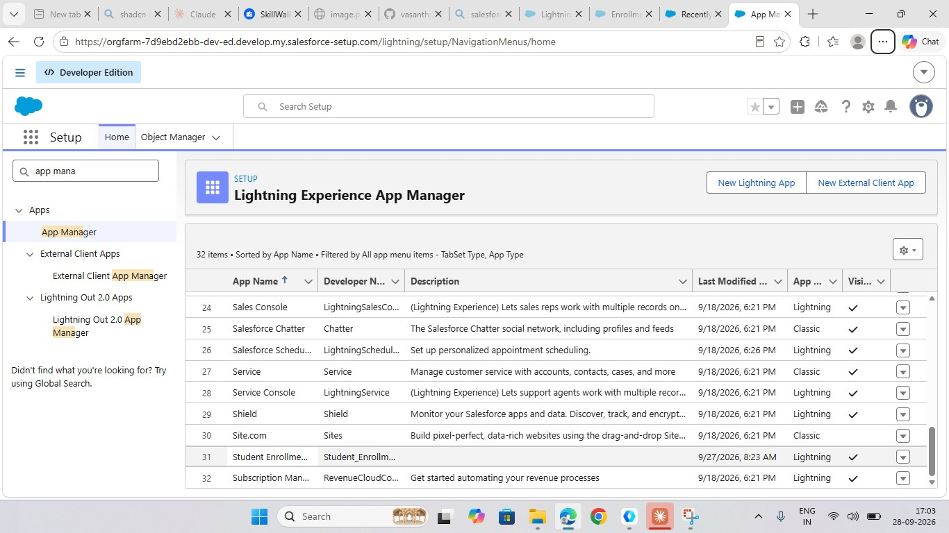
Student_Email_Domain_Validation shows the error "Email must be a valid student institutional email." on the Email field.
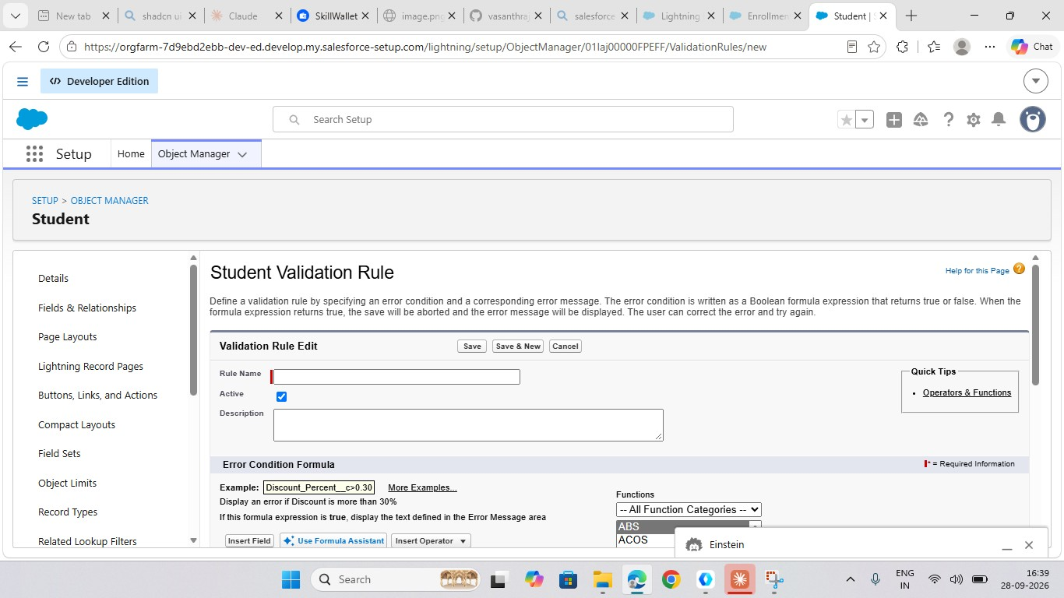
Figure 9: Creating a new validation rule on the Student object
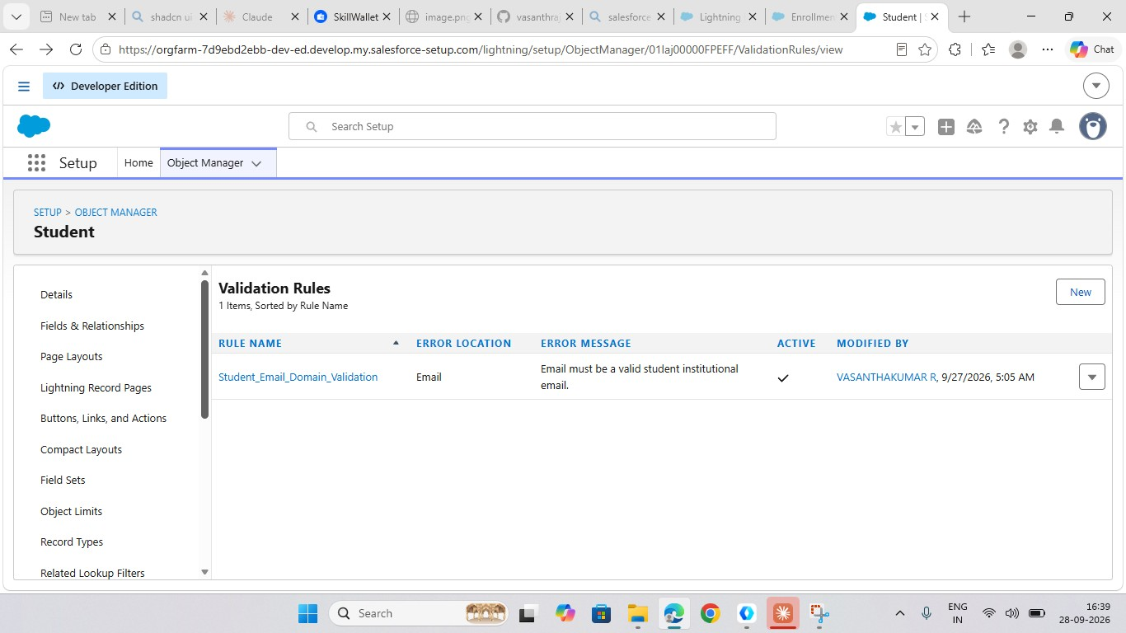
Figure 10: Active validation rule on the Student object

3.5 Flow Automation
Flow | Type | Purpose
Set Enrollment Date | Record-Triggered After Save | Sets enrollment date
Send Student Email | Record-Triggered After Save | Emails the student
AutoAssign_Instructor | Record-Triggered After Save | Assigns instructor
Create_Followup_Task | Record-Triggered After Save | Creates follow-up task
Enrollment Approved Action | Record-Triggered After Save | Actions after approval
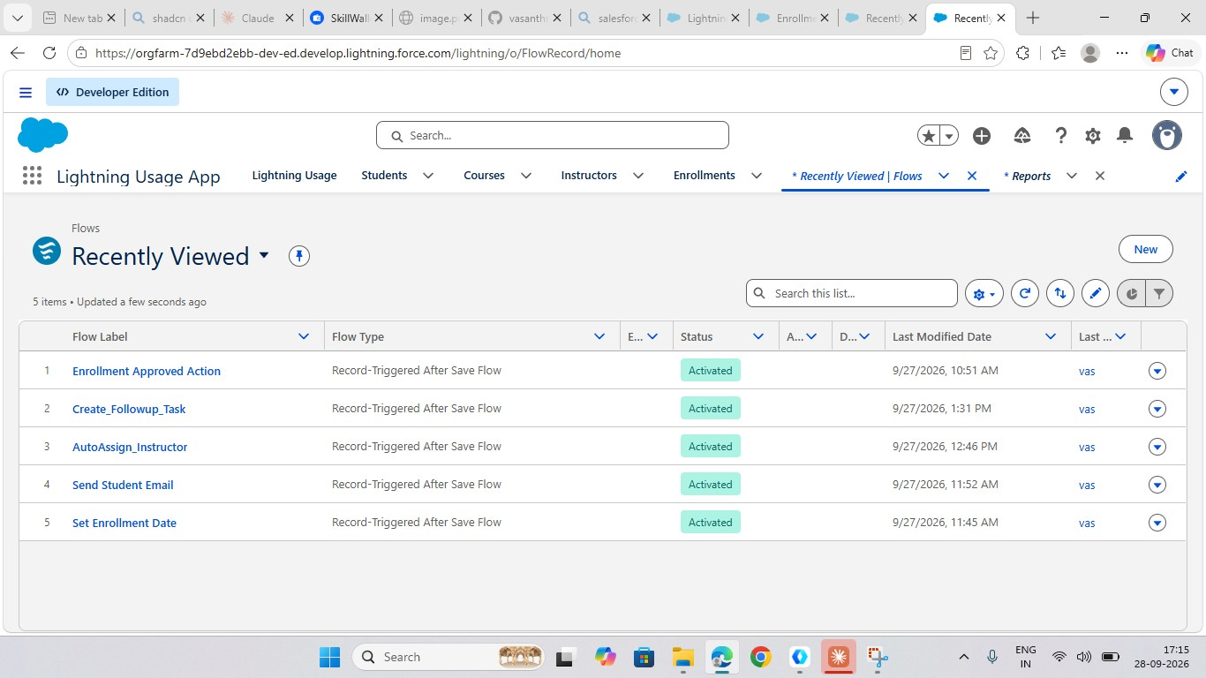
Figure 11: Five activated flows

3.6 Approval Process
Approval Enrollment Request sends enrollment requests to the Training Manager.
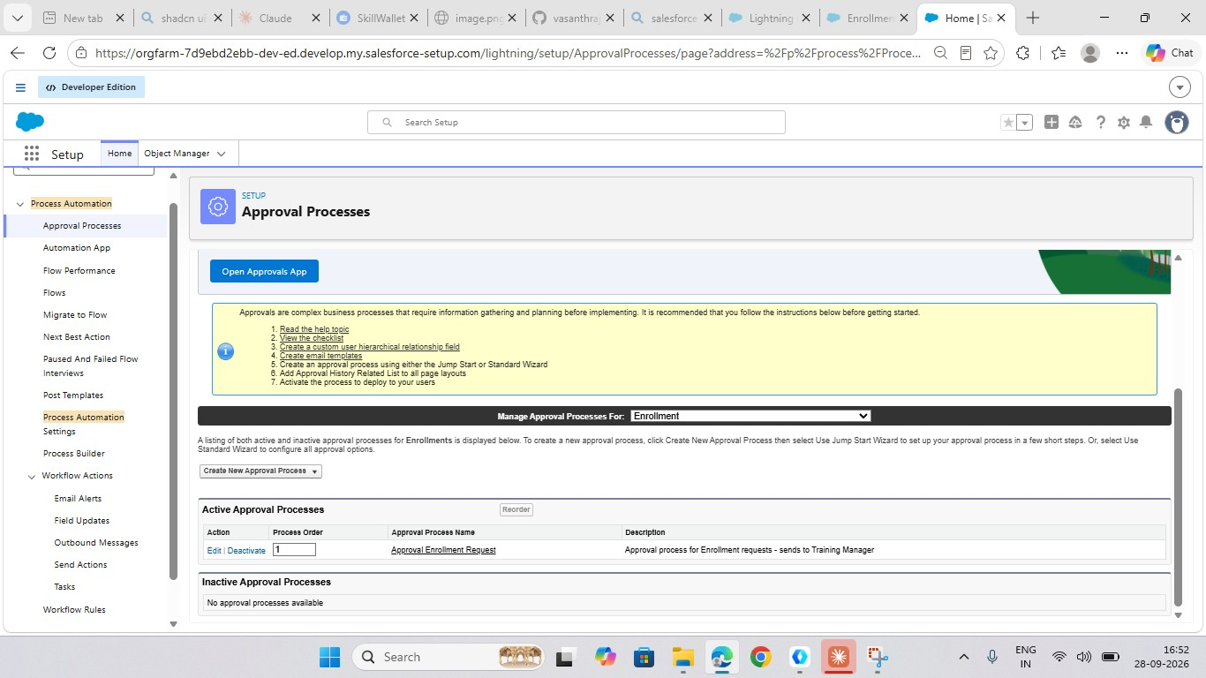
Figure 12: Approval process for the Enrollment object

3.7 Reports
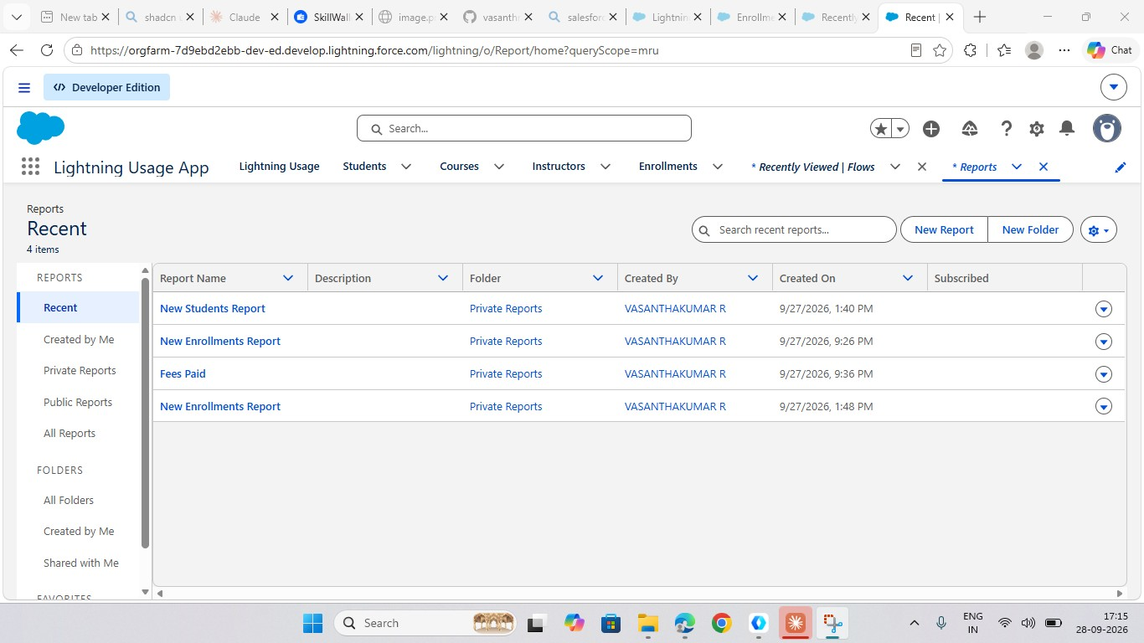
Figure 13: New Students, New Enrollments and Fees Paid reports

3.8 Dashboard
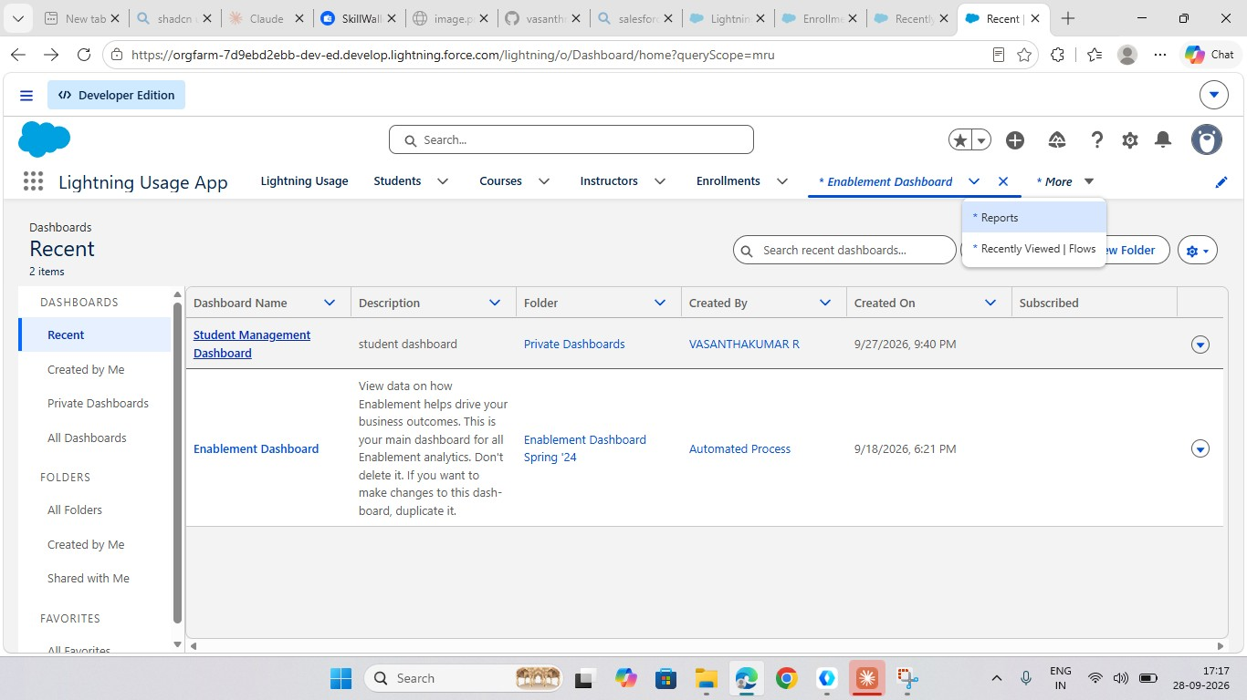
Figure 14: Student Management Dashboard

4. Summary
The SECMS application was successfully developed with custom objects, relationships, a Lightning app, validation, flow automation, an approval process, reports and a dashboard.

