SECMS
Student Enrollment & Course Management System
Built on the Salesforce Platform
Phase 7: Final Project Documentation
Project Name | SECMS
Platform | Salesforce Developer Edition (Lightning Experience)
Phase | 7 of 8 - Project Documentation
Team Name / Members | Member 1: Vasanthakumar R | Team Lead  Member 2: Saravanan V  Member 3: Syed Kutbudeen S  Member 4: Raji P  Member 5: Sriram S

Contents
- 1. Project Overview
- 2. Problem Statement & Objectives
- 3. Requirements
- 4. System Design
- 5. Implementation
- 6. Testing Summary
- 7. Results & Benefits
- 8. Future Scope
- 9. Conclusion
- 10. Project Repository Structure

1. Project Overview
SECMS (Student Enrollment & Course Management System) is a Salesforce Lightning application that manages students, courses, instructors, enrollments and fee payments in one place. It replaces scattered spreadsheets and manual follow-ups with connected records, automation, approvals, reports and a dashboard.

2. Problem Statement & Objectives
Problem: Student, course and fee information is often stored in separate files, so enrollments are slow, error-prone and hard to track.
Objectives:
- Centralize student, course, instructor, enrollment and fee data on Salesforce.
- Automate enrollment tasks using Flow and route special cases through an approval process.
- Protect data quality with validation rules.
- Give administrators real-time reports and a dashboard.

3. Requirements

3.1 Functional Requirements
ID | Requirement
FR1 | Create and manage Student, Course and Instructor records
FR2 | Enroll a student in a course and track enrollment status
FR3 | Validate student email as an institutional email
FR4 | Set enrollment date, assign instructor, send student email and create follow-up task automatically
FR5 | Route enrollment requests to the Training Manager for approval
FR6 | Track fee payment status
FR7 | Provide reports and a dashboard for students, enrollments and fees

3.2 Non-Functional Requirements
- Usability: simple Lightning interface with tabs for each object.
- Security: role-based access through Salesforce profiles and permission sets.
- Reliability: data hosted on the Salesforce cloud platform.
- Scalability: new objects, fields and automations can be added without code.

4. System Design

4.1 Data Model
Object | Purpose | Relationships
Student | Student personal and contact details | Linked to Enrollment
Course | Course details, fee and duration | Linked to Enrollment and Instructor
Instructor | Instructor profile | Assigned to courses / enrollments
Enrollment | Connects a Student to a Course with status and date | Student + Course
Payment / Fees | Fee payment status for an enrollment | Linked to Enrollment

4.2 Automation Design
Component | Type | Purpose
Student_Email_Domain_Validation | Validation Rule | Blocks emails that are not institutional emails
Set Enrollment Date | Record-Triggered Flow | Sets the enrollment date on save
AutoAssign_Instructor | Record-Triggered Flow | Assigns an instructor automatically
Send Student Email | Record-Triggered Flow | Emails the student after enrollment
Create_Followup_Task | Record-Triggered Flow | Creates a follow-up task
Enrollment Approved Action | Record-Triggered Flow | Runs actions after approval
Approval Enrollment Request | Approval Process | Sends enrollment requests to the Training  Manager

5. Implementation
The application was built on a Salesforce Developer Edition org using point-and-click tools: Object Manager, App Manager, Flow Builder, Approval Processes, Reports and Dashboards.

5.1 Objects

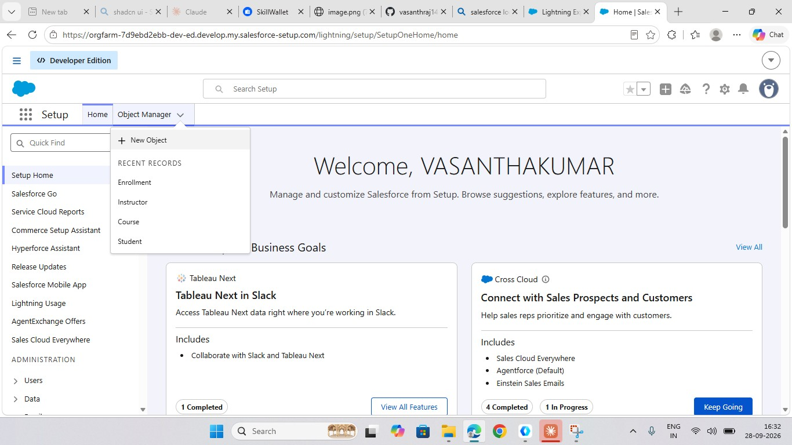
Figure 1: Custom objects Enrollment, Instructor, Course and Student in Object Manager
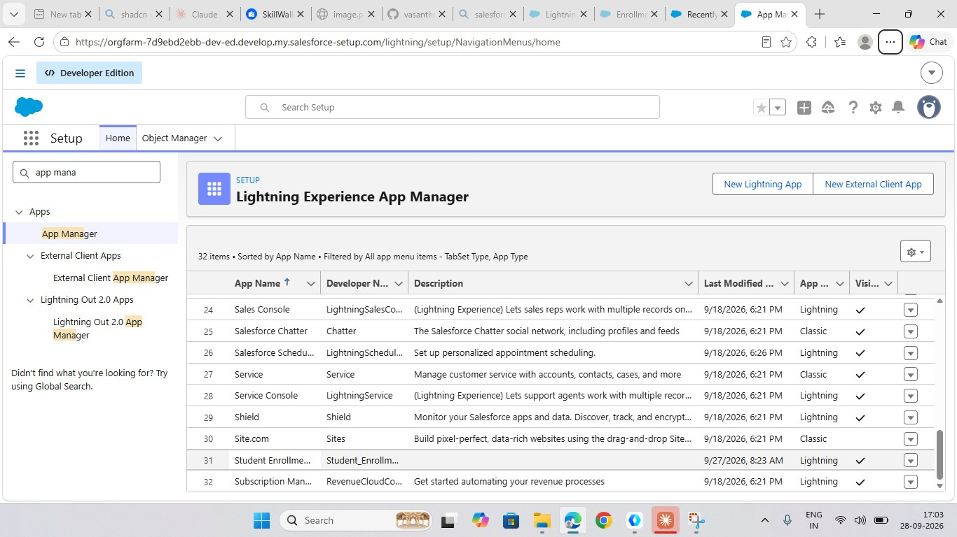
5.2
Lightning App
Figure 2: Student Enrollment Lightning app in App Manager

5.3 Validation Rule
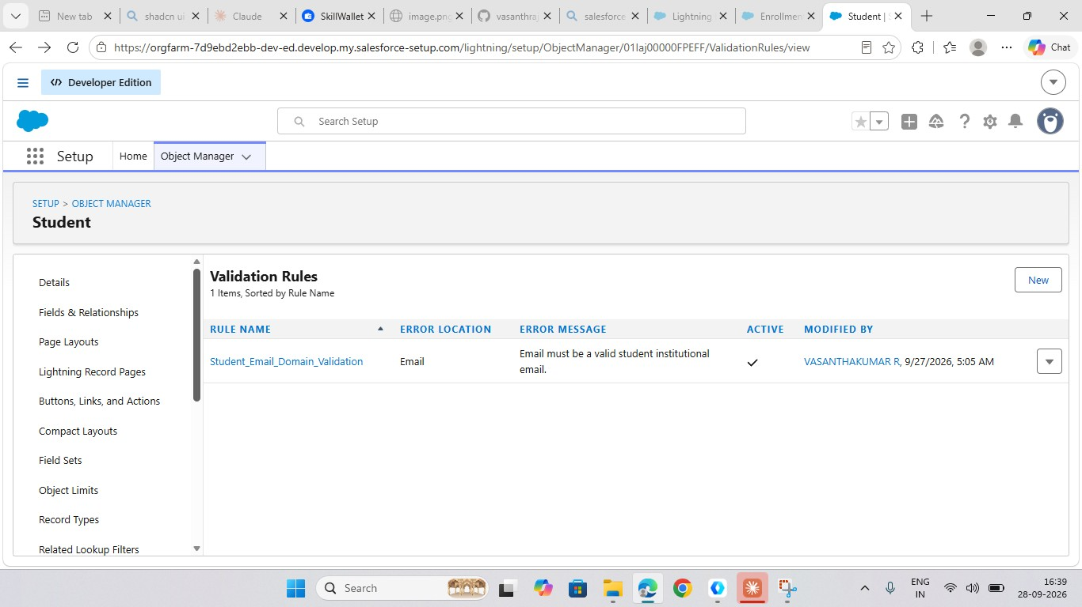
Figure 3: Student_Email_Domain_Validation rule (active)

5.4 Flow Automation
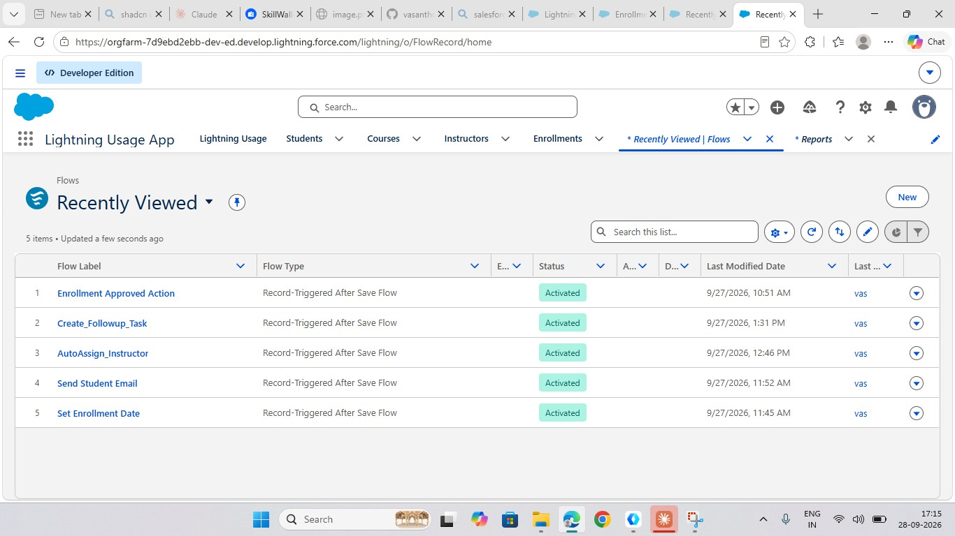
Figure 4: Five activated record-triggered flows

5.5 Approval Process
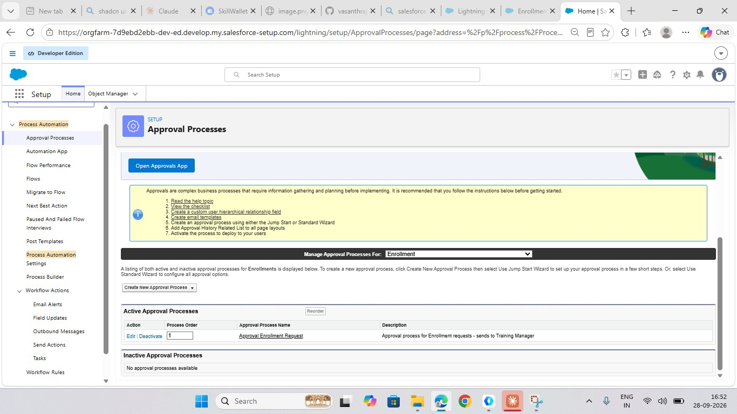
Figure 5: Approval Enrollment Request process for the Enrollment object
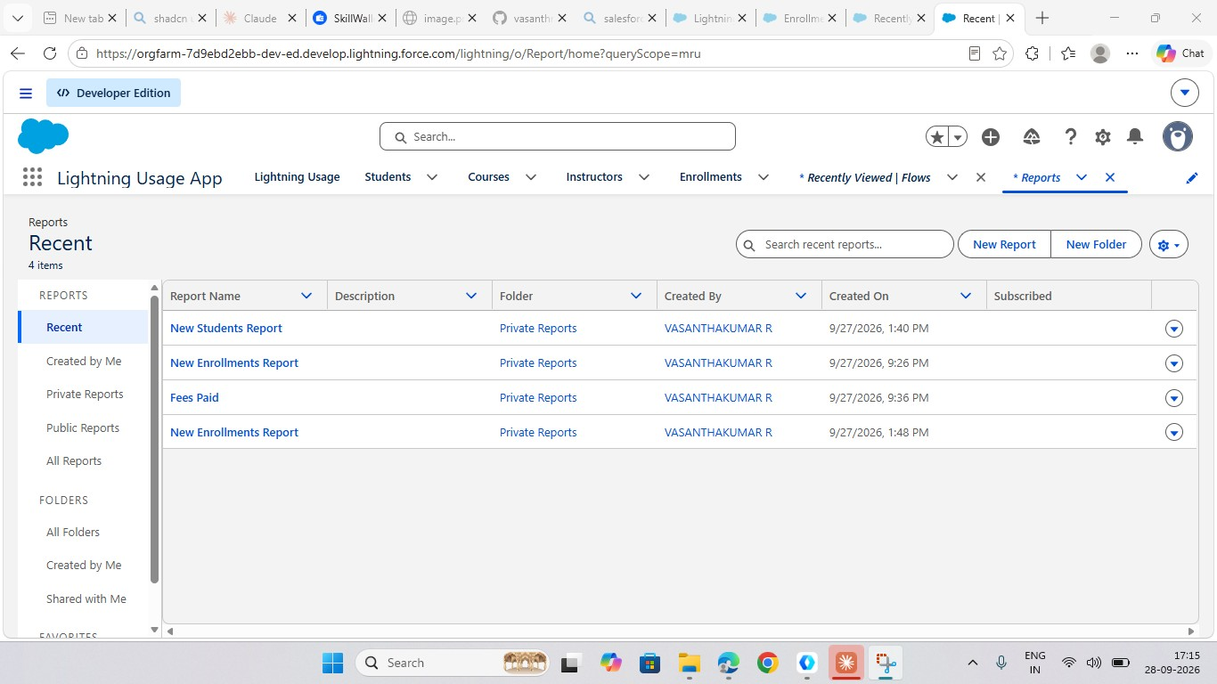
5.6
Reports
Figure 6: New Students, New Enrollments and Fees Paid reports

5.7 Dashboard
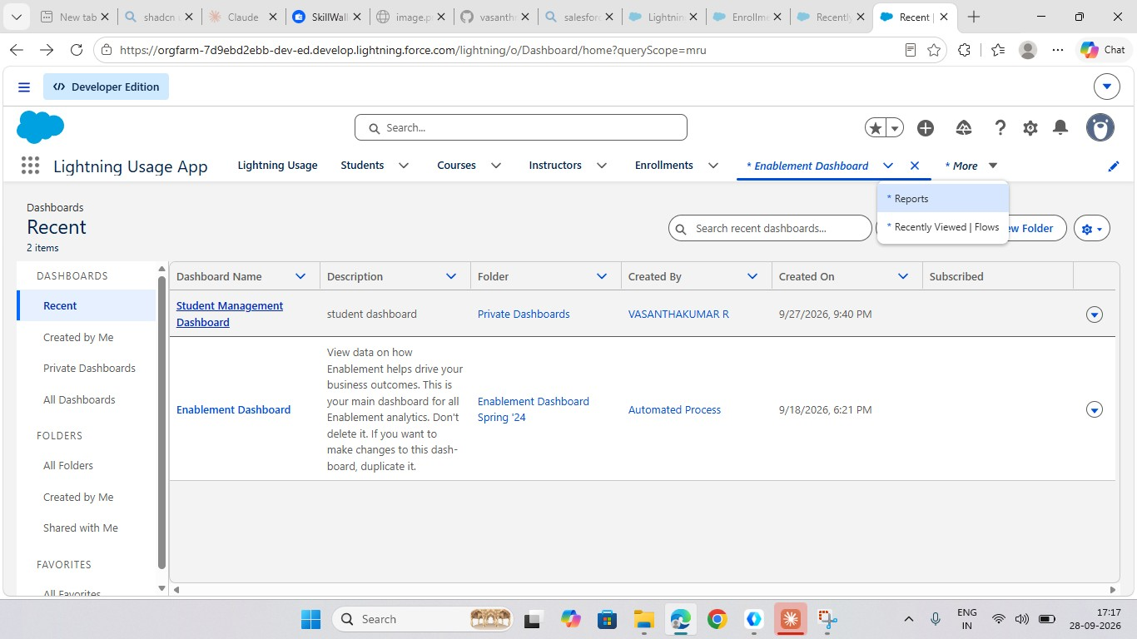
Figure 7: Student Management Dashboard

6. Testing Summary
Functional testing covered records, validation, flows, approval process, reports and dashboard.
Details are in the Phase 6 Testing Report.
Total Test Cases | Passed | Failed | Pass Rate
16 | 16 | 0 | 100%

7. Results & Benefits
- One connected system for students, courses, instructors, enrollments and fees.
- Less manual work because dates, instructor assignment, emails and tasks are automated.
- Better data quality through validation rules.
- Controlled enrollment through an approval process.
- Quick insight through reports and a dashboard.

8. Future Scope
- Experience Cloud student portal for self-service enrollment.
- Online payment gateway integration.
- Attendance and grade tracking objects.
- Mobile access through the Salesforce mobile app.
- Einstein / AI-based course recommendations.

9. Conclusion

SECMS shows how Salesforce can be used to build a complete student enrollment and course management solution without custom code. The project delivered structured data, automation, approvals and analytics, and it can be extended easily as requirements grow.

10. Project Repository Structure
Folder | Contents
01-Brainstorming-and-Ideation | Ideation PDF and diagram
02-Requirement-Analysis | Requirement analysis PDF
03-Project-Design | Design PDF, architecture and ER diagrams
04-Project-Planning | Project plan PDF and timeline
05-Project-Development | Salesforce screenshots
06-Project-Testing | Testing report and test screenshots
07-Project-Documentation | This document
08-Project-Demonstration | Demo script and video link

