SECMS
Student Enrollment & Course Management System
Built on the Salesforce Platform
Phase 6: Project Testing - Testing Report
Project Name | SECMS
Platform | Salesforce Developer Edition (Lightning Experience)
Phase | 6 of 8 - Project Testing
Testing Type | Functional / Manual Testing
Team Name / Members | Member 1: Vasanthakumar R | Team Lead  Member 2: Saravanan V  Member 3: Syed Kutbudeen S  Member 4: Raji P  Member 5: Sriram S

1. Introduction
This report documents the testing of the SECMS Salesforce application. The goal was to verify that the objects, validation rules, flows, approval process, reports and dashboard built in Phase 5 behave as designed and meet the requirements defined earlier.

2. Testing Objectives
- Verify that Student, Course, Instructor and Enrollment records can be created and saved correctly.
- Confirm that validation rules block invalid data with clear error messages.
- Confirm that flow automations run after save and update the related records.
- Verify that the enrollment approval process routes requests to the Training Manager.
- Confirm that reports and the dashboard show the expected data.

3. Scope & Test Environment
Item | Details
Application | Student Enrollment (Lightning app)
Org type | Salesforce Developer Edition
Objects tested | Student, Course, Instructor, Enrollment, Payment / Fees
Automation tested | Validation Rule, 5 Record-Triggered Flows, Approval Process
Analytics tested | 3 Reports, Student Management Dashboard
Browser | Microsoft Edge (Windows)
Testing method | Manual functional testing by the project team

4. Test Cases & Results
ID | Module | Test Scenario | Expected Result | Status
TC01 | Student | Create a student with all required fields | Record saved successfully | Pass
TC02 | Student | Create a student without a required field | Save blocked; required field error shown | Pass
TC03 | Validation | Enter an email that is not an institutional email | Error: Email must be a valid student institutional email. | Pass
TC04 | Validation | Enter a valid institutional email | Record saved without error | Pass
TC05 | Course | Create a course with name, fee and duration | Course record saved | Pass
TC06 | Instructor | Create an instructor record | Instructor record saved | Pass
TC07 | Enrollment | Create an enrollment linking a  Student and a Course | Enrollment saved and linked to both records | Pass
TC08 | Flow | Save a new enrollment (Set  Enrollment Date flow) | Enrollment date is set automatically | Pass
ID | Module | Test Scenario | Expected Result | Status
TC09 | Flow | Save a new enrollment  (AutoAssign_Instructor flow) | Instructor is assigned automatically | Pass
TC10 | Flow | Save a new enrollment (Send  Student Email flow) | Confirmation email sent to the student | Pass
TC11 | Flow | Save an enrollment  (Create_Followup_Task flow) | Follow-up task created | Pass
TC12 | Approval | Submit an enrollment for approval | Request routed to the Training  Manager | Pass
TC13 | Approval | Approve the request (Enrollment  Approved Action flow) | Approved action runs and status is updated | Pass
TC14 | Payment | Record fee payment for an enrollment | Payment / fee status saved and shown in Fees Paid report | Pass
TC15 | Reports | Open New Students, New  Enrollments and Fees Paid reports | Reports open and list the correct records | Pass
TC16 | Dashboard | Open Student Management  Dashboard | Dashboard opens with the three report components | Pass

5. Test Evidence (Screenshots)
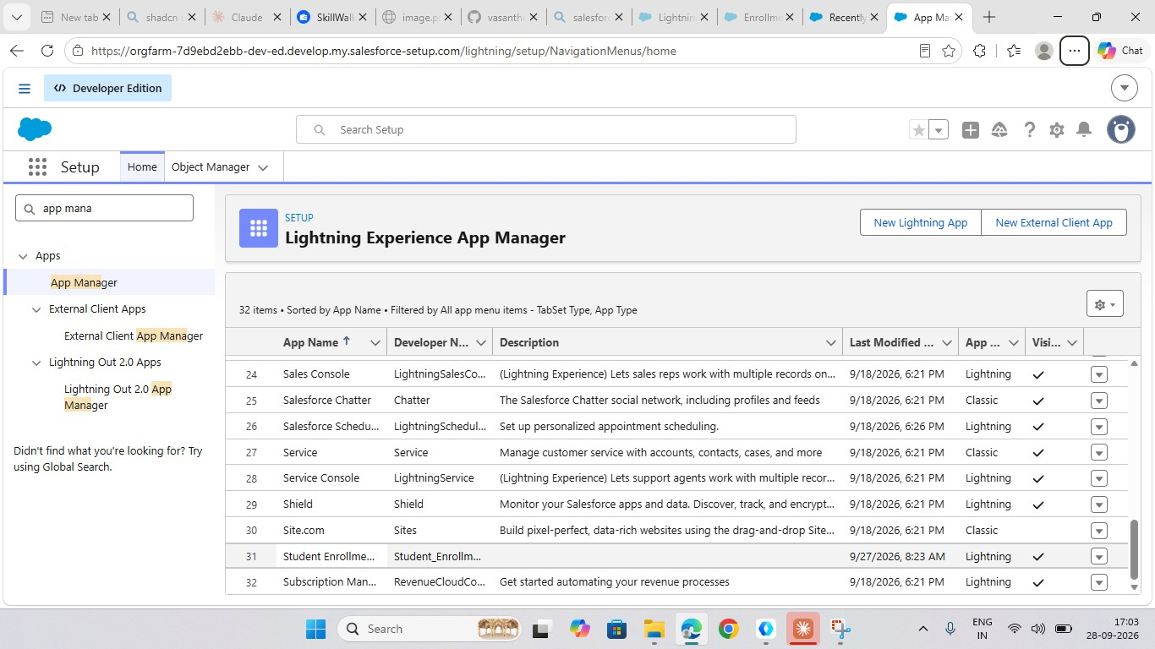
5.1
Application
Figure 1: Student Enrollment Lightning app available in App Manager (TC01-TC07)

5.2 Validation Rule Testing

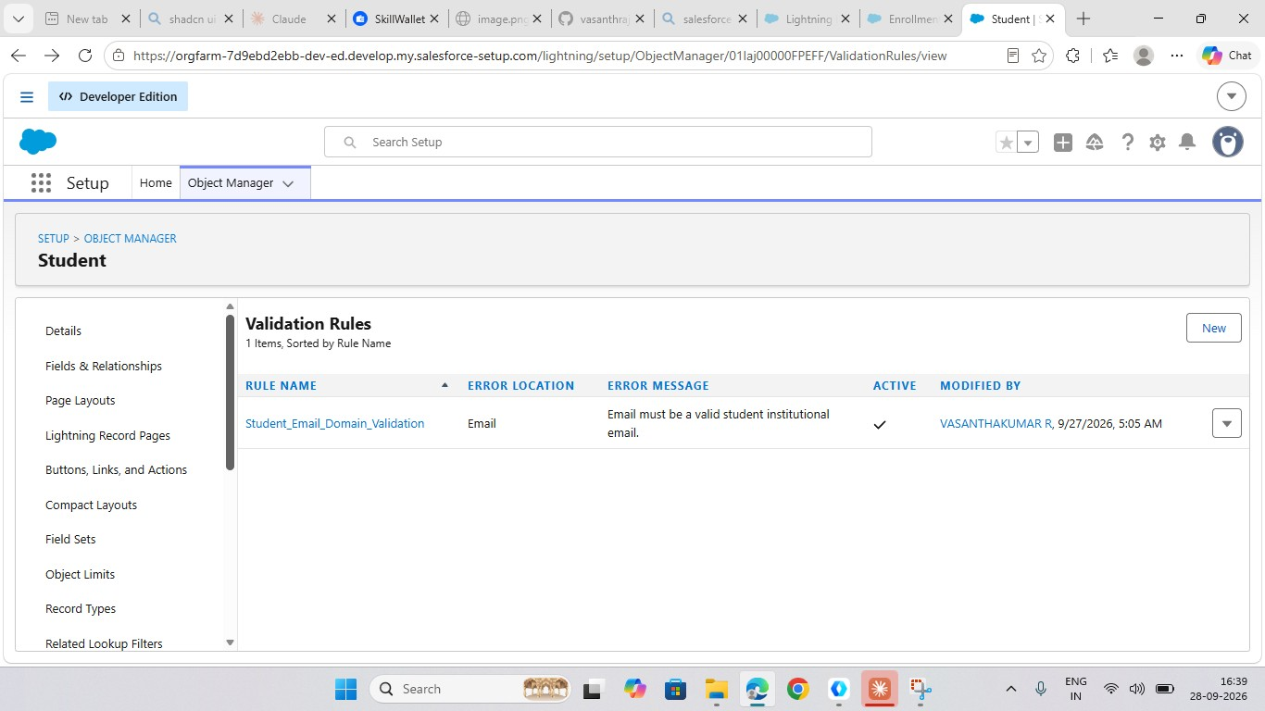
Figure 2: Student_Email_Domain_Validation - active, error shown on the Email field (TC03, TC04)
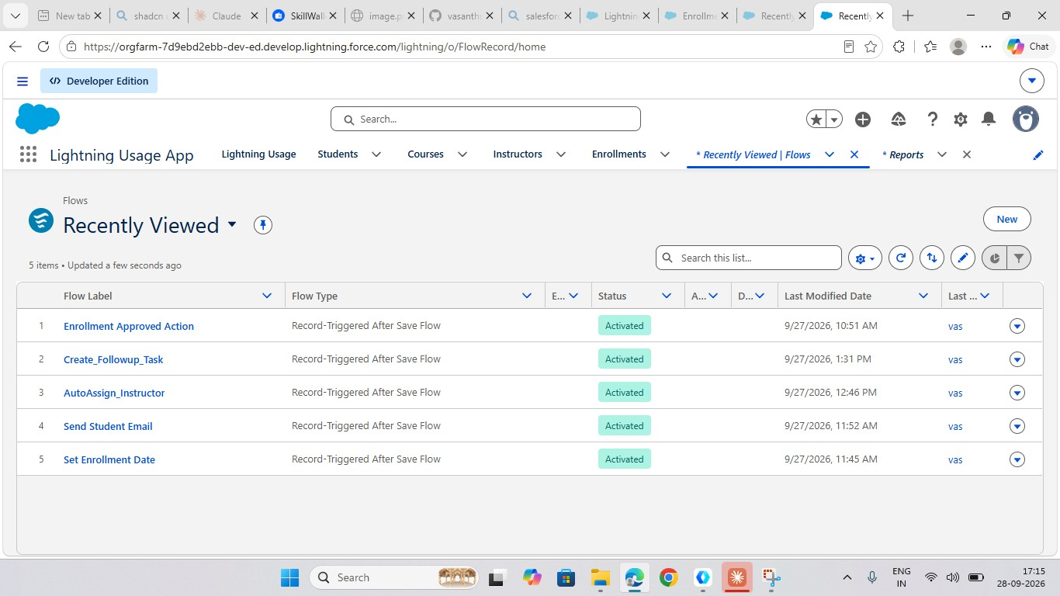
5.3
Flow Automation Testing
Figure 3: Five record-triggered flows in Activated status (TC08-TC11, TC13)

5.4 Approval Process Testing
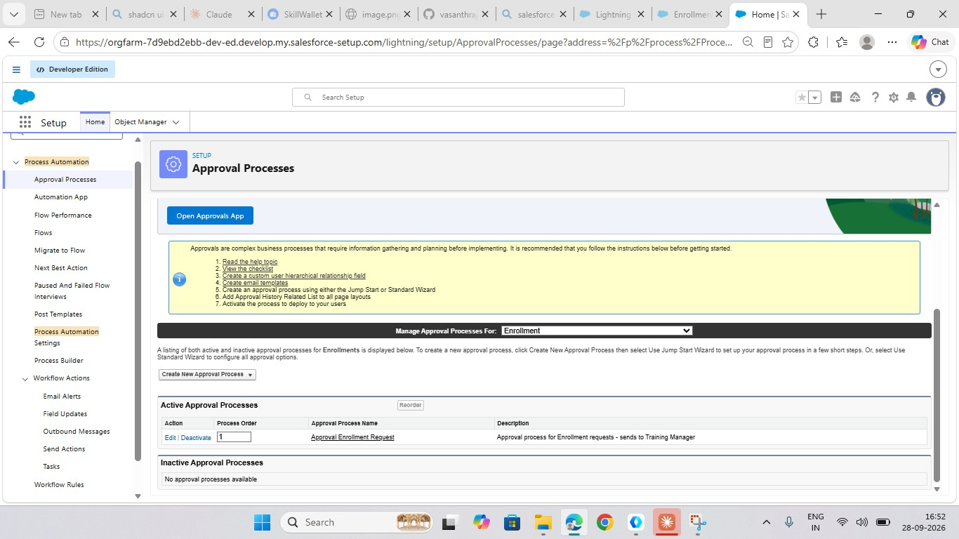
Figure 4: Approval Enrollment Request - active, sends requests to Training Manager (TC12)
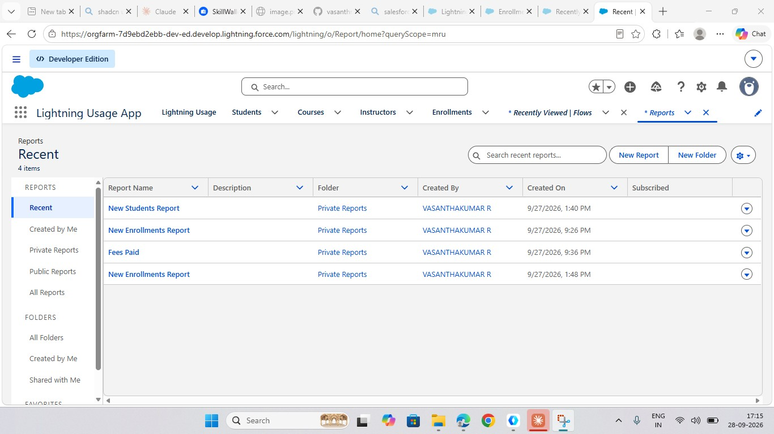
5.5
Reports & Dashboard Testing
Figure 5: New Students, New Enrollments and Fees Paid reports (TC14, TC15)
Figure 6: Student Management Dashboard listed under Dashboards (TC16)

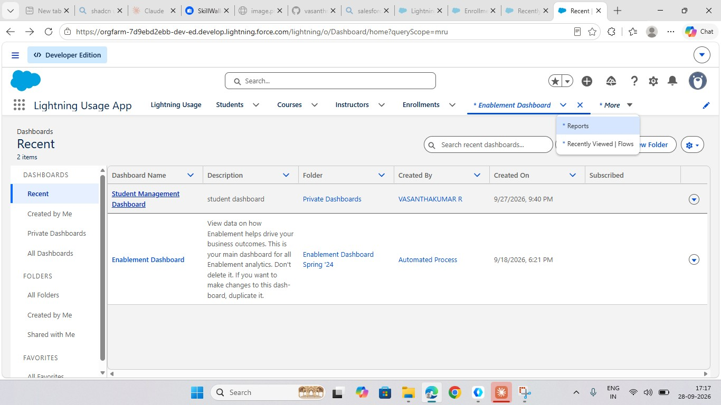
6. Test Summary
Total Test Cases | Passed | Failed | Pass Rate
16 | 16 | 0 | 100%

7. Conclusion
All planned functional tests were executed and the SECMS application met the expected results. The validation rule, flows and approval process work as designed, and the reports and dashboard are available for monitoring students, enrollments and fee payments. The system is ready for final documentation and demonstration.

