**DSP LABWORK**

Name: Vasanth Kumar V Date: 12/03/2021

Roll no: 2019105064

**Week 1**: **Generation of Given Sequences using MATLAB**

**Aim:**

To generate any given Discrete Time Signal and plot them in MATLAB

**Software Used:**

MATLAB R2020

**Pseudo Code:**

1. Recall the definition of standard signals
2. Implement the equations of standard signals in MATLAB
3. Modify and perform operations on standard signals to arrive at any given Discrete Time Signal

**Signals to be generated:**

1. (a)Unit Impulse del[n]- n varies from 0 to 10 where n values not specified

(b)Unit Step u[n] - ''

(c)Unit ramp r[n]- ''

(d)y[n] = 2del[n-1] -4del[n+2] ; -5 <= n <= 5

(e)x[n] = cos[0.04*pi*n]

(f)x[n] = n[u[n] - u[n-10]] + 10e-0.3(n-10)[u[n] - u[n-10]]; 0<=n<=20

2. If x[n] = {1 2 3 4 5 6 7 6 5 4 3 2 1}

a. X1[n] = 2x[n-5] - 3x[n+4]

b. x2[n] = x[3-n] - x[n]x[n-2]

3. If x[n] = = e(0.1+j0.3)n ; -10 <= n <= 10, plot its magnitude, phase, real part and imaginary part

**Question 1:**

1. **Code:**

%Impulse signal

%Signal Generation

clc

clear all

n = [-10:10];

for i=1:length(n)

if(n(i)==0)

xn(i) = 1;

else

xn(i) = 0;

end

end

%This is for plotting

subplot(2,2,1); stem(n,xn);

xlabel("n");

ylabel("del[n]");

title("Unit impulse signal");

**Waveform:**

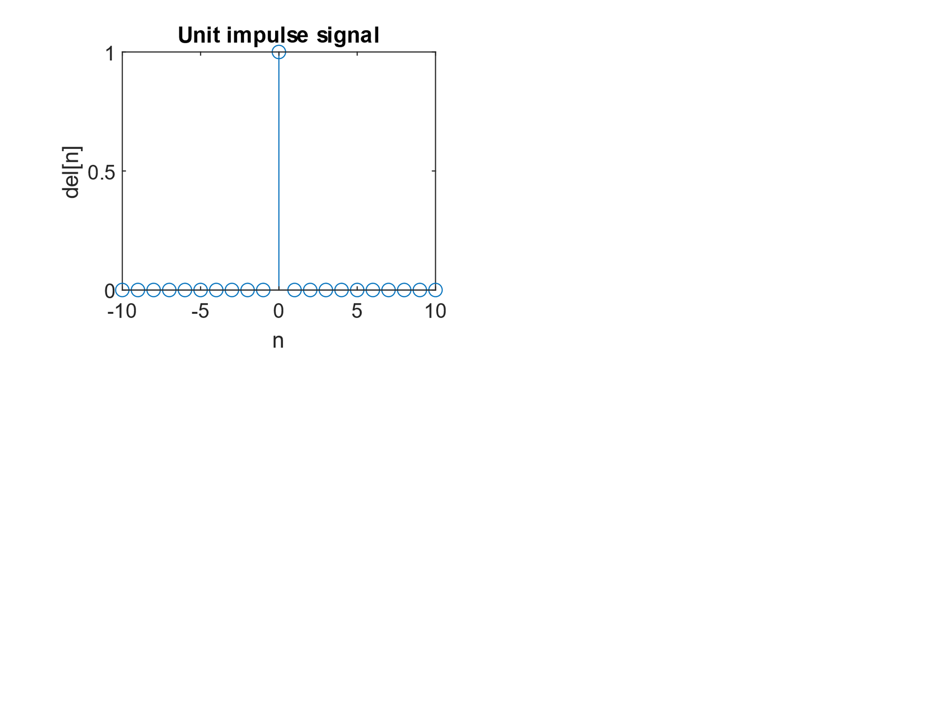

1. **Code:**

%Unit step signal

%Signal Generation

clc

clear all

n = [-10:10];

for i=1:length(n)

if(n(i) >= 0)

xn(i)=1;

else

xn(i)=0;

end

end

%This is for plotting

stem(n,xn);

xlabel("n");

ylabel("u[n]");

title("Unit step signal");

**Waveform:**

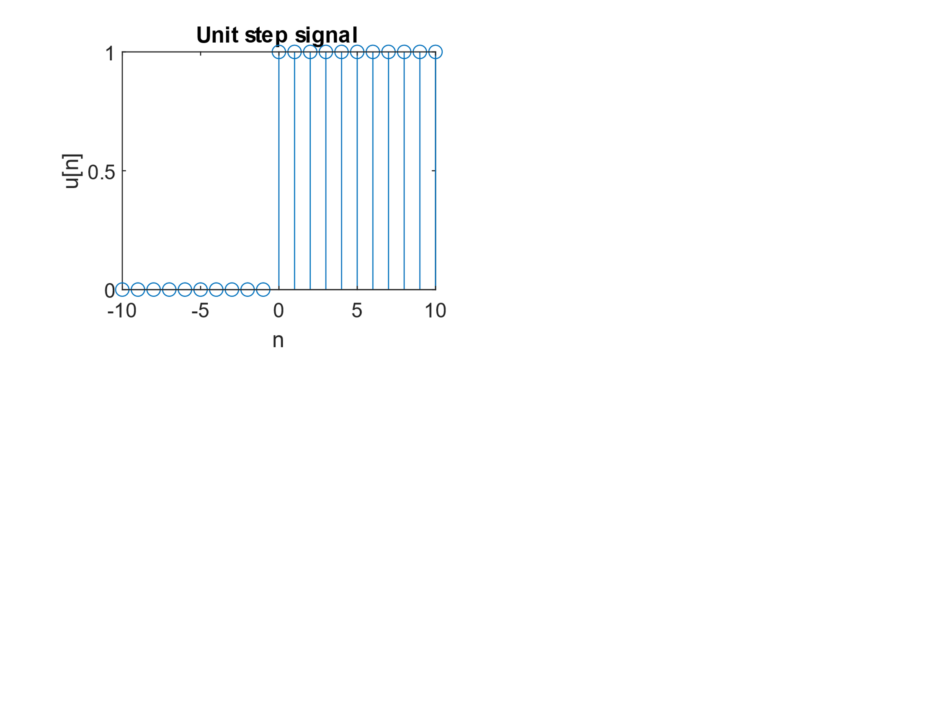

1. **Code:**

%Ramp signal

%Signal Generation

clc

clear all

n = [-10:10];

for i = 1:length(n)

if(n(i)>=0)

xn(i)=n(i);

else

xn(i) = 0;

end

end

%This is for plotting

stem(n,xn);

xlabel("n");

ylabel("r[n]");

title("Ramp signal")

**Waveform:**

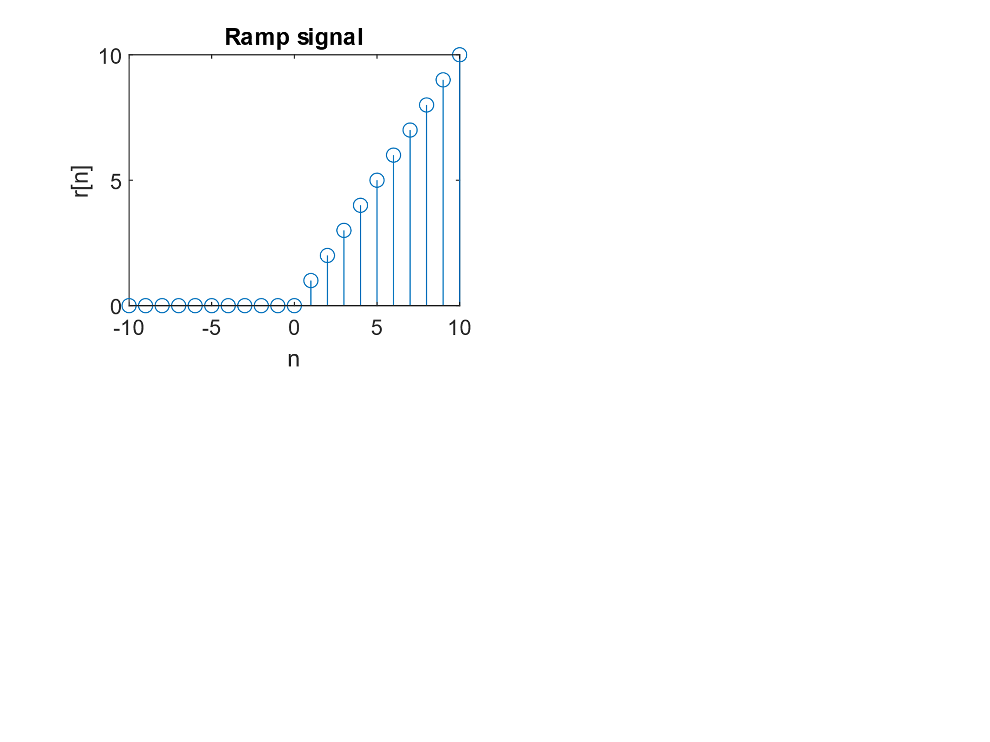

1. **Code:**

%y[n]=2*del[n-1]-4*del[n+2]; -5<= n <= 5

clc

clear all

n = [-5:5];

for i=1:length(n)

if(n(i)==1)

delnm1(i) = 1;

else

delnm1(i) = 0;

end

end

for i=1:length(n)

if(n(i)==-2)

delnp2(i) = 1;

else

delnp2(i) = 0;

end

end

yn = 2*delnm1 - 4*delnp2;

subplot(2,2,1); stem(n,delnm1);

xlabel("n");ylabel("del[n-1]");title("del[n-1]");

subplot(2,2,2); stem(n,delnp2);

title("del[n+2]");xlabel("n");ylabel("del[n+2]");

subplot(2,2,3); stem(n,yn);

title("yn = 2*del[n-1]-4*del[n+2]");xlabel("n");ylabel("y[n]");

**Waveform:**

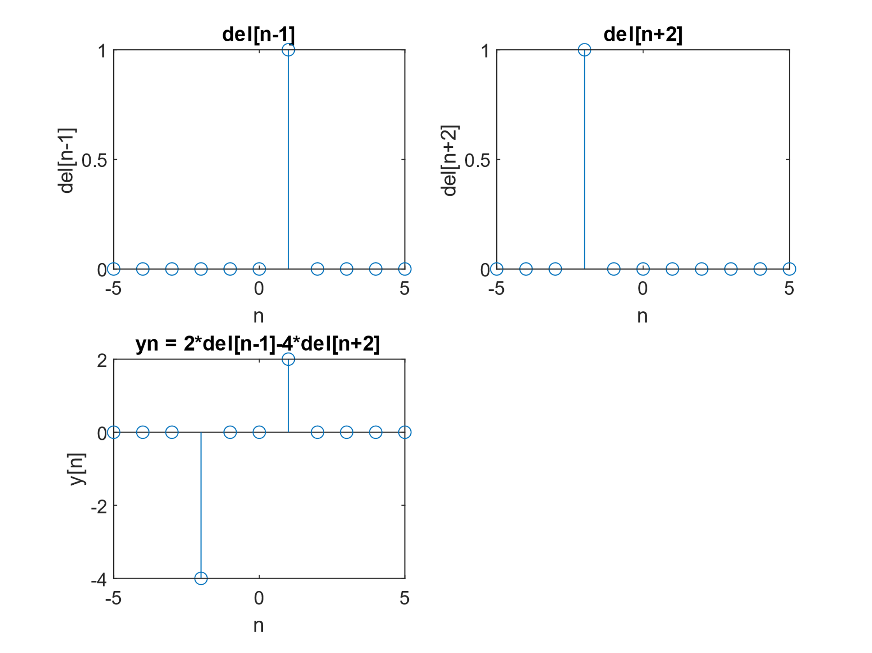

1. **Code:**

%y[n] = cos[0.04*pi*n] ; -5 <= n <= 5

clc

clear all

n = [-50:50];

%yn=zeros(length(n));

for i = 1:length(n)

yn(i) = cos(0.04*pi*n(i));

end

stem(n,yn);title("y[n] = cos[0.04*pi*n]");xlabel("n");ylabel("y[n]");

**Waveform:**

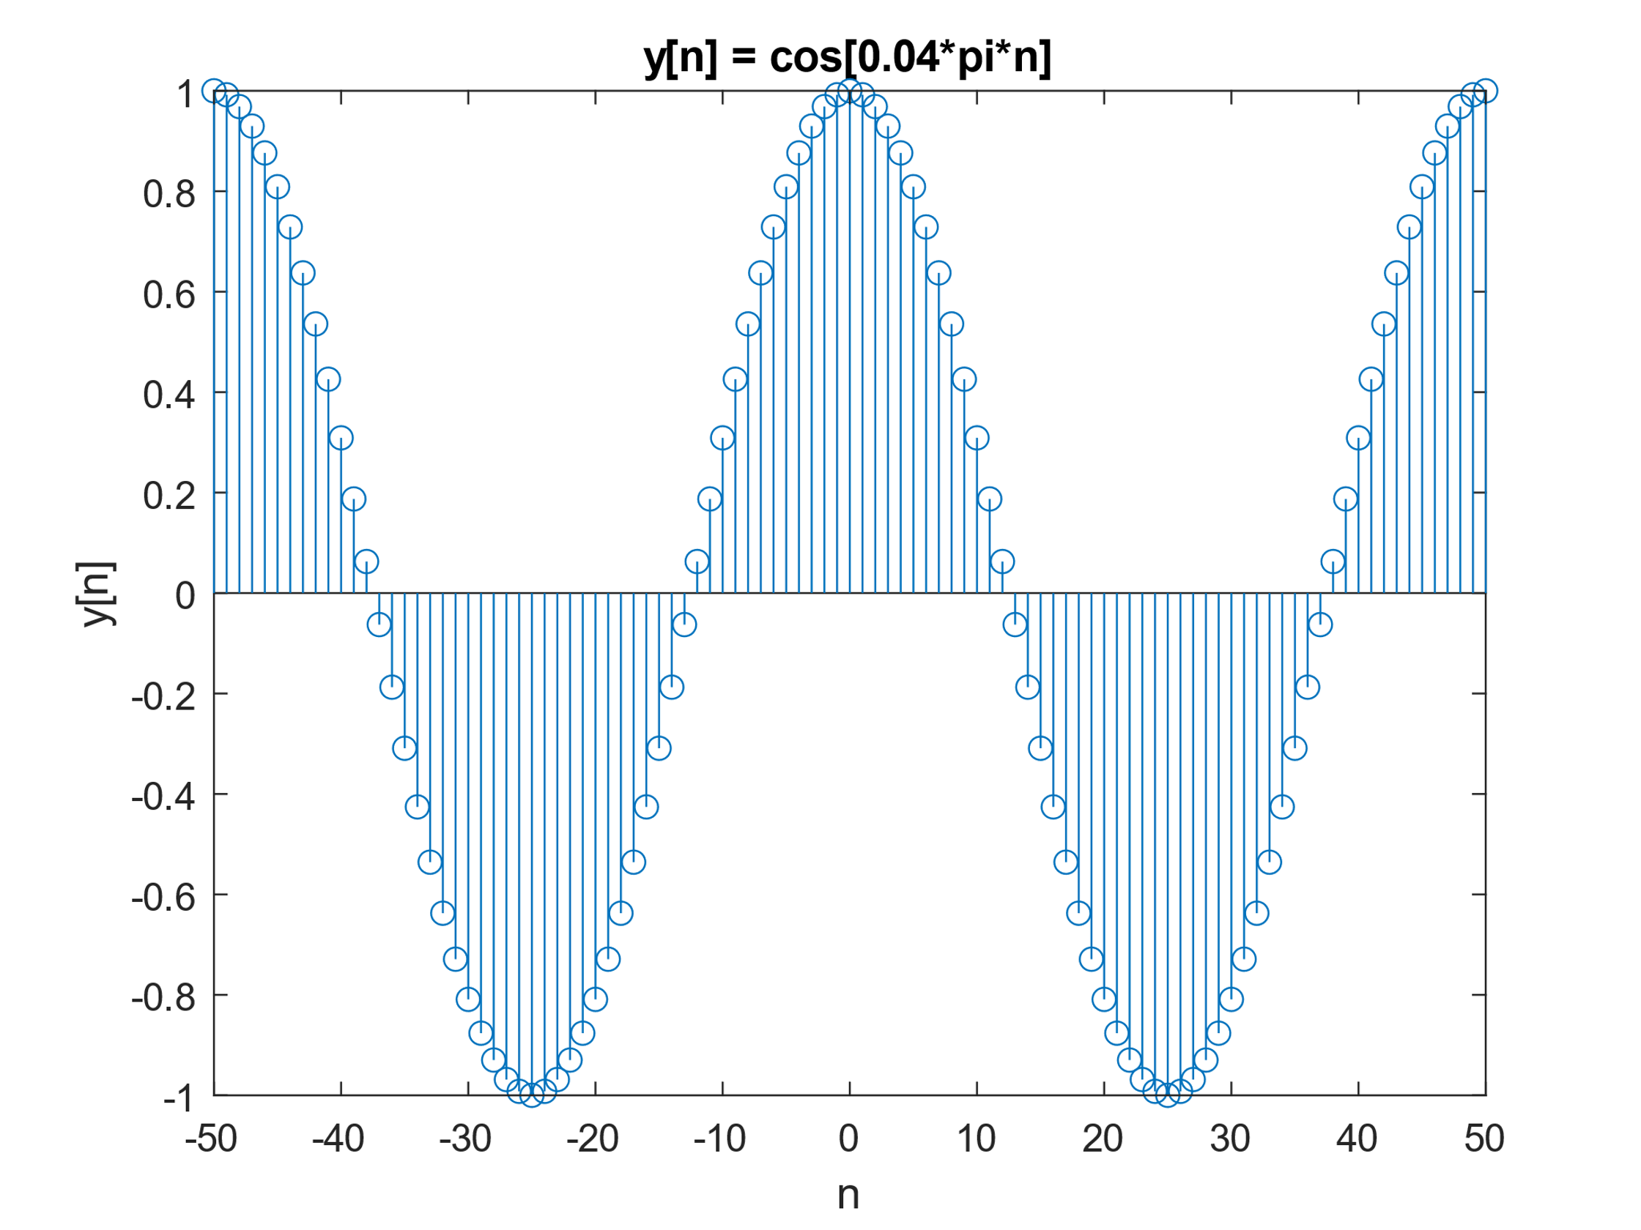

1. **Code:**

%x[n] = n[u[n] - u[n-10]] + 10e-0.3(n-10)[u[n] - u[n-10]]; 0<=n<=20

clc

clear all

n = [-20:20];

for i=1:length(n)

if(n(i) >= 0)

un(i)=1;

else

un(i)=0;

end

end

for i=1:length(n)

if(n(i) >= 10)

unm10(i)=1;

else

unm10(i)=0;

end

end

for i=1:length(n)

part1(i) = n(i)*(un(i) - unm10(i))

end

for i=1:length(n)

part2(i) = 10*exp(-0.3*(n(i)-10))*(un(i)-unm10(i));

end

yn = part1 + part2;

sgtitle("x[n] = n[u[n] - u[n-10]] + 10???.?(????) [u[n] - u[n-10]]")

subplot(2,3,1); stem(n,un);

xlabel("n");ylabel("u[n]");title("u[n]");

subplot(2,3,2); stem(n,unm10);

xlabel("n");ylabel("u[n-10]");title("u[n-10]");

subplot(2,3,3); stem(n,un-unm10);

xlabel("n");ylabel("u[n]-u[n-10]");title("u[n]-u[n-10]");

subplot(2,3,4); stem(n,part1);

xlabel("n");ylabel("part1");title("n[u[n] - u[n-10]]");

subplot(2,3,5); stem(n,part2);

xlabel("n");ylabel("part2");title("10???.?(????)*[u[n] - u[n-10]]");

subplot(2,3,6); stem(n,yn);

xlabel("n");ylabel("y[n]");title("y[n]");

**Waveform:**

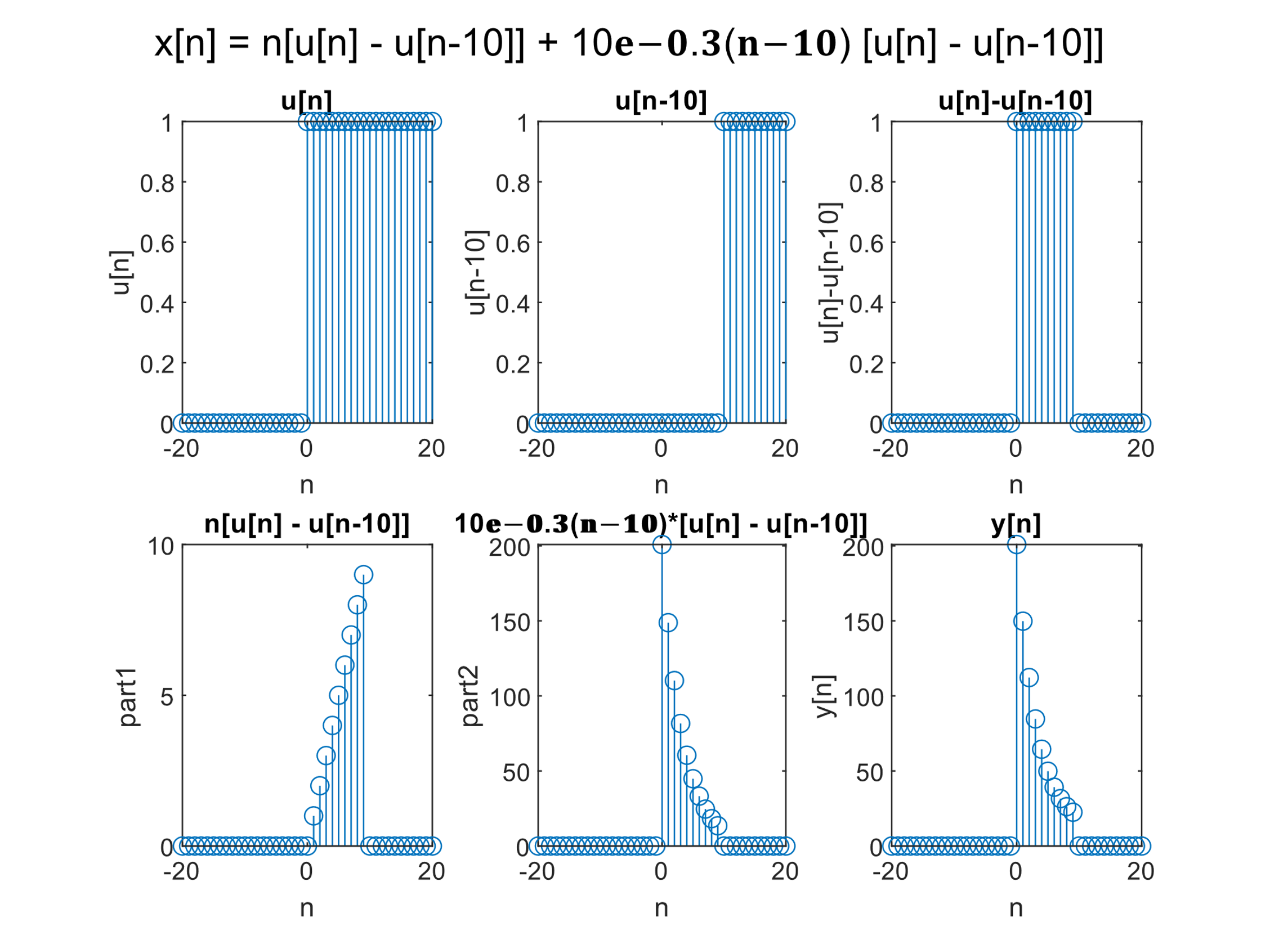

**Question 2:**

1. **and (b) Code:**

%2. If x[n] = {1 2 3 4 5 6 7 6 5 4 3 2 1}

%a. X1[n] = 2x[n-5] - 3x[n+4]

%b. x2[n] = x[3-n] - x[n]x[n-2]

clc

clear variables

xn = [1, 2, 3, 4 ,5, 6, 7, 6, 5, 4, 3, 2, 1];

xnSize = length(xn);

xntemp(1:6) = 0; %Change 10 to any other number

%if full signal is not visibles

sizeOfHalf = length(xn) + length(xntemp);

xn = [xntemp, xn*0, xn, xntemp]; %Since we are shifting,

%let's add few extra 0s to x[n]

%Creating symmetrical sampling

%points

n = [-(length(xntemp)+xnSize) : (length(xntemp)+xnSize-1)];

%x[n-5]

for i=1:length(n)

if(i <= 5)

xnm5(i) = 0;

else

xnm5(i) = xn(i-5);

end

end

%x[n+4]

for i= 1:length(n)

if(i >= length(xn)-4 )

xnp4(i) = 0;

else

xnp4(i) = xn(i+4);

end

end

%a. X1[n] = 2x[n-5] - 3x[n+4]

sgtitle("X1[n] = 2x[n-5] - 3x[n+4] ; X2[n] = x[3-n] - x[n]x[n-2]");

X1n = 2*xnm5 - 3*xnp4

subplot(3,3,1); stem(n,xn);

xlabel("n");ylabel("x[n]");title("x[n]");

subplot(3,3,2); stem(n,xnm5);

xlabel("n");ylabel("x[n-5]");title("x[n-5]");

subplot(3,3,3); stem(n,xnp4);

xlabel("n");ylabel("x[n+4]");title("x[n+4]");

subplot(3,3,4); stem(n,X1n);

xlabel("n");ylabel("X1[n]");title("X1[n] = 2x[n-5]-3x[n+4]");

%x[n-2]

for i=1:length(n)

if(i <= 2)

xnm2(i) = 0;

else

xnm2(i) = xn(i-2);

end

end

%x[-n]

%The index n=0 is length(xntemp)+xnSize+1

indexOfZero = sizeOfHalf+1;

xrev = xn;

for i=1:xnSize

temp = xrev(indexOfZero+i);

xrev(indexOfZero+i) = xrev(indexOfZero-i);

xrev(indexOfZero-i)=temp;

end

%x[3-n] = x[-n+3]

for i=1:length(xrev)

if(i>=length(xrev)-3)

x3mn(i)=0;

else

x3mn(i)=xrev(i+3);

end

end

%b. x2[n] = x[3-n] - x[n]x[n-2]

X2n = x3mn - xn.*xnm2;

subplot(3,3,7); stem(n,x3mn);

xlabel("n");ylabel("x[3-n]");title("x[3-n]");

subplot(3,3,8); stem(n,xn.*xnm2);

xlabel("n");ylabel("x[n]x[n-2]");title("x[n]x[n-2]");

subplot(3,3,9); stem(n,X2n);

xlabel("n");ylabel("X2[n]");title("X2[n] = x[3-n]-x[n]x[n-2]");

**Waveform:**

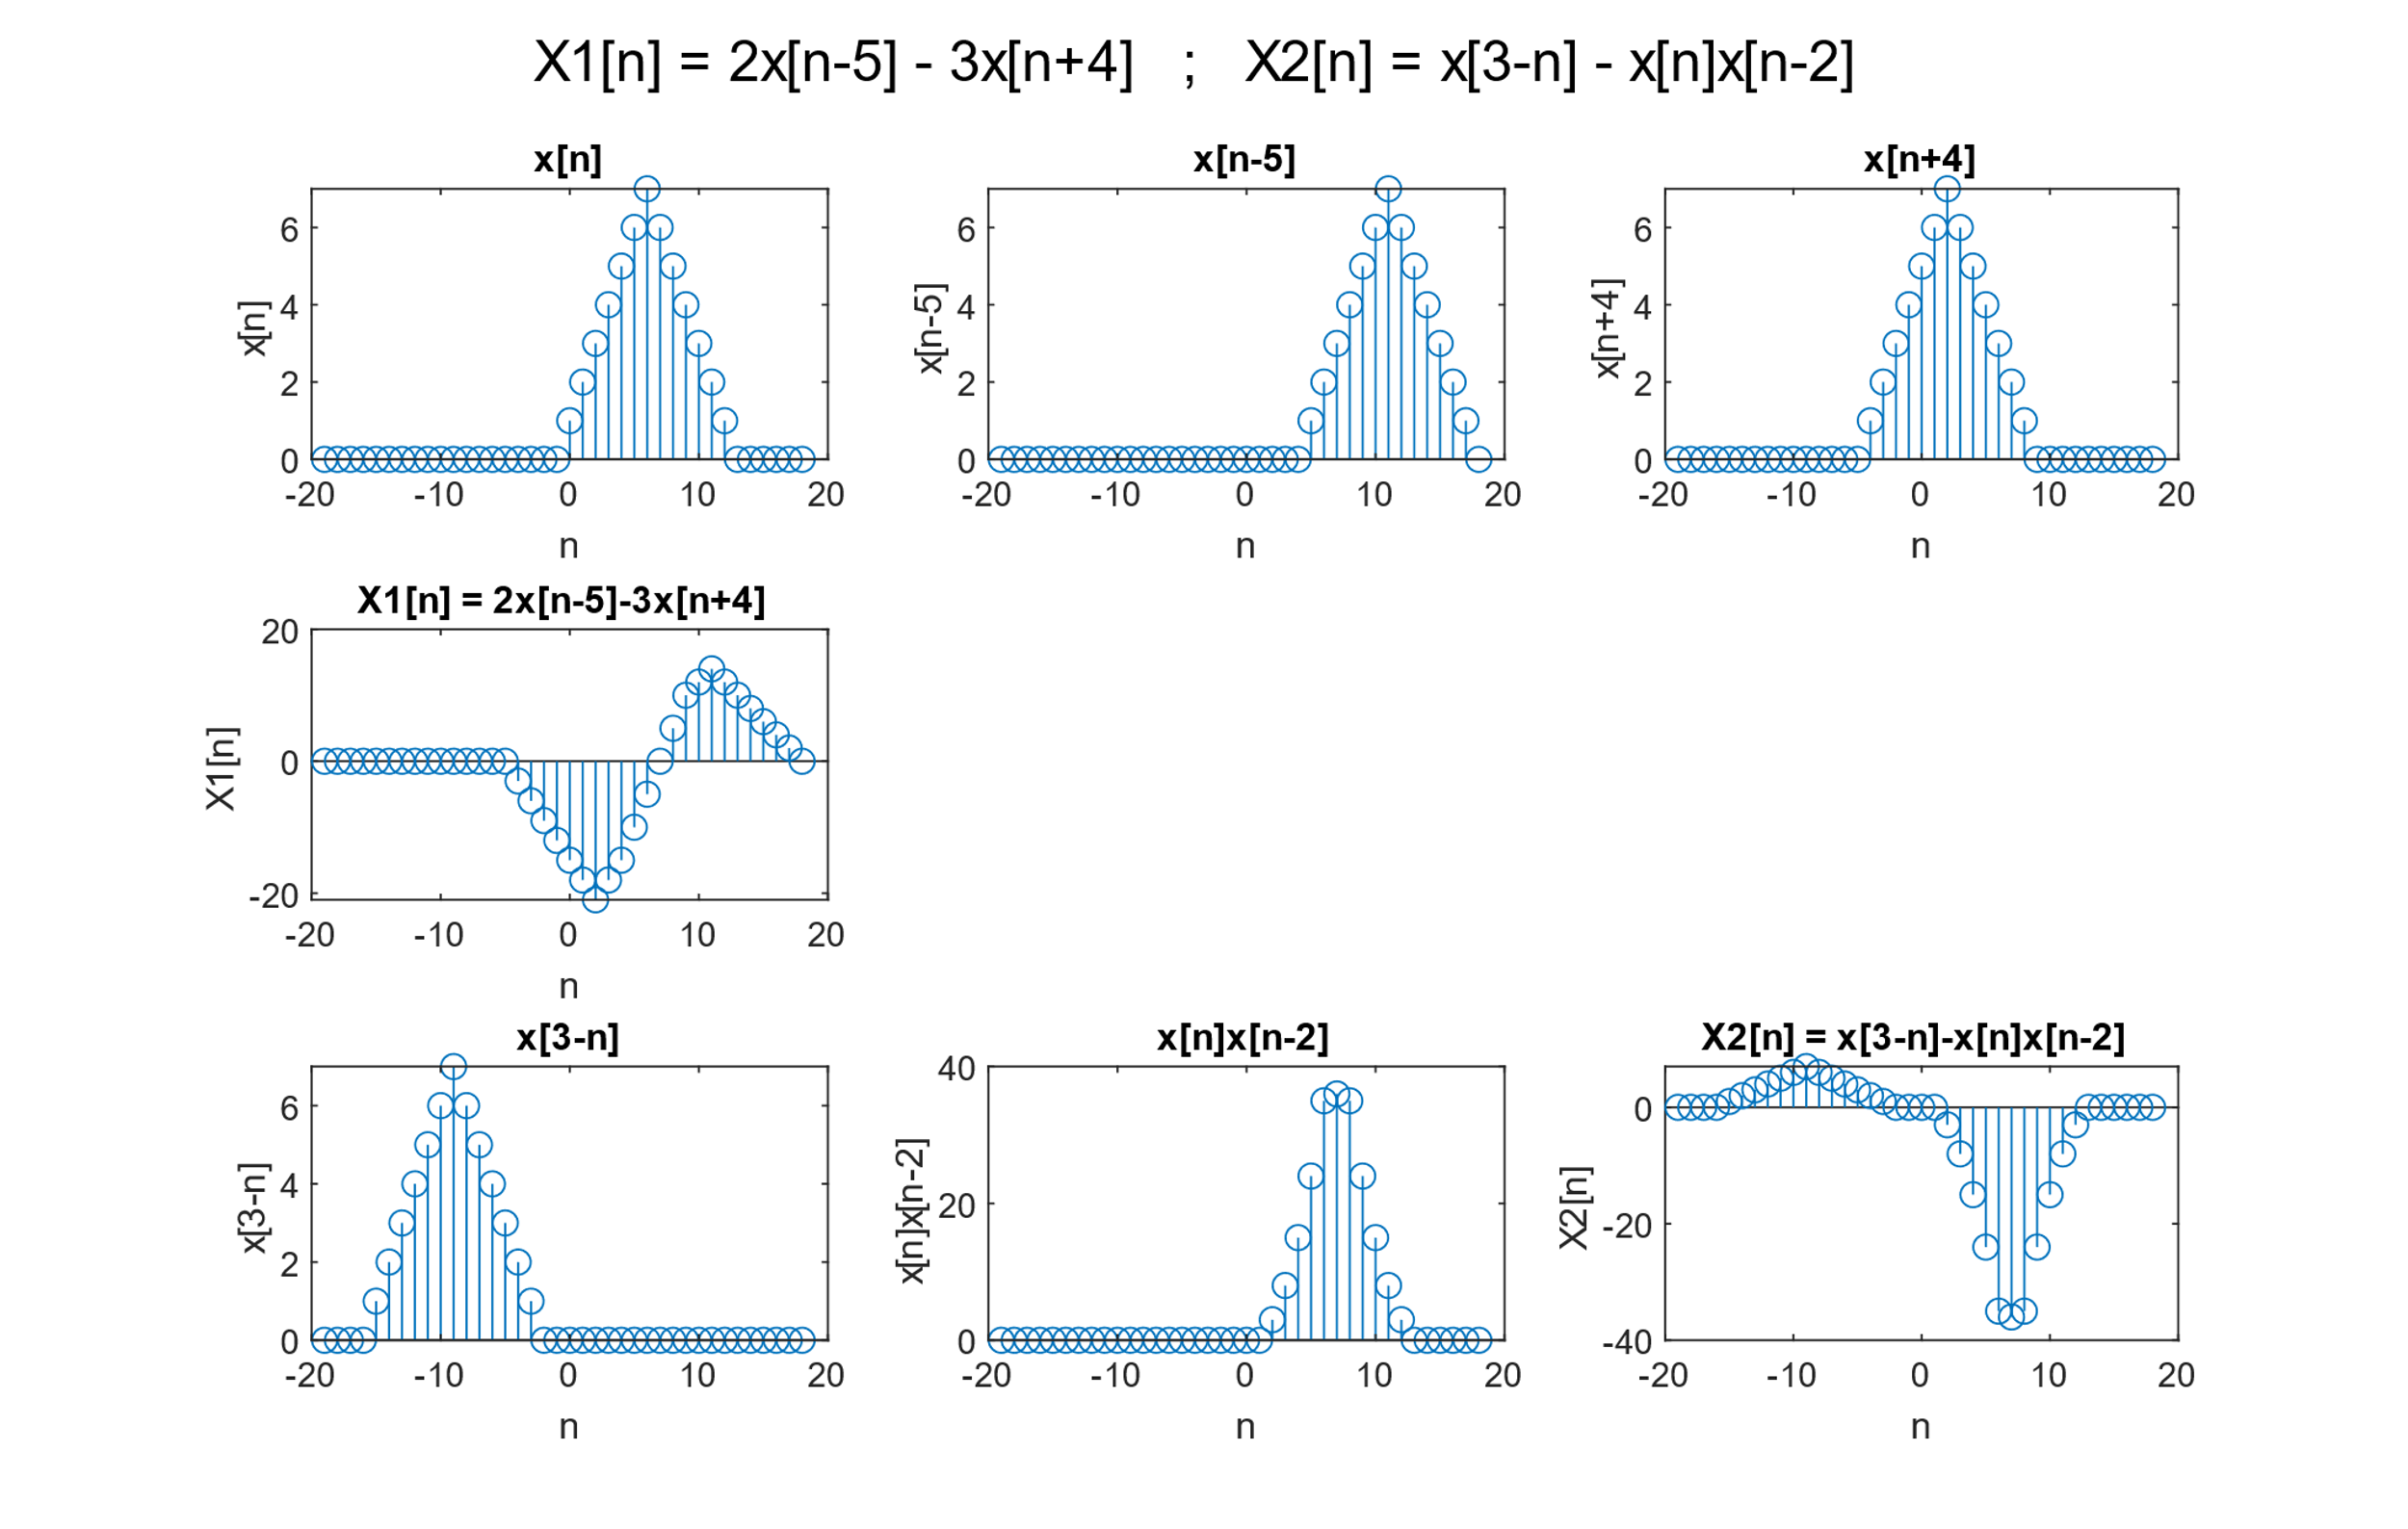

**Question 3:**

1. **Code:**

%x[n] = = e(?0.1+j0.3)n ; -10 ? n ? 10,

n=[-10:10];

xn = exp((-0.1+0.3j)*n);

sgtitle("x[n] = = e(?0.1+j0.3)n");

subplot(2,2,1);stem(n,real(xn));

xlabel("n");ylabel("Re(x[n])");title("Re{x[n]}");

subplot(2,2,2);stem(n,imag(xn));

xlabel("n");ylabel("Im(x[n])");title("Im{x[n]}");

subplot(2,2,3);stem(n,abs(xn));

xlabel("n");ylabel("|x[n]|");title("|x[n]|");

subplot(2,2,4);stem(n,angle(xn));

xlabel("n");ylabel("<(x[n]");title("<(x[n])");

**Waveform:**

