DBMS MINI PROJECT – PHASE 1
Semantic E-Commerce Engine & Supply Chain Hub
Database Design Report — Final Submission

1. Abstract
The Semantic E-Commerce Engine & Supply Chain Hub is a database design for an integrated e-commerce and supply-chain environment. Phase 1 focuses on the conceptual ER model and its exact relational mapping. The model represents customers, products, shopping carts, orders, order items, payments, warehouses, inventory, shipments, deliveries, reviews, and the many-to-many browsing relationship. The design uses Chen notation, explicit weak entities, composite/partial keys, primary and foreign keys, and cardinality constraints. It is structured as a normalized foundation for later SQL implementation and future semantic-search capabilities.

2. Problem Statement
An e-commerce platform must maintain consistent information about customers, products, carts, orders, individual order items, payments, warehouse stock, shipments, deliveries, and reviews. If these data are modeled independently, duplication and referential inconsistencies can occur. The proposed database provides a structured conceptual and relational model that preserves dependencies between business objects and supports traceability from a customer's order through shipment and delivery.

3. Objectives
- Design a complete Chen-notation ER model for the e-commerce and supply-chain workflow.
- Represent customers, products, carts, orders, order items, payments, warehouses, inventory, shipments, deliveries, and reviews.
- Represent the CUSTOMER–PRODUCT browsing M:N relationship using the BROWSES relation during ER-to-relational conversion.
- Identify weak/dependent entities and use appropriate composite keys.
- Map all 1:N and 1:1 relationships through foreign keys and uniqueness constraints.
- Maintain referential integrity and avoid ambiguous SQL names by using CUSTOMER_ORDER instead of ORDER.
- Produce an exact, implementation-ready relational schema that matches the supplied ER diagram without adding or removing business concepts.

4. Scope
- Customer profile and account information.
- Product catalogue information.
- Shopping cart ownership and status.
- Customer order placement and order details.
- Individual order-product lines.
- Payment recording.
- Warehouse and product inventory management.
- Shipment generation and delivery tracking.
- Customer order and delivery review information.
- Product browsing relationships.
- Future semantic-search/vector retrieval is outside the mandatory Phase 1 implementation.

5. ER Model — Chen Notation
The supplied ER diagram uses Chen notation. Rectangles represent strong entities, double rectangles represent weak entities, diamonds represent relationships, ovals represent attributes, underlined attributes represent primary keys, and dashed-underlined attributes represent partial keys. Cardinality labels are shown beside relationship lines.
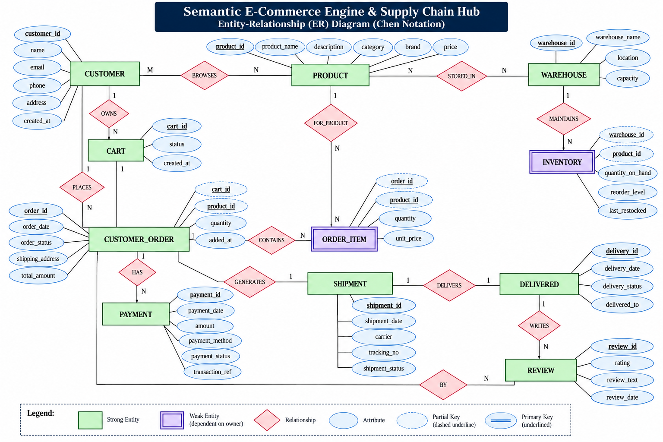
Figure 1. Final Chen-notation ER diagram used as the source model for the relational schema.

5.1 Strong Entities
Entity | Purpose | Primary Key
CUSTOMER | Stores customer identity and contact information. | customer_id
PRODUCT | Stores product catalogue information. | product_id
WAREHOUSE | Stores warehouse information. | warehouse_id
CART | Stores a customer's shopping cart. | cart_id
CUSTOMER_ORDER | Stores a customer's placed order. | order_id
PAYMENT | Stores payment information for an order. | payment_id
SHIPMENT | Stores shipment and tracking information. | shipment_id
DELIVERED | Stores delivery completion information for a shipment. | delivery_id
REVIEW | Stores review information associated with an order and its delivery. | review_id

5.2 Weak / Dependent Entities
Entity | Owner / Identifying Context | Composite Primary Key | Reason
ORDER_ITEM | CUSTOMER_ORDER | (order_id, product_id) | An order item is dependent on its parent order and identifies a product within that order.
INVENTORY | WAREHOUSE + PRODUCT | (warehouse_id, product_id) | A stock record is identified by the warehouse-product combination.
BROWSES is an M:N relationship in the ER model, not an additional strong/weak entity. During relational conversion, it becomes the BROWSES relation containing the primary keys of CUSTOMER and PRODUCT.

5.3 Relationships and Cardinalities
Relationship | Cardinality | Relational Mapping
CUSTOMER — OWNS — CART | 1 : N | CART.customer_id → CUSTOMER.customer_id
CUSTOMER — BROWSES — PRODUCT | M : N | BROWSES(customer_id, product_id)
PRODUCT — STORED_IN — WAREHOUSE | N : N | INVENTORY(warehouse_id, product_id)
WAREHOUSE — MAINTAINS — INVENTORY | 1 : N | INVENTORY.warehouse_id → WAREHOUSE.warehouse_id
PRODUCT — FOR_PRODUCT — ORDER_ITEM | 1 : N | ORDER_ITEM.product_id → PRODUCT.product_id
CUSTOMER — PLACES — CUSTOMER_ORDER | 1 : N | CUSTOMER_ORDER.customer_id → CUSTOMER.customer_id
CUSTOMER_ORDER — CONTAINS — ORDER_ITEM | 1 : N | ORDER_ITEM.order_id → CUSTOMER_ORDER.order_id
CUSTOMER_ORDER — HAS — PAYMENT | 1 : N | PAYMENT.order_id → CUSTOMER_ORDER.order_id
CUSTOMER_ORDER — GENERATES — SHIPMENT | 1 : 1 | SHIPMENT.order_id → CUSTOMER_ORDER.order_id; UNIQUE
SHIPMENT — DELIVERS — DELIVERED | 1 : 1 | DELIVERED.shipment_id → SHIPMENT.shipment_id; UNIQUE
CUSTOMER_ORDER — BY — REVIEW | 1 : N | REVIEW.order_id → CUSTOMER_ORDER.order_id
DELIVERED — WRITES — REVIEW | 1 : N | REVIEW.delivery_id → DELIVERED.delivery_id

6. Entity Attributes
Relation | Attributes
CUSTOMER | customer_id (PK), name, email (UNIQUE), phone, address, created_at
PRODUCT | product_id (PK), product_name, description, category, brand, price
WAREHOUSE | warehouse_id (PK), warehouse_name, location, capacity
CART | cart_id (PK), status, created_at; customer_id is added as FK from OWNS
INVENTORY | warehouse_id (PK/FK), product_id (PK/FK), quantity_on_hand, reorder_level, last_restocked
CUSTOMER_ORDER | order_id (PK), order_date, order_status, shipping_address, total_amount; customer_id is added as FK from PLACES
ORDER_ITEM | order_id (PK/FK), product_id (PK/FK), quantity, unit_price
PAYMENT | payment_id (PK), payment_date, amount, payment_method, payment_status, transaction_ref; order_id is added as FK from HAS
SHIPMENT | shipment_id (PK), shipment_date, carrier, tracking_no, shipment_status; order_id is added as UNIQUE FK from GENERATES
DELIVERED | delivery_id (PK), delivery_date, delivery_status, delivered_to; shipment_id is added as UNIQUE FK from DELIVERS
REVIEW | review_id (PK), rating, review_text, review_date; order_id and delivery_id are added as FKs from BY and WRITES

7. Final Relational Schema
The following schema is derived directly from the supplied ER diagram. Foreign keys introduced by relationship mapping are explicitly shown. No CART_ITEM relation, no WAREHOUSE–SHIPMENT relation, no dispatch_date attribute, and no direct PRODUCT–REVIEW relationship are included because they are not present in the supplied ER diagram.
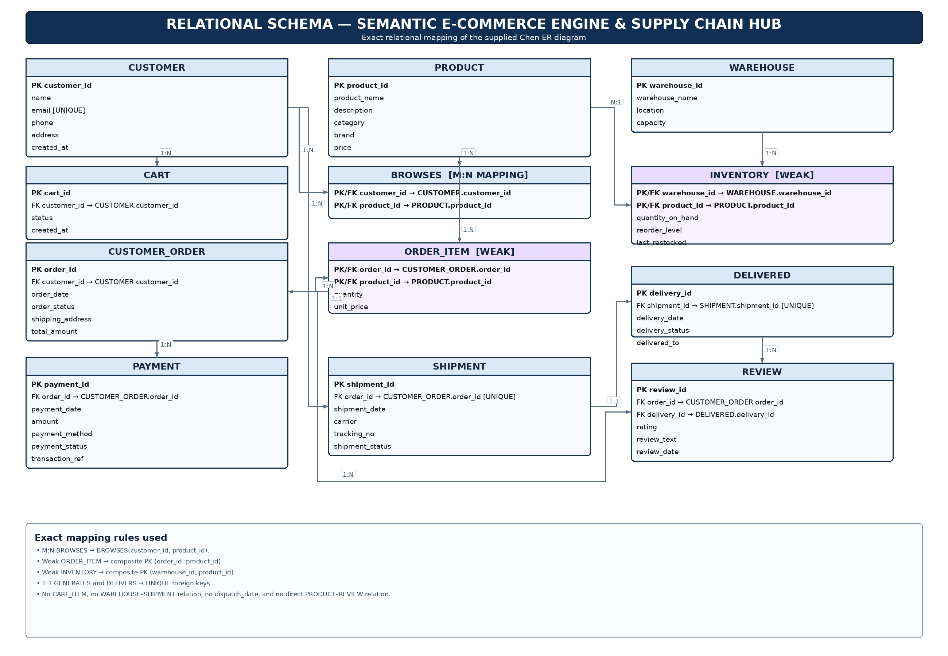
Figure 2. Final relational schema — exact mapping of the supplied ER diagram.

7.1 Relation Definitions
Relation | Final Definition
CUSTOMER | customer_id PK; name; email UNIQUE; phone; address; created_at
PRODUCT | product_id PK; product_name; description; category; brand; price
WAREHOUSE | warehouse_id PK; warehouse_name; location; capacity
CART | cart_id PK; customer_id FK → CUSTOMER.customer_id; status; created_at
BROWSES | customer_id PK/FK → CUSTOMER.customer_id; product_id PK/FK → PRODUCT.product_id
INVENTORY | warehouse_id PK/FK → WAREHOUSE.warehouse_id; product_id PK/FK → PRODUCT.product_id; quantity_on_hand; reorder_level; last_restocked
CUSTOMER_ORDER | order_id PK; customer_id FK → CUSTOMER.customer_id; order_date; order_status; shipping_address; total_amount
ORDER_ITEM | order_id PK/FK → CUSTOMER_ORDER.order_id; product_id PK/FK → PRODUCT.product_id; quantity; unit_price
PAYMENT | payment_id PK; order_id FK → CUSTOMER_ORDER.order_id; payment_date; amount; payment_method; payment_status; transaction_ref
SHIPMENT | shipment_id PK; order_id UNIQUE FK → CUSTOMER_ORDER.order_id; shipment_date; carrier; tracking_no; shipment_status
DELIVERED | delivery_id PK; shipment_id UNIQUE FK → SHIPMENT.shipment_id; delivery_date; delivery_status; delivered_to
REVIEW | review_id PK; order_id FK → CUSTOMER_ORDER.order_id; delivery_id FK → DELIVERED.delivery_id; rating; review_text; review_date

8. Why BROWSES Appears in the Relational Schema
BROWSES is drawn as a relationship diamond in the ER diagram, not as a separate entity. Because CUSTOMER and PRODUCT participate in a many-to-many relationship, the standard ER-to-relational transformation creates a separate relation named BROWSES. Its composite primary key is (customer_id, product_id), and both columns are also foreign keys. Therefore, BROWSES is not an extra business entity; it is the relational representation of the M:N relationship shown in the ER diagram.

9. Why CUSTOMER_ORDER and ORDER_ITEM Are Different
CUSTOMER_ORDER represents the order-level transaction: the customer who placed it, order date, status, shipping address, and total amount. ORDER_ITEM represents an individual product line within that order: the product, quantity, and unit price. Therefore, one CUSTOMER_ORDER can contain multiple ORDER_ITEM records. ORDER_ITEM is dependent on CUSTOMER_ORDER and uses the composite key (order_id, product_id).

10. Weak Entity and Composite-Key Justification
ORDER_ITEM depends on CUSTOMER_ORDER for its identity, so order_id participates in its primary key. INVENTORY depends on the warehouse-product combination, so (warehouse_id, product_id) forms its composite primary key. These keys prevent duplicate product lines within the same order and duplicate stock records for the same product in the same warehouse.

11. Normalization
- 1NF: All attributes are atomic. Repeating product/order information is separated into ORDER_ITEM, and warehouse-product stock is separated into INVENTORY.
- 2NF: In composite-key relations, non-key attributes describe the complete identifying combination. For example, quantity and unit_price belong to a particular (order_id, product_id) pair.
- 3NF: Customer, product, warehouse, payment, shipment, delivery, and review attributes are stored in their appropriate relations rather than being repeated across unrelated records.
- Referential integrity is enforced through foreign keys.

12. Integrity Constraints
- Every primary key is unique and NOT NULL.
- CUSTOMER.email is UNIQUE.
- Foreign keys must reference existing parent rows.
- ORDER_ITEM and INVENTORY use composite primary keys.
- SHIPMENT.order_id is UNIQUE to preserve the 1:1 CUSTOMER_ORDER–SHIPMENT relationship shown in the ER diagram.
- DELIVERED.shipment_id is UNIQUE to preserve the 1:1 SHIPMENT–DELIVERED relationship shown in the ER diagram.
- Quantity values should be positive.
- Product price, payment amount, and order total should be non-negative.
- Review rating should be restricted to the chosen valid range, such as 1–5.

13. Functional Flow
- A CUSTOMER owns one or more CART records.
- A CUSTOMER browses many PRODUCT records, and a PRODUCT can be browsed by many customers; this is represented by BROWSES.
- PRODUCTs are stored in WAREHOUSEs; INVENTORY records identify each warehouse-product stock combination.
- A CUSTOMER places a CUSTOMER_ORDER.
- A CUSTOMER_ORDER contains ORDER_ITEM records, each identifying a PRODUCT and its quantity and unit price.
- A CUSTOMER_ORDER can have PAYMENT records.
- A CUSTOMER_ORDER generates one SHIPMENT in the Phase 1 ER model.
- A SHIPMENT delivers one DELIVERED record.
- A REVIEW is associated with a CUSTOMER_ORDER through BY and with a DELIVERED record through WRITES.

15. Conclusion
The final Phase 1 database design provides a clean and consistent conceptual-to-relational mapping for the Semantic E-Commerce Engine & Supply Chain Hub. The relational schema is derived directly from the supplied Chen ER diagram. The design preserves the ER cardinalities, represents the M:N BROWSES relationship as a relational mapping, uses composite keys for dependent records, and uses UNIQUE foreign keys for the two 1:1 relationships. No additional business entity, attribute, or relationship has been introduced beyond the supplied ER model. The resulting design is suitable as the basis for subsequent SQL implementation and future semantic-search extensions.

