EE 527: Machine Learning Laboratory

**Assignment 2**

Due date: 23 Jan 2023

________________________________________________________________________________________________________________________

1. Generate **N** points in an interval **[a, b].** Evaluate the normalized frequency distribution of these points. Make m bins for constructing the distribution.

* Let **a** = -100 and **b** = 100.
* Experiment with **N** = 100, 1000 & 10000.
* Choose the value of m appropriately.
* Plot the normalized frequency distribution.

1. With **N** = 5000 and **m** = 400, construct a normalized frequency distribution (**Q1**). Treat this distribution as a weighted dataset $$\left\{\left(x_{ i}, p_{ i} \right); i= 1,2,… m\right\}$$, where $$\sum_{i=1}^{m}{p} _{i} =1$$.

Evaluate the weighted **AM**, **GM**, **HM**, **median** and **mode**.

1. Write a general code that takes any weighted dataset $$\left\{\left(x_{ i}, ω_{ i} \right); i= 1,2,… n\right\}$$ as input and provides the weighted AM, GM, HM, median and mode. In this particular case, $$ω_{i} ≥ 0$$ and $$\sum_{i=1}^{n}{ω} _{i} ≠1$$.
2. **Generation of Points**
   1. Randomly generate **n**=1000 2D points $$S_{e} = \left\{x_{1}, x_{2}, … x_{n}\right\}$$ inside an a 2D ellipse of axes $$r_{x}$$ = 150, $$r_{y}$$ = 100 and centered at $$x_{c}$$ = (-10,20). The axes of the ellipse are aligned with the co-ordinate system axes.
   * 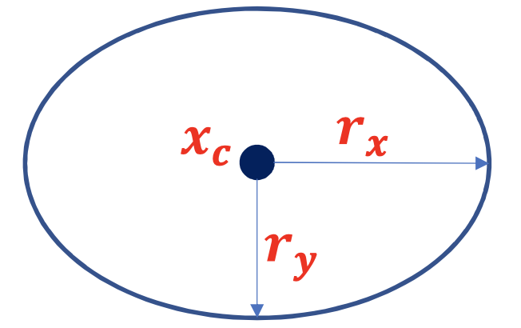
   1. Randomly generate **n**=1000 points $$S_{hs} = \left\{x_{1}, x_{2}, … x_{n}\right\}$$ inside a 10-Dimensional hypersphere of radius r =100, centered at xc= (-1, 2, -1, 0, 0, 0, 3, 4, 9, 0).

* 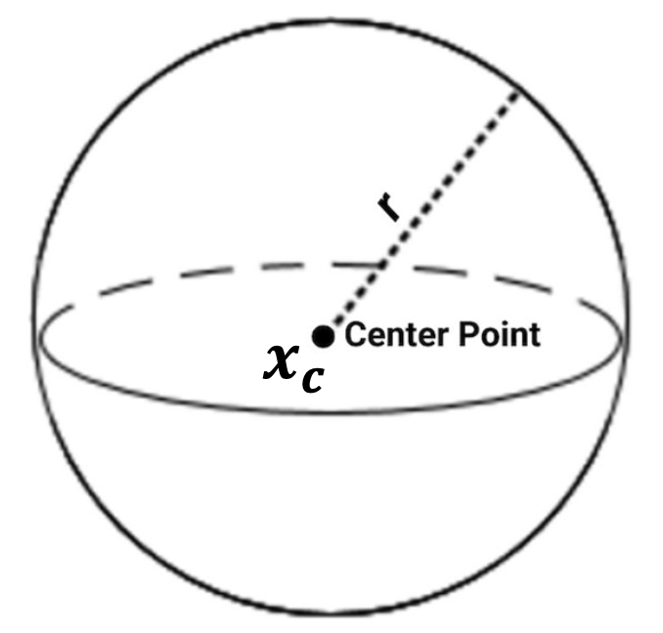
  1. Randomly generate **n** = 1000 2D points $$S_{eo} = \left\{x_{1}, x_{2}, … x_{n}\right\}$$ inside an oriented 2D ellipse of axes $$r_{x} =150$$, $r_{y}=100$ and centered at $$x_{c}= \left(−10,20\right)$$. The major axis makes an angle of $θ=\frac{π}{3}$ with the horizontal axis $\hat{X}$.
  + 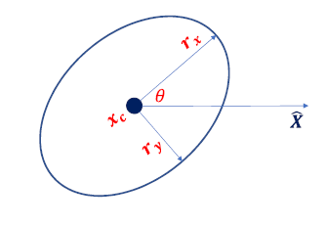

1. **Covariance Matrix Computation**

Compute the 2x2 Covariance Matrix **C** using the points in $$S_{eo}$$. Plot the Eigen Vectors $\left({\hat{e}}_{1},{\hat{e}}_{2}\right)$ of **C** and the axes of the oriented ellipse, all originating from the center $$x_{c}$$. The lengths of $\left({\hat{e}}_{1},{\hat{e}}_{2}\right)$ should be respectively set to $$\left(k\sqrt{λ_{1}}, k\sqrt{λ_{2}}\right)$$. Change the value of **n** and report observations. Try plotting with k = 3, 4, 5.

* 