EE 527: Machine Learning Laboratory

Assignment 7

Due date: 21 March 2023

1. **PCA & KD-Tree**

**The MNIST Dataset:**

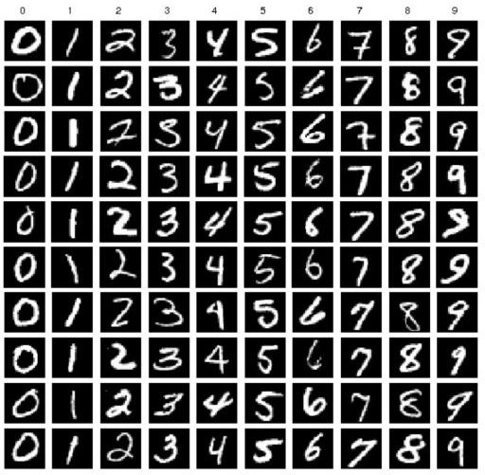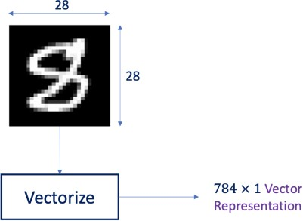

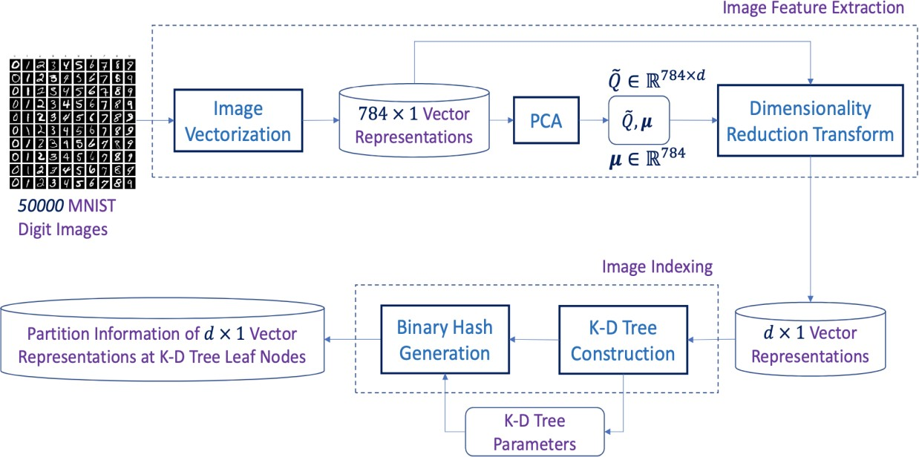

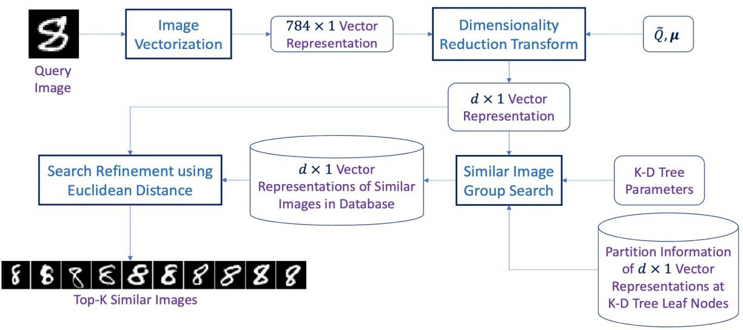

**Performance Evaluation:**

*Number of Responses Matching Query Image*

***Search Precision* =**

*Query Response Size (K for Top-K Responses)*

Experiment with varying values of target feature subspace dimension ***d***, K-D Tree maximum dept ***Dmax***, and leaf node data number threshold ***m***.

Report ***Search Precision*** for different cases.

The MNIST data set can be accessed through the Keras library.

1. **Spherical Clustering**

Consider the YALE face dataset of the previous assignment, consisting of 15 subjects of 11 faces each. Downscale the images by a factor of 2 along both the height and width axes. Flatten the images into vectors 𝑥1, 𝑥2, … 𝑥𝑛.

Perform spherical clustering on these vectors by choosing an appropriate cluster number

K and visualize the mean face of the each of the clusters at convergence.