  - 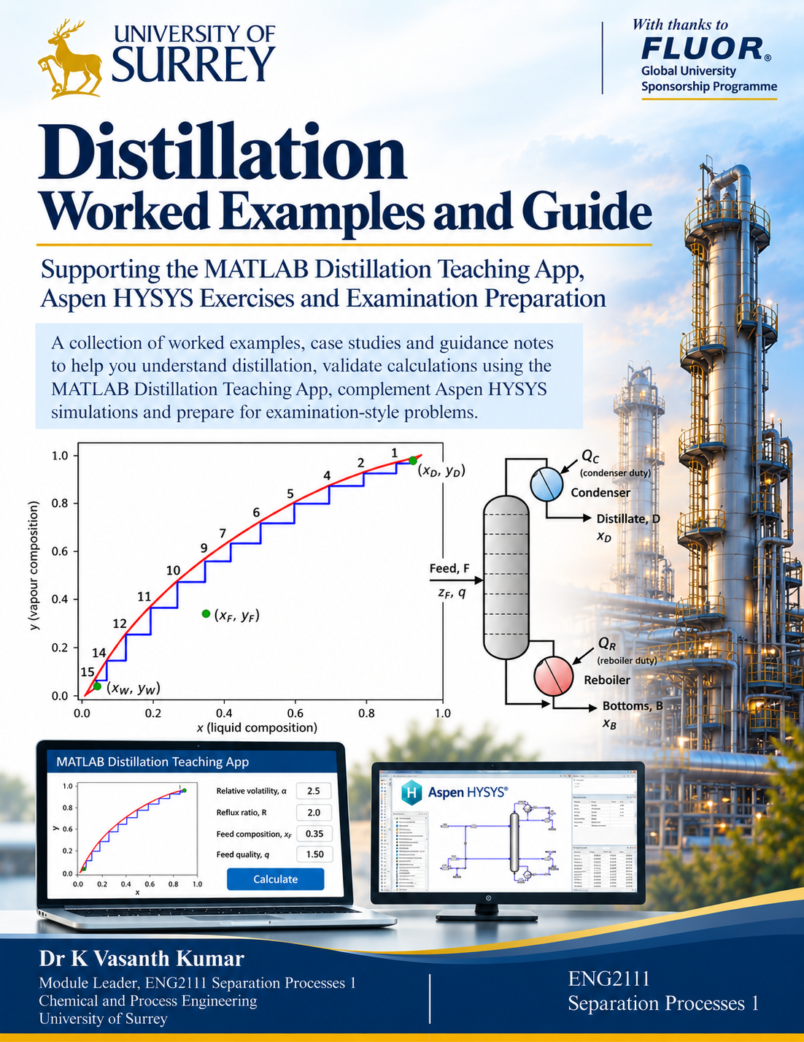
  - Preface: A Guide to Learning and Understanding Distillation
  - ENG2111 Separation Processes 1 | MATLAB Distillation Teaching App and Worked Examples
Dear Students,
Distillation is one of the most important separation processes in chemical engineering. Understanding how a distillation column operates requires knowledge of vapour–liquid equilibrium, material and energy balances, reflux ratio, feed conditions, and the relationship between the condenser, reboiler and individual equilibrium stages. These concepts are introduced during lectures and explored further through process simulation exercises using Aspen HYSYS.
This document has been developed as a supplementary learning resource to accompany the MATLAB Distillation Teaching App provided as part of ENG2111 Separation Processes 1. The primary purpose is to bring together worked examples and case studies developed while testing and validating the MATLAB application. Rather than keeping these examples solely for software validation, we have made them available to support your understanding of distillation.

Two Approaches to Understanding Distillation
The first approach is based on the classical McCabe–Thiele method. It allows you to investigate vapour–liquid equilibrium, operating lines, feed conditions, reflux ratio and the number of theoretical equilibrium stages. It is particularly useful for conventional examination-style distillation problems.
The second approach extends the analysis to simple distillation case studies, including material flow rates, feed-stage location and approximate condenser and reboiler heat duties. It provides an opportunity to explore how operating conditions influence column performance.
The MATLAB application is a simplified teaching tool. It uses assumptions such as constant relative volatility and constant molar overflow, and its condenser and reboiler duty calculations are based primarily on latent heat. It does not replace the more rigorous thermodynamic and energy-balance calculations performed by Aspen HYSYS.

How This Document Can Help You
Several worked examples in this document resemble problems you may encounter in examinations. The solutions demonstrate the underlying calculations step by step. Try each problem independently before consulting the solution; then use the MATLAB app to check your calculations, visualise operating lines and equilibrium stages, and explore the effect of changing input parameters.

Connecting MATLAB with Aspen HYSYS
After completing a binary distillation simulation in HYSYS, you can use the MATLAB application to independently estimate theoretical stages, investigate feed-stage location and obtain approximate condenser and reboiler heat duties. These calculations can provide a useful preliminary check on HYSYS results.
The two applications will not necessarily produce identical answers. HYSYS uses more detailed thermodynamic models and energy balances, whereas the MATLAB app uses simplified relationships. Differences may arise from sensible heat, nonideal vapour–liquid equilibrium and variations in internal liquid and vapour flow rates.
For example, changing the feed-stage location in HYSYS may affect product compositions, temperature profiles and energy requirements. The MATLAB app can help explore the corresponding McCabe–Thiele construction, but its simplified duty model may not reproduce every condenser or reboiler duty change predicted by HYSYS. It is therefore a complementary learning and preliminary-validation tool, not a replacement for rigorous simulation.

Supporting Your Coursework — Not Adding Another Task
The purpose of providing this document and the MATLAB application is not to introduce another task or increase your coursework workload. Quite the opposite: these resources are intended to make learning easier, help you complete coursework more efficiently and provide additional ways to check your understanding.
When completing the distillation component of your HYSYS coursework, you may use the MATLAB application for an independent preliminary calculation. This can help identify unexpected results, assess whether operating conditions are reasonable and understand why a HYSYS simulation behaves as it does. You should still explain any discrepancies and the assumptions behind your comparison.

Bringing Everything Together
Lectures provide the theoretical foundation. Worked examples show how the equations are applied. The MATLAB app helps visualise and check calculations. Aspen HYSYS lets you investigate more realistic distillation systems. Together, these resources should strengthen your understanding, build confidence with examination-style problems and support a more critical approach to process simulation.
I encourage you to use the MATLAB application not simply to obtain an answer, but to explore why the answer changes when the reflux ratio, feed condition, feed-stage location or separation requirements are modified.
Ultimately, the objective is not just to operate a distillation column in HYSYS or solve a McCabe–Thiele problem in an examination. It is to understand the chemical engineering principles that connect the two. I hope these resources make distillation more accessible and help you complete your coursework with greater confidence and less unnecessary effort.

Dr K Vasanth Kumar
Module Leader, ENG2111 Separation Processes 1 and HYSYS
Chemical and Process Engineering
University of Surrey

  - The Elegance of the McCabe–Thiele Method
  - A reflection on how thermodynamics and conservation of mass meet on a single graph

A complex column, a remarkably simple picture
A distillation column involves simultaneous heat and mass transfer, countercurrent liquid and vapour flows, changing compositions and phase equilibrium. Yet Warren L. McCabe and Ernest W. Thiele showed in 1925 that much of this complexity could be represented using just a few lines and a staircase on a two-dimensional diagram. That is an extraordinary contribution to chemical engineering.
At first glance, the operating lines can look like three lines flying across an equilibrium diagram. Why should a straight line drawn between two points say anything meaningful about a real column? Look more closely: these lines are not decorative, arbitrary or fitted simply to make the graph work. They are material-balance expressions applied at different locations in the column.

What the lines really mean
Graphical feature | Physical principle
Equilibrium curve | Thermodynamics: liquid and vapour leaving an ideal stage are in equilibrium.
Rectifying operating line | Component balance around the condenser and upper section.
Stripping operating line | Component balance around the reboiler and lower section.
Feed q-line | Feed mass balance and the change in internal flows associated with feed thermal condition.
The remarkable connection: the equilibrium curve describes which phase compositions can coexist; the operating lines describe which compositions satisfy conservation of mass.

Why the staircase is so beautiful
A horizontal move from an operating-line point to the equilibrium curve finds the liquid composition in equilibrium with a known vapour composition on an ideal stage. A vertical move then applies the appropriate section material balance to obtain the vapour composition for the next stage. Repeating these two operations solves a sequence of equilibrium and material-balance equations graphically, one theoretical stage at a time.
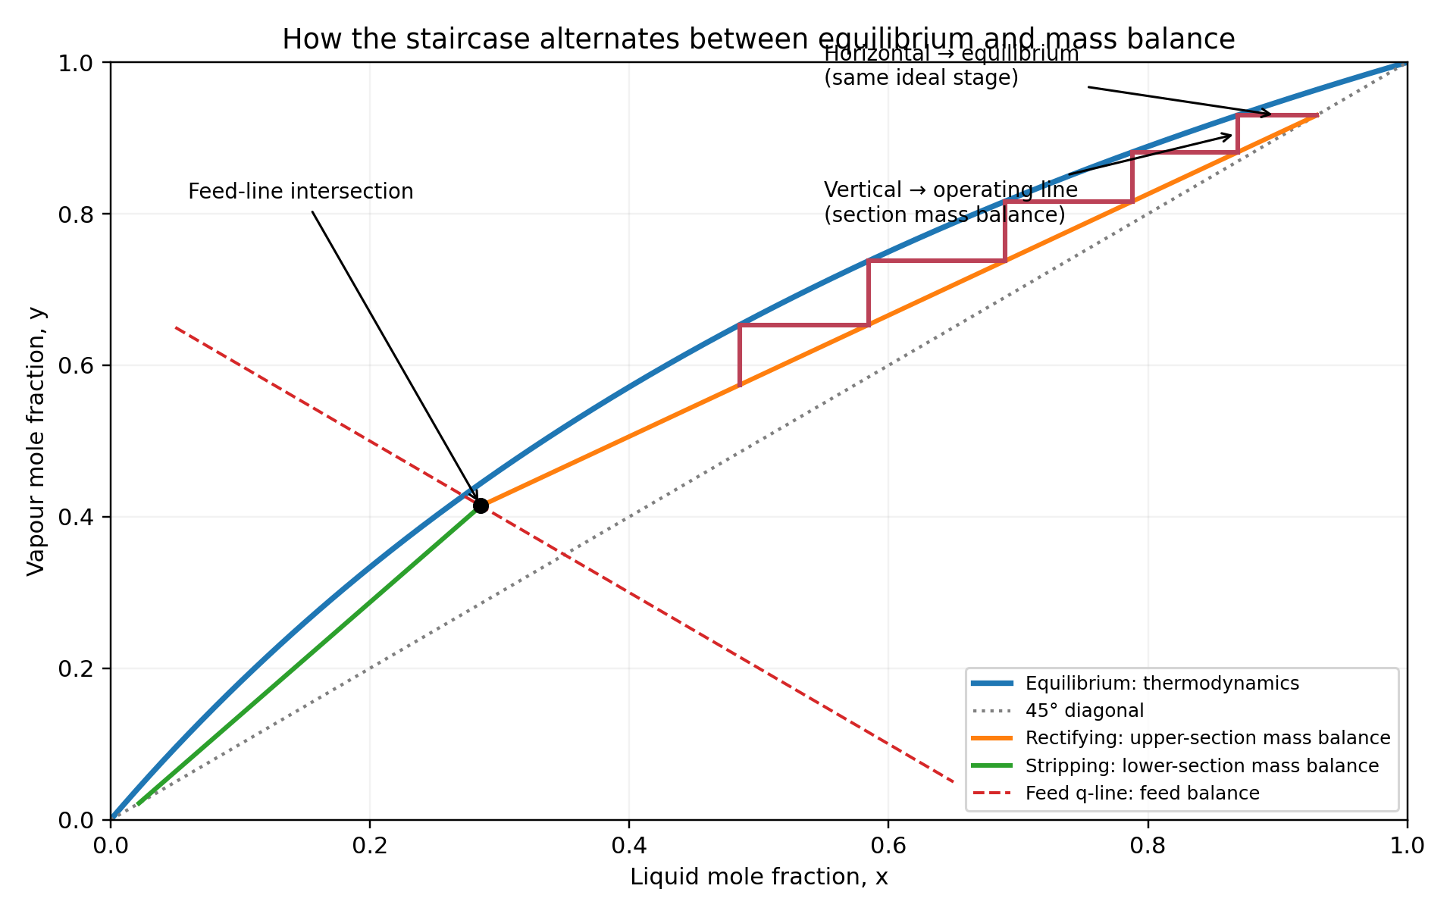
Illustrative McCabe–Thiele staircase: horizontal steps apply vapour–liquid equilibrium; vertical steps apply section-wide component balances. The q-line locates the transition between the two operating sections.

The equations hidden behind the drawing
For steady-state operation with constant molar overflow and a total condenser, a component balance around the upper section gives $V y_{n+1} = L x_{n} + D x_{D}$. The total balance and reflux definition are $V = L + D, R = \frac{L}{D}$.
Rectifying operating line: $y_{n+1} = \frac{R}{R + 1} x_{n} + \frac{x_{D}}{R + 1}$
Similarly, a component balance around the lower section gives $\overline{L} x_{n} = \overline{V} y_{n+1} + B x_{B}$, with $\overline{L} = \overline{V} + B$.
Stripping operating line: $y_{n+1} = \frac{\overline{L}}{\overline{V}} x_{n} - \frac{B}{\overline{V}} x_{B}$
For a binary mixture described by constant relative volatility $α$, the equilibrium curve is:
Vapour–liquid equilibrium: $y_{n} = \frac{α x_{n}}{1 + (α - 1)x_{n}}$
The feed q-line is also a balance relationship, not an equilibrium equation. With feed quality q and composition z_F:
$$q x - (q - 1)y = z_{F}$$
Equivalently, for q ≠ 1:
$$y = \frac{q}{q - 1}x - \frac{z_{F}}{q - 1}$$
The staircase then alternates between equilibrium and material balance:
$$x_{n} = \frac{y_{n}}{α - (α - 1)y_{n}} (horizontal: equilibrium)$$
$$y_{n+1} = m x_{n} + c (vertical: operating-line material balance)$$
Here m and c are the slope and intercept of the relevant operating line; they change when the staircase passes from the rectifying section to the stripping section.
Each horizontal move applies the equilibrium condition for one ideal stage; each vertical move applies the component balance that links neighbouring stages. The graphical steps are therefore a sequential solution of the stage equations, not an empirical construction.
These equations play different roles. Equilibrium relates vapour and liquid leaving the same ideal stage; an operating line relates streams associated with adjacent stages through a section material balance. The staircase alternates between them.

Why this still matters a century later
In 1925, engineers did not have digital computers, MATLAB or Aspen HYSYS. A ruler-and-pencil method that turned coupled stage calculations into a repeatable graphical procedure was profoundly useful. Even today, it can reveal the physics more clearly than pressing Run in a process simulator.
Our MATLAB Distillation Teaching Tool makes that reasoning visible. Change the reflux ratio and the upper operating line moves. Change the feed quality and the q-line rotates. Change the separation specification and the staircase changes. Students can see the consequences of mass balance and equilibrium instead of treating the column as a black box.

An important engineering qualification
The conventional straight operating lines rely on approximately constant internal molar flows within each section (constant molar overflow). Real columns may have appreciable sensible-heat effects, variable latent heats, pressure drop, heat losses or nonideal behaviour. Material conservation remains valid, but the simple straight-line construction can become inaccurate. The equilibrium diagram is an x–y plot; a T–x–y diagram is useful for obtaining equilibrium data but is not the plane on which the standard staircase is drawn.
My reflection. What I find most elegant is that nothing magical is hiding in the drawing. The apparently free-floating lines are balances around the top, bottom and feed; the staircase repeatedly joins those balances to thermodynamic equilibrium. A century-old graphical method becomes a remarkably clear expression of chemical engineering thinking: conservation laws and thermodynamics working together.

ENG2111 | Distillation Teaching Tool
Student instructions: relative volatility, latent heat and simplified energy duties
Purpose. Use Aspen HYSYS to estimate the inputs required by the MATLAB McCabe–Thiele teaching tool, then compare its simplified energy-duty predictions with HYSYS. Record the component system, property package, pressure, compositions, units and assumptions for every value.

1. Before you begin
Use a converged binary distillation column and identify the light key (more volatile component) and heavy key. Record column top and bottom pressures, feed rate $F$, feed composition $z_{F}$, reflux ratio $R$, distillate flow $D$, feed thermal condition $q$ and number of trays. Ensure the MATLAB and HYSYS definitions of trays and the reboiler are consistent.

2. Relative volatility: what does it mean?
For a binary mixture with light-component liquid mole fraction $x$ and equilibrium vapour mole fraction $y$, relative volatility is:
$$α=\frac{y/\left(1-y\right)}{x/\left(1-x\right)}=\frac{y \left(1-x\right)}{x \left(1-y\right)}$$
If $α>1$, the light component preferentially enters the vapour phase. The MATLAB tool assumes a single, constant $α$ and uses the equilibrium relation:
$$y=\frac{αx}{1+\left(α-1\right) x}$$
In real systems $α$ generally varies with composition, temperature and pressure.

3. Method A — estimate $α$ from a HYSYS T–x–y diagram
In HYSYS, choose the same component list and thermodynamic property package as the column. Open the binary phase-equilibrium / property-analysis utility available in your HYSYS version (menu names differ by release).
Generate an isobaric T–x–y diagram at a representative column pressure. Identify the bubble-point liquid curve ($x$) and dew-point vapour curve ($y$).
At one common temperature, take a horizontal tie line between the bubble and dew curves. Read the equilibrium pair $x$ and $y$ for the light component. Do not take $x$ and $y$ at the same horizontal composition coordinate.
Calculate $α$ from the equation above. Repeat at several equilibrium tie lines, avoiding $x$ or $y$ extremely close to 0 or 1 where reading errors become large.
Choose and justify a representative $α$ (for example, the median of calculated values) and report its observed range. If the range is wide, explain why the constant-$α$ MATLAB approximation is weak.
Worked example (illustrative equilibrium pair): at $x=0.40$ and $y=0.625$,
$$α=\frac{0.625×0.60}{0.40×0.375}=2.50$$
This is an example calculation, not a HYSYS prediction.

4. Method B — estimate $α$ from saturation vapour pressures
For an approximately ideal liquid mixture obeying Raoult’s law and an ideal vapour, $K_{i}≈P_{i}^{sat}\left(T\right)/P$. Thus:
$$α_{12}≈\frac{P_{1}^{sat}\left(T\right)}{P_{2}^{sat}\left(T\right)}$$
Choose a representative equilibrium temperature (for example, a mid-column tray temperature). Both saturation pressures must be evaluated at the same temperature.
Obtain pure-component saturation vapour pressures from HYSYS property utilities or a reliable vapour-pressure correlation such as Antoine. Check the correlation’s temperature range and pressure units.
Divide the light-component saturation pressure by the heavy-component saturation pressure. Repeat at top and bottom representative temperatures to assess whether $α$ varies substantially.
For nonideal liquids, a better approximation is:
$$α_{12}≈\frac{γ_{1} P_{1}^{sat}\left(T\right)}{γ_{2} P_{2}^{sat}\left(T\right)}$$
with activity coefficients $γ_{i}$; at elevated pressures additional fugacity corrections may be needed.
Important: do not use the ratio of the pure-component normal boiling points, or saturation pressures evaluated at two different temperatures. The saturation-pressure ratio is not generally valid for strongly nonideal mixtures (e.g. near azeotropes).

5. Latent heat: what exactly is being estimated?
Molar latent heat of vaporisation is the enthalpy required to vaporise one kilomole at a specified phase-change condition, with no change in chemical composition. Units: kJ/kmol. The reverse condensation releases approximately the same magnitude under corresponding conditions.
For a binary mixture, phase change can occur over a temperature range and the equilibrium liquid and vapour compositions differ. Consequently, an “effective latent heat” from a bubble-to-dew calculation is an approximation and is not necessarily the enthalpy change across the actual condenser or reboiler.

6. Condenser latent heat $λ_{C}$ — HYSYS procedure
From the converged column, locate the vapour leaving the top tray and entering the condenser (overhead vapour). In a column subflowsheet, this may be an internal stream rather than an external product stream.
Record its composition, pressure, temperature and molar enthalpy. The distillate liquid alone is not sufficient to determine latent heat.
For a practical teaching estimate, use HYSYS property analysis or auxiliary flash streams to obtain saturated-vapour and saturated-liquid molar enthalpies at the condenser pressure. State whether you use a fixed overall composition or the actual inlet/outlet stream compositions.
Calculate the effective condenser latent heat in kJ/kmol:
$$λ_{C,eff}≈h_{V}-h_{L}$$
If you use the actual condenser inlet and outlet stream enthalpies, the difference may include sensible cooling and is an effective condenser enthalpy drop, not pure latent heat.
For a total condenser, compare the MATLAB estimate with the condenser energy stream duty shown by HYSYS. For a partial condenser, the simple MATLAB expression requires additional care.

7. Reboiler latent heat $λ_{R}$ — HYSYS procedure
Identify the liquid flowing from the bottom tray into the reboiler and the boil-up vapour returning from the reboiler to the column. These may be internal column streams.
Record reboiler pressure, temperature and representative bottom-region composition. Do not use only the liquid bottoms product stream as the latent heat.
Estimate the effective reboiler latent heat using saturated-vapour minus saturated-liquid molar enthalpy at the bottom pressure, documenting the composition convention used:
$$λ_{R,eff}≈h_{V}-h_{L}$$
For a partial reboiler, the liquid product and boil-up vapour usually have different compositions. The actual reboiler duty must be obtained from the HYSYS reboiler energy stream for a rigorous comparison.
Enter $λ_{R,eff}$ in the MATLAB app and record the HYSYS reboiler duty separately.

8. Simplified MATLAB condenser and reboiler duties
Under constant molar overflow (CMO), a total condenser, a partial reboiler and a single feed, the internal molar flows are:
$$L=RD V=\left(R+1\right) D$$
$$\overset{‾}{L}=L+qF \overset{‾}{V}=V-\left(1-q\right) F$$
Condenser duty magnitude:
$$|Q_{C}|≈\frac{V λ_{C}}{3600} \left[kW\right]$$
Reboiler heat input:
$$Q_{R}≈\frac{\overset{‾}{V} λ_{R}}{3600} \left[kW\right]$$
Here $F$ and $D$ are in kmol/h, $λ$ in kJ/kmol, and division by 3600 converts kJ/h to kW. The condenser removes heat (often reported with a negative sign in process simulators), while the reboiler adds heat. Compare magnitudes with consistent sign conventions.
Example: $F=100$ kmol/h, $D=50$ kmol/h, $R=2$, $q=1$, $λ_{C}=30,000$ and $λ_{R}=33,000$ kJ/kmol. Then $V=\overset{‾}{V}=150$ kmol/h;
$$|Q_{C}|=\frac{150×30,000}{3600}=1250 kW Q_{R}=\frac{150×33,000}{3600}=1375 kW$$
The 125 kW difference is not automatically an energy-balance error: the simplified equations omit the remaining stream enthalpy terms.

9. What is sensible heat, and why is it ignored?
Sensible heat changes temperature without a phase change. A simple estimate is:
$$Q_{sens}≈\dot{n} C_{p,m} ΔT$$
where $\dot{n}$ is molar flow, $C_{p,m}$ is molar heat capacity and $ΔT$ is temperature change. Examples include cooling superheated overhead vapour to its dew point, subcooling condensed distillate, heating a subcooled feed to its bubble point, and heating or cooling liquid/vapour within the column.
The teaching app treats each duty as approximately “molar vapour flow × one effective latent heat”. It does not explicitly add sensible-heat terms, subcooling, superheating, heat losses, mixing heats or detailed enthalpy effects. The feed quality $q$ accounts approximately for feed phase condition in the internal molar flows; it does not replace a full feed enthalpy balance.

10. Assumptions and limitations — read before interpreting results
- Binary mixture, equilibrium stages and approximately constant relative volatility; actual VLE may be nonideal or azeotropic.
- Constant molar overflow: internal liquid/vapour flows are treated as constant within each section. This assumes near-constant molar heats of vaporisation, limited sensible-heat effects and modest heat of mixing.
- Total condenser and partial reboiler with no heat losses; the model is not appropriate without modification for partial condensation or complex column configurations.
- Separate but constant effective $λ_{C}$ and $λ_{R}$ values. Their use is a pragmatic teaching approximation and can be inconsistent with strict CMO or a closed energy balance.
- No explicit sensible heat, feed preheating, product subcooling, pressure-drop effects on enthalpy, heat of mixing or hydraulic limitations.
- Changing feed-stage location at fixed $F$, $D/F$, $R$ and $q$ may change product compositions while leaving estimated $Q_{C}$ and $Q_{R}$ unchanged. This is a limitation of the fixed-flow duty equations, not proof that feed location has no real energy effect.
- A HYSYS column solves more detailed phase-equilibrium and enthalpy relationships. Differences between MATLAB and HYSYS should be discussed rather than forced to match.

11. Student submission checklist
- System, property package, column pressure(s) and HYSYS flowsheet screenshot.
- T–x–y plot with at least three labelled x–y tie-line pairs, $α$ calculations and selected representative $α$; OR vapour-pressure table at representative temperatures and $α$ calculations.
- Overhead and bottom stream identification, temperatures, pressures, compositions and latent-heat extraction method.
- $λ_{C}$ and $λ_{R}$ in kJ/kmol; MATLAB and HYSYS condenser/reboiler duties in kW.
- One worked duty calculation with units and a short explanation of sensible heat, CMO assumptions and likely reasons for discrepancies.

ENG2111 | Worked Case Study 1 – for the Distillation App
Binary distillation at 1,000 Pa • Vapour–liquid equilibrium • Minimum reflux • Five theoretical stages
Student guide for the MATLAB McCabe–Thiele Distillation Teaching Tool | University of Surrey

1. Problem statement
A binary feed contains 60 mol% component A (lauric acid) and 40 mol% component B (myristic acid). It is separated at a constant pressure of 1,000 Pa into an overhead product containing 90 mol% A and a bottoms product containing 15 mol% A. The feed enters as a saturated liquid at its boiling point. Raoult’s law applies. Determine (a) the VLE curve, (b) the minimum reflux ratio, and (c) the reflux ratio that gives five theoretical equilibrium stages including the reboiler.
$$ln\left(\frac{P_{1}^{sat}}{Pa}\right)=20.8375-\frac{2210}{T}-\frac{1715400}{T^{2}}$$
$$ln\left(\frac{P_{2}^{sat}}{Pa}\right)=19.9356-\frac{1467}{T}-\frac{2072300}{T^{2}}$$
T is in kelvin; pressures are in pascal. Component A is the more volatile component over the studied temperature range.

Symbol | Value | Meaning
P | 1,000 Pa | Operating pressure
zF | 0.60 | Feed mole fraction of A
xD | 0.90 | Distillate mole fraction of A
xB | 0.15 | Bottoms mole fraction of A
Q | 1 | Saturated-liquid feed
N | 5 | Total ideal stages, counting partial reboiler

2. Construct the vapour–liquid equilibrium curve

Step 1 — Apply Raoult’s law
For an ideal liquid mixture and an ideal-gas vapour, Raoult’s law relates each component’s vapour and liquid compositions through its saturation vapour pressure. The resulting bubble-point equation is:
$$P=x_{1}P_{1}^{sat}\left(T\right)+\left(1-x_{1}\right)P_{2}^{sat}\left(T\right)$$
For each selected liquid composition x₁ between 0 and 1, solve this equation numerically for the bubble-point temperature T. A spreadsheet Goal Seek, MATLAB fzero, or HYSYS property calculation can be used.

Step 2 — Calculate equilibrium vapour composition
$$y_{1}=\frac{x_{1}P_{1}^{sat}\left(T\right)}{P}$$
Repeat for x₁ = 0, 0.05, 0.10, …, 1.00. Plot y₁ against x₁ for the McCabe–Thiele equilibrium curve. To construct a T–x–y diagram, plot bubble temperature versus x₁ and the same temperature versus y₁.

Step 3 — Demonstrate one numerical point
At x₁ = z_{F} = 0.600, numerical solution of the bubble-point equation gives T = 444.947 K (171.797 °C). Substituting the vapour pressure of component A gives y₁ = 0.808491.

x₁ | Bubble T (K) | Equilibrium y₁ | α(T)
0.00 | 459.089 | 0.0000 | 2.656
0.15 | 454.583 | 0.3230 | 2.703
0.30 | 450.851 | 0.5405 | 2.745
0.60 | 444.947 | 0.8085 | 2.814
0.90 | 440.405 | 0.9628 | 2.872
1.00 | 439.103 | 1.0000 | 2.889
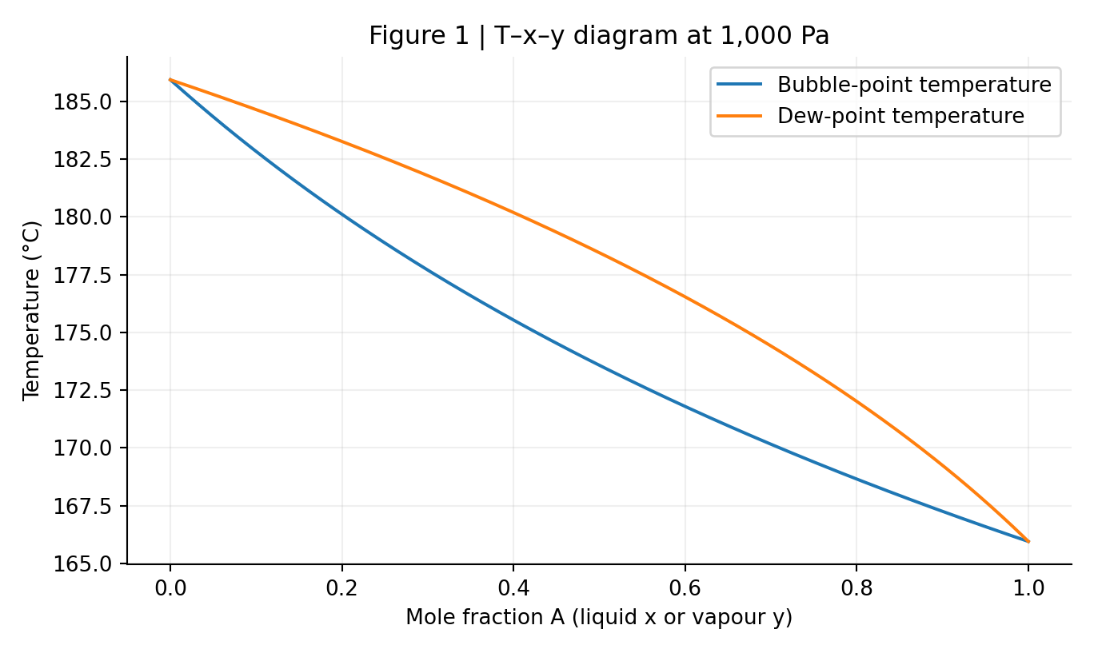
Figure 1. Bubble- and dew-point loci derived from the supplied vapour-pressure equations.

3. Determine relative volatility for the teaching app
Relative volatility compares the vapour/liquid enrichment of component A with component B:
$$α_{12}=\frac{y_{1}/x_{1}}{y_{2}/x_{2}}=\frac{y_{1}}{1-y_{1}}\frac{1-x_{1}}{x_{1}}$$
Under Raoult’s law, relative volatility is the ratio of the pure-component saturation vapour pressures at the same temperature. Temperature changes with composition, so relative volatility is not exactly constant along the column.
$$α_{12}(T) = \frac{P_{1}sat}{P_{2}sat}$$
$$y = \frac{αx}{1 + (α - 1)x}$$
At the feed bubble point, α_{F} = 2.8144. For the current MATLAB app, use α ≈ 2.81 as a representative approximation. The app equilibrium curve is then y = αx/[1+(α−1)x]. This curve is close to, but not identical to, the exact Raoult-law curve.
$$q = 1$$

4. Feed condition and the q-line
The feed is at its bubble point, so it enters as a saturated liquid. The general feed-line expression has a denominator that vanishes for a saturated-liquid feed; in that case the q-line is vertical.
$$q=1 ⇒ x=z_{F}=0.600$$
The feed-line intersection with the equilibrium curve is the minimum-reflux pinch point: (x_{P}, y_{P}) = (0.600, 0.808491).

5. Minimum reflux ratio — graphical and algebraic method
The rectifying operating line for a total condenser under constant molar overflow is:
$$y=\frac{R}{R+1}x+\frac{x_{D}}{R+1}=m_{R}x+b_{R}$$
Its slope is m_{R} = R/(R+1), and its y-intercept is b_{R} = x_{D}/(R+1). Therefore:
$$R=\frac{m_{R}}{1-m_{R}}=\frac{x_{D}}{b_{R}}-1$$
At minimum reflux, the rectifying line passes through (x_{D},x_{D}) and the pinch point (z_{F},y_{P}). Calculate its slope from two points:
$$m_{min}=\frac{y_{P}-x_{D}}{z_{F}-x_{D}}=\frac{0.808491-0.900}{0.600-0.900}=0.305032$$
$$R_{min}=\frac{m_{min}}{1-m_{min}}=0.438914≈0.439$$
$$b_{min}=\frac{x_{D}}{R_{min}+1}=0.625472$$
Graphical interpretation: draw a straight line from (0.90,0.90) to the pinch (0.60,0.8085). Extend it to the y-axis. Read the intercept b ≈ 0.6255 and calculate R_{min} = 0.90/b − 1.
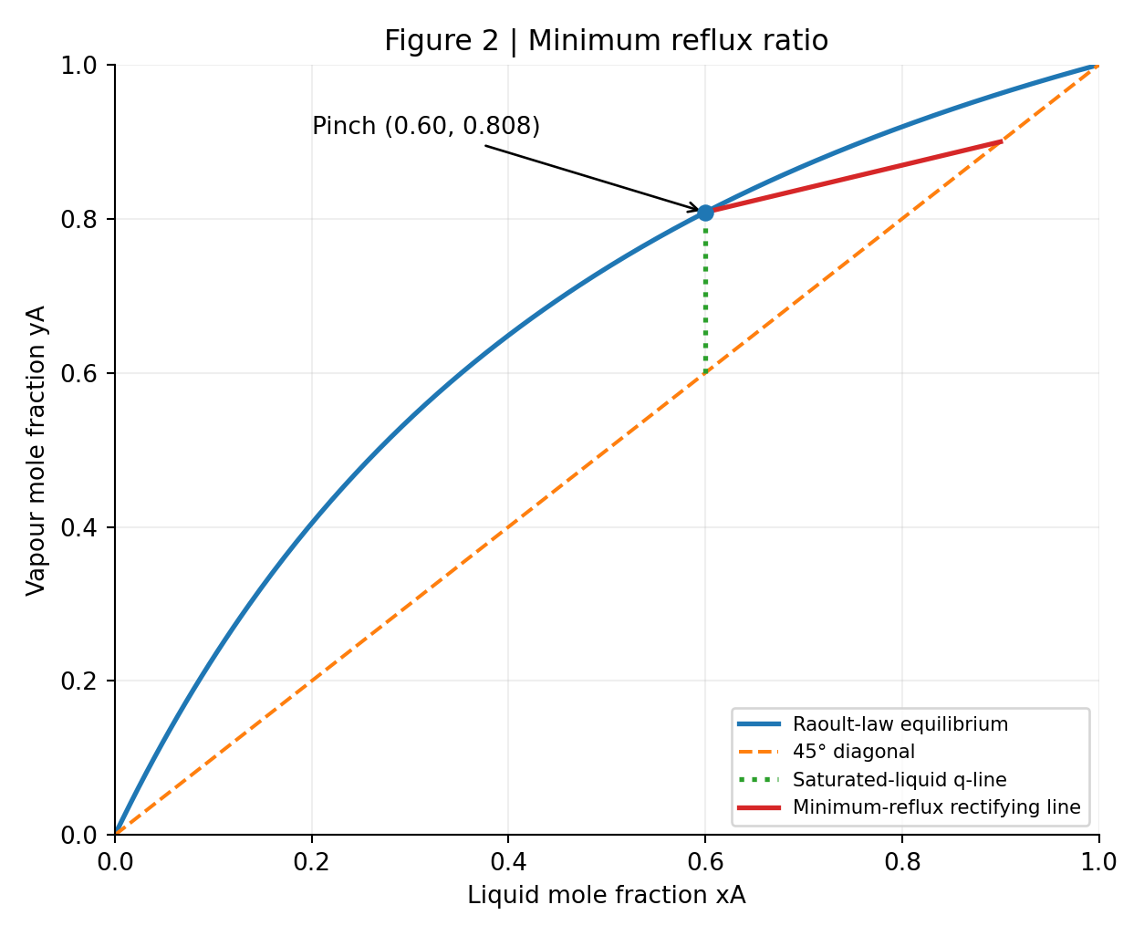
Figure 2. The saturated-liquid q-line, equilibrium pinch and minimum-reflux rectifying line.

6. Operating lines at a trial reflux ratio
Choose a trial reflux ratio R > R_{min}. The rectifying line slope and intercept are:
$$m_{R}=\frac{R}{R+1}, b_{R}=\frac{x_{D}}{R+1}$$
For q = 1, the operating-line intersection is at x = z_{F}. First calculate y_{I} = m_{R}z_{F} + b_{R}. The stripping line passes through (x_{B},x_{B}) and (z_{F},y_{I}):
$$m_{S}=\frac{y_{I}-x_{B}}{z_{F}-x_{B}}, b_{S}=x_{B}\left(1-m_{S}\right)$$
$$y=m_{S}x+b_{S}$$
$$N_{total} = N_{trays} + 1 (partial reboiler)$$
If the feed molar flow rate is specified, the overall and component material balances give the distillate and bottoms flow rates:
$$D = F \frac{z_{F} - x_{B}}{x_{D} - x_{B}}$$
$$B = F - D$$
Under constant molar overflow, the internal liquid and vapour flow rates in the rectifying section are:
$$L = RD$$
$$V = (R + 1)D$$
In the stripping section, the corresponding internal flow rates are:
$$\overline{L} = L + qF$$
$$\overline{V} = V - (1 - q)F$$

7. Stage stepping and reflux ratio for five stages
Start at the point (x_{D},x_{D}) on the diagonal. Move horizontally to the equilibrium curve to determine the liquid composition on the first equilibrium stage. Move vertically to the appropriate operating line to find the next vapour composition. Repeat. Above the feed intersection, use the rectifying line; below it, use the stripping line. Count the partial reboiler as the final equilibrium stage. A total condenser is not counted as an equilibrium stage.
For each trial R, count the steps required to reach x_{B} = 0.15. Decrease R to increase the number of stages, or increase R to reduce the number. Use trial-and-error or numerical root finding until N = 5. If the last step crosses x_{B}, use a stated fractional-stage interpolation convention.

Trial R | Estimated stages (including reboiler)
0.600 | 8.150
1.000 | 5.989
1.500 | 5.341
1.909 | 5.000
2.000 | 4.954
3.000 | 4.631

With the exact Raoult-law VLE and linear interpolation of the last stage, R ≈ 1.909 gives N ≈ 5.000 theoretical stages. Since the count depends on the fractional-stage convention, small differences are expected from hand-drawn graphical results.
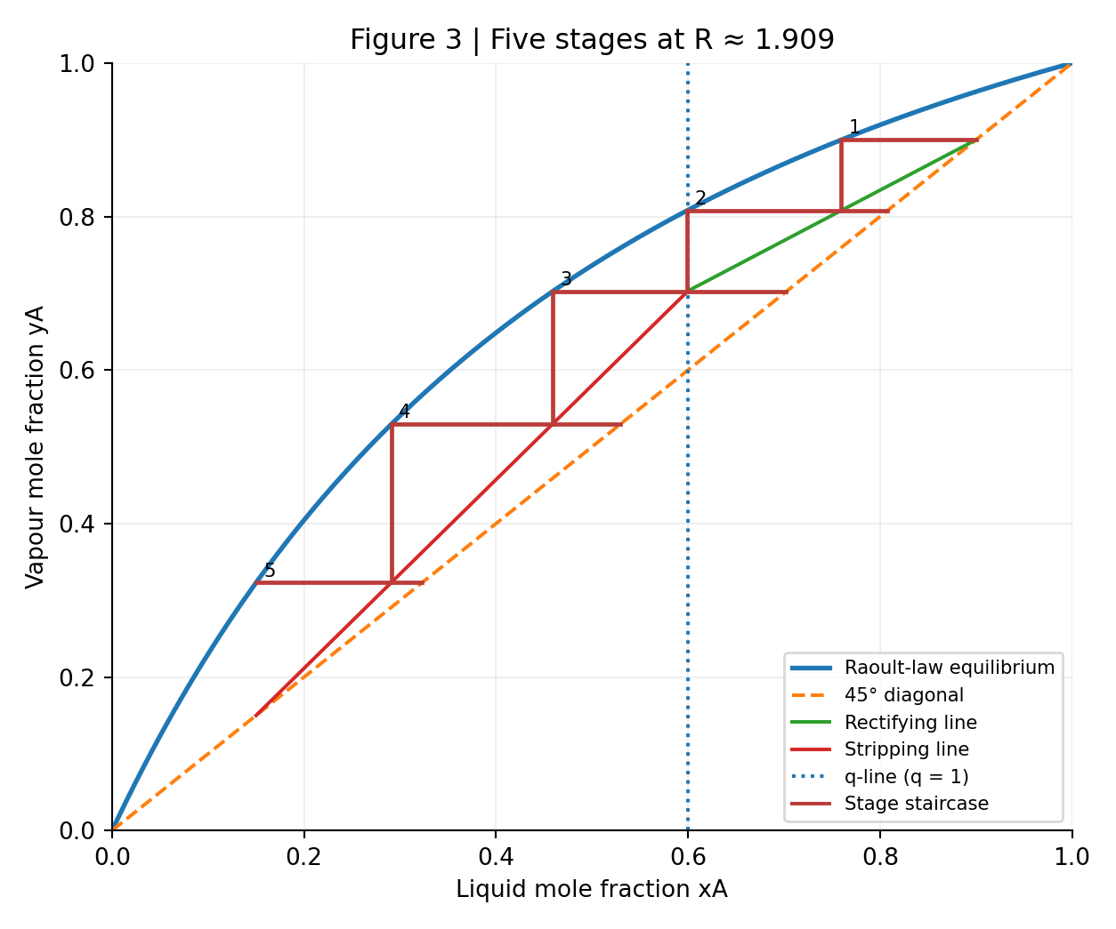
Figure 3. Stage stepping at R = 1.909 using the temperature-dependent Raoult-law equilibrium curve.

8. Worked operating-line coefficients at the five-stage solution
$$y=0.656246x+0.309379$$
$$\left(x_{I},y_{I}\right)=\left(0.600000,0.703126\right)$$
$$y=1.229170x-0.034375$$
The first few equilibrium-stage liquid compositions (top to bottom) are: x₁ = 0.7597, x₂ = 0.5992, x₃ = 0.4585, x₄ = 0.2907, x₅ = 0.1500. The final stage reaches x_{B} ≈ 0.15.

9. Enter the problem into the MATLAB teaching app
1. Select McCabe–Thiele Design Mode (not Manual Feed-Stage Simulation).
2. Enter relative volatility α = 2.814 (representative value at the feed bubble point).
3. Enter x_{D} = 0.90, x_{B} = 0.15, z_{F} = 0.60 and q = 1.00.
4. Set reflux ratio R to a value above R_{min} ≈ 0.439; start with R = 2.0.
5. Read the number of equilibrium stages from the staircase. Adjust R until the app indicates approximately five stages, checking whether its counting convention includes the reboiler.
6. Compare the app result with the exact VLE benchmark R ≈ 1.909. Because the app assumes constant α, its five-stage reflux ratio will not be identical; for α = 2.814, a consistent fractional-step calculation gives approximately R ≈ 1.775.
7. If the app requires F or latent heats, those are additional inputs for material/energy estimates; they are not specified in this question. Use clearly labelled illustrative values only, and do not present resulting duties as answers to this problem.

10. Assumptions, limitations and questions for students
Assumptions: steady-state binary distillation; ideal Raoult-law liquid; ideal vapour approximation; equilibrium stages; total condenser; partial equilibrium reboiler; negligible pressure drop; constant molar overflow for operating lines; saturated-liquid feed. A constant-α model is an additional approximation made by the teaching app, not by the exact Raoult-law calculation.
Limitations: real tray efficiency is less than 100%; mixture nonideality, temperature-dependent molar enthalpy, heat losses and pressure variations are omitted. The pressure 1,000 Pa is unusually low for many teaching examples, but the calculations here deliberately use the pressure as supplied. Check that the vapour-pressure correlations are valid over the calculated temperature range before applying the results to real equipment.
Discuss: (i) Why is the q-line vertical? (ii) What happens to the stage count as R approaches R_{min}? (iii) Why does α vary across the column? (iv) Why does the constant-α app differ from the exact Raoult-law solution? (v) What changes if the reboiler is excluded from the count?

11. Summary of numerical answers

Requested quantity | Result
Feed bubble point | 444.947 K (171.797 °C)
Equilibrium yA at xA = 0.60 | 0.80849
Relative volatility at feed | 2.81445
Minimum reflux ratio | 0.43891
Reflux ratio for 5 stages, exact VLE | ≈ 1.909
Approx. app value with constant α = 2.814 | ≈ 1.775

Prepared for ENG2111 teaching. Numerical results obtained from the supplied vapour-pressure expressions; no external property package was used. Prepared by Dr K Vasanth Kumar. The example problem was taken from ‘Mass transfer in Engineering Practice’ by Aksel. L. Lydersen., John Wiley & Sons.

ENG2111 | Worked Case Study 2 – for the Distillation App
Binary Distillation with a Partially Vaporised Feed | MATLAB McCabe–Thiele Teaching Tool
University of Surrey • Chemical and Process Engineering •

1. Problem statement
A binary feed contains 35 mol% of component 1 (the more volatile component) and 65 mol% of component 2. The relative volatility of component 1 with respect to component 2 is 2. The distillate contains 96% of the component 1 entering with the feed is recovered in the distillate. The feed contains 50 mol% vapour. The external reflux ratio is 4. Determine the theoretical equilibrium stages in the rectifying and stripping sections, counting the partial reboiler.
The 96% figure is component-1 recovery, NOT 96% of the total feed withdrawn as distillate.
Parameter | Symbol | Value
Feed composition | $$z_{F}$$ | 0.35
Distillate purity | $$x_{D}$$ | 0.93
Component-1 recovery | $$η_{1}$$ | 0.96
Relative volatility | $$α$$ | 2
Feed vapour fraction | $$1-q$$ | 0.50
Feed liquid fraction | $$q$$ | 0.50
Reflux ratio | $$R$$ | 4

2. Choose a feed basis and calculate product streams
Take a convenient feed basis of $F$ = 100 kmol/h. Overall and component-1 material balances are:
$$F = D + B$$
$$F z_{F} = D x_{D} + B x_{B}$$
The recovery definition is:
$$η_{1} = D x_{D} / (F z_{F})$$
Rearranging for the distillate flow:
$$D = η_{1} F z_{F} / x_{D} = 0.96 × 100 × 0.35 / 0.93 = 36.1290 kmol/h$$
$$B = F - D = 100 - 36.1290 = 63.8710 kmol/h$$
$$x_{B} = (F z_{F} - D x_{D}) / B = 0.021919$$
Thus, the bottoms product contains approximately 2.192 mol% of component 1.

3. Vapour–liquid equilibrium and its inverse
For a binary mixture with constant relative volatility:
$$y = α x / (1 + (α-1)x)$$
$$y = 2x / (1+x)$$
For horizontal McCabe–Thiele steps, we need to find liquid composition from a known vapour composition:
$$y(1+x) = 2x$$
$$y + yx = 2x$$
$$y = x(2-y)$$
$$x = y / (2-y)$$
The inverse equilibrium equation is used at every equilibrium stage, regardless of the section.
Liquid mole fraction $x$ | Equilibrium vapour mole fraction $y$
0.00 | 0.0000
0.10 | 0.1818
0.20 | 0.3333
0.35 | 0.5185
0.50 | 0.6667
0.70 | 0.8235
0.90 | 0.9474
1.00 | 1.0000

4. Feed condition and q-line
The feed is 50% vapour, so the liquid fraction is $q$ = 0.5. The q-line equation is:
$$y = q x / (q-1) - z_{F} / (q-1)$$
$$y = -x + 0.70$$
The q-line has slope −1 and passes through the diagonal point (0.35, 0.35).

5. Rectifying operating line
For a total condenser and constant molar overflow:
$$y = R x / (R+1) + x_{D} / (R+1)$$
$$y = 4x/5 + 0.93/5 = 0.8x + 0.186$$
The rectifying line has slope 0.8 and intercept 0.186. It passes through the point ($x_{D}$, $x_{D}$) = (0.93, 0.93).

6. Feed intersection and stripping operating line
The intersection of the rectifying operating line and q-line is denoted ($x_{I}$, $y_{I}$). Solve the two equations simultaneously:
$$0.8x_{I} + 0.186 = -x_{I} + 0.70$$
$$x_{I} = (0.70-0.186)/1.8 = 0.285556$$
$$y_{I} = 0.8 × 0.285556 + 0.186 = 0.414444$$
The stripping line passes through ($x_{B}$, $x_{B}$) and ($x_{I}$, $y_{I}$). Its slope and intercept are:
$$m_{S} = (y_{I}-x_{B})/(x_{I}-x_{B}) = 1.488889$$
$$b_{S} = x_{B}(1-m_{S}) = -0.010716$$
$$y = 1.488889x - 0.010716$$
The operating-line switch is made after the horizontal equilibrium step gives a liquid composition below $x_{I}$ = 0.285556.
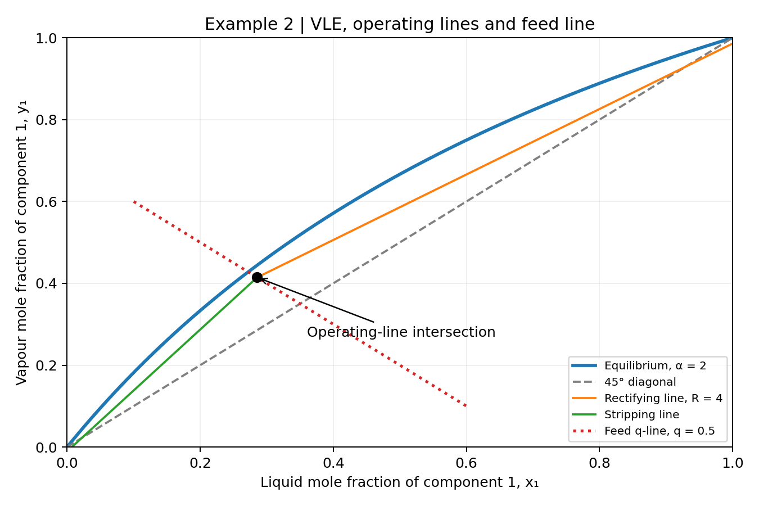
Figure 1. Equilibrium curve, diagonal, feed q-line and operating lines (from the original worked example).

7. Internal flows and stripping-line verification
$$L = RD = 4 × 36.1290 = 144.516 kmol/h$$
$$V = (R+1)D = 180.645 kmol/h$$
$$\underline{L} = L + qF = 194.516 kmol/h$$
$$\underline{V} = V - (1-q)F = 130.645 kmol/h$$
$$m_{S} = \underline{L} / \underline{V} = 1.488889$$

8. Detailed McCabe–Thiele stepping: where each new vapour composition comes from
Begin at ($x_{D}$, $x_{D}$) = (0.93, 0.93) on the diagonal. Because the condenser is total, the vapour entering it has composition $y_{1}$ = $x_{D}$ = 0.93. The total condenser is not counted as an equilibrium stage. The partial reboiler is counted.
Every horizontal step uses the inverse equilibrium relation:
$$x_{n} = y_{n} / (2-y_{n})$$
Every vertical step uses the rectifying line above the feed, or the stripping line below the feed:
$$y(n+1) = 0.8x_{n} + 0.186 (rectifying)$$
$$y(n+1) = 1.488889x_{n} - 0.010716 (stripping)$$

Stage 1 — first horizontal and vertical steps
$$y_{1} = x_{D} = 0.93$$
$$x_{1} = y_{1}/(2-y_{1}) = 0.93/1.07 = 0.869159$$
$$y_{2} = 0.8x_{1} + 0.186 = 0.881327$$

Stage 2
$$x_{2} = y_{2}/(2-y_{2}) = 0.881327/1.118673 = 0.787833$$
$$y_{3} = 0.8x_{2} + 0.186 = 0.816266$$

Stage 3
$$x_{3} = y_{3}/(2-y_{3}) = 0.816266/1.183734 = 0.689569$$
$$y_{4} = 0.8x_{3} + 0.186 = 0.737655$$
Continue in the rectifying section until the calculated liquid composition falls below the operating-line intersection. The feed transition occurs between Stages 8 and 9 in this stepping convention.

Stage 8 — last rectifying operating-line step
$$y_{8} = 0.458542$$
$$x_{8} = 0.458542/(2-0.458542) = 0.297473$$
$$y_{9} = 0.8 × 0.297473 + 0.186 = 0.423978$$
Since $x_{8}$ = 0.297473 is greater than $x_{I}$ = 0.285556, the rectifying line is used for this vertical step.

Stage 9 — feed transition and first stripping step
$$x_{9} = y_{9}/(2-y_{9}) = 0.423978/1.576022 = 0.269018$$
Now $x_{9}$ = 0.269018 is below $x_{I}$ = 0.285556. Therefore, switch to the stripping operating line for the next vertical step:
$$y_{10} = 1.488889 × 0.269018 - 0.010716 = 0.389822$$

Stage 10 — stripping section
$$x_{10} = 0.389822/(2-0.389822) = 0.242099$$
$$y_{11} = 1.488889 × 0.242099 - 0.010716 = 0.349742$$

Stage 11 — stripping section
$$x_{11} = 0.349742/(2-0.349742) = 0.211932$$
$$y_{12} = 1.488889 × 0.211932 - 0.010716 = 0.304827$$

Stage 12 — stripping section
$$x_{12} = 0.304827/(2-0.304827) = 0.179820$$
$$y_{13} = 1.488889 × 0.179820 - 0.010716 = 0.257016$$
These three stripping-section examples show the repeated use of the same equilibrium relation followed by the stripping operating line.

9. Full stage table and stage count
Stage | Vapour $y_{n}$ | Liquid $x_{n}$ | Section
1 | 0.930000 | 0.869159 | Rectifying
2 | 0.881327 | 0.787833 | Rectifying
3 | 0.816266 | 0.689569 | Rectifying
4 | 0.737655 | 0.584353 | Rectifying
5 | 0.653483 | 0.485313 | Rectifying
6 | 0.574250 | 0.402771 | Rectifying
7 | 0.508217 | 0.340677 | Rectifying
8 | 0.458542 | 0.297473 | Rectifying
9 | 0.423978 | 0.269018 | Stripping
10 | 0.389822 | 0.242099 | Stripping
11 | 0.349742 | 0.211932 | Stripping
12 | 0.304827 | 0.179820 | Stripping
13 | 0.257016 | 0.147458 | Stripping
14 | 0.208832 | 0.116590 | Stripping
15 | 0.162873 | 0.088657 | Stripping
16 | 0.121284 | 0.064557 | Stripping
17 | 0.085402 | 0.044606 | Stripping
18 | 0.055697 | 0.028646 | Stripping
19 | 0.031935 | 0.016226 | Stripping
Stage 18 gives $x_{18}$ = 0.028646, above the required $x_{B}$ = 0.021919. Stage 19 gives $x_{19}$ = 0.016226, below the specification. Thus 19 whole equilibrium stages are required, including the partial reboiler.
$$N_{total} = N_{rectifying} + N_{stripping} = 8 + 11 = 19$$
Linear interpolation of the final graphical step gives an illustrative fractional count:
$$N_{fractional} = 18 + (0.028646-0.021919)/(0.028646-0.016226) = 18.54$$
This fractional result is a graphical interpolation, not a tray-efficiency correction. The feed-tray allocation must be stated according to the selected convention.
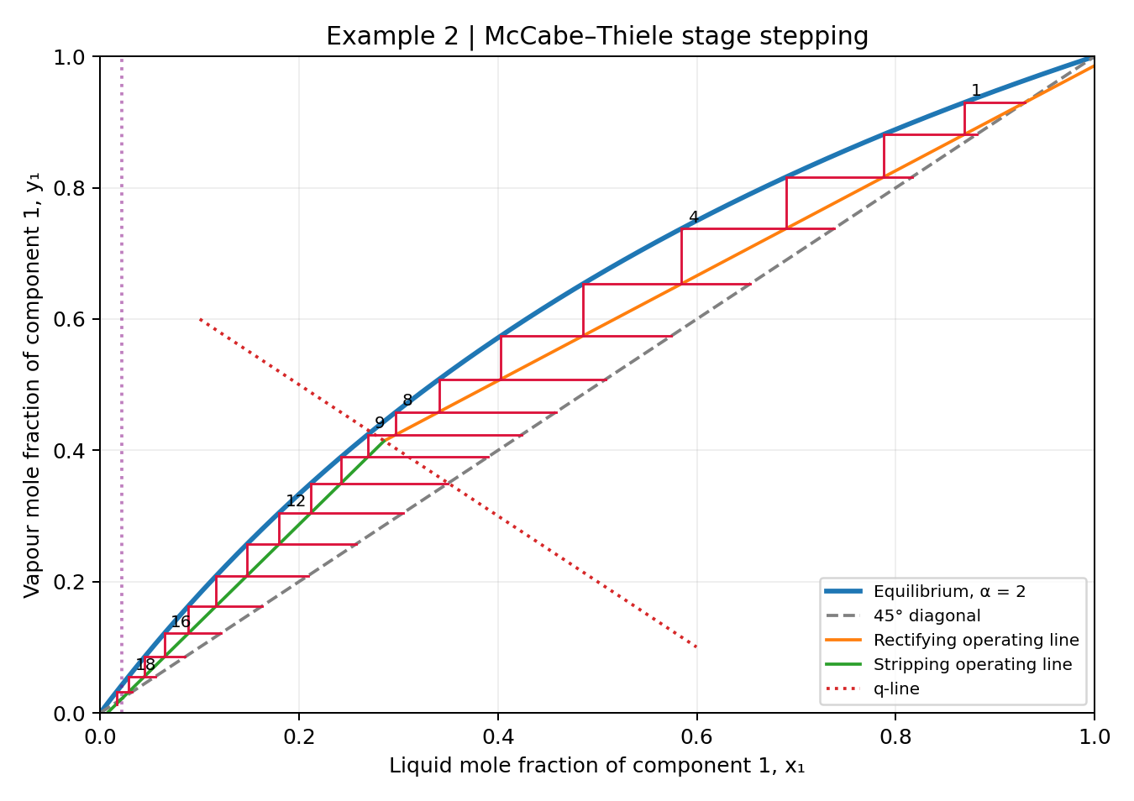
Figure 2. McCabe–Thiele staircase for the specified reflux ratio, showing the change between operating lines (original example).

10. Enter Example 2 into the MATLAB teaching app
Select “McCabe–Thiele design”. Enter $α$ = 2, $x_{D}$ = 0.93, $x_{B}$ = 0.021919, $z_{F}$ = 0.35, $q$ = 0.50 and $R$ = 4. Use $F$ = 100 kmol/h as the calculation basis. The problem does not specify latent heats, so any latent-heat inputs used to run the app must be identified as illustrative, not as results of this case study.
Read the staircase and compare the rectifying and stripping stage counts with the table. If the app adopts a different feed-switch or fractional-stage convention, report that difference explicitly.

11. Assumptions and limitations
Steady-state binary distillation; constant relative volatility; equilibrium stages; total condenser; partial equilibrium reboiler; constant molar overflow; negligible pressure drop and heat losses; and fixed reflux ratio. Real tray efficiency, variable molar enthalpies and sensible-heat contributions are not included. Condenser and reboiler duties cannot be determined from the specified data alone.

12. Final answers
Quantity | Result
Distillate flow (100 kmol/h basis) | 36.129 kmol/h
Bottoms flow | 63.871 kmol/h
Bottoms composition $x_{B}$ | 0.021919
Feed intersection ($x_{I}$, $y_{I}$) | (0.285556, 0.414444)
Rectifying operating line | $y$ = 0.8$x$ + 0.186
Stripping operating line | $y$ = 1.488889$x$ − 0.010716
Rectifying stages | 8
Stripping stages, including reboiler | 11
Total whole theoretical stages | 19
Interpolated graphical stage count | 18.54
Prepared by Dr K Vasanth Kumar for ENG2111: Separation Processes 1 and HYSYS, University of Surrey.

Worked Example 3 | CS₂–CCl₄ Binary Distillation
ENG2111 Separation Processes 1 • MATLAB McCabe–Thiele Teaching App • Student worked guide

1. Problem statement
A continuous fractionating column operating at atmospheric pressure separates a mixture containing 15.67 mass% CS₂ and 84.33 mass% CCl₄. The overhead product contains 91 mass% CS₂; the bottoms product contains 97.3 mass% CCl₄. The external reflux ratio is 3.16 kmol reflux per kmol distillate, and the overall plate efficiency is 70%. The feed enters at 290 K; its boiling point is 336 K and its mass-specific heat capacity is 1.7 kJ kg⁻¹ K⁻¹. Determine the theoretical equilibrium stages and the actual column plates using the VLE data provided at the end of this guide.
Source and adaptation: Adapted from Coulson and Richardson’s Chemical Engineering, Volume 5, Problem 11.5 (as identified in the source exercise). The source specifies a latent heat of 25.9 kJ/kmol, an implausibly small value. For this teaching calculation, 25.9 kJ/mol = 25,900 kJ/kmol is assumed instead. This is a transparent, unverified correction to the stated unit, not a confirmed erratum.

2. Composition conversion: mass to mole fractions
Use molecular masses $M_{CS2}$ = 76.14 kg/kmol and $M_{CCl4}$ = 153.82 kg/kmol. The app uses mole fractions; the problem gives mass percentages.
$$x_{CS₂} = (w_{CS₂}/M_{CS₂}) / [(w_{CS₂}/M_{CS₂}) + (1 - w_{CS₂})/M_{CCl₄}]$$
$$z_{F} = (0.1567/76.14) / [(0.1567/76.14) + (0.8433/153.82)] = 0.272935$$
$$x_{D} = (0.91/76.14) / [(0.91/76.14) + (0.09/153.82)] = 0.953329$$
$$x_{B} = (0.027/76.14) / [(0.027/76.14) + (0.973/153.82)] = 0.053084$$

3. Subcooled-feed quality and $q$-line
$$M_{F} = 1 / [(0.1567/76.14) + (0.8433/153.82)] = 132.618 kg/kmol$$
$$C_{p},m = (1.7 kJ kg⁻¹ K⁻¹)(132.618 kg/kmol) = 225.451 kJ kmol⁻¹ K⁻¹$$
$$q = 1 + C_{p},m(T_{b} - T_{F})/λ = 1 + (225.451)(336 - 290)/25900 = 1.400415$$
Because $q$ > 1, the feed is subcooled. Under constant molar overflow, the feed increases the downward liquid flow by qF and reduces the upward vapour flow by ($q$ − 1)$F$.
$$q x - (q - 1)y = z_{F}$$
$$y = [q/(q - 1)]x - [z_{F}/(q - 1)] = 3.497407x -0.681631$$

4. Rectifying and stripping operating lines
$$y = [R/(R + 1)]x + x_{D}/(R + 1)$$
$$y_{R} = 0.759615x + 0.229166 (R = 3.16)$$
Solve the rectifying-line and $q$-line equations simultaneously to locate the feed intersection.
$$(x_{I}, y_{I}) = (0.332676, 0.481871)$$
The stripping line passes through both the intersection and ($x_{B}$, $x_{B}$).
$$m_{S} = (y_{I} - x_{B})/(x_{I} - x_{B}) = (0.481871 - 0.053084)/(0.332676 - 0.053084) = 1.533619$$
$$y_{S} = m_{S} x + x_{B}(1 - m_{S}) = 1.533619x -0.028327$$

5. Staircase method: sample calculations
Start at $y_{1}$ = $x_{D}$ for a total condenser. For each stage, interpolate horizontally to the experimental VLE curve to find xₙ; then use the appropriate operating line vertically to find the next vapour composition. A total condenser is not an equilibrium stage.
Stage 1 (rectifying section):
$$y_{1} = 0.953329 → VLE interpolation → x_{1} = 0.904188$$
$$y_{2} = 0.759615(0.904188) + 0.229166 = 0.916001$$
Stage 2 (rectifying section):
$$y_{2} = 0.916001 → VLE interpolation → x_{2} = 0.829912$$
$$y_{3} = 0.759615(0.829912) + 0.229166 = 0.859580$$
Stage 5 (rectifying section):
$$y_{5} = 0.670307 → VLE interpolation → x_{5} = 0.394839$$
$$y_{6} = 0.759615(0.394839) + 0.229166 = 0.529091$$
Stage 6 (stripping section):
$$y_{6} = 0.529091 → VLE interpolation → x_{6} = 0.276036$$
$$y_{7} = 1.533619(0.276036) -0.028327 = 0.395008$$
Stage 7 (stripping section):
$$y_{7} = 0.395008 → VLE interpolation → x_{7} = 0.187953$$
$$y_{8} = 1.533619(0.187953) -0.028327 = 0.259922$$
Stage 8 (stripping section):
$$y_{8} = 0.259922 → VLE interpolation → x_{8} = 0.107899$$
$$y_{9} = 1.533619(0.107899) -0.028327 = 0.137150$$
Stage 9 (stripping section):
$$y_{9} = 0.137150 → VLE interpolation → x_{9} = 0.051999$$
$$y_{10} = 1.533619(0.051999) -0.028327 = 0.051420$$
The operating-line switch occurs between stages 5 and 6: $x5$ = 0.394839 > $x_{I}$, whereas $x6$ = 0.276036 < $x_{I}$. The ninth step reaches $x9$ = 0.051999, slightly below the target $x_{B}$ = 0.053084.

6. Complete stage-by-stage results
Stage | Vapour yₙ | Liquid xₙ | Operating line
1 | 0.953329 | 0.904188 | Rectifying
2 | 0.916001 | 0.829912 | Rectifying
3 | 0.859580 | 0.721976 | Rectifying
4 | 0.777589 | 0.580743 | Rectifying
5 | 0.670307 | 0.394839 | Rectifying
6 | 0.529091 | 0.276036 | Stripping
7 | 0.395008 | 0.187953 | Stripping
8 | 0.259922 | 0.107899 | Stripping
9 | 0.137150 | 0.051999 | Stripping
The graphical construction requires approximately nine equilibrium stages, including an ideal partial reboiler. Fractional-stage interpolation between the eighth and ninth liquid compositions gives approximately 8.98 stages; report nine whole ideal stages for design.
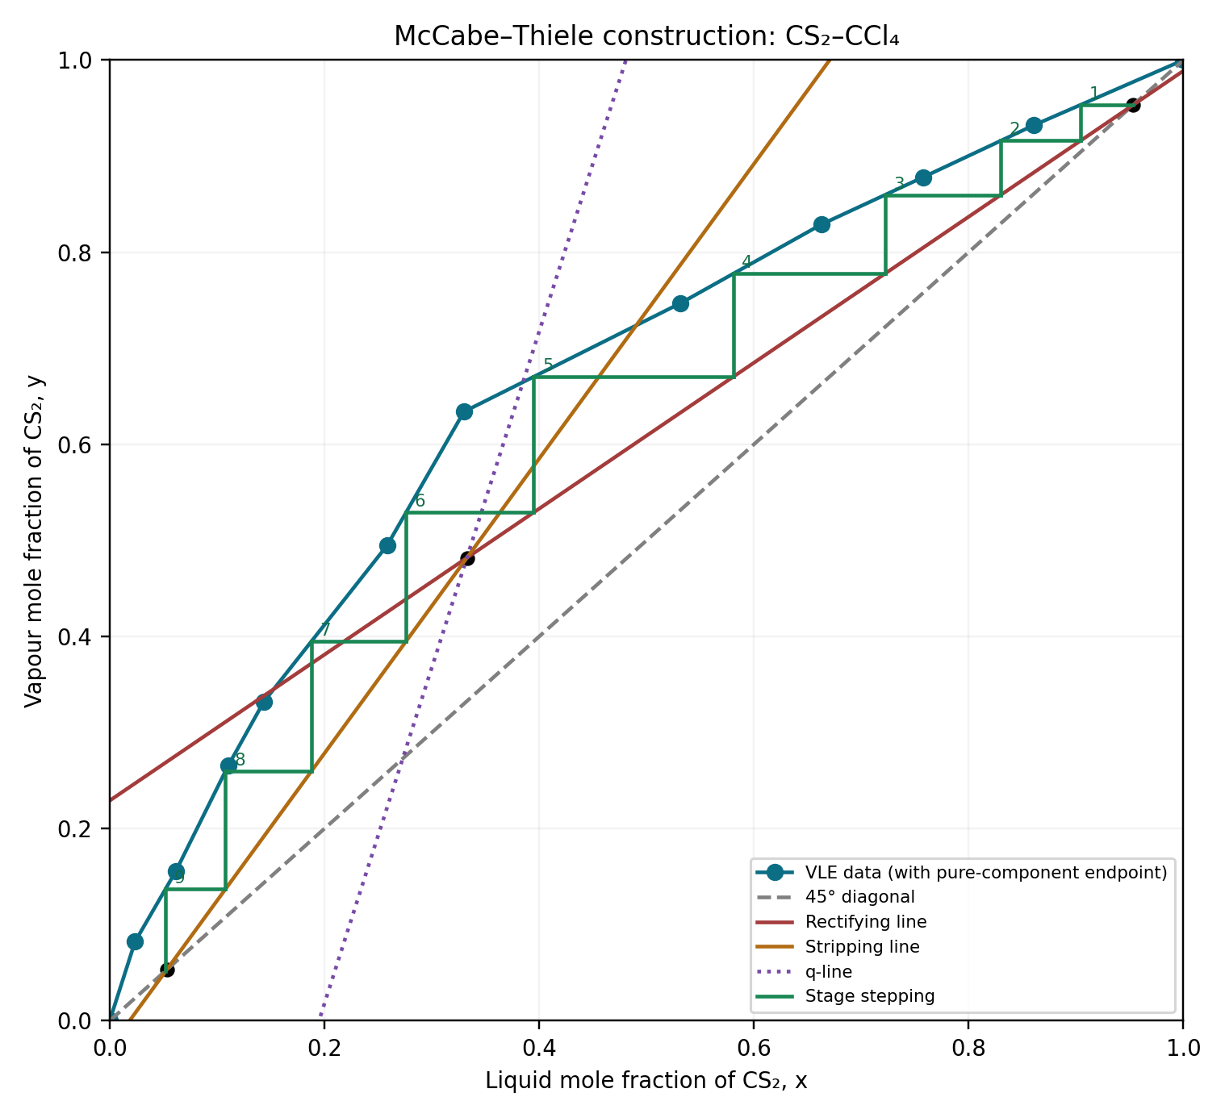
Figure 1. McCabe–Thiele construction using piecewise-linear interpolation of the supplied equilibrium data. The pure-component endpoint (1,1) is added to extend the supplied data for the distillate composition.

7. Plate efficiency and reboiler convention
$$N_{equilibrium} ≈ 9 (including an ideal partial reboiler)$$
$$N_{actual}, textbook convention = (9/0.70) = 13 plates$$
$$N_{actual} trays, reboiler counted separately = [(9 - 1)/0.70] = 12 trays$$
Note to students: The calculated number of actual plates must always be rounded up to the next whole number, as a fraction of a plate cannot be installed. For example, 12.86 plates should be rounded up to 13 plates.
The original textbook answer is 13 plates, obtained by applying the 70% overall plate efficiency directly to all nine graphical stages. If the ninth stage is an ideal partial reboiler and is excluded from the physical tray count, the alternative specification is 12 actual trays plus one partial reboiler. Both conventions are shown; do not confuse a reboiler with a physical tray.

8. MATLAB app: student instructions
Enter the converted mole fractions $z_{F}$, $x_{D}$ and $x_{B}$; reflux ratio $R$ = 3.16; feed quality $q$ ≈ 1.4004; and the tabulated equilibrium compositions below (convert mol% to fractions). Select the experimental/tabulated VLE mode if available. Generate the McCabe–Thiele diagram, identify the operating-line intersection and count the steps. Compare your app output with the nine ideal-stage result and explain the two plate-counting conventions. As the current version of the app only supports constant relative volatility, use the fitted approximation below and state that it will not reproduce the tabulated VLE result exactly.

9. Supplied equilibrium data and relative volatility
The textbook supplies paired VLE compositions, not a single constant relative volatility. Use the complete paired x–y dataset where the app supports tabulated equilibrium.
CS₂ liquid x (mol%) | CS₂ vapour y (mol%) | Pointwise $α$ = y(1−x)/[x(1−y)]
0.00 | 0.00 | —
2.36 | 8.23 | 3.710
6.15 | 15.55 | 2.810
11.06 | 26.60 | 2.914
14.35 | 33.20 | 2.966
25.85 | 49.50 | 2.812
33.00 | 63.40 | 3.517
53.18 | 74.70 | 2.599
66.30 | 82.90 | 2.464
75.75 | 87.80 | 2.304
86.04 | 93.20 | 2.224
At x = 0 or y = 0, pointwise relative volatility is undefined. The pure-component endpoint (100%, 100%) is an assumed physical endpoint, not a supplied experimental observation.
The pointwise relative volatility varies across the composition range (approximately 2.22 to 3.71); a single constant $α$ cannot exactly reproduce the original experimental curve. For a constant-$α$-only app, fit a representative value and explicitly identify it as an approximation rather than the textbook VLE dataset.

10. Summary for students
Quantity | Result
$$z_{F}$$ | 0.272935
$$x_{D}$$ | 0.953329
$$x_{B}$$ | 0.053084
$$q$$ | 1.400415
Feed intersection | (0.332676, 0.481871)
Rectifying line | y = 0.759615x + 0.229166
Stripping line | y = 1.533619x -0.028327
Ideal stages | ≈ 9 including partial reboiler
Textbook convention | 13 plates
Reboiler-separated convention | 12 trays + partial reboiler
Teaching note: The straight operating lines express section-wise material balances; the equilibrium curve expresses thermodynamics. Each staircase step alternates between these two physical constraints.

Worked Example 4 | Binary Distillation and Heat Duties
ENG2111 Separation Processes 1 • MATLAB McCabe–Thiele Teaching App

Problem statement
A continuous distillation column separates a binary mixture of components A and B (A is more volatile). A total condenser and partial reboiler are used. The feed is saturated liquid. Determine the material balances, operating lines and equilibrium stages using the MATLAB app; then estimate condenser and reboiler duties by including both sensible and latent heat. Compare the estimates with the latent-heat-only approximation used in the app.
Quantity | Symbol | Value
Feed flow | $$F$$ | 100 kmol/h
Feed composition | $$z_{F}$$ | 0.40
Distillate composition | $$x_{D}$$ | 0.95
Bottoms composition | $$x_{B}$$ | 0.05
Relative volatility | $$α$$ | 2.5
Reflux ratio | $$R$$ | 3.0
Feed quality | $$q$$ | 1.0
Condenser saturation temperature | $$T_{C}$$ | 350 K
Reboiler saturation temperature | $$T_{R}$$ | 390 K
Condenser molar latent heat | $$λ_{C}$$ | 30,000 kJ/kmol
Reboiler molar latent heat | $$λ_{R}$$ | 35,000 kJ/kmol
Vapour molar heat capacity | $$C_{p,V}$$ | 100 kJ/(kmol K)
Liquid molar heat capacity | $$C_{p,L}$$ | 150 kJ/(kmol K)
For the illustrative condenser calculation, vapour enters at 355 K, condenses at 350 K and the resulting reflux/distillate liquid leaves at 345 K. For the illustrative reboiler calculation, the liquid to be vaporised is assumed to enter at 385 K and vapour is generated at 390 K. Use a 1-hour flow basis; report heat duties in kW.

Worked solution

1 | Material balances
$$F = D + B$$
$$F z_{F} = D x_{D} + B x_{B}$$
$$D = \frac{F(z_{F} - x_{B})}{x_{D} - x_{B}} = \frac{100(0.40 - 0.05)}{0.95 - 0.05} = 38.889 kmol/h$$
$$B = F - D = 100 - 38.889 = 61.111 kmol/h$$

2 | Internal molar flows
$$L = R D = 3(38.889) = 116.667 kmol/h$$
$$V = L + D = 155.556 kmol/h$$
$$L_{bar} = L + q F = 216.667 kmol/h$$
$$V_{bar} = V - (1 - q)F = 155.556 kmol/h$$
Here $L_{bar}$ and $V_{bar}$ denote the stripping-section liquid and vapour flows, respectively; the overbar is represented by the “bar” suffix in the symbolic labels above. For $q$ = 1, the stripping and rectifying vapour flow rates are equal.

3 | McCabe–Thiele relationships for the app
$$y = \frac{α x}{1 + (α - 1)x} = \frac{2.5x}{1 + 1.5x}$$
$$y_{R} = \frac{R}{R + 1} x + \frac{x_{D}}{R + 1} = 0.75x + 0.2375$$
$$x = z_{F} = 0.40 (saturated-liquid feed)$$
$$y_{I} = 0.75(0.40) + 0.2375 = 0.5375$$
$$m_{S} = \frac{y_{I} - x_{B}}{z_{F} - x_{B}} = \frac{0.5375 - 0.05}{0.40 - 0.05} = 1.392857$$
$$y_{S} = 1.392857x - 0.019643$$
Students should enter the compositions, relative volatility, reflux ratio and feed quality in the MATLAB app and record the staircase stage count and feed-stage location. The partial reboiler counts as an equilibrium stage but not a physical column tray.

4 | Condenser duty: sensible plus latent heat
The condenser duty is the heat removed to (i) desuperheat the incoming vapour, (ii) condense it, and (iii) subcool the liquid. The total condensed flow is $V$ (reflux plus distillate), not only $D$.
$$Q_{C} = \frac{V}{3600} [ C_{p,V}(355 - 350) + λ_{C} + C_{p,L}(350 - 345) ]$$
$$Q_{C,v} = \frac{155.556(100)(5)}{3600} = 21.60 kW$$
$$Q_{C,latent} = \frac{155.556(30000)}{3600} = 1296.30 kW$$
$$Q_{C,l} = \frac{155.556(150)(5)}{3600} = 32.41 kW$$
$$Q_{C} = 21.60 + 1296.30 + 32.41 = 1350.31 kW$$
$$Q_{C,approx} = \frac{V λ_{C}}{3600} = 1296.30 kW$$
The sensible contribution is 54.01 kW, or approximately 4.0% of the full condenser duty. In this example the latent-only approximation underpredicts the magnitude of the cooling duty by about 4.0%.

5 | Reboiler duty: sensible plus latent heat
For this simplified equipment-level estimate, the vapour-generating portion of the incoming liquid is heated by 5 K and then vaporised. The vapour-generation rate is $V_{bar}$.
$$Q_{R} = \frac{V_{bar}}{3600} [ C_{p,L}(390 - 385) + λ_{R} ]$$
$$Q_{R,sensible} = \frac{155.556(150)(5)}{3600} = 32.41 kW$$
$$Q_{R,latent} = \frac{155.556(35000)}{3600} = 1512.35 kW$$
$$Q_{R} = 32.41 + 1512.35 = 1544.76 kW$$
$$Q_{R,approx} = \frac{V_{bar} λ_{R}}{3600} = 1512.35 kW$$
The sensible contribution is approximately 2.1% of the full reboiler duty. The model is illustrative: a rigorous reboiler balance must also include the sensible enthalpy of liquid withdrawn as bottoms and the enthalpies of every inlet/outlet stream.

6 | Summary of estimated duties
Contribution | Condenser (kW) | Reboiler (kW)
Sensible heat | 54.01 | 32.41
Latent heat | 1296.30 | 1512.35
Total (illustrative) | 1350.31 | 1544.76
Latent-only app estimate | 1296.30 | 1512.35

When does sensible heat become important? The role of feed condition
The sensible-heat contribution becomes significant when the feed is far from its saturation temperature, especially when it is strongly subcooled or superheated. For a subcooled liquid feed, $q$ exceeds unity: extra energy is needed to warm the feed to its bubble point, which can condense some rising vapour, increase the stripping-section liquid flow and alter both operating lines and heat duties. For a superheated vapour feed, $q$ can be negative: the excess feed enthalpy may vaporise additional liquid, changing the internal flows and potentially reducing external reboiler heating. These effects grow with the feed flow rate, heat capacity and temperature difference from saturation.
$$q ≈ 1 + \frac{C_{p,F}(T_{b} - T_{F})}{λ_{F}} (subcooled liquid; consistent molar units)$$
A useful scale for sensible versus latent heat is $C_{p} ΔT / λ$. When this ratio is small, latent-heat-only estimates are often adequate for preliminary teaching calculations; when it approaches 0.1 or more, ignoring sensible heat can materially affect the energy estimate. The feed also affects duties through $V$ and $V_{bar}$: the thermal condition can change the vapour rates even if the condenser and reboiler temperatures are unchanged. The simplified q-based method assumes constant molar overflow and is not a substitute for a rigorous enthalpy balance.

Obtaining condenser and reboiler latent heats in Aspen HYSYS
In Aspen HYSYS, select a suitable property package for the mixture and column pressure range. After converging the distillation column, inspect the condenser and reboiler temperatures, pressures, stream compositions and energy streams. The condenser and reboiler energy-stream duties are the rigorous HYSYS results; they are not themselves latent heats. To estimate an effective molar latent heat at the condenser, create or inspect corresponding saturated-vapour and saturated-liquid states at the condenser pressure and representative top composition, then obtain their molar enthalpies from the stream/property view and calculate the difference. Repeat independently at the reboiler pressure and representative bottom composition. Use the same reference basis and a physically consistent saturation state for each pair; mixture phase compositions may differ at equilibrium. If needed, use a flash/property calculation to determine the relevant equilibrium states.
$$λ_{C},eff = h_{V,C}^\{sat\} - h_{L,C}^\{sat\}$$
$$λ_{R},eff = h_{V,R}^\{sat\} - h_{L,R}^\{sat\}$$
Enter these effective latent heats in kJ/kmol in the MATLAB app. For the most reliable energy estimate, use the converged HYSYS condenser and reboiler energy-stream duties directly, since they include the modelled sensible and latent contributions. A single latent-heat difference for a mixture is an approximation and should not be confused with a full multistream energy balance.
Teaching note: The given thermal states and heat capacities are illustrative and are not guaranteed to satisfy a complete column-wide first-law balance. The purpose is to isolate sensible and latent contributions and show why the MATLAB app uses a simplified preliminary-duty model.

Estimating Condenser and Reboiler Latent Heats in Aspen HYSYS
ENG2111 Separation Processes 1 | Supplementary guide for the MATLAB Distillation Teaching App
Purpose: Obtain separate effective molar latent heats for the top and bottom of a binary distillation column. The condenser and reboiler generally operate at different temperatures, pressures and compositions. All example enthalpy values below are illustrative, not HYSYS outputs.

1 | Condenser: saturated-stream enthalpy method
1. Open the converged distillation column. Record the overhead vapour composition and condenser operating pressure. For a total condenser, the vapour entering the condenser is usually near its dew point.
2. Create two hypothetical material streams in the flowsheet with the SAME overall composition as the overhead vapour and the SAME condenser pressure. Specify vapour fraction = 1 for stream C–V and vapour fraction = 0 for stream C–L. Allow HYSYS to calculate the respective saturation temperatures.
3. Read each stream’s molar enthalpy (kJ/kmol) from its properties worksheet. Subtract the saturated-liquid enthalpy from the saturated-vapour enthalpy:
$$λ_{C} = h_{C,V} - h_{C,L}$$
Illustrative example: saturated-vapour enthalpy = −85,000 kJ/kmol; saturated-liquid enthalpy = −115,000 kJ/kmol.
$$λ_{C} = -85,000 - (-115,000) = 30,000 kJ/kmol$$
Enter 30,000 kJ/kmol as the condenser latent-heat estimate in the MATLAB app.

2 | Reboiler: saturated-stream enthalpy method
1. Open the converged column and record the reboiler pressure and bottoms-liquid composition. In a partial reboiler, the returning vapour and exiting bottoms liquid generally have different compositions.
2. Create two hypothetical streams at the SAME reboiler pressure and with the SAME chosen overall composition (initially, the bottoms composition). Specify vapour fraction = 0 for stream R–L and vapour fraction = 1 for stream R–V.
3. Read the molar enthalpies and calculate:
$$λ_{R} = h_{R,V} - h_{R,L}$$
Illustrative example: saturated-vapour enthalpy = −70,000 kJ/kmol; saturated-liquid enthalpy = −105,000 kJ/kmol.
$$λ_{R} = -70,000 - (-105,000) = 35,000 kJ/kmol$$
Enter 35,000 kJ/kmol as the reboiler latent-heat estimate in the MATLAB app.

3 | Important limitation for mixtures
For a binary mixture at fixed pressure and overall composition, the saturated-liquid bubble-point temperature and saturated-vapour dew-point temperature are generally different. Consequently, the difference between these two hypothetical stream enthalpies is an EFFECTIVE phase-change enthalpy across a temperature interval, not necessarily the latent heat of a single isothermal equilibrium transition. This approximation is suitable for preliminary teaching calculations but is not a rigorous equipment energy balance.

4 | Alternative: infer effective values from HYSYS duties
After converging the column, read the actual condenser and reboiler duties and the corresponding vapour molar flow rates. For duties in kW and flows in kmol/h:
$$λ_{C,eff} = 3600 |Q_{C}| / V$$
$$λ_{R,eff} = 3600 Q_{R} / V̄$$
Here V is the overhead vapour flow entering a total condenser and V̄ is the vapour flow returning from the partial reboiler. These are duty-per-mole estimates: they may include sensible heat, subcooling, superheating and mixture enthalpy effects, so they must not automatically be interpreted as pure latent heats.

5 | How the MATLAB app uses these inputs
$$Q_{C} ≈ V λ_{C} / 3600$$
$$Q_{R} ≈ V̄ λ_{R} / 3600$$
These simplified relationships estimate the magnitude of heat removed in the condenser and heat supplied in the reboiler, respectively. The app neglects sensible heat and other enthalpy effects. For rigorous design, calculate the condenser duty from its actual vapour-inlet and liquid-outlet enthalpy flows, and the reboiler duty from the entering liquid, returning vapour and bottoms-liquid enthalpy flows.

6 | Recommended student workflow
Step | Condenser | Reboiler
Reference conditions | Overhead vapour composition and condenser pressure | Bottoms composition and reboiler pressure
Hypothetical streams | VF = 1 and VF = 0 | VF = 1 and VF = 0
Estimated latent heat | h(C,V) − h(C,L) | h(R,V) − h(R,L)
Cross-check | Actual condenser duty and overhead vapour flow | Actual reboiler duty and returning vapour flow
Note: Use the saturated-stream method to estimate two distinct effective latent heats independently of the column duties. Then compare the app’s simplified heat-duty predictions with the rigorous duties reported by HYSYS, explaining any differences.

