PROJECT REPORT
Smart Parking Slot Analysis and Management System Using R
R Programming Project (R Shiny, dplyr, ggplot2)
Submitted by: ____________________
Register No.: ____________________
Guide: ____________________
Department / College: ____________________

1. Introduction
Parking space is limited in malls, offices, hospitals and apartment buildings, and managing it by hand is slow and error-prone. Operators need quick answers to simple questions: how many slots are free, which floor is full, when do most vehicles arrive, and how much money is earned.
This project, Smart Parking Slot Analysis and Management System Using R, reads parking records from a CSV file and presents the answers in an interactive R Shiny dashboard. It uses only basic data analysis (counting, averaging, grouping and conditional logic); no machine learning is involved.

2. Problem Statement
Parking records are often kept in registers or plain spreadsheets. It is difficult to find occupancy, peak hours, average parking time or revenue from such records, and managers cannot easily compare floors or vehicle types. A simple, visual and automatic analysis system is needed to turn raw parking records into useful information.

3. Objectives
- Display total, occupied and available parking slots and the occupancy percentage.
- Analyse the number and percentage of Bikes, Cars, SUVs and Autos.
- Calculate parking duration from entry and exit times, and find the average, maximum and minimum.
- Calculate parking fees using conditional logic based on vehicle type and duration.
- Analyse occupancy and revenue for each area (Ground Floor, First Floor, Basement, Open Parking).
- Identify the busiest and least busy hours of the day.
- Calculate daily, vehicle-wise and area-wise revenue.
- Provide an interactive dashboard with filters and automatically generated insights.

4. Existing System
In the existing system, vehicle entries and exits are written in a register or typed into a spreadsheet and the fee is calculated by the attendant. Its main drawbacks are:
- Manual calculation of duration and fees can lead to mistakes.
- No instant view of available slots or floor-wise occupancy.
- Peak hours and busy areas cannot be identified without long manual effort.
- Revenue reports are prepared late and are difficult to compare.
- No graphs or filters, so decisions are based on guesswork.

5. Proposed System
The proposed system is an R-based application that loads the parking CSV file automatically, cleans and validates it, calculates duration and fees, and shows results in a Shiny dashboard. The user can filter by date, area, vehicle type and parking status, and every summary card, graph, table and insight updates immediately. The Parking Insights section writes plain-English statements that are calculated from the data, not typed in advance.

6. Methodology
The project follows these steps:
- Data collection: parking records are stored in data/parking_data.csv.
- Data loading and validation: the app checks that the file exists, all columns are present, and dates, areas, vehicle types and statuses are valid. Invalid rows are skipped.
- Data preparation: entry and exit date-times are created, duration is calculated in hours and the fee is calculated with conditional logic (case_when).
- Analysis with dplyr: group_by, summarise, count and mutate are used for occupancy, vehicle, duration, peak-hour and revenue analysis.
- Visualisation with ggplot2: seven graphs are drawn from the filtered data.
- Interface with Shiny: filters, summary cards, tabs and insights are connected through reactive expressions.
- Testing: results on the dashboard are compared with manual calculations on the CSV file.
Fee rule: fee = hourly rate x hours. Any part of an hour is charged as a full hour and the minimum charge is one hour.
Vehicle Type | Rate (Rs. per hour)
Bike | 10
Car | 20
SUV | 30
Auto | 15

7. Technologies Used
Technology | Purpose
R | Programming language for data analysis
R Shiny | Interactive web dashboard and user interface
dplyr | Data cleaning, filtering, grouping and summarising
ggplot2 | Creating graphs
CSV file | Storage of parking data (data/parking_data.csv)
RStudio | Development environment (optional)

8. Dataset Description
The dataset parking_data.csv contains 574 parking records for 60 slots (15 in each area) over seven days, from 21 to 27 September 2026. Entry times follow a realistic pattern, with a morning peak, a lunch-time rise and a strong evening peak, and weekends are busier than weekdays. Vehicle mix differs by area, for example more bikes and autos in open parking and more SUVs in the basement.
Column | Description
Slot_ID | Slot code: G (Ground), F (First), B (Basement), O (Open)
Area | Ground Floor, First Floor, Basement or Open Parking
Vehicle_Type | Bike, Car, SUV or Auto
Entry_Date | Date of entry (YYYY-MM-DD)
Entry_Time | Time of entry (HH:MM)
Exit_Time | Time of exit; blank if the vehicle is still parked
Duration_Hours | Parking duration in hours
Status | Occupied (still parked at snapshot time) or Completed (left)
Parking_Fee | Fee in rupees
At the snapshot time (27 September 2026, 9:00 PM) 32 vehicles are still parked (Status = Occupied), so 32 of the 60 slots are occupied and 28 are available. A slot with no occupied vehicle is shown as Available. For vehicles that are still parked, the snapshot time is used as the temporary exit time.

9. Modules

Data Loading and Validation Module
Reads the CSV, checks columns and values, removes invalid rows and shows an error page if the file is unusable.

Parking Slot Management Module
Shows total, occupied and available slots, occupancy percentage and the status of each slot.

Vehicle Analysis Module
Counts vehicles and percentage for Bike, Car, SUV and Auto.

Duration Analysis Module
Calculates parking duration and its average, maximum and minimum by vehicle type.

Fee Calculation Module
Applies conditional logic to calculate fees and includes a fee calculator tab.

Area / Floor Analysis Module
Gives slots, occupancy and revenue for each area.

Peak Hour Module
Counts vehicle entries per hour and finds the busiest and least busy hours.

Revenue Module
Calculates total, daily, vehicle-wise, area-wise and average revenue per vehicle.

Dashboard and Insights Module
Provides filters, summary cards, graphs and automatic insight statements.

10. Data Analysis
The values below are calculated from the complete dataset (all dates, areas, vehicle types and statuses).

10.1 Vehicle Analysis
Vehicle Type | Vehicles | Percentage
Car | 250 | 43.6%
Bike | 147 | 25.6%
SUV | 103 | 17.9%
Auto | 74 | 12.9%
Total | 574 | 100%

10.2 Parking Duration Analysis (hours)
Vehicle Type | Average | Maximum | Minimum
Bike | 3.63 | 10.00 | 0.77
Car | 3.43 | 10.00 | 0.67
SUV | 3.39 | 10.00 | 0.33
Auto | 1.12 | 2.63 | 0.30
All vehicles | 3.17 | 10.00 | 0.30

10.3 Area Analysis
Area | Total Slots | Occupied | Available | Occupancy % | Revenue (Rs.)
Ground Floor | 15 | 8 | 7 | 53.3 | 15,290
First Floor | 15 | 13 | 2 | 86.7 | 10,830
Basement | 15 | 9 | 6 | 60.0 | 8,855
Open Parking | 15 | 2 | 13 | 13.3 | 4,370
Total | 60 | 32 | 28 | 53.3 | 39,345

10.4 Peak Hour Analysis
The busiest entry hour is 6 PM with 77 vehicles, followed by 5 PM (67) and 9 AM and 7 PM (57 each). The least busy hour is 7 AM with 8 vehicles. A smaller peak appears at 12 noon (51 vehicles).

10.5 Revenue Analysis
Measure | Value
Total revenue | Rs. 39,345
Average revenue per vehicle | Rs. 68.55
Revenue from Car | Rs. 19,520
Revenue from SUV | Rs. 11,940
Revenue from Bike | Rs. 6,070
Revenue from Auto | Rs. 1,815
Highest daily revenue | Rs. 6,595 on 26 September 2026

Date | Revenue (Rs.)
21 Sep 2026 | 4,795
22 Sep 2026 | 5,085
23 Sep 2026 | 5,175
24 Sep 2026 | 5,765
25 Sep 2026 | 5,920
26 Sep 2026 | 6,595
27 Sep 2026 | 6,010

11. Graphs
The dashboard contains the following seven graphs, all drawn with ggplot2 and updated automatically when the filters change. The figures below show the same results for the complete dataset.
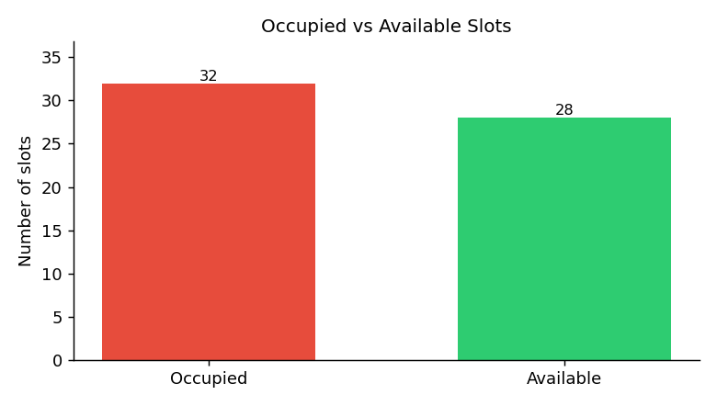
Figure 1: Occupied vs Available Slots
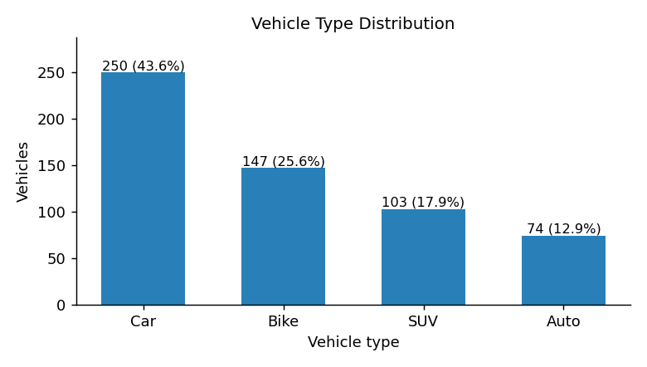
Figure 2: Vehicle Type Distribution
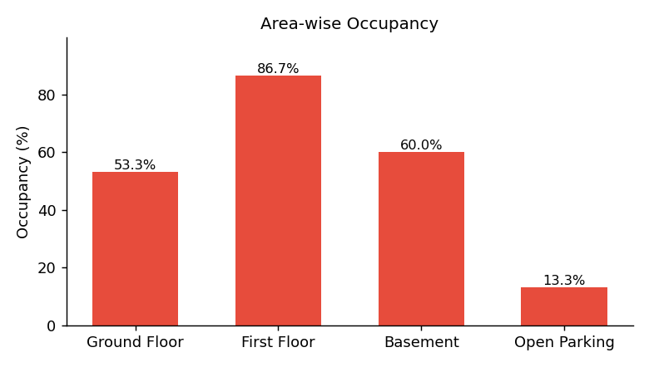
Figure 3: Area-wise Occupancy
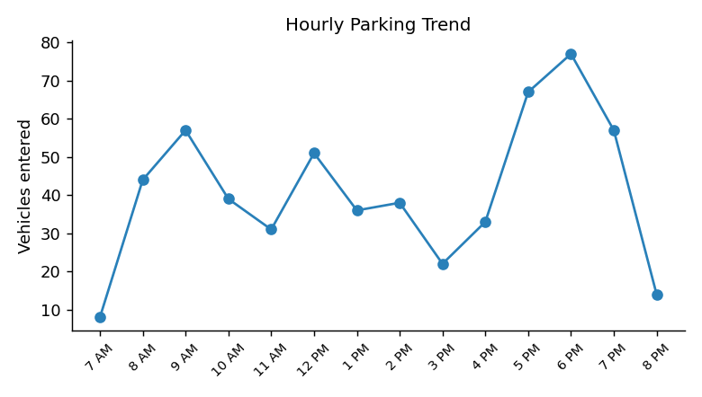
Figure 4: Hourly Parking Trend
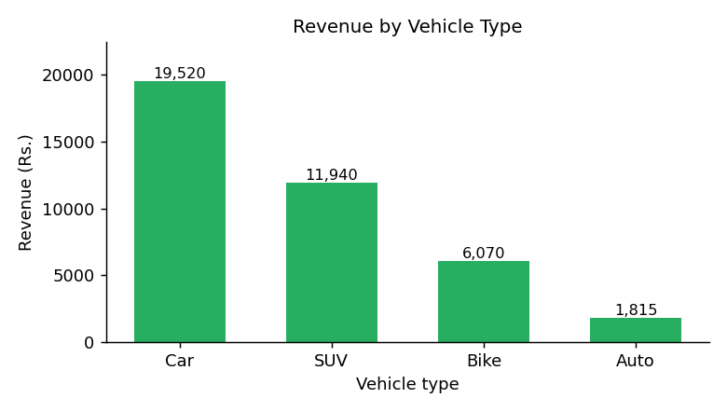
Figure 5: Revenue by Vehicle Type
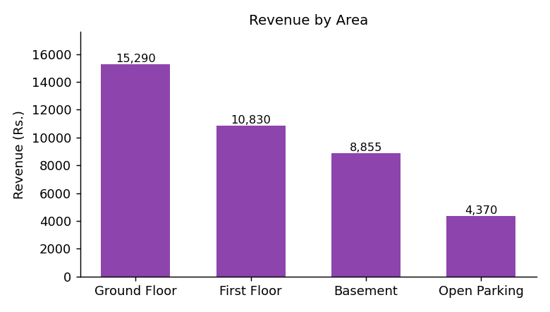
Figure 6: Revenue by Area
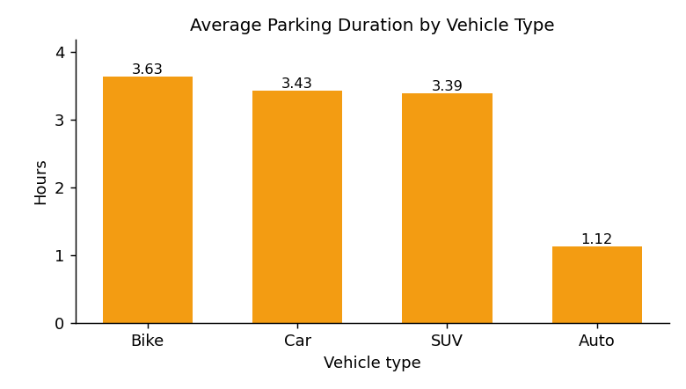
Figure 7: Average Parking Duration by Vehicle Type

12. Results
- Parking occupancy at the snapshot time is 53.3% (32 of 60 slots occupied, 28 available).
- First Floor has the highest occupancy (86.7%); Open Parking has the lowest (13.3%).
- Cars are the most common vehicle type (43.6%), followed by Bikes (25.6%), SUVs (17.9%) and Autos (12.9%).
- The average parking duration is 3.17 hours; Autos stay the shortest (1.12 hours on average).
- Peak parking time is 6 PM and the least busy hour is 7 AM.
- Total parking revenue is Rs. 39,345, an average of Rs. 68.55 per vehicle.
- Cars earn the most revenue (Rs. 19,520) and the Ground Floor earns the most among areas (Rs. 15,290).
- The highest daily revenue was Rs. 6,595 on 26 September 2026.
These statements appear on the Parking Insights tab and are calculated from the data each time the filters change.

13. Advantages
- Simple, easy to understand and suitable for demonstration.
- Instant, error-free calculation of duration and fees.
- Interactive filters with automatic updating of all results.
- Helps managers find busy floors and peak hours and plan staff and pricing.
- Insights are generated automatically from the data.
- Runs offline after the packages are installed; uses only free software.
- Includes validation and error handling for missing or invalid data.

14. Limitations
- Uses a stored CSV file; it does not read live data from sensors or cameras.
- The dataset is sample data for seven days, so long-term trends cannot be studied.
- Occupancy is calculated at a single snapshot time, not continuously.
- No login system, slot booking or online payment.
- Fixed fee rules; no discounts, night charges or penalties.

15. Future Enhancement
- Connect the system to a database or live sensors for real-time slot status.
- Add slot booking and online payment.
- Add a login system with separate admin and operator roles.
- Add number-plate based entry and exit recording.
- Add export of reports to PDF or Excel.
- Add forecasting of peak hours using longer historical data.
- Develop a mobile-friendly version for drivers.

16. Conclusion
The Smart Parking Slot Analysis and Management System Using R shows how basic R programming with dplyr, ggplot2 and Shiny can turn raw parking records into clear and useful information. The dashboard gives quick answers on slot availability, occupancy, vehicle types, duration, fees, peak hours and revenue, and its filters and automatic insights make it practical for daily use. The project is simple enough to explain in a demonstration and can be extended with live data and more features in the future.

