
FoodConnect
1. Project Overview:
This project focuses on a CRM application designed to manage food donations and distribution, addressing the issues of food waste and hunger. The goal is to deliver a comprehensive solution by leveraging the Salesforce platform and integrating modern tools like mobile applications and community portals. Through this project, we aim to:
- Streamline the donation process.
- Improve collaboration between donors, recipients, and volunteers.
- Enhance data visibility.
- Support the long-term mission of reducing food insecurity and waste.
2. Objectives:
a. Create forms for donors and recipients to submit and track donations.
b. Set up a comprehensive Salesforce environment to manage food donations, inventory, and logistics.
c. Streamline the entire process of food donation and distribution to make it more efficient and user-friendly.
d. Automate the matching of food donations with recipients to save time and reduce manual effort.
e. Enable real-time tracking of food deliveries using Salesforce and integrated tools.
f. Provide insightful dashboards and reports to monitor donation trends and impact.
g. Foster collaboration through community portals for donors, recipients, and volunteers.


3. Salesforce Key Features and Concepts Utilized:
- Salesforce Objects
- Classes
- Flows
- Triggers
- Creation of Fields
- Creation of Users
- Salesforce App Builder
- Creation of Public Groups
- Creation of Reports
- Lightning Components

Detailed Steps to Solution Design:
1.Create objects

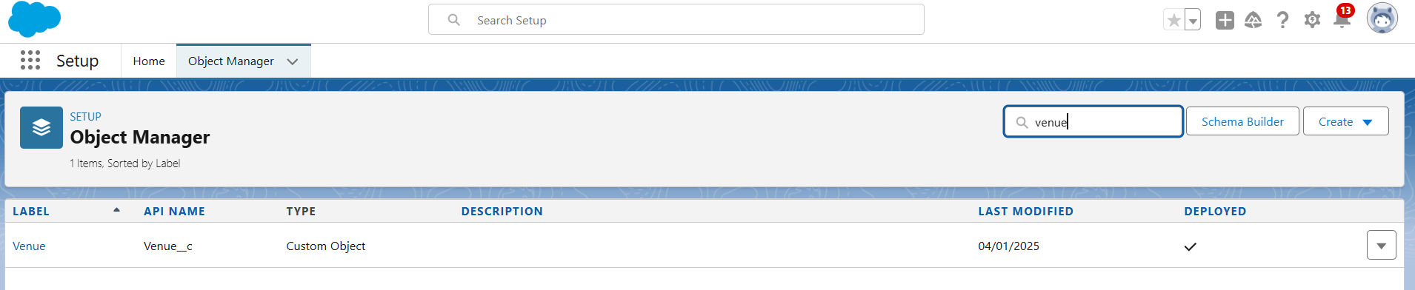

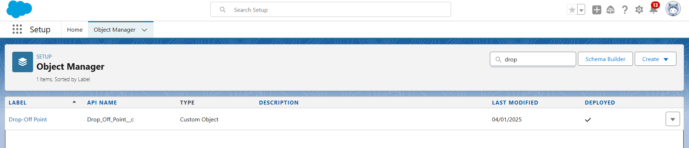

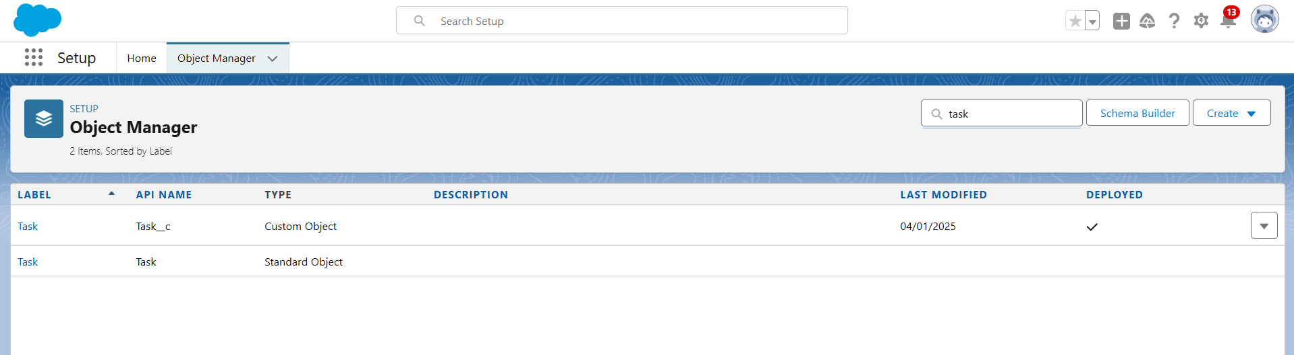

2.Creating Flows and Fields
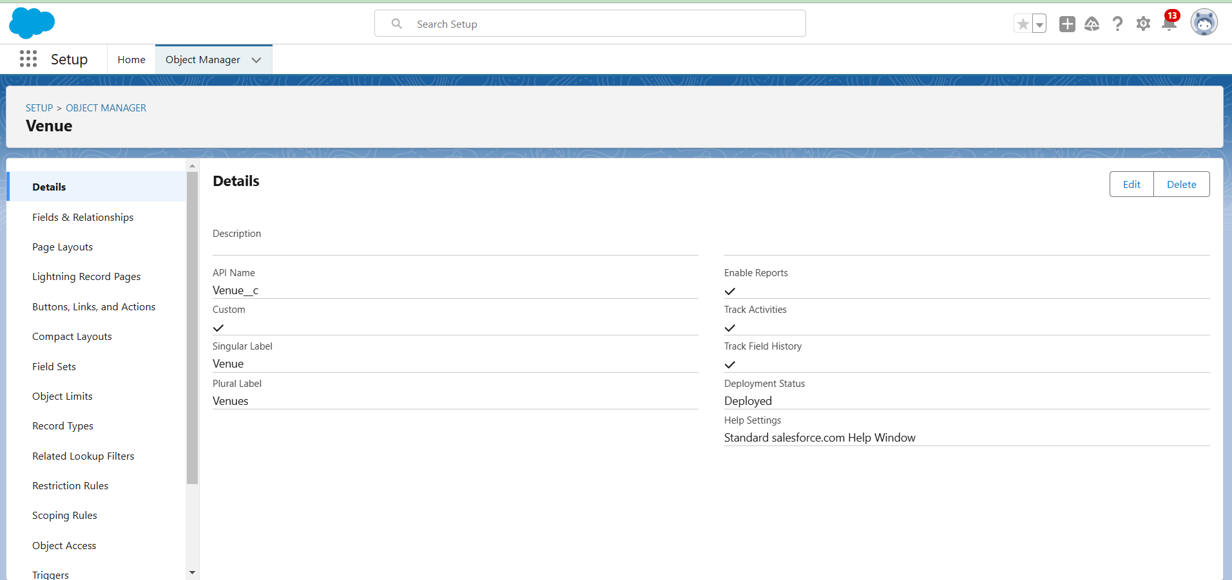

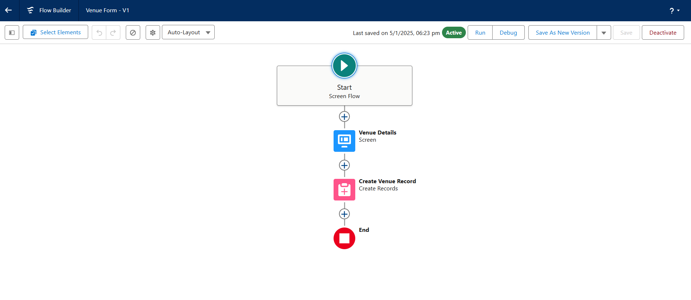

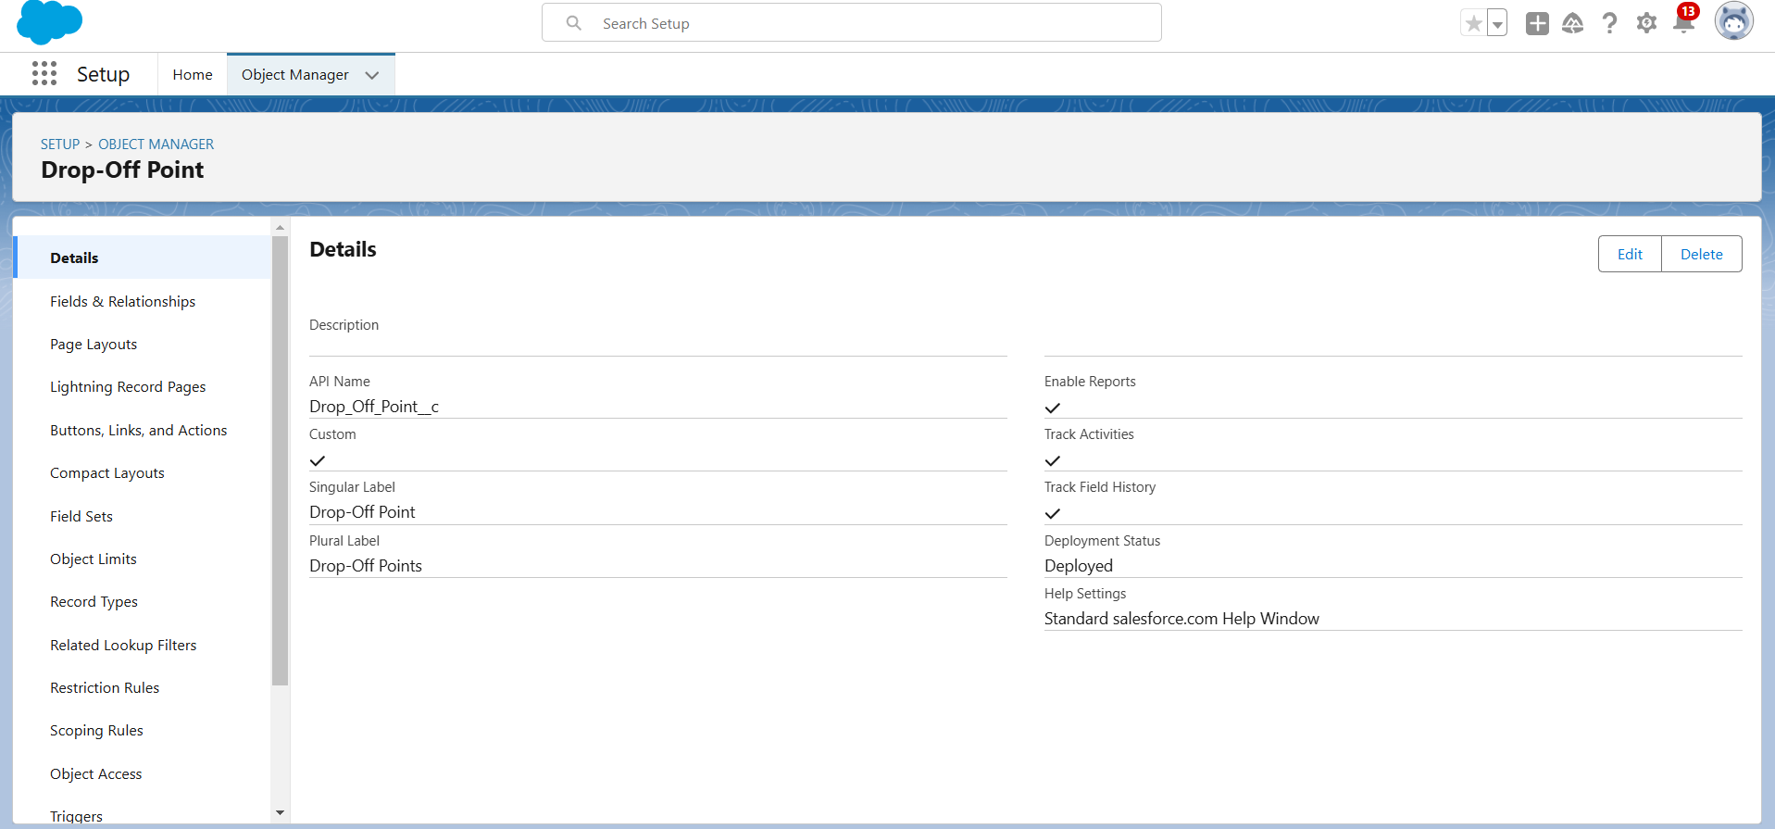

Creation of Triggers:
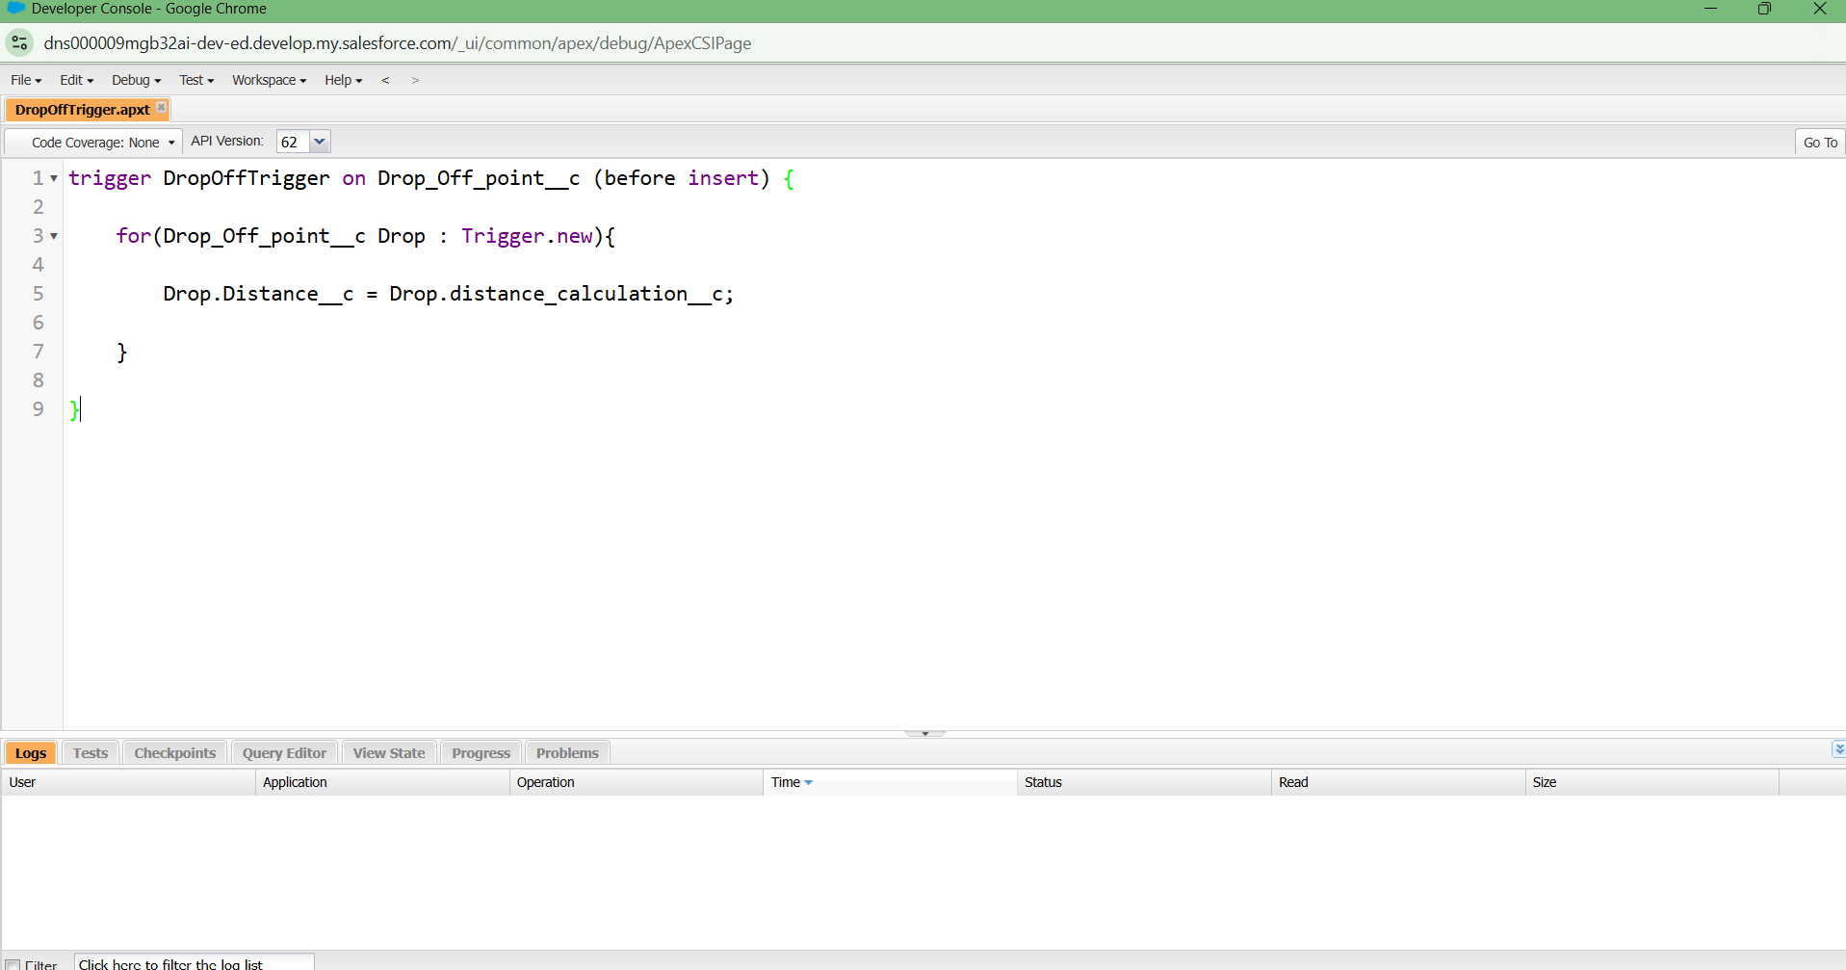

Creation of Users:
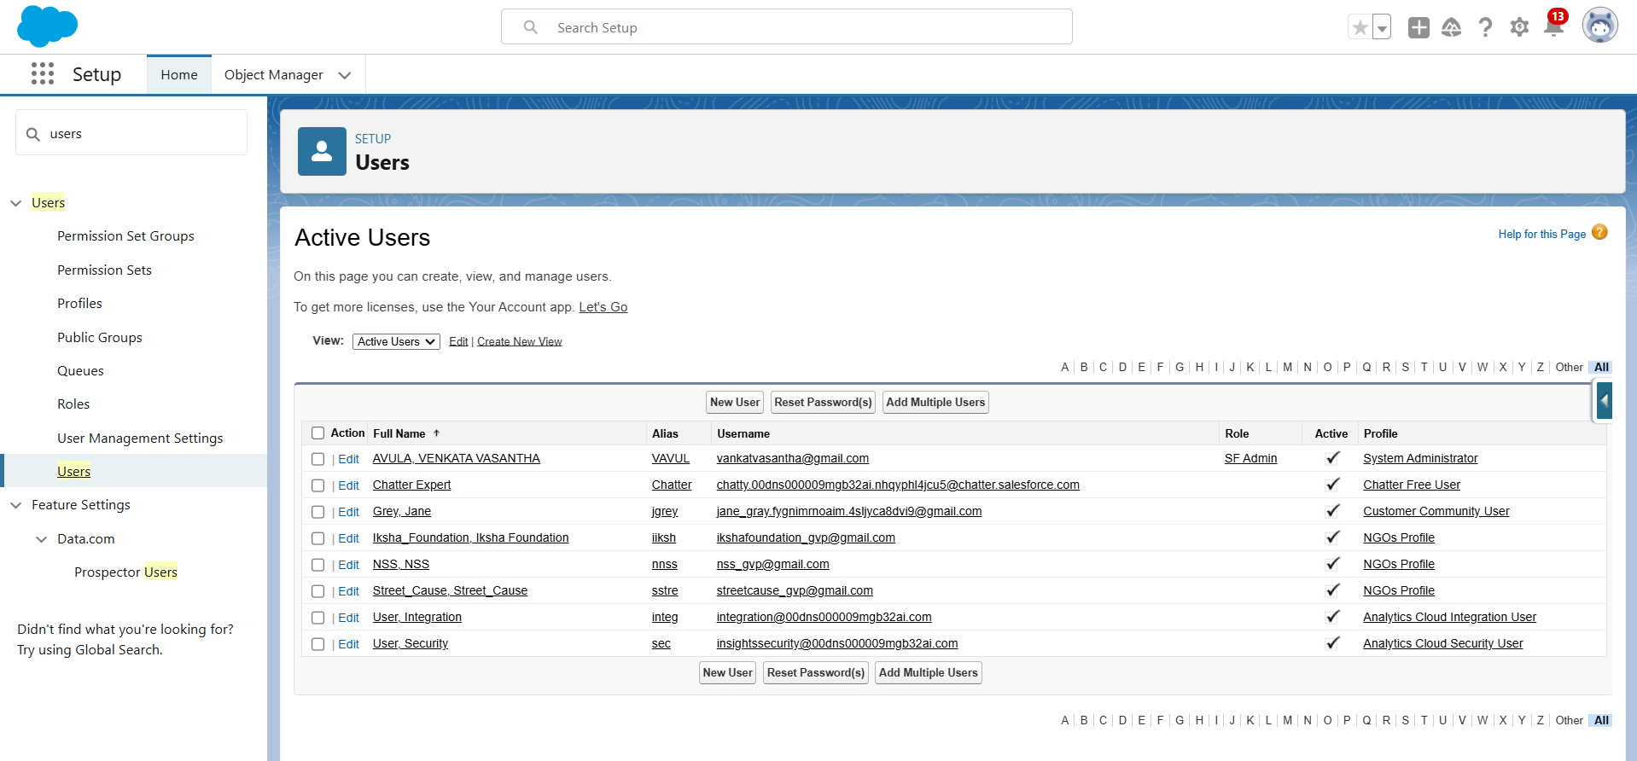

Creation of Public Groups:
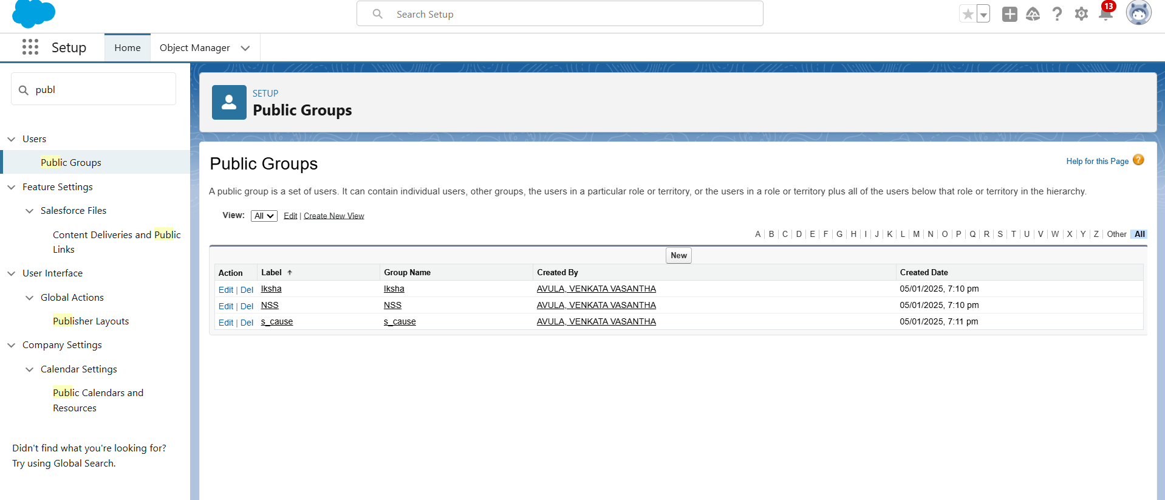

Creation of report types:
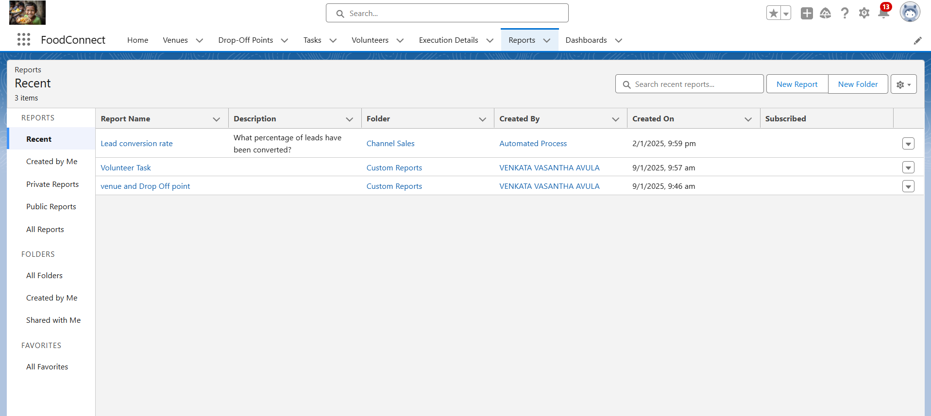

Create App page using App Builder:
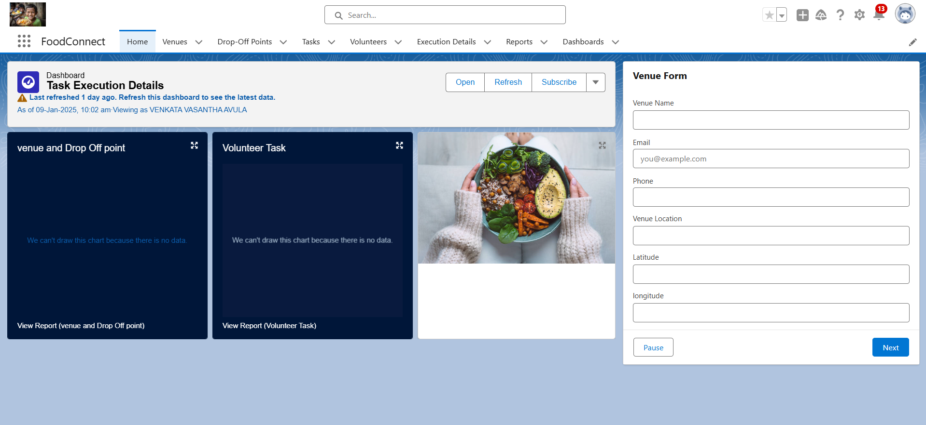

5. Testing and Validation:
Tested all the users, reports, and dashboards thoroughly to ensure there are no flaws in the application.
6. Key Scenarios Addressed by Salesforce in the Implementation Project:
- Simplifies and streamlines the entire process of managing food donations and distribution with an intuitive user interface for both administrators and end users.
- Enhances collaboration between donors, recipients, and volunteers, ensuring a seamless experience for all stakeholders.
- Maximizes efficiency and impact in food donation and distribution.
7. Conclusion:
Gained a comprehensive understanding of the Salesforce environment and successfully implemented various tools and features to streamline food donation and distribution processes.
Enhanced efficiency, collaboration, and data accuracy while addressing real-world challenges of food waste and hunger through the FoodConnect project.

