**TABLEAU ANALYSIS**

Identifying potential defaulters:

**Motivation**: A borrower who fails to make mortgage payments on time can be categorized as a defaulter. If we identify potential defaulters by identifying the borrower’s loan payment trends, this would help bank identify borrowers who could cause potential loss to them.

**Approach**:

1. For every borrower, the amount that is due after the last payment was computed.

actual_amount_due=original_UPB - current_actual_UPB (last occurrence)

1. The ideal pending amount was calculated by computing the installment amount and loan age

Installment_amount= original_UPB / original_loan_term

Ideal_pending_amount=installment_amount * loan_age

1. By comparing the ideal_pending_amount and the actual_amount_due, 563 such occurrences were seen where the actual_amount_due exceeded the ideal_pending_amount. (i.e 563 borrowers had more amount due than expected)
2. Top 50 such borrowers were chosen and their Original_Combined_Loan_To_Value, Original_Debt_To_Income_Ratio, Credit_Score and Property_State were analyzed.

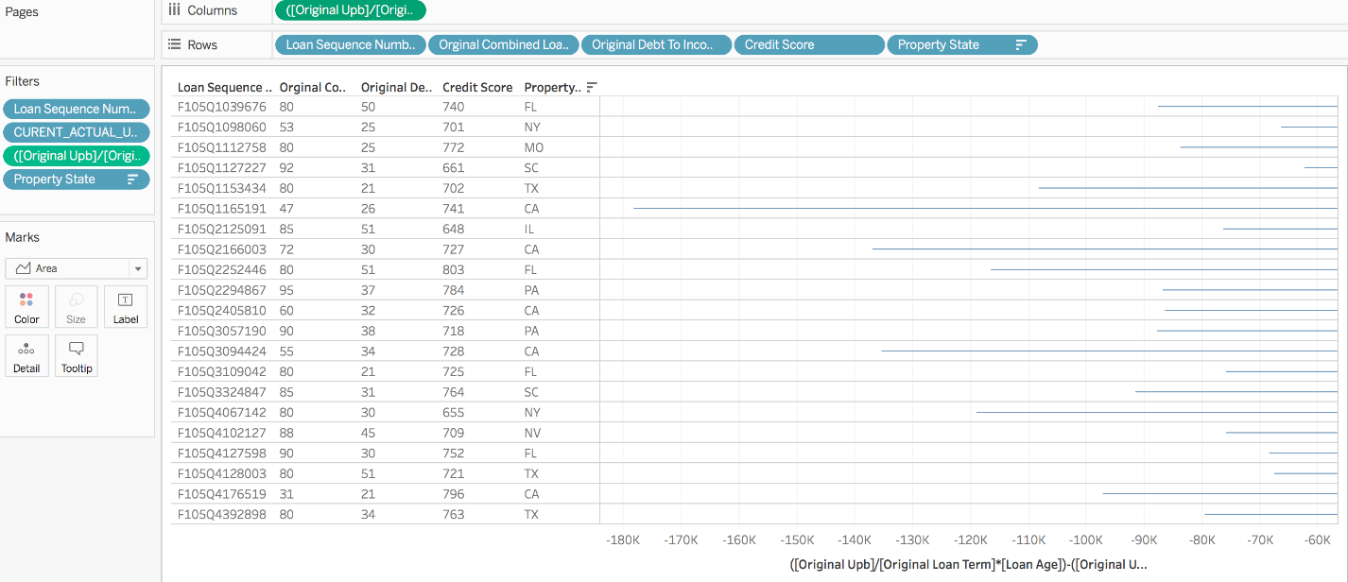

**Conclusion:**

**Property State effects the defaulting of loan largely. Identified States CA, FL and NY**

**Default loans vs Interest Rate**

**The following graph shows effect of interest rate on defaulting of loan. Highest rate of default in 2007. Housing bubble credit crisis.**

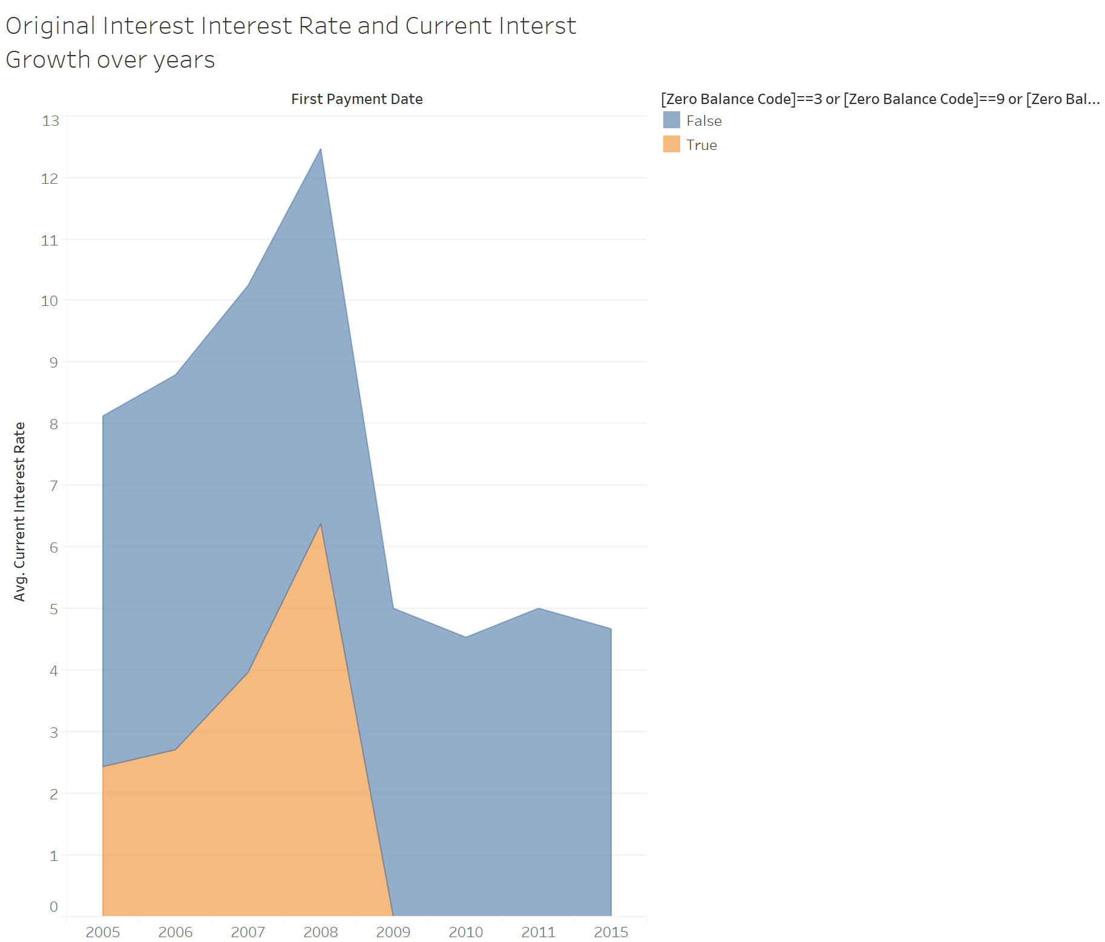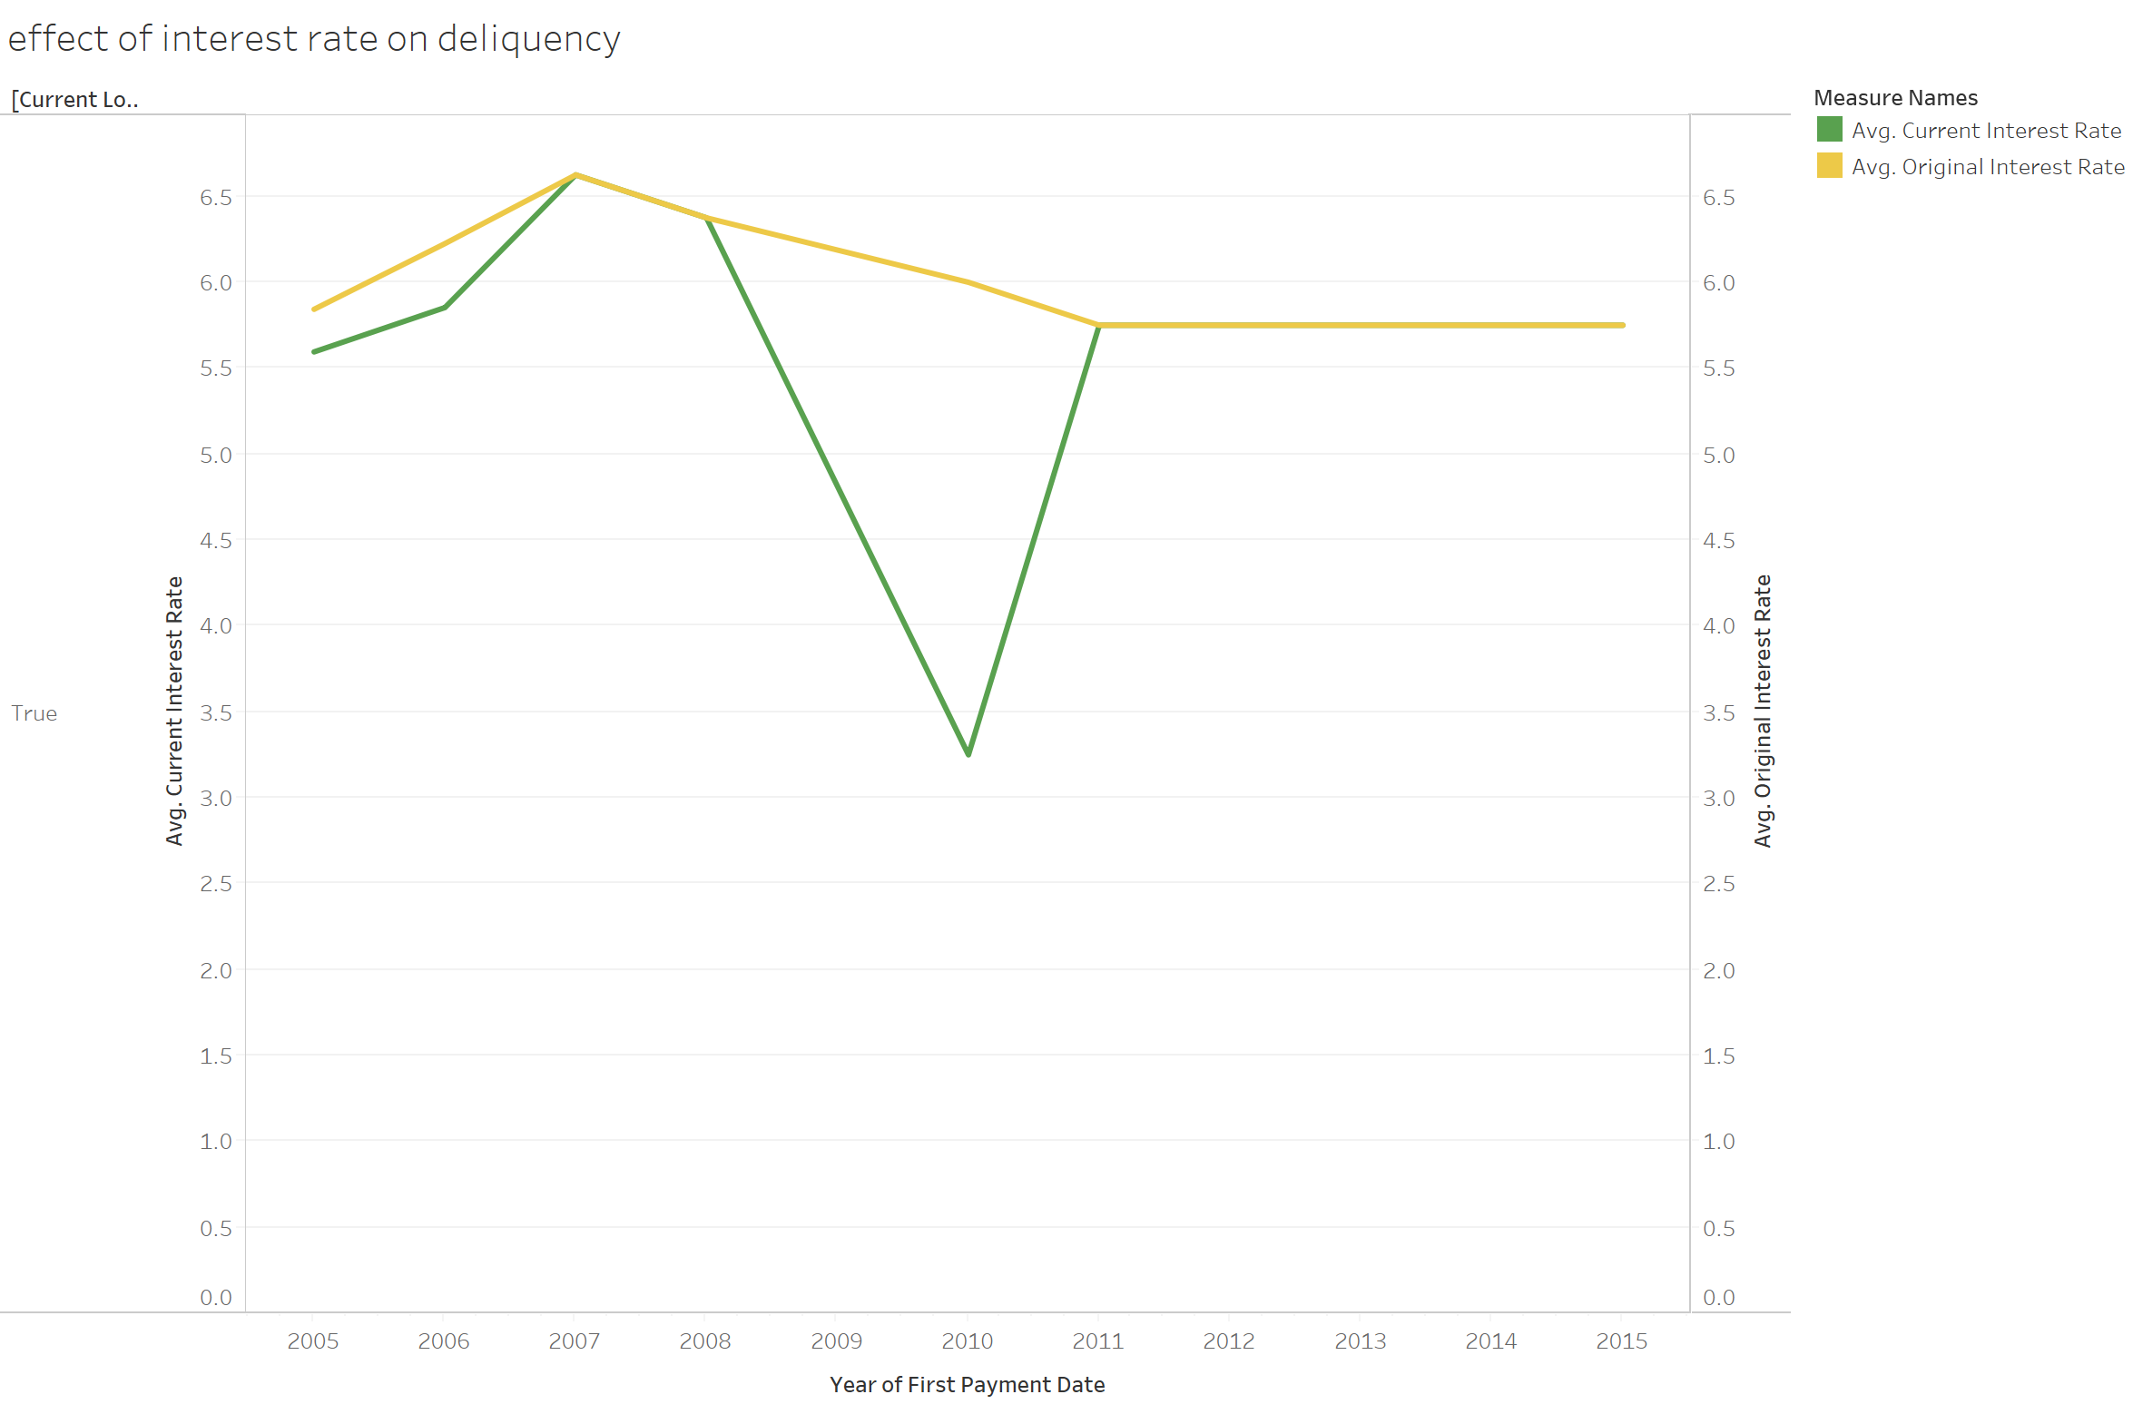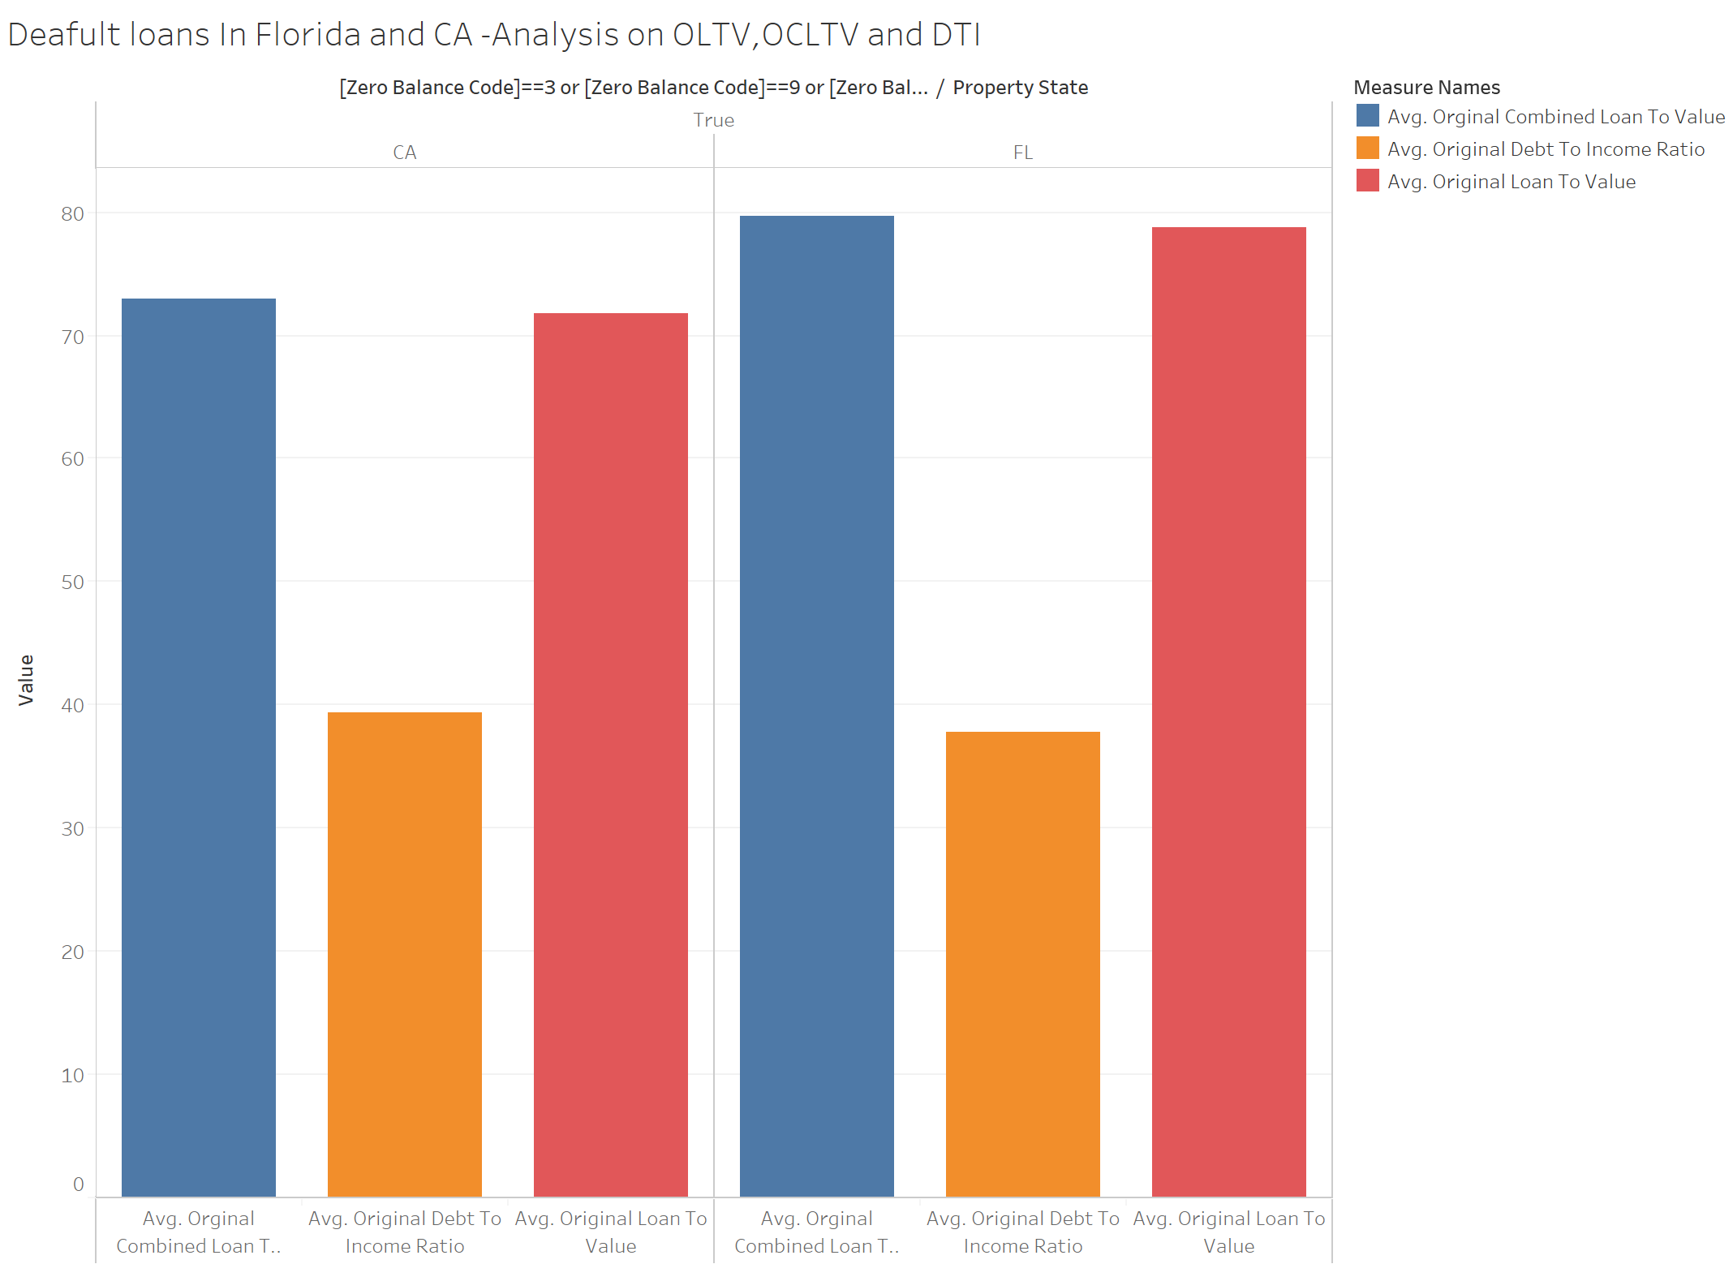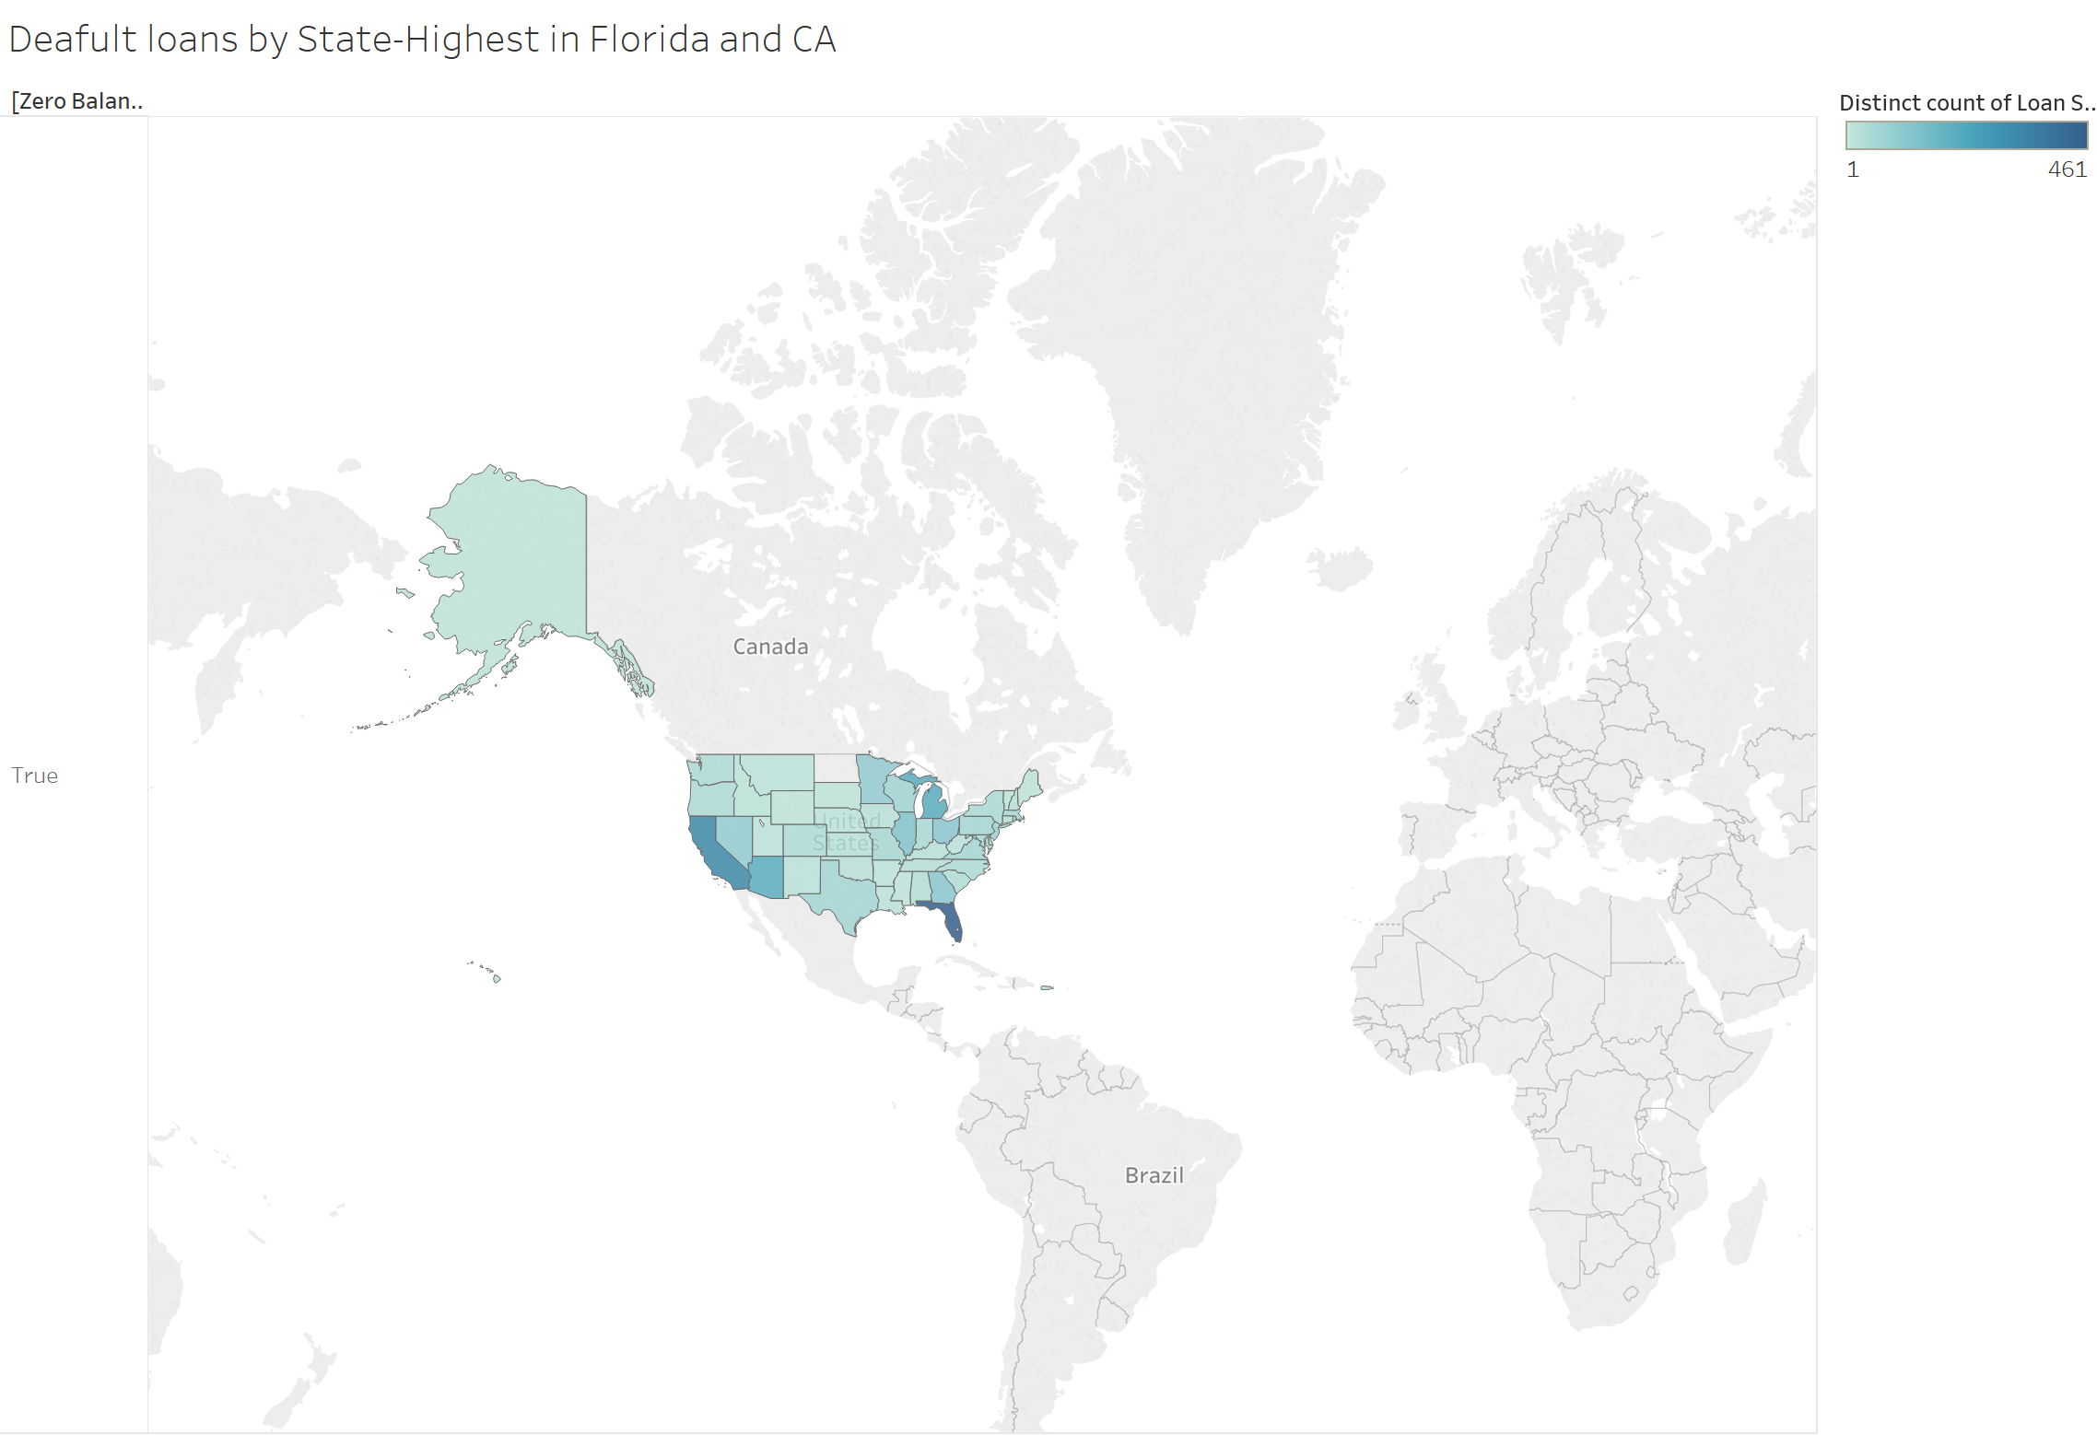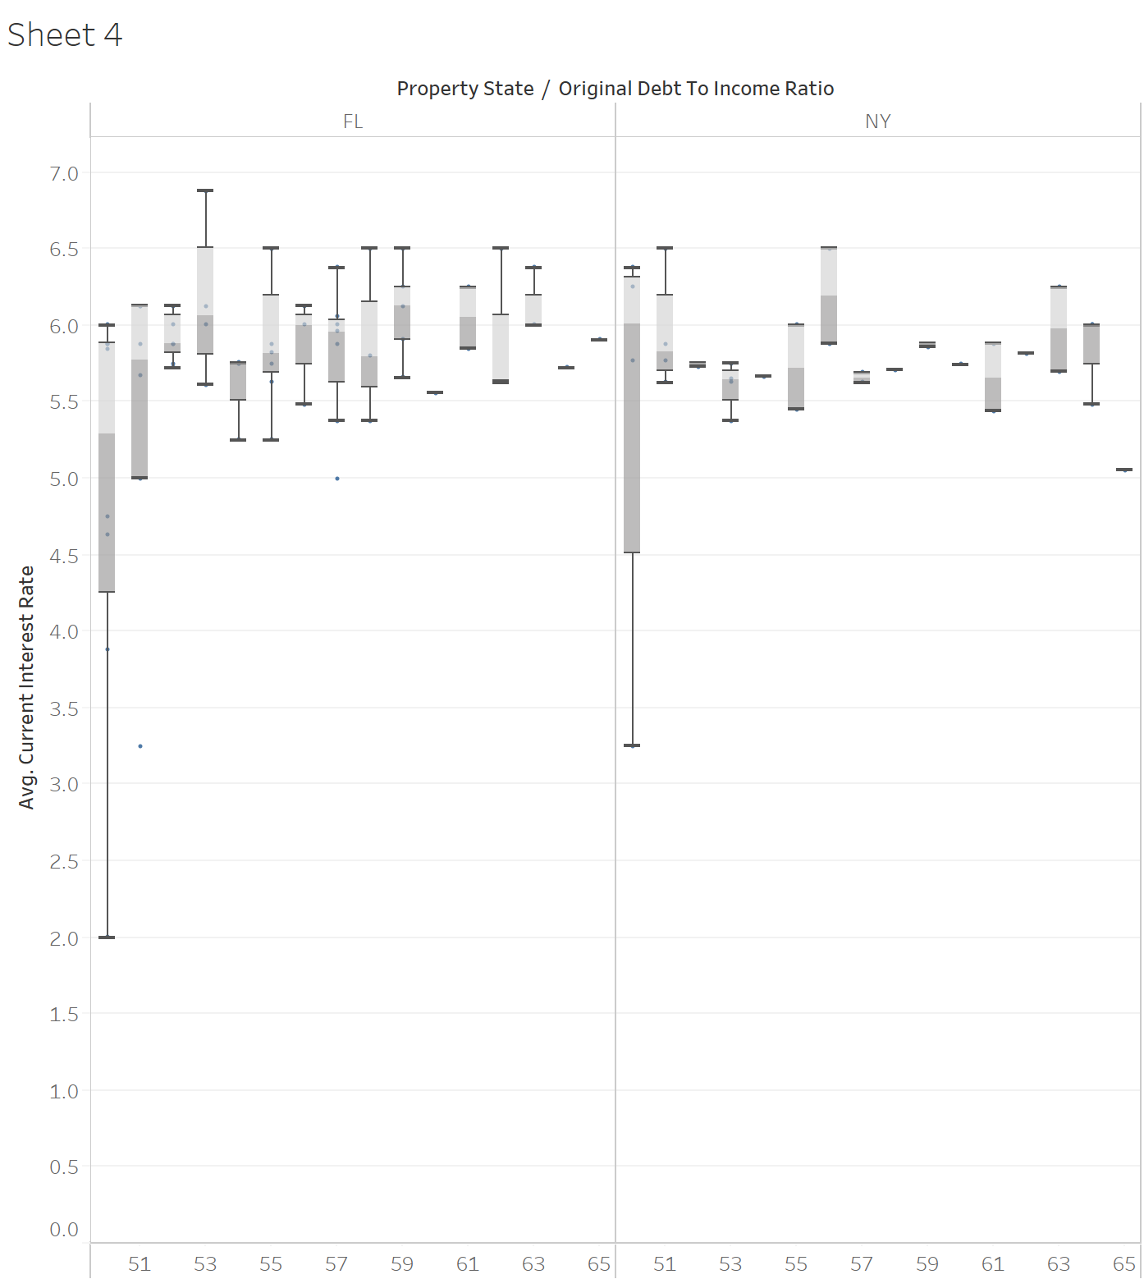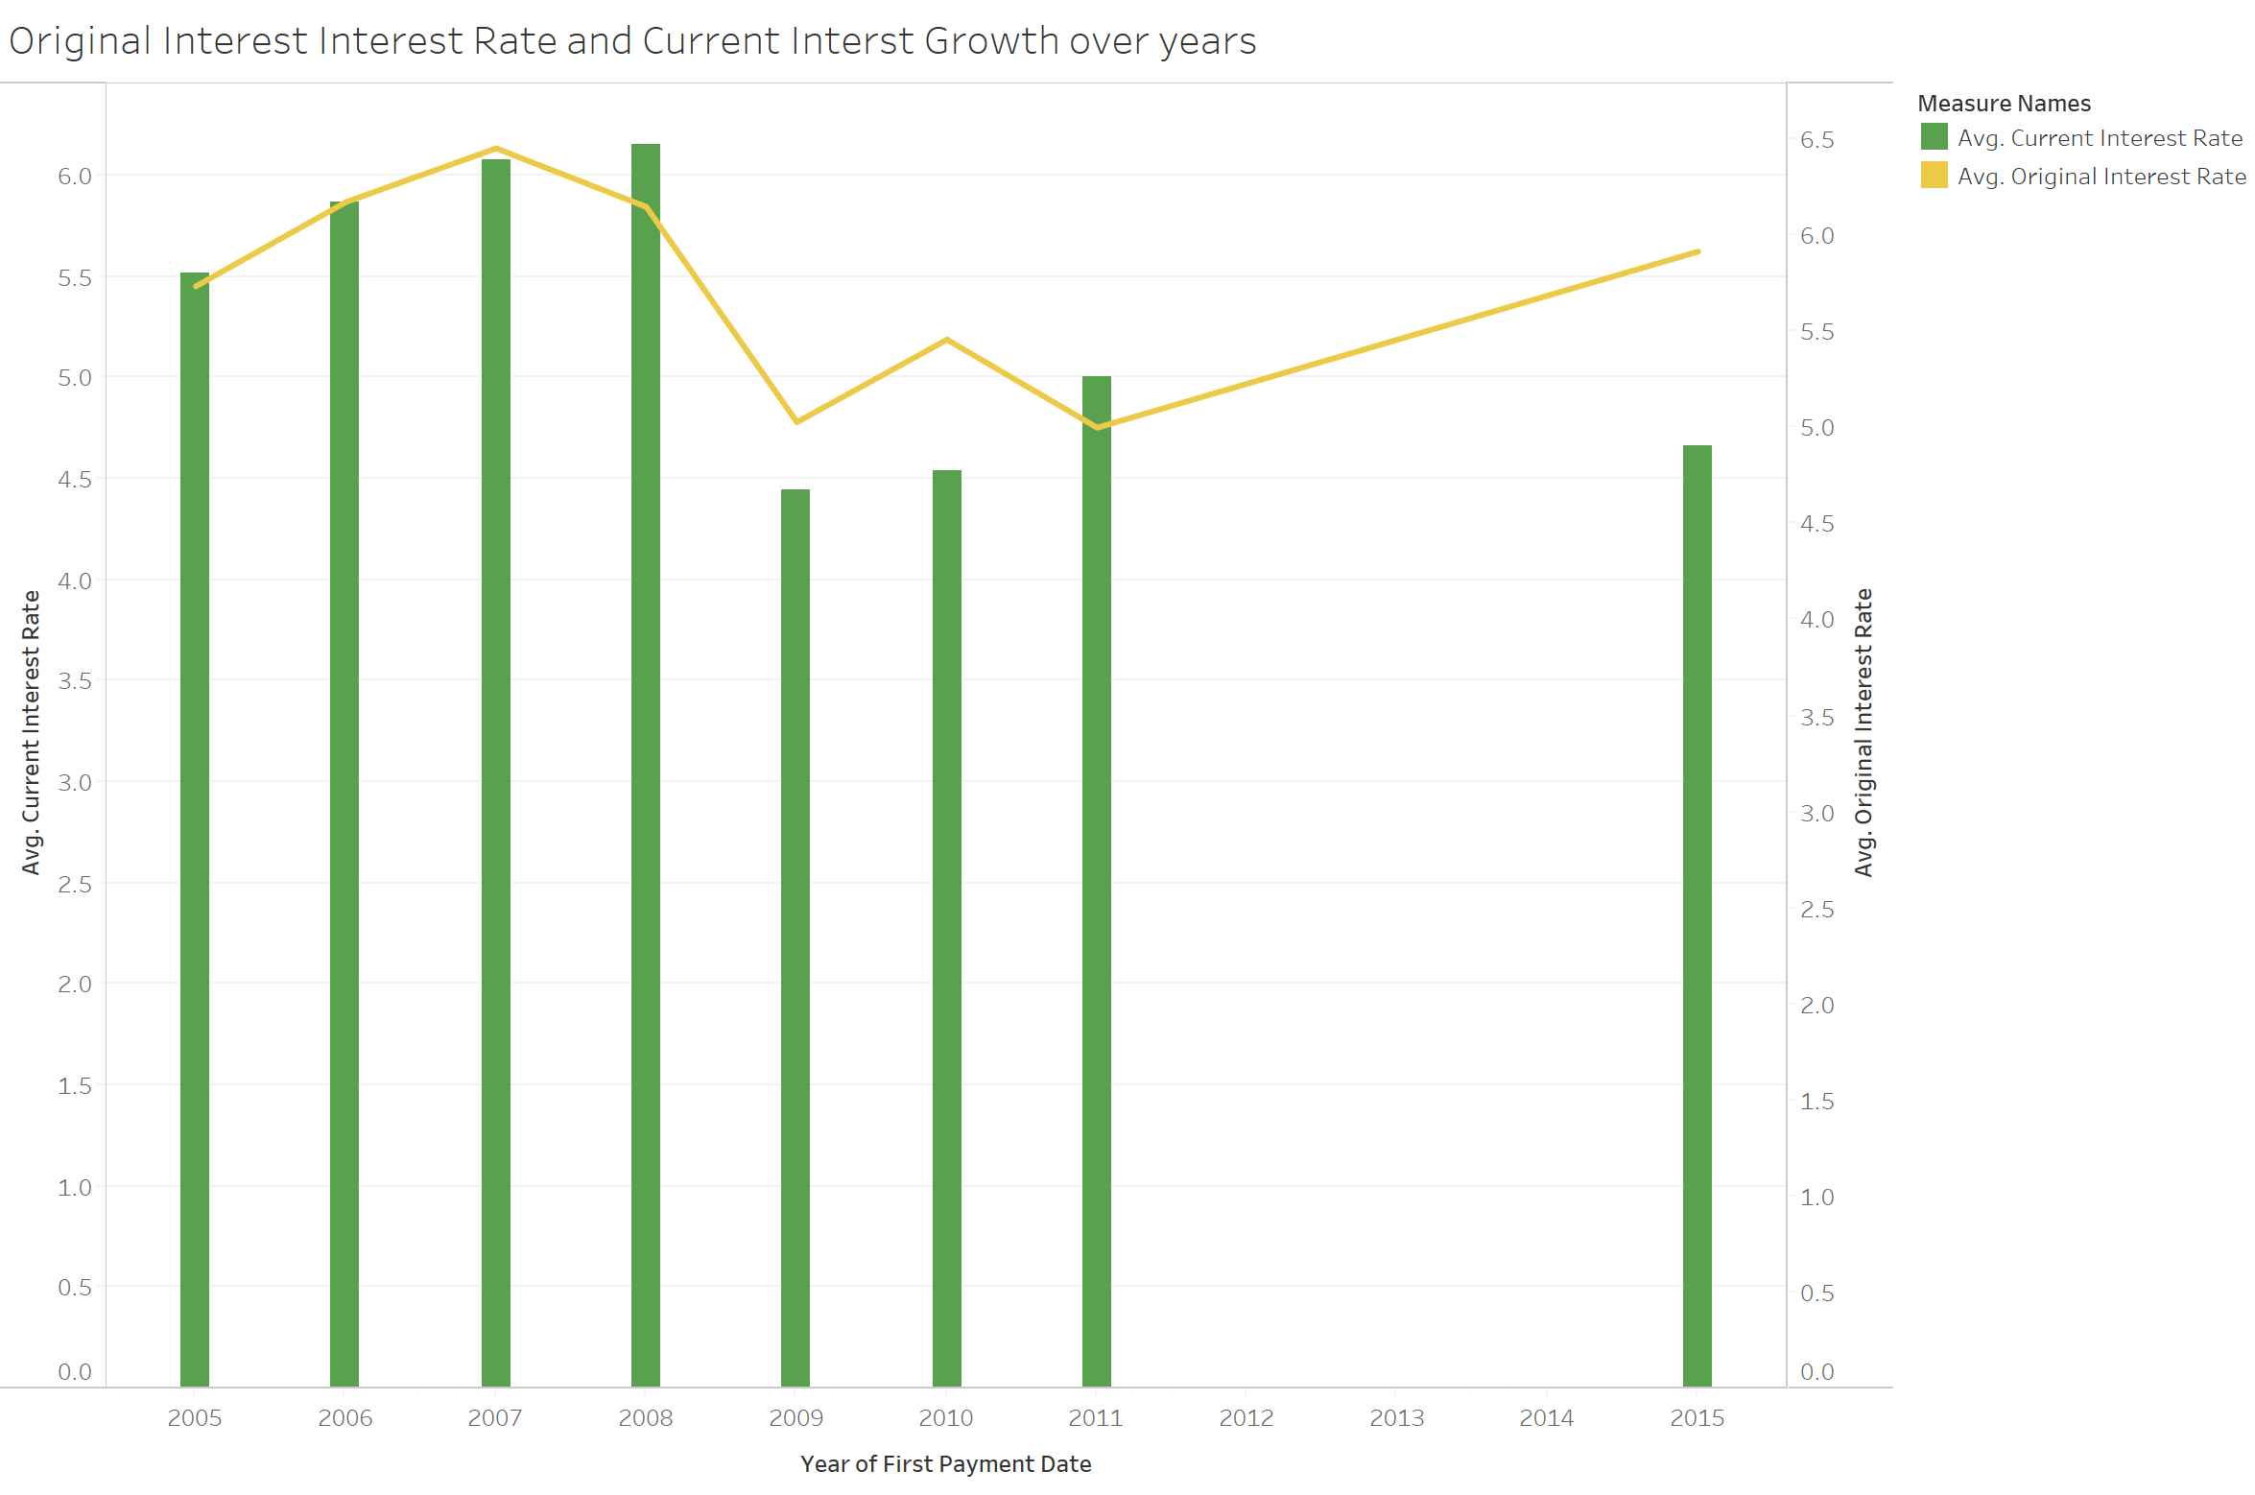

The total number of loans in various states. Highest taken in CA and NY, FL.(Populated states and )

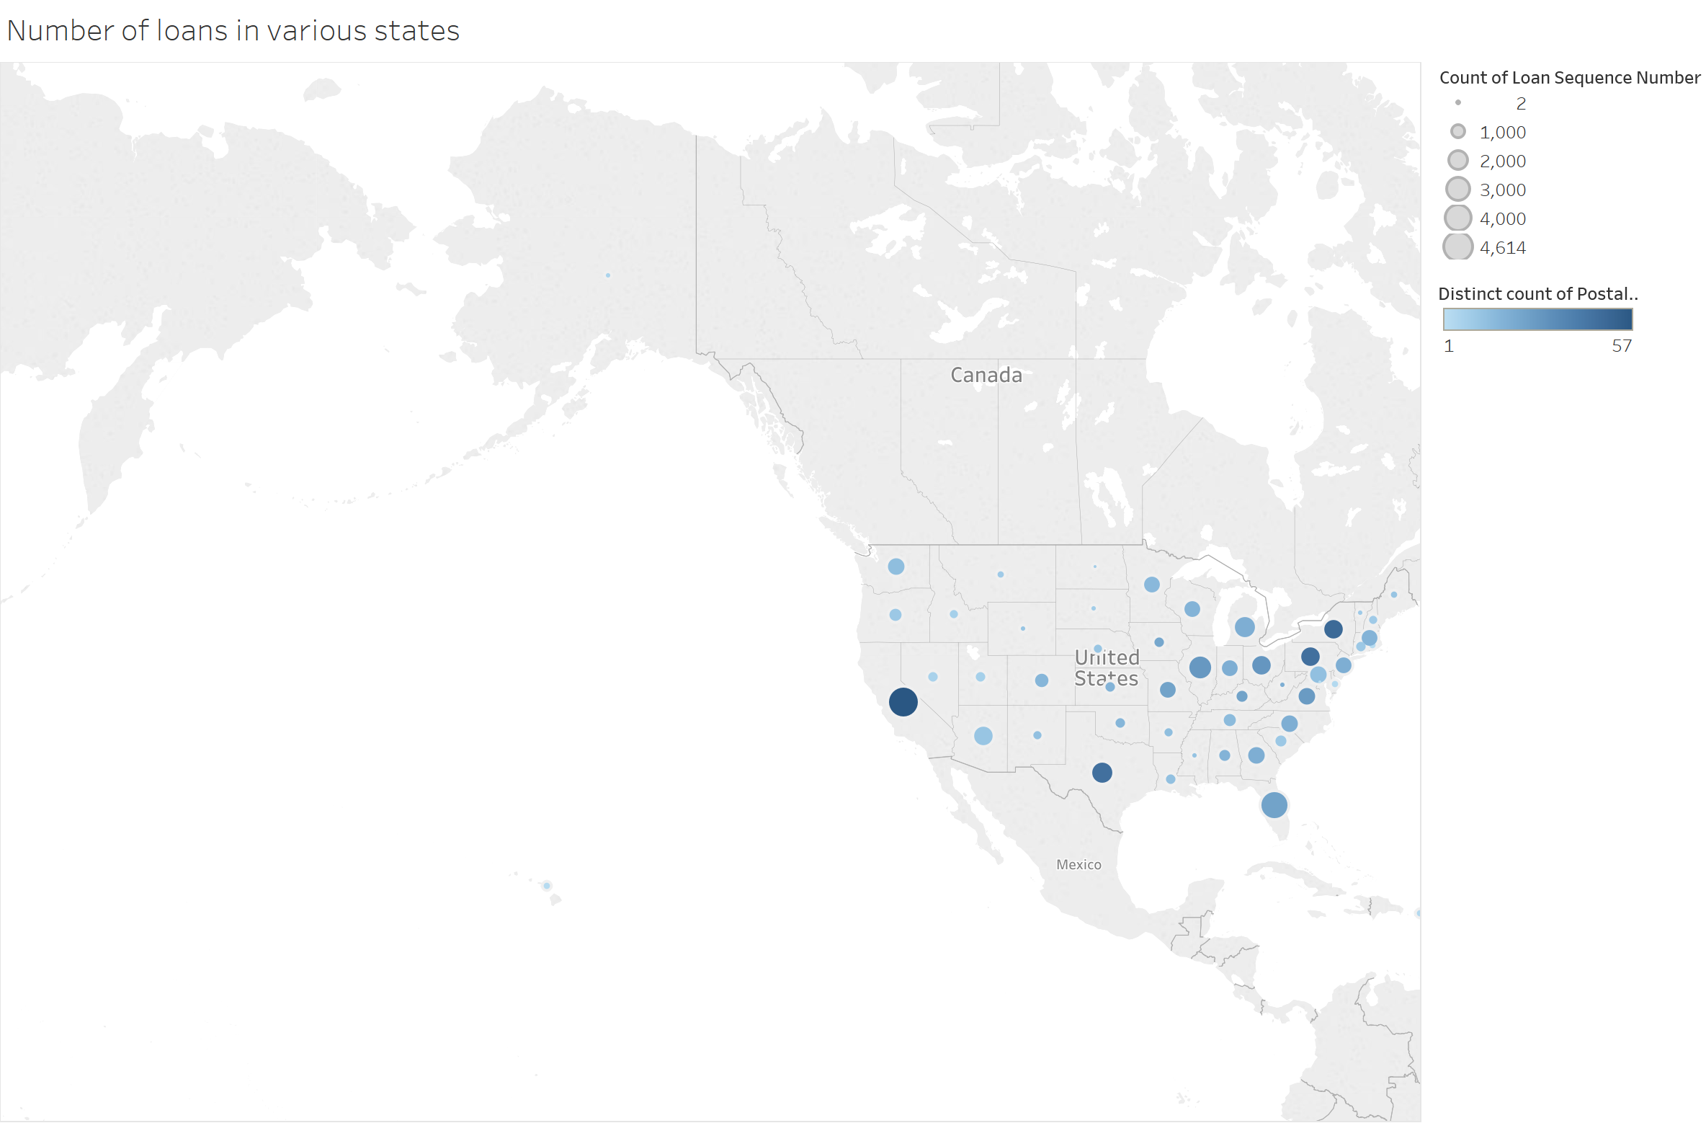

Highest Delinquency recorded in FL and NY.

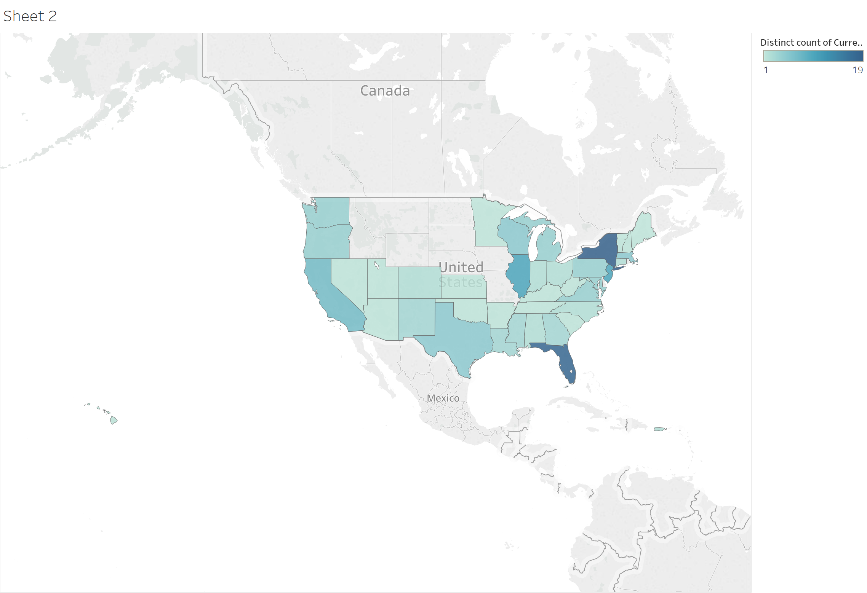

**Average Credit Score for Default and Non Defaul loans per state. Which is pretty high for defaulters. Credit Score alone cannot be used to predict people failing to pay loan.**

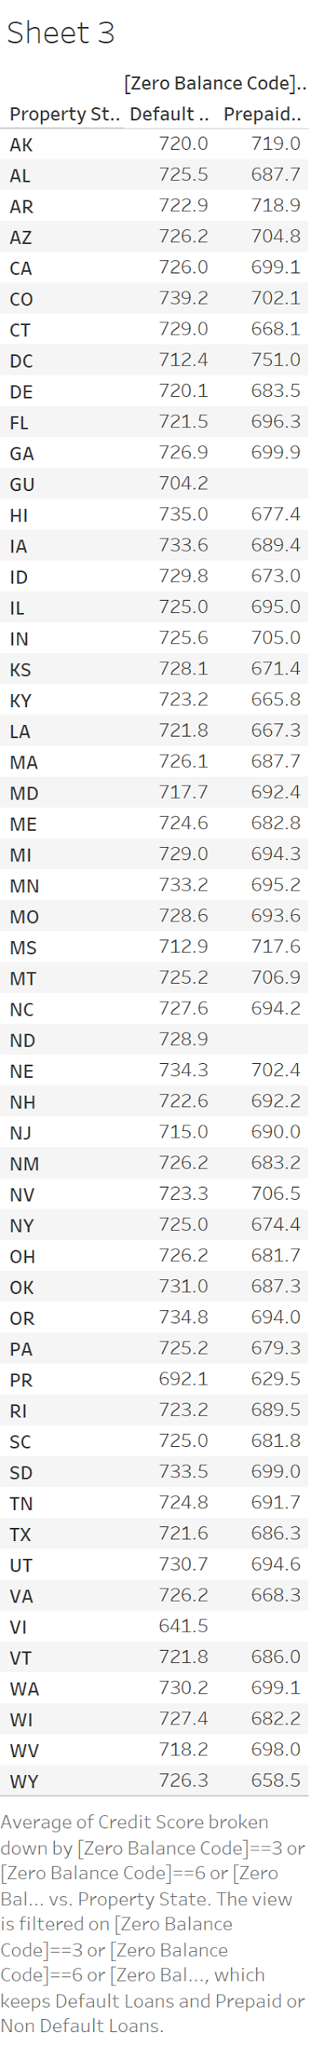

**People defaulting in FL have high OCLTV than NY**

