**TENSORBOARD USING DOCKER**

The easiest way to run TensorFlow on a windows machine is by using Docker. Docker is an easy to deploy environment for building, assembling and shipping applications from a Windows PC.

Following are the steps to install TensorFlow using Docker:

1. Install Docker toolbox for Windows

Refer to the instructions [here](https://www.docker.com/products/docker-toolbox)

1. Once done, open up the Docker Quickstart Terminal

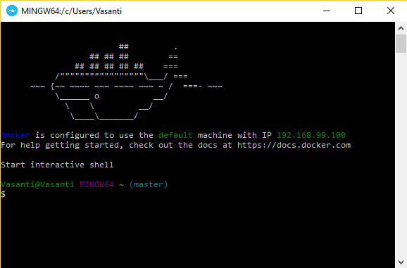

1. Download an image to install TensorFlow with connectivity to Jupyter notebooks and TensorBoard. Run the following command:

docker run -it -p 8888:8888 –name=’TF_Full’-p 6006:6006 b.gcr.io/tensorflow/tensorflow



This will create a docker container with the image.

1. Bash into the container using the following command:



1. Open the Jupyter notebook by typing the following in the browser:

<http://192.168.99.100:8888/tree>

(Docker Machine IP)

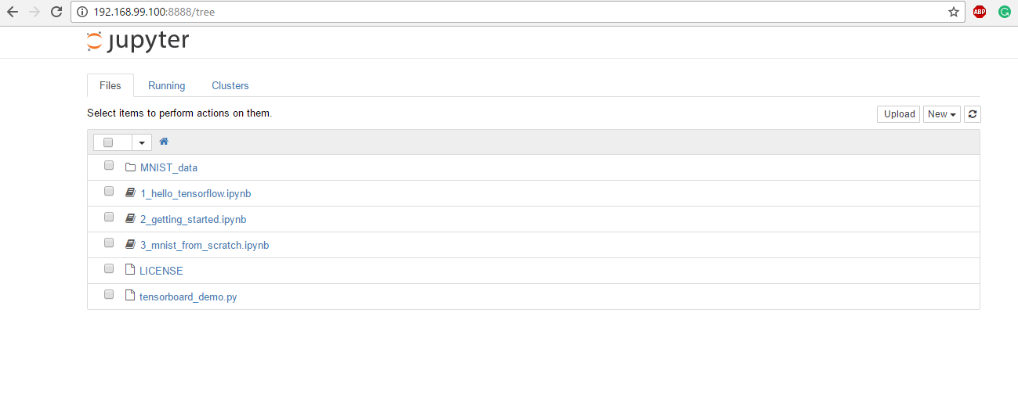

1. Upload the TensorFlow program using the upload option. [Refer to sample program](https://github.com/vasantivmahajan/tensorflow_tutorials/blob/master/Examples/tensorboard_demo.py).
2. Execute the program using the command

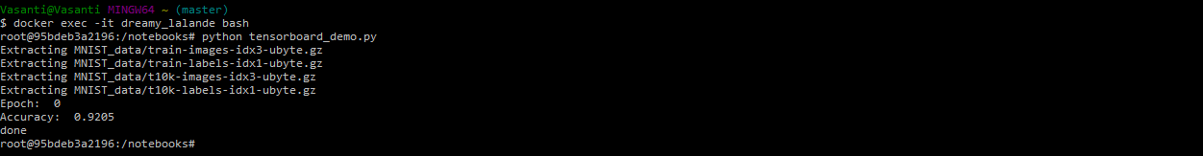

This creates the event files in the log_dir.



1. Run TensorBoard to view the graphical representation of the quantitative metrics using the following command:

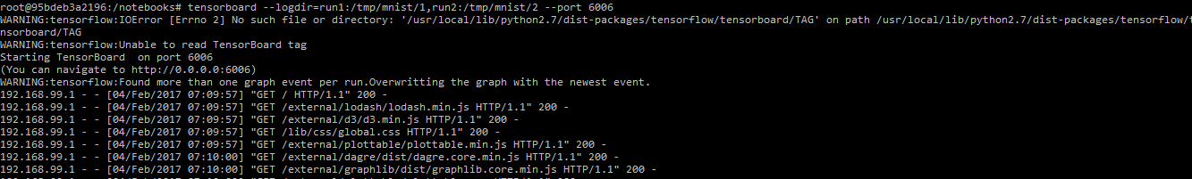

Open the link <http://192.168.99.100:6006/> in the browser to view TensorBoard graphs and events (Use Docker Machine’s IP address)

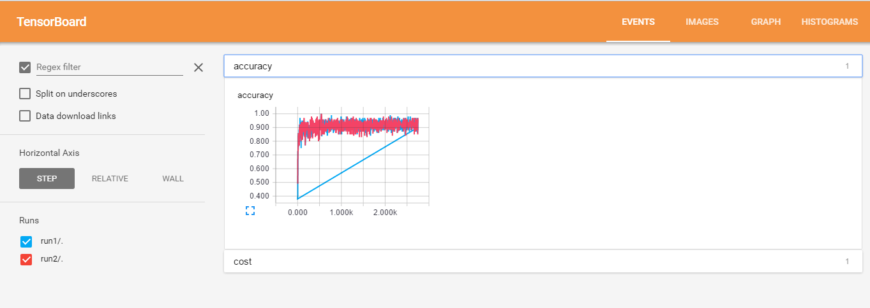

1. We can try various combinations of parameters and run the graph several time, logging the results in separate folders and comparing the results using TensorBoard