**Digital Image Processing**

**Assignment No.3**

Submitted by-

Vasa Vamsi Krishna

(19210112)

Submitted on-

16th Nov, 2019

Table of contents Page No.

1. Solution ………………….............................................................................................3
2. Referrences...................................................................................................................10
3. **Solution (Halftoning):**

The functions defined in the code are as follows:

* tresh ( ):
* Input arguments – Input Image (Img)
* Output arguments – Tresholded binary image w.r.t T = 127 (y)
* add_noise ( ):
* Input arguments – Input image (Img)
* Output arguments – Image added with uniformly distributed noise in range of [-128, 128] (y).
* ordr_dith( ):
* Input arguments – Input Image (Img)
* Output arguments – Thresholded image w.r.t the bayer’s matrices with sizes (2x2), (4x4), (8x8), i.e y1, y2, y3.
* dith( ):
* Input arguments – Input Image (Img), Threshold matrix (T).
* Output arguments – Thresholded image w.r.t the Threshold matrix provided (y).
* Err_diff ( ):
* Input arguments – Input Image (Img)
* Output arguments – Halftoned image w.r.t

**Understanding the algorithm:**

* Here the multithresh_19210112( ) function is used to get the required no. of levels (i.e not more than 3). Here if the second input argument is missing, it will give single threshold using otsu’s method. With second argument as 1, it will give output as single threshold using Global thresholding method. With second argument as 2 or 3 it will give respective thresholds taking maximum in between variance as the function of them.
* The formula used to calculate the in-between variance in otsu’s method for single threshold is

**σB2 = P1P2*(µ1 - µ2)2**

**σB2 =** in-between variance

**P1 =** Probability from 0 to threshold (varying from 0 : 255)

**P2**= Probability from threshold to 255.

**µ1**= mean of Class-1 (i.e 0 : thtreshold)

**µ2**= mean of Class-2 (i.e thtreshold : 255)

* The formula used to calculate in-between variance in otsu’s method for more than one threshold is

**σB2** = **(µ1 - µG)2P1 + (µ2 - µG)2P2** + **(µ3 - µG)2P3**

**µ1, µ2, µ3** are the means of classes bifurcated by the thresholds chosen.

**P1, P2, P3** are the probabilities of those classes.

**µG** is the global mean.

* Similar formula is elaborated for N = 3, with four classes.
* For Global threshold the standard algorithm is used, the tolerance between present and previous threshold is taken as 5 pixels.
* After getting the levels, values should be 1 element more than the levels provided.
* The quantization_19210112 will directly use these values to give the required output.

**Test case-1 (Single threshold using Global thresholding method):**

Input image – liftingbody.png (inbuilt demo image in Matlab for testing)

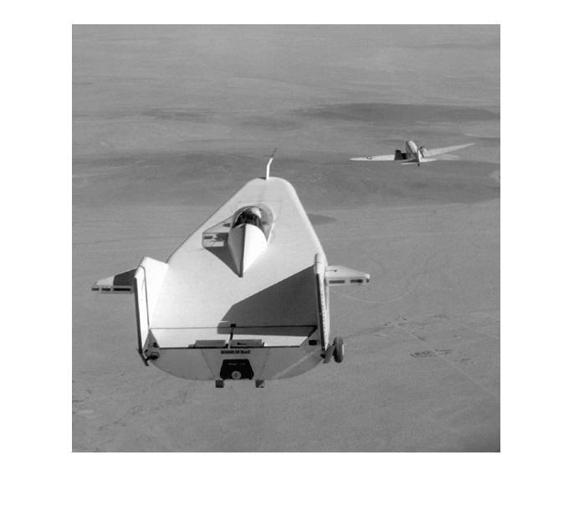

Original Image

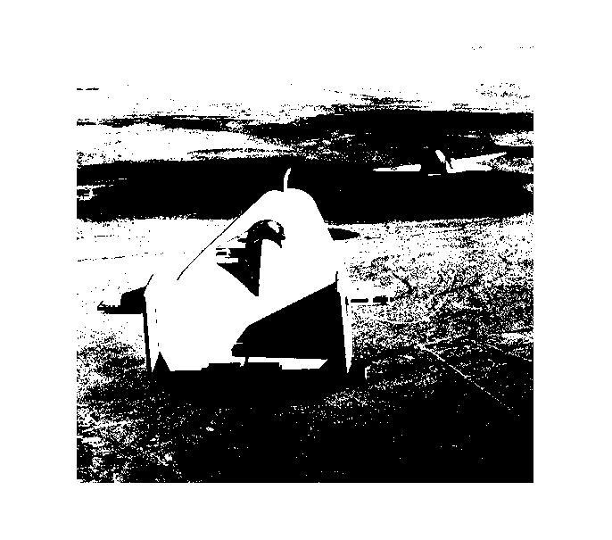

After Global thresholding

**Test case-2 (Single threshold with Otsu’s method):**

Input image - cameraman.tif (inbuilt demo image in Matlab for testing)

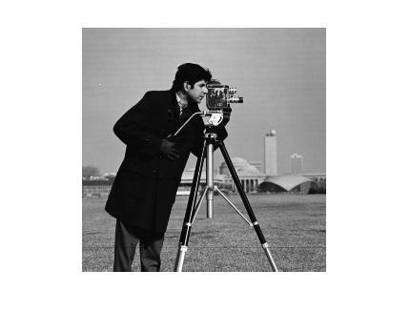

Original Image

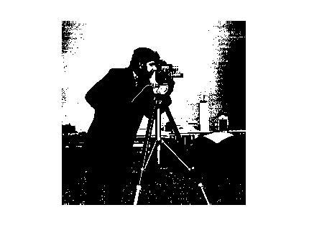

Otsu’s method for single threshold

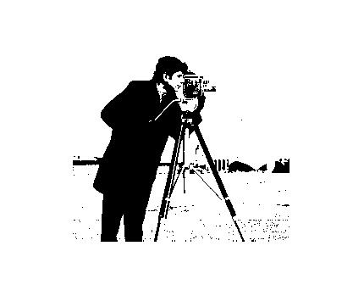

With inbuilt function

**Test case-3 (Multiple threshold with Otsu’s method):**

Input image - coins.png (inbuilt demo image in Matlab for testing)

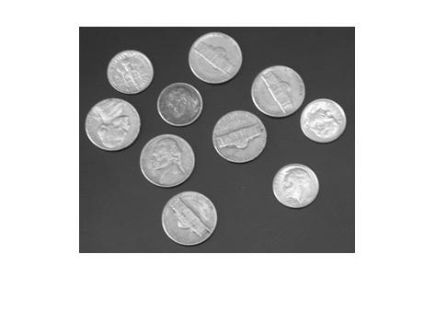

Original image

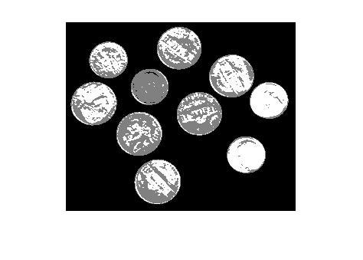

With multiple thresholding (N=2)

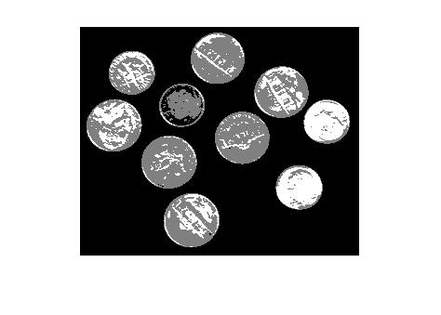

With inbuilt function

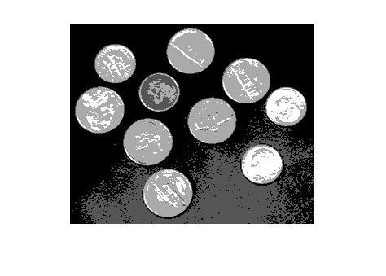

With multiple thresholding (N=3)

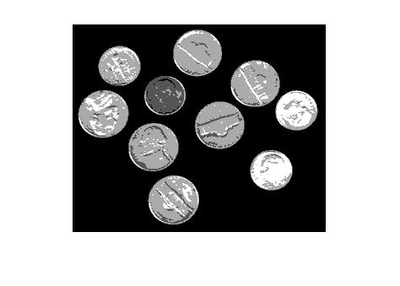

With inbuilt function

**Comments:**

* With single thresholding using otsu’s method, the output threshold may vary from the output given by inbuilt function.
* for any N>3, it will take by default input, i.e N = 3.
* With multiple thresholding the output obtained would be different from the inbuilt function. But the algorithm used is obtained from the standard procedure of multiple thresholding using otsu’s method.

Elapsed time for the coded and inbuilt functions:

* multithresh_19210112( ) – 0.27924 seconds
* multithresh( ) - 1.670404 seconds
* imquantize_19210112( ) - 0.637596 seconds
* imquantize( ) - 0.495296 seconds

1. **Solution to the Question no. 6 (Arithmetic Coding):**

The functions defined in the code are as follows:

* rastor ( ):
* Input arguments – Input Image(I)
* Output arguments – Single sequence of image pixels in rastor order.
* histogram_19210112 ( ):
* Input arguments – Input Image (I).
* Output arguments –Probability table (y).
* arith_code( ):
* Input arguments – Symbol table(input), No. of symbols to be coded together(N), message to be transferred(msg), flag to denote the answer to be in binary or in decimal system(flag).
* Output arguments – column vector of the encoded messages(y)
* bin_19210112 ( ):
* Input arguments – initial value for the range(ini_val), final value for the range(fin_val)
* Output arguments – binary output of the message with minimal no. of bits(y)

**Understanding the algorithm:**

* Here, the input can be either an Image or the manual probability table (with Nx2 dimensions). If the input is image then probability table for the same is obtained by calling histogram_19210112( ). And the message is obtained by the rastor order scan of the image.
* N is the input for length of each message, and flag decides whether the output to be in binary or decimal digits.
* For decimal digits, the code will give the output with the least decimal values and for binary with the least binary digits.

**Test case:**

* Probability table:

|  |  |
| --- | --- |
| *Symbol* | *probability* |
| 1 | 0.3 |
| 2 | 0.2 |
| 3 | 0.1 |
| 4 | 0.2 |
| 5 | 0.1 |
| 6 | 0.1 |

* Message to be encoded – [2 3 4 5 2 4 1 4 6 3 4]
* No. of symbols to be coded together – 4
* Output in decimal system – [0.4153 0.428 0.957]T
* Output in binary system – [0.0110101011 0.011011011 0.11110101]T

**Comments:**

* Whatever format for the input is not used to be commented out as per stated in the code.
* Due to the use “format long”, extra 0’s are added at the end of the encoded message to be neglected.
* The code is tested with the random image of 15x15 size, and the output in decimal system is obtained fine, but with the binary system the output will be obtained after a long time, due to the requirement of algorithm.
* Time elapsed by this code is 0.028999 seconds (for the above test case).

**References**

* Liao, P.S., Chen, T.S. and Chung, P.C., 2001. A fast algorithm for multilevel thresholding. *J. Inf. Sci. Eng.*, *17*(5), pp.713-727.
* Priya, M.S. and Nawaz, D.G.K., 2017. Multilevel Image Thresholding using OTSU’s Algorithm in Image Segmentation. International Journal of Scientific & Engineering Research, 8(5).
* Rafael C. Gonzalez and Richard E. Woods, Chapter 10: Image segmentation, Digital Image Processing, 3rd edition, Pearson Education Inc., 2008.