TRAINING REPORT ON
Software for SRS Requirements Management System

Defence Research and Development Laboratory(DRDL)
Kanchan Bagh, Hyderabad – 500058

Submitted in partial fulfillment of
B.Tech in Computer Sceince and Engineering – Cyber Security


Maisammaguda, Dhulapally, Kompally, Medchal, Hyderabad-500100

Submitted by
B.Vasavi
23N31A6204
Under the Guidance of

Shri B.V. Hari Krishna Nanda, Scientist ‘G’
Technology Director, DIT, DRDL
DECLARATION
I B.Vasavi, hereby declare that this report is being submitted for partial fulfilment of the requirements of our internship at Defence Research & Development Laboratory (DRDL).

This report is an original work carried out by me during my internship & have been completed under the guidance of Shri. B.V. Hari Krishna Nanda, Scientist 'G' & Smt. B. Deepika, Scientist-E, Head, SDD/DIT.
This internship was undertaken as a part of the academic curriculum of Malla Reddy College of Engineering and Technology, Hyderabad.

B.Vasavi
23N31A6204

Smt. B.Deepika
Sientist-E
Head, SDD/DIT

B.V. Hari Krishna Nanda, Scientist 'G'
Technology Director, DIT, DRDL

Acknowledgement

We wish to express our sincere gratitude to the Defence Research and Development Laboratory (DRDL) for providing a highly professional environment to undertake this work.

We are deeply indebted to Shri B.V. Hari Krishna Nanda, Scientist 'G' for granting us the invaluable opportunity to work on this project and for his continuous guidance. We extend our heartfelt thanks to Smt. B. Deepika, SC-E for her unwavering support and technical insights throughout the project duration.

Our gratitude also goes to the entire Department team for their cooperative spirit and constant encouragement.

Additionally, we are thankful to the library and other administrative staff at DRDL for providing seamless access to essential resources and facilities.

B. Vasavi
23N31A6204

The Defence Research and Development Laboratory (DRDL) is one of the India's most important missile development laboratories under the Defence Research and Development Organisation (DRDO). It is located in Kanchan Bagh, Hyderabad and plays a central role in India's missile technology development.



The Formative Amalgamation (1958):
Before its formal establishment in Hyderabad, the genesis of the laboratory began in 1958. It originated from the amalgamation of the Technical Development Establishment (TDEs) of the Indian Army and the Directorate of Technical Development and Production (DTDP) with the Defence Science Organisation (DSO). This merger was part of a larger national initiative to create a dedicated, self-supporting defence research entity.

Established in 1961, the laboratory plays a foundational role in India's strategic defence infrastructure and aerospace technologies. Today, the laboratory is globally recognized for designing, developing, and successfully evaluating critical weapon platforms — including the Agni, Prithvi, Akash, Trishul and Nag missile families, alongside the supersonic BrahMos cruise missile—thereby ensuring the nation's self-reliance in tactical and strategic missile systems.

HISTORY

The Defence Research and Development Laboratory (DRDL) was established in June 1961 in New Delhi as a small, specialized unit within the Defence Science Laboratory. Recognizing the urgent need for vast, isolated testing grounds and dedicated engineering facilities, the Ministry of Defence relocated the laboratory to Hyderabad in 1962. DRDL initially occupied the historic, repurposed Nizam's army barracks in Phool Bagh an area now known as Kanchan Bagh. This move provided the physical footprint required to lay down the permanent structural infrastructure for India's indigenous missile design.
Early Experimental Programs (1960s–1970s):
During its first two decades, DRDL undertook highly ambitious classified projects that laid the foundational expertise for Indian aerospace engineering. In the 1960s, the laboratory launched Project Indigo, an early attempt to engineer a Surface-to-Air Missile (SAM) that was ultimately halted by strict international technology embargoes. In the 1970s, DRDL transitioned to Project Devil and Project Valiant, which focused on reverse-engineering the Soviet SA-2 liquid propellant missile and designing a long-range ballistic system.
While the government formally shelved both programs before mass production, they served as critical learning crucibles, training a generation of DRDL scientists in liquid rocket propulsion, telemetry, and advanced fabrication.
The IGMDP Golden Era (1983–2008):
The true turning point for the laboratory arrived in 1982 when Dr. A.P.J. Abdul Kalam took charge as Director, radically restructuring the laboratory into a unified, mission driven powerhouse. In 1983, the Government of India officially sanctioned the Integrated Guided Missile Development Programme (IGMDP), appointing DRDL as the lead design architecture house.
ABSTRACT
The SRS Requirements and Design Management System is a web-based application developed to streamline and automate the documentation, tracking, and mapping of software project specifications. The project was undertaken to modernize traditional, static document-based development lifecycle pipelines by implementing a React.js based Single Page Application (SPA), thereby improving user experience, data-input responsiveness, and development workflow maintainability.

The system provides a centralized platform for managing various software engineering specifications, including Basic Specifications Modules (Project Information, User Profiles, Functional Specs, Non-Functional Specs, and System Interfaces) and Design Specifications Blueprints (System Architecture, Module Designs, Database & Class Designs, API Security, and UI Navigation Flows). It supports the complete lifecycle of project scoping, extending from primary metadata entries to data architecture schema visualization and final administrative validation. The application incorporates structural step-by-step UI frameworks to maximize data-entry ergonomics for exhaustive datasets, alongside data field limit checks to prevent specification drift.

The frontend of the application is developed using React.js to provide a dynamic, component-based, and highly responsive dashboard user interface. The backend is implemented using Spring Boot, which handles complex business logic, validation layers, and REST API services. An Oracle Database is used for secure and efficient storage of structural configuration inputs and user profile relations. API testing and endpoint connectivity validation were systematically performed to ensure reliable, high-integrity communication between system components.

By migrating from a traditional document-centric process to a modern React-and-Spring-Boot-based system workspace, development pipelines achieve improved tracking clarity, enhanced scalability across modules, better code reusability, and simplified lifecycle maintenance. The developed solution successfully addresses the limitations of unmapped specification drift and provides an efficient, secure, and reliable platform for establishing a single source of truth in project requirements.

TABLE OF CONTENTS
S.No | CONTENT | Page no
1 | Certificate | 1
2 | Declaration | 2
3 | Acknowledgement | 3
4 | History | 5
5 | Abstract | 6
6 | Table of content | 7
7 | List of figures | 9
 | PART-A
8 | Orientation of Software Application and Ecosystem Modules | 10
 | PART-B
 | Chapter 1: INTRODUCTION | 12
1.1 | Background / Objectives of the project | 12
1.2 | Problem statement / Scope of the project | 14
1.3 | Tools and Technologies Used | 16
 | Chapter 2: SYSTEM ARCHITECTURE | 17
2.1 | System Architecture Specs | 19
2.2 | System Design & Database Design Blueprints | 20
2.3 | Module Description | 27
2.4 | Implementation (Frontend, Backend & Database) | 29
2.5 | Workflow of the System | 34
 | Chapter 3: TESTING AND EVALUATION | 35
3.1 | Testing and Evaluation Phases | 35
3.2 | Commands used for testing | 36
 | Chapter 4: OUTPUT | 37
4.1 | Output Snapshots | 37
4.2 | Challenges Faced and Lessons Learned | 38
 | Chapter 5: CONCLUSION & FUTURE ENHANCEMENT | 40

LIST OF FIGURES

Fig no | Figure Name | Page no
2.1.1 | System Flow Diagram | 20
2.4.1 | Main Dashboard | 31
2.4.2 | Requirements Page | 31
2.4.3 | Controller Backend | 32
2.4.4 | Entity Backend | 32
2.4.5 | Repository Backend | 33
4.1.1 | Main Dashboard | 36
4.1.2 | Basic Requirements | 37
4.1.3 | Design Requirements | 38

PART-A
ORIENTATION OF SOFTWARE APPLICATION AND TOOLS USED FOR THE PROJECT
Understanding the software environment:
The software environment for the platform demands secure data handling and efficient lifecycle tracking. The SRS Requirements and Design Management System operates on a three-tier architecture. The presentation tier displays the user interface inside the browser using modern modular frameworks. The application tier manages business logic, automated routing, and input data validation rules on the backend server. The data tier ensures secure persistence in the database instance. This architecture isolates core computations and software specification mapping from direct client modification. It guarantees high security, strict data integrity, and system fault tolerance during operations.
Learning tools:
Building this platform requires enterprise-grade software development tools. Developers use Spring Tool Suite and Visual Studio Code IDEs. These environments facilitate backend compilation and frontend script configuration. Apache Maven automates building processes and manages external software dependencies. Oracle SQL Developer assists in schema creation and query execution. Postman serves as the primary tool to test API endpoints.
- Learning and Development Tools Spring Tool Suite (STS) / VS Code: Used as primary development IDEs for backend compiling and modular frontend scripting.
- Apache Maven: Manages backend software lifecycles, automated builds, and external dependency files.
- Oracle SQL Developer: Used to configure database tables, set integrity constraints, and optimize search indexes.
- Postman API Client: Used to validate, debug, and perform behavioral verification on REST API endpoints.

Design of software system:
The design framework structures the SRS Requirements and Design Management System cleanly. React.js manages client-side components like forms and specification layouts. Spring Boot backend services handle verification checks and core configuration workflows. The Oracle Database functions as the secure relational storage repository. Data transfers between these tiers use lightweight RESTful API contracts. This decoupled design ensures high modularity and scalable system maintenance.

Development of the software system:
Software development translates system designs into executable program components. Developers implement secure login modules using distinct username and password inputs. The authentication module runs role-based filters to verify user identities. The frontend uses React hooks to manage dynamic view updates. Axios instances handle communication requests by passing serialized JSON data blocks. Database tables securely store credentials using encrypted hash strings to protect logins.

Testing and integration of software:
Rigorous testing and integration verify complete application stability before deployment. Unit testing evaluates standalone backend services and frontend view inputs. Engineers utilize Postman to check RESTful API response status codes. Database integration testing confirms stable connection pooling under heavy specification entry loads. End-to-End testing runs complete operational cycles from user login to final blueprint updates. This ensures the entire integrated application executes smoothly without errors.

PART-B
Chapter 1
Introduction
1.1 Background [Existing system]
The existing process for managing Software Requirements Specifications was largely based on manual file storage or static document records. The workflow was designed to manage foundational software lifecycle records such as functional specs, user role bounds, non-functional constraints, and high-level architecture designs. Although this traditional approach was functional, it faced several limitations in terms of user experience, maintainability, and scalability. In the existing manual layout, fields were modified directly on physical files or static tables, requiring frequent manual tracking or re-distribution whenever team members navigated between modules or submitted blueprint changes. This resulted in increased response time and a less interactive tracking experience. As projects grew, maintaining large documentation files became difficult because data structuring logic and layout rendering were closely coupled. The existing system also lacked the advantages of a dynamic Single Page Application (SPA) architecture. Users experienced full-page manual overheads during updates, which affected tracking responsiveness and workflow efficiency. Reusing interface elements across different engineering forms was limited, leading to increased administrative and maintenance effort.
To address these challenges, the system was modernized using React.js. React follows a component-based architecture and supports Single Page Application (SPA) development, allowing dynamic content updates without reloading the entire page. This provides faster navigation, improved responsiveness, better code reusability, and an enhanced user experience.
Limitations of the Existing Manual/Document-Based System:
- Manual or static file rendering resulted in frequent updating overhead.
- Lack of Single Page Application (SPA) capabilities.
- Slower tracking transitions between independent modules.
- Limited interface responsiveness and real-time interactivity.
- Higher dependency between frontend documentation layout and backend data validation.
- Reduced reusability of form fields and interface elements across multiple blueprints.

1.2 Objectives of Project
- To modernize the existing document-based or manual SRS pipeline using React.js for improved user experience and maintainability.
- To develop a Single Page Application (SPA) that provides faster navigation and reduces unnecessary page reloads.
- To automate the tracking and validation of software requirements specification datasets such as Basic Specifications Modules and Design Specification Blueprints.
- To provide a secure authentication mechanism that allows access only to authorized software developers, architects, and managers.
- To implement a structured, multi-step workflow for project information layout entries, user class configurations, and system blueprint definitions.
- To validate input requirement records and ensure that specification lengths do not exceed database column limits.
- To organize requirements classification states into progressive, intuitive multi-step wizard categories.
- To improve data consistency and accuracy by integrating the application with an Oracle Database server instance.
- To establish seamless communication between the React frontend, Spring Boot backend, and Oracle Database through standard REST APIs.
- To reduce manual documentation overhead and improve the baseline coordination efficiency of agile project lifecycles.
- To provide a scalable and maintainable system architecture that supports future extensions and additional design analysis modules.
- To improve the overall responsiveness, usability, and visual processing performance of the workspace compared to traditional manual document files.
- To enforce referential data integrity constraints across dependent tables during blueprint mapping updates.
1.3 Problem Statement of Project
The existing approach for documenting and tracking software requirements specification modules was developed using traditional manual documentation tools or fragmented text files. It was used to manage fundamental design configurations and requirements records such as project metadata, user profile classes, and logical system boundaries. Although the manual documentation framework was functional, it faced several challenges related to user experience, maintainability, and application performance.
The file-based or legacy architecture relied on synchronous page modifications, resulting in frequent structural fragmentation and slower tracking navigation between documentation sections. As the application definitions evolved, maintaining and enhancing the user entry interface became increasingly complex due to the tight coupling between data validation states and presentation logic. The legacy layout also lacked the benefits of a Single Page Application (SPA), leading to reduced documentation tracking responsiveness and a less interactive user experience.
In addition, managing multi-step development lifecycles such as project parameters registration, design validation, tracking configurations, and final structural table persistence required a more efficient and scalable frontend architecture. The legacy layout was not optimized to provide the level of functional flexibility, modular component reusability, and lifecycle maintainability expected in modern web applications.
Therefore, there was a need to redesign and modernize the existing system using React.js while retaining the core functional properties of requirements tracing. The proposed solution aims to provide a faster, more responsive, and maintainable application that improves user experience, supports efficient specification dataset processing, and enables future scalability and design enhancement extensions.
1.4 Scope of The Project
The scope of this project is to modernize the existing manual or document-centric requirements management system by developing a React-based Single Page Application (SPA) while preserving and enhancing the existing foundational engineering lifecycle workflows. The project focuses on improving the dashboard user interface, workspace system responsiveness, source code maintainability, and overall user experience.

The project scope includes:
- Migration of the existing manual or document-based frontend to a React.js-based Single Page Application (SPA).
- Development of a responsive and user-friendly interface for software specification management.
- Implementation of secure user authentication and access control.
- Management of Basic Specifications Modules and Design Specifications Blueprints through a structured multi-step workflow.
- Processing of Functional Specs and System Architecture models through dedicated modules.
- Validation of transaction data and input constraints limits before final processing.
- Automated form progress tracking based on predefined wizard steps (Part 1, Part 2, and Part 3).
- Integration of React frontend with Spring Boot backend using REST APIs.
- Storage and management of transaction data using Oracle Database.
- Improvement of application performance, code reusability, and maintainability through a component-based architecture.
- Provision of a scalable framework that can support future enhancements and additional analysis modules.
The project is intended to provide a modern, efficient, and reliable solution for managing software project blueprints while overcoming the limitations of the previous manual document-based system.

1.5 Tools and Technologies Used
Frontend:
React.js
- Used to develop the user interface of the application
- Provides component-based architecture for reusable UI components
- Handles navigation between different modules such as login, basic, design.
Backend:
Spring Boot
- Used to implement the business logic of the application
- Handles REST API creation and request processing between frontend and
- Built using Maven for dependency management
- Ensures validation, calculations (form steps, progress tracking)
- Used to implement the business logic of the application
- Ensures work flow management
Database:
Oracle 21C
- Used to store all transactional and user data securely
- Manages data related to specs, blueprints, software components, and approvals
- Ensures data integrity and consistency across the system
- Utilizes indexes
- Supports complex transaction management
- Configured with secure user access levels
- Manages data related to specs, blueprints, software components, and approvals
- Utilizes constraints.

Development & Supporting Tools:
- VS Code – Leveraged with extensions like Prettier and ESLint to maintain clean, standardized code formatting across React files
- SQL Developer – Used to design database schemas, write complex joins, and monitor execution plans for performance tuning.
- Postman – Utilized to build automated test collections and simulate environment variables for rapid API verification.
- GitHub – Maintained branching strategies (such as main and feature branches) to ensure clean version control and conflict-free code integration

Chapter 2
2.1 System Architecture
The SRS Requirements and Design Management System follows a 3-tier architecture model, which separates the application into three logical layers: Presentation Layer, Business Logic Layer, and Data Layer. This helps in better modularity, scalability, and maintenance of the system.
2.1.1 Architecture Overview
The system is structured into the following layers:
Presentation Layer (Frontend)
- Built using React.js.
- Provides user interface for:
- Login page
- Dashboard
- Basic Specifications Modules and Design Specifications Blueprints forms
- Sends user requests to backend using REST APIs
- Displays processed data received from backend services
Business Logic Layer (Backend)
- Built using Spring Boot (Maven-based).
- Handles core functionalities such as:
- Authentication validation
- Specification data entries and blueprint processing
- Form progress validation (Step 1, Step 2, and Step 3 wizard metrics)
- Field size constraint validation
- Workflow management (module tracking $→$ validation checks $→$ final table persistence)
- Communicates between frontend and database using APIs
Data Layer (Database)
- Uses Oracle Database.
- Responsible for:
- Storing user credentials
- Storing software specification entries and project blueprint details
- Ensures data consistency and integrity

2.1.2 System Flow Steps:
- User accesses the system through the login page
- Credentials are validated by the Spring Boot backend using database records
- After successful login, user is redirected to the dashboard
- User selects a module (Basic Specifications Modules / Design Specifications Blueprints)
- Data is entered in the frontend forms (React)
- Input data is sent to backend through REST APIs
- Backend performs:
- Validation checks
- Form wizard step tracking and completion verification
- Constraint verification against column schema thresholds
- Processed data is stored in Oracle database
- Backend sends response back to frontend
- UI displays success/failure or processed results to the user

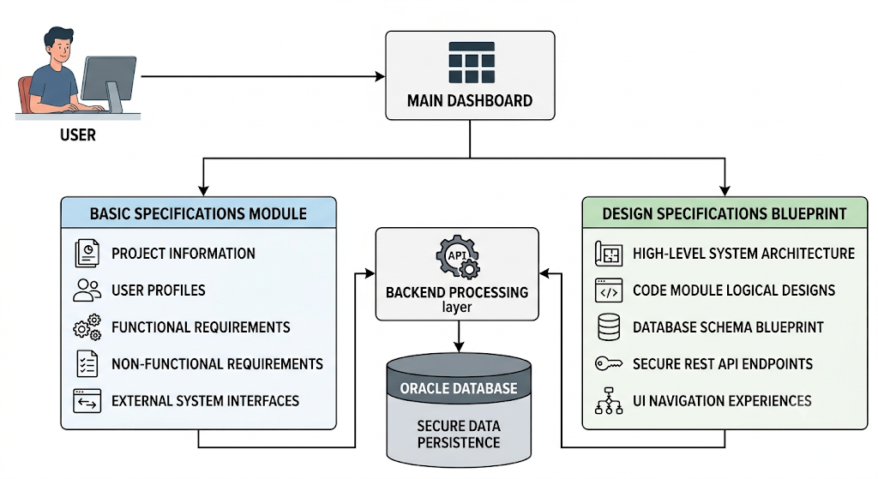

2.2 System Design, Database Design
2.2.1 System Design:
The System Design of the SRS Requirements and Design Management System defines the internal structure and functional behavior of the application. It explains how different modules interact with each other to perform configuration tracking operations such as module updates, parameter validation, workflow tracking, and blueprint mapping. The design focuses on dividing the system into independent functional modules to ensure better control and maintainability.
- Dashboard Module
- Project Information Module
- User Profiles Module
- Functional Requirements Module
- Non-Functional Requirements Module
- External System Interfaces Module
- Design Specifications Blueprint Module
2.2.2 Database Design:
The Database Design defines how data is logically structured and stored in the Oracle database. It ensures proper organization of specification records and supports efficient retrieval and processing of tracking data.
Data Organization Approach
The database is structured to store data based on functional grouping of modules rather than a single table structure. Each type of specification record is stored separately but linked logically through identifiers.
Data Categories:
User Data
- Stores basic identity fields of active engineers and administrators
- Used for tracking modification ownership and system log updates

Basic Specification Data
- Stores Project Information, User Profiles, and Functional Requirement metrics
- Acts as the starting point of the software specifications workflow
Design Blueprint Data
- Stores structural architecture model configurations
- Includes database class layouts, API security schemas, and UI navigation data
Processed Log Data
- Stores committed and validated workspace tracking records
- Includes timestamp indicators and final system configuration snapshots
Module Documentation Files
- Stores standalone binary files or uploaded reference artifacts
- Includes file attachment names, types, and descriptive notes metadata
Database Design Characteristics
- Data is logically grouped based on specification tracking module type
- Maintains consistency across basic specification records, design blueprints, and log entries
- Uses unique identifiers for tracing requirements dependencies across entities
- Supports fast retrieval for analytical report checking and layout verification
- Ensures data integrity through relational structured storage constraints
- Avoids data redundancy by separating logical module types into distinct target tables
- Uses unique identifiers for tracking modification paths across sessions
- Optimizes storage allocation efficiently through normalized schemas
- Utilizes system-level row security configurations
Tables and their Attributes:
PROJECT_INFORMATION
Attribute | Type | Size
PROJECT_ID | VARCHAR2 | 30
PROJECT_NAME | VARCHAR2 | 100
PROJECT_ACRONYM | VARCHAR2 | 20
PROJECT_VERSION | NUMBER | 4,2
START_DATE | DATE | -
EXPECTED_END_DATE | DATE | -
ESTIMATED_BUDGET | NUMBER | 15,2
PROJECT_TYPE | VARCHAR2 | 20
PROJECT_CATEGORY | VARCHAR2 | 25
PROJECT_PRIORITY | VARCHAR2 | 10
PROJECT_STATUS | VARCHAR2 | 20
USER_CLASSES | VARCHAR2 | 25
BUSINESS_DOMAIN | VARCHAR2 | 50

USER_PROFILES
Attribute | Type | Size
PROFILE_ID | NUMBER | 10
USER_CLASS | VARCHAR2 | 50
INTENDED_USER_GROUP | VARCHAR2 | 100
EXEMPTIONS_ALLOWED | VARCHAR2 | 5
PERMISSION_LEVEL | VARCHAR2 | 20
TOTAL_USERS_COUNT | NUMBER | 6
ALERTS_FLAG | VARCHAR2 | 1
SYSTEM_ACCESS_TYPE | VARCHAR2 | 30
DOCUMENTATION_NOTES | CLOB | -
FUNCTIONAL_REQUIREMENTS
Attribute | Type | Size
REQUIREMENT_ID | VARCHAR2 | 20
PROJECT_ID | VARCHAR2 | 30
REQUIREMENT_NAME | VARCHAR2 | 100
MODULE_NAME | VARCHAR2 | 50
INPUT_PARAMETERS | VARCHAR2 | 250
PROCESSING_LOGIC | CLOB | -
NON_FUNCTIONAL_REQUIREMENTS
Attribute | Type | Size
NFR_ID | VARCHAR2 | 20
PROJECT_ID | VARCHAR2 | 30
CATEGORY_TYPE | VARCHAR2 | 40
PERFORMANCE_METRIC | VARCHAR2 | 100
SCALABILITY_TARGET | VARCHAR2 | 100
AVAILABILITY_RATE | VARCHAR2 | 10
SYSTEM_INTERFACES
Attribute | Type | Size
INTERFACE_ID | NUMBER | 10
PROJECT_ID | VARCHAR2 | 30
INTERFACE_NAME | VARCHAR2 | 50
SYSTEM_TYPE | VARCHAR2 | 40
DATA_FORMAT | VARCHAR2 | 20
SYSTEM_ARCHITECTURE
Attribute | Type | Size
ARCHITECTURE_ID | NUMBER | 10
MODEL_NAME | VARCHAR2 | 50
TIER_COUNT | NUMBER | 3
FRONTEND_TECH | VARCHAR2 | 40
BACKEND_TECH | VARCHAR2 | 40
DATABASE_TECH | VARCHAR2 | 40

2.3 Module Description
The SRS Requirements and Design Management System is divided into multiple functional modules to handle different configuration tracking operations in a structured and efficient manner. Each module is responsible for a specific part of the specification entry process, ensuring proper validation, processing, and storage of data.
2.3.1 Dashboard Module
The Dashboard Module acts as the central navigation point for workspace interaction. Functionality:
- Displays available software specification modules:
- Basic Specifications Module (Project Information, User Profiles, Functional Specs)
- Design Specifications Blueprint (System Architecture, Database Designs, API Security)
- Configuration Logs
- Text Search Fields
- Allows users to select required tracking modules
- Provides navigation between different interface sub-components
Importance:
- Acts as control centre of the system
- Facilitates efficient monitoring and quick configuration checking
2.3.2 Basic Specifications Module
The Basic Specifications Module handles the collection and storage of primary project tracking criteria. Functionality:
- Captures high-level configuration parameters such as Project Name and Version
- Defines targeted User Profiles along with associated clearance levels
- Tracks core software metrics including Functional and Non-Functional specs
- Maps interface parameters dynamically within structural multi-step wizards
Importance:
- Establishes the architectural baseline for all subsequent tracking files
- Ensures data length checks are evaluated immediately at the entry level
2.3.3 Design Specifications Blueprint Module
The Design Specifications Blueprint Module handles the structural configuration, logical partitioning, and security mappings of the target system architecture.
- Captures high-level deployment architectures including tier divisions, framework coupling factors, and synchronization mechanisms.
- Defines database schema specifications along with corresponding object-relational class mapping tables and data persistence indexes.
- Tracks secure endpoint configurations including HTTP method definitions, parameter validation checks, and role bounds.
- Maps interactive layout parameters and canvas view boundaries dynamically using automated stepper verification metrics.
Importance:
- Establishes the technical baseline for low-level software component generation and logical flow tracing.
- Ensures interface constraints and database relationship integrity are validated immediately before data persistence layers.

2.4 Implementation
The implementation of the SRS Requirements and Design Management System is done using a 3-tier architecture approach, where the frontend, backend, and database are developed and integrated separately. The system is implemented to handle system configurations and project documentation metrics such as basic specifications mapping, database schema blueprints, backend REST endpoint controls, and interface dashboard actions in a structured and automated manner.
The Implementation focuses on:
- Dynamic workspace rendering
- Modular specification processing
- Data validation and field parameter constraint checking
2.4.1 Frontend Implementation (React.js)
The frontend is developed using React.js to provide an interactive and user-friendly interface for the user.
Key Implementations
- Dashboard with module navigation
- Forms for:
- Project Information
- User Profiles
- Functional Requirements
- Non-Functional Requirements
- External System Interfaces
- Form validation before sending data
- API integration with backend using REST calls
Key Features
- Component-based UI design
- Controlled form inputs
- Navigation between modules
- Real-time response display from backend
2.4.2 Backend Implementation (Spring Boot)
The backend is developed using Spring Boot with Maven, which handles all business logic, validations, and API processing.
Key Implementations
- REST API development for all modules
- Configuration validation using database records
- Specification and blueprint processing logic
- Data constraint evaluation logic
- Step completion state metrics (Step 1, Step 2, and Step 3 wizard states)
- Field validation (input text length vs column schema limits)
- Data transfer between frontend and database
Key Features
- Controller-Service-Repository structure
- Exception handling for invalid inputs
- JSON-based request/response handling
2.4.3 Database Implementation (Oracle Database)
Oracle Database is used to store and manage all specification metrics and user related data securely.
Key Implementations
- Creation of tables for:
- User credentials
- Project Information
- User Profiles
- Functional Requirements
- Design Specifications Blueprint (System Architecture, Database Designs, API Security)
- Primary key and foreign key relationships
- Auto-generated identifiers for tracking records
- Default values for specific fields (e.g., status type, active flag = Y)
Key Features
- Structured relational database design
- Data integrity using constraints
- Efficient query handling
- Secure storage of project data

CODE SNIPPETS:
2.4.1 MAIN DASHBOARD
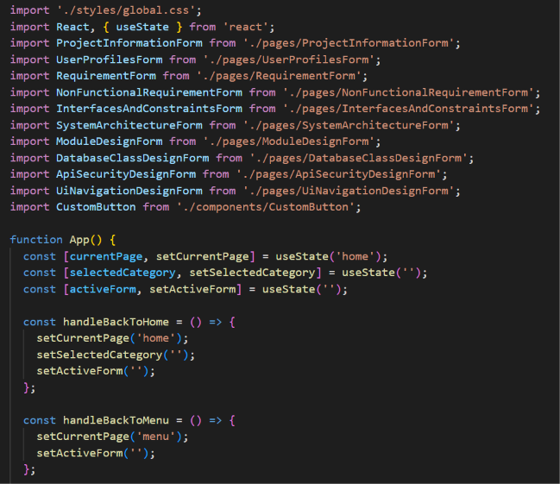
2.4.2 REQUIREMENTS PAGE
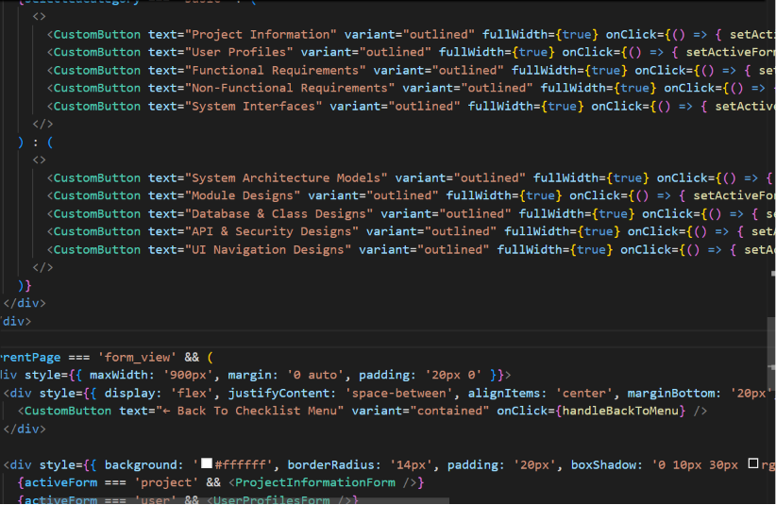

2.4.3 CONTROLLER BACKEND
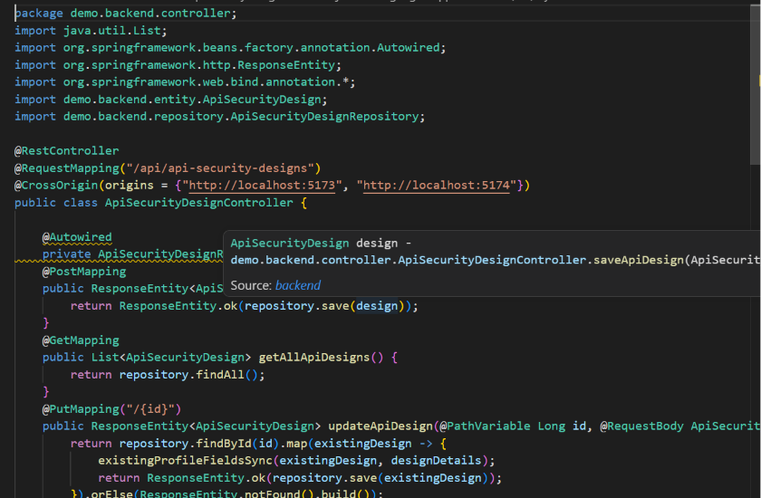
2.4.4 ENTITY BACKEND
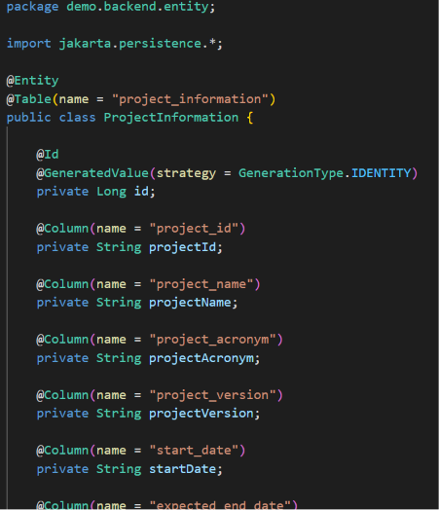

2.4.5 REPOSITORY BACKEND
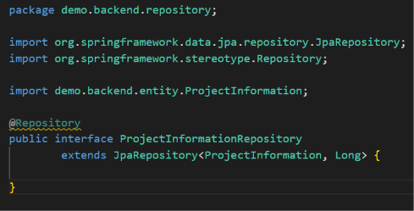

2.5 WORKFLOW OF THE SYSTEM
The workflow of the SRS Requirements and Design Management System describes the complete flow of operations starting from user system interaction to final configuration storage in the database. The system handles two main modules: Basic Specifications Modules and Design Specifications Blueprints.
Complete System Workflow (Step-by-Step)
- The user accesses the application directly through the main workspace URL.
- The dashboard displays available tracking modules:
  - Project Information
  - User Profiles
  - Functional Requirements
  - Non-Functional Requirements
  - External System Interfaces
  - Design Specifications Blueprints
- The user selects any one module based on the required documentation type.
- If Basic Specifications Module is selected:
  - User enters project high-level parameters (Project Name, Acronym, Version, etc.).
  - System performs real-time length validation against column schema constraints.
  - User proceeds to the next wizard screen to define targeted User Profile configurations.
  - User maps functional specs such as input elements, processing logic, and expected outputs.
  - If valid, system proceeds to the final confirmation stage.
  - System bundles the multi-step parameters into serialized JSON data blocks.
  - Final tracking record is generated and stored in the Oracle database.
- If Design Specifications Blueprint Module is selected:
  - User enters structural architecture parameters such as framework options and tier divisions.
  - System assigns default configuration validation flags like active flag = Y.

Chapter 3
Testing and Evaluation
3.1 Testing:
Testing and evaluation are required to ensure that the developed system works correctly and meets all the specified requirements before it is used in real conditions. The purpose of testing and evaluation in the SRS Requirements and Design Management System is to ensure that the developed application works correctly, reliably, and securely according to the required specifications. Testing is performed to verify that all modules such as dashboard view, basic specifications module, design specifications blueprint module, data constraints, and relational database table operations function properly without errors. Types of Testing Used
3.1.1 Unit Testing
- Each module (dashboard, basic specs, design blueprint, etc.) is tested individually
- Ensures each function works correctly
3.1.2 Integration Testing
- Checks communication between frontend, backend, and database
- Ensures data flows correctly through APIs
3.1.3 Functional Testing
- Verifies that all system features work according to requirements
- Example: workflow step state tracker, input data constraint validation
3.1.4. System Testing
- Entire application is tested as a complete system
- Ensures end-to-end workflow works properly
3.2 Evaluation
The system is evaluated based on:
- Accuracy of form step validation and rule processing metrics
- Correctness of data storage and retrieval in the relational database instances

- Response time between frontend and backend
- Security of dynamic operational data transfer
- Proper handling of valid and invalid inputs
3.3 Commands Used for Execution
Since your project uses React + Spring Boot + Oracle DB, the execution commands are as follows:
3.3.1 Frontend (React) Execution
npm install
Install dependencies (first time only)
npm start
Starts the React development server
Runs on: http://localhost:3000
3.3.2 Backend (Spring Boot) Execution
Using Maven: mvn clean install
Next Builds the project and downloads dependencies
mvn spring-boot:run
Starts Spring Boot application
Backend runs on: http://localhost:8080
3.3.3 Database (Oracle SQL Developer)
No command execution like terminal is used here. Instead:
- Open SQL Developer
- Connect to Oracle database
- Run SQL scripts like:
  - SELECT * FROM PROJECT_INFORMATION;
  - INSERT INTO USER_PROFILES VALUES (...);

CHAPTER 4
4.1 OUTPUT SNAPSHOTS
4.1.1 MAIN DASHBOARD
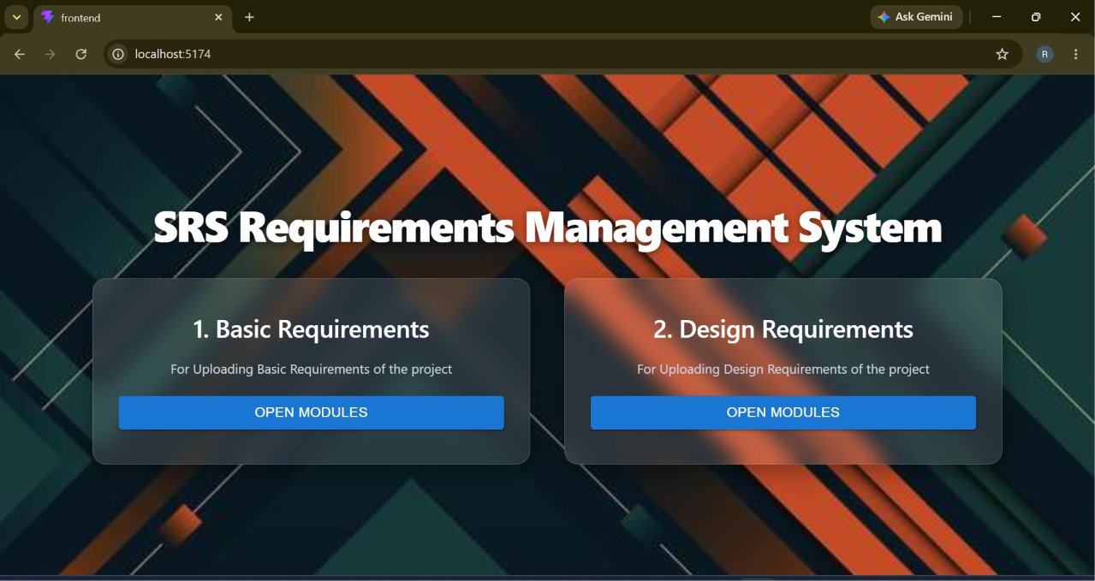
4.1.2 BASIC REQUIREMENTS
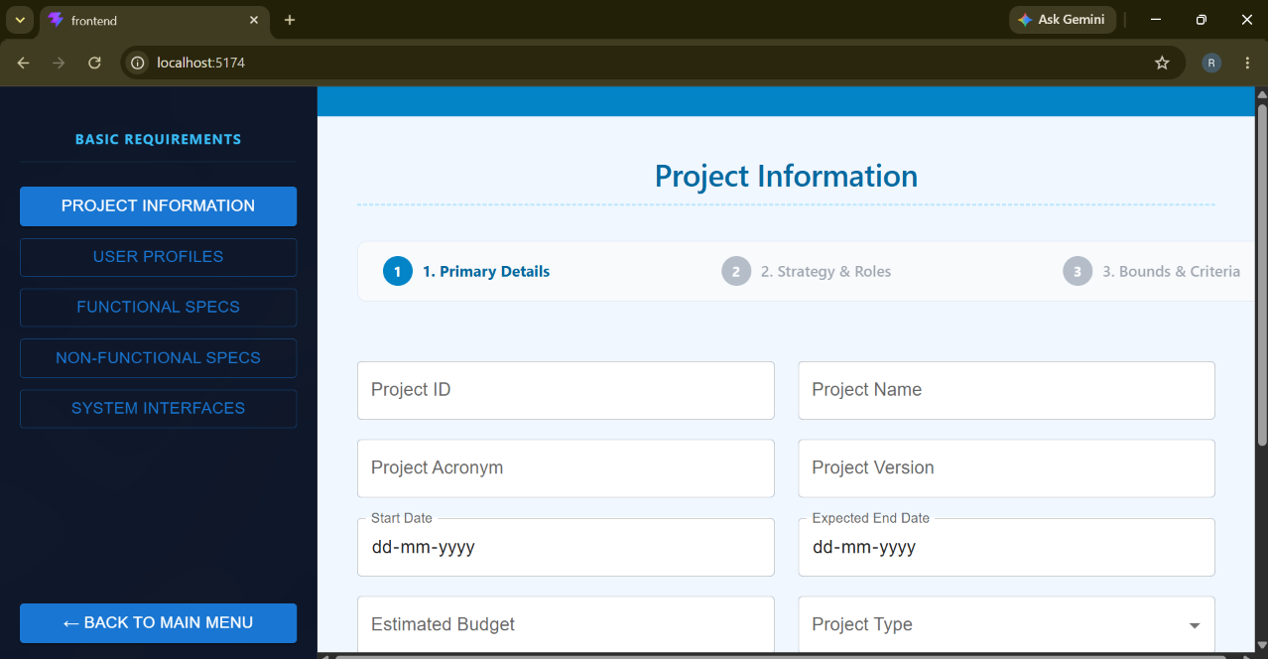

4.1.3 DESIGN REQUIREMENTS
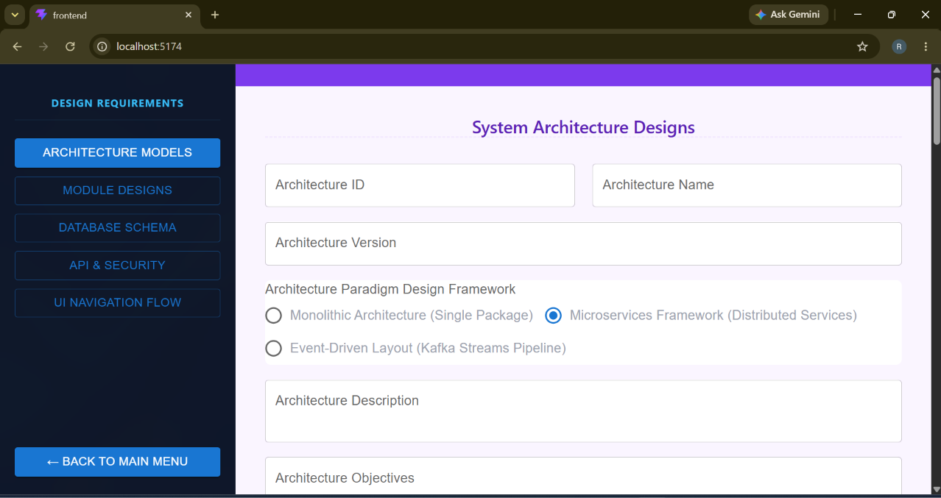

4.2 Challenges Faced:
During the development of the SRS Requirements and Design Management System, several technical and implementation challenges were encountered:
Integration of Frontend and Backend:
Establishing proper communication between React (frontend) and Spring Boot (backend) using REST APIs required careful handling of request and response formats.
Data Flow Management Across Modules:
Managing data transfer between multiple steps (Project Info $→$ User Profiles $→$ Functional Specs) was complex and required proper state handling.
Validation of Architectural Constraints:
Implementing constraints such as field text character limits checking against database configurations and preventing truncated strings required accurate backend logic.
Wizard Progress State Logic:
Handling multiple interactive step options (Part 1, Part 2, Part 3) and applying them correctly during step transitions required precise implementation.
Database Consistency:
Ensuring proper storage and retrieval of related configuration data across multiple operations in Oracle Database was challenging.
Debugging and API Testing:
Identifying errors in API calls and resolving validation issues during Postman testing required multiple iterations.
4.3 Learning Outcomes:
The development of this project provided strong practical knowledge and technical learning in full-stack application development:
- Gained hands-on experience in React.js frontend development
- Learned backend development using Spring Boot and REST APIs
- Understood database integration using Oracle SQL Developer
- Improved understanding of 3-tier architecture system
- Learned how to implement real-time validation and business logic
- Gained experience in API testing using Postman
- Developed skills in problem-solving and debugging full-stack applications
- Understood how engineering tracking platforms handle work flow based structural processing
- Learned version control and project management using GitHub

Chapter 5
Conclusion and Future Enhancements:
Conclusion:
The SRS Requirements and Design Management System was successfully designed and developed as a web-based application to manage system specifications in an organized and efficient manner. The system integrates multiple modules such as Basic Specifications Module and Design Specifications Blueprint Module, enabling structured handling of configuration-related operations. The application ensures a complete workflow starting from dashboard navigation, module selection, step processing, criteria validation, and final storage in the database. The use of a 3-tier architecture (React, Spring Boot, Oracle Database) provides a clear separation of responsibilities, making the system modular, scalable, and easy to maintain.
This system reduces manual effort involved in specification tracking and minimizes errors in software design archiving by implementing proper validation rules and automated field constraint checking. It also improves transparency and accuracy in handling system design records.
Overall, the project successfully achieves its objective of building a secure, efficient, and reliable management system with proper workflow control and data integrity.
FUTURE ENHANCEMENTS
The SRS Requirements and Design Management System can be further improved by adding advanced features such as multilevel approval workflows, role-based access control for different engineering users, and real-time notification alerts for baseline changes. In future, the system can also be enhanced by integrating analytics and reporting dashboards to provide better insights into blueprint completeness and module dependency metrics. Additionally, cloud deployment and mobile application support can be added to improve accessibility and scalability of the system.

